0595-健身器材握把3D打印生产记录
Fitness equipment grip
🖨️ SLS尼龙烧结
🖥️ 打印机: HP
📦 材料: SLS尼龙
人生就像一次健身旅程，唯有坚持才能见到成效。有人找到我们，希望制作健身器材握把，帮助他们更好地锻炼。
Life is like a fitness journey; only with persistence can we see results. Someone reached out to us, hoping to create grips for fitness equipment to help them exercise better.
________________________________________________________________________________
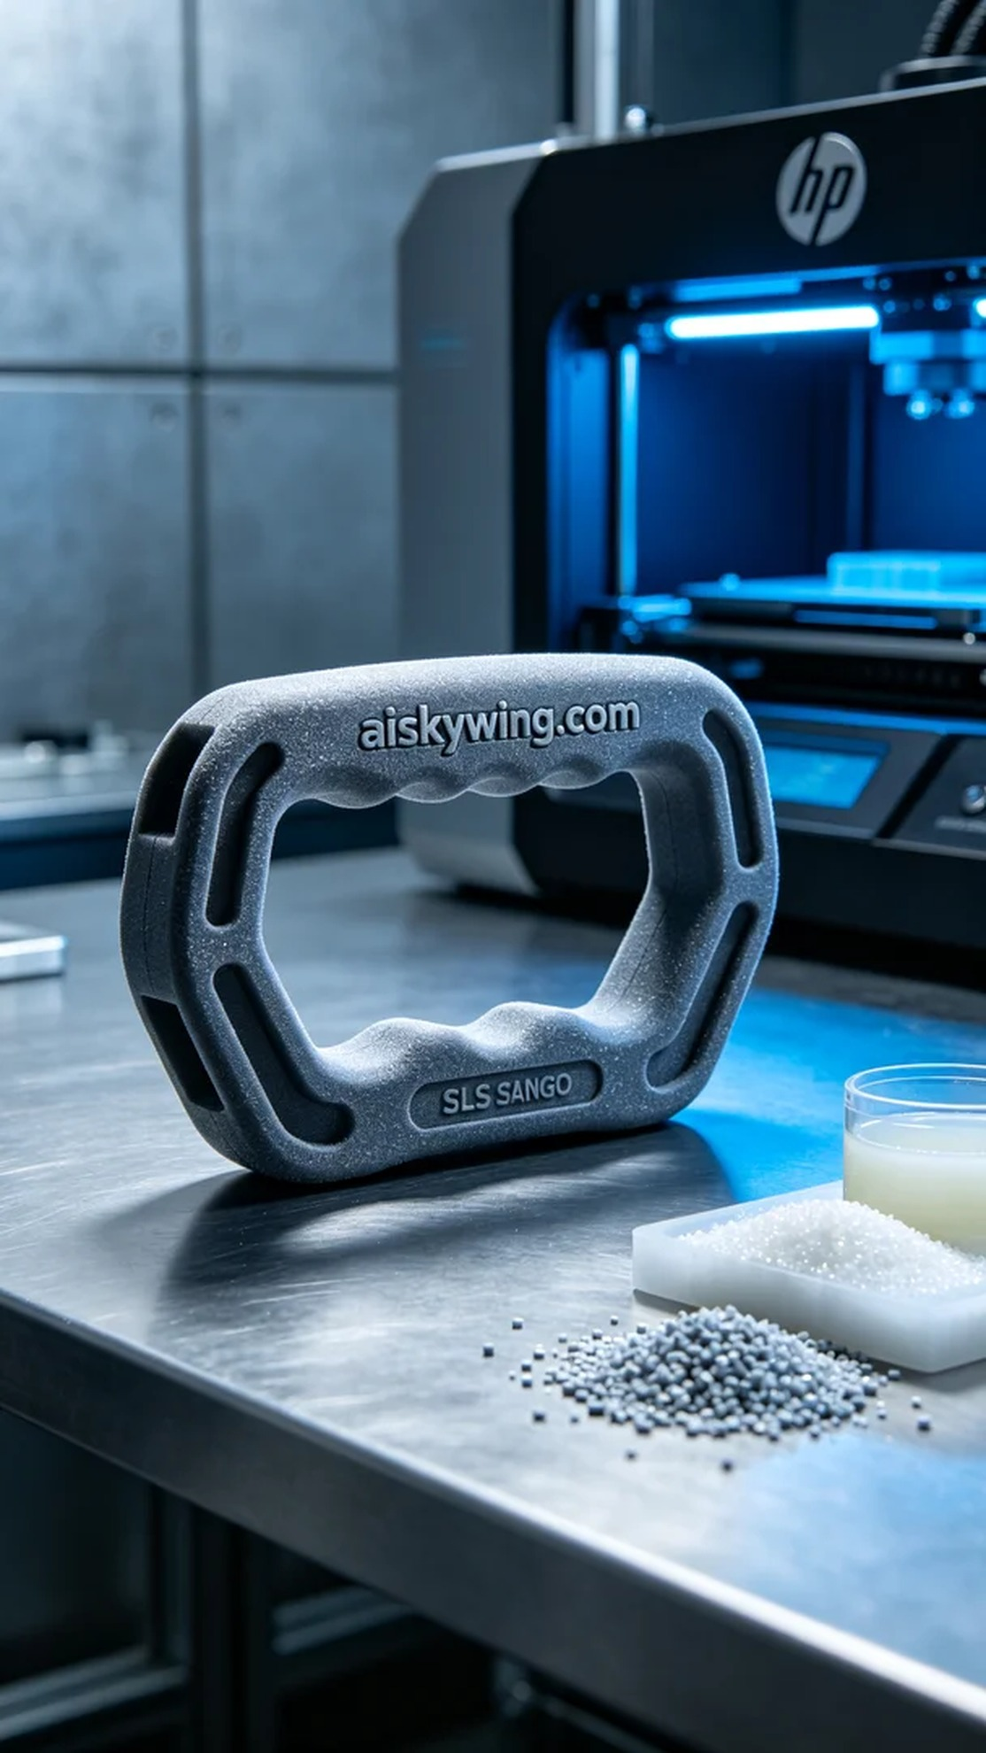
Life is like a fitness journey; only persistence leads to results. Someone reached out to us on Facebook, hoping to create a fitness equipment grip to enhance their workout experience.
For this project, we chose SLS nylon as the primary material due to its excellent mechanical properties and durability. We prepared the HP 3D printer and set the printing parameters: layer thickness at 0.1 mm, printing temperature at 180 degrees Celsius, power maintained at 80%, and printing speed set to 50 mm per hour, ensuring high precision and strength of the final product.
During the printing process, the HP printer operated smoothly, and we maintained constant quality monitoring, observing the layer-by-layer addition of materials to ensure precise alignment. After about half an hour, the first prototype of the grip began to take shape, which was quite exciting.
Once the printing was complete, we moved on to the post-processing steps. First, we cleaned the final product and excess nylon powder to remove any residue. Next, we sanded the grip to ensure a smooth touch that wouldn’t hurt the palms. Then, we carried out a curing process to enhance its strength and durability, followed by a thorough inspection to ensure every detail met standards.
In the end, after a series of meticulous procedures, the fitness equipment grip was perfectly presented. This process was not just about production; it was a commitment to quality and pursuit of excellence.
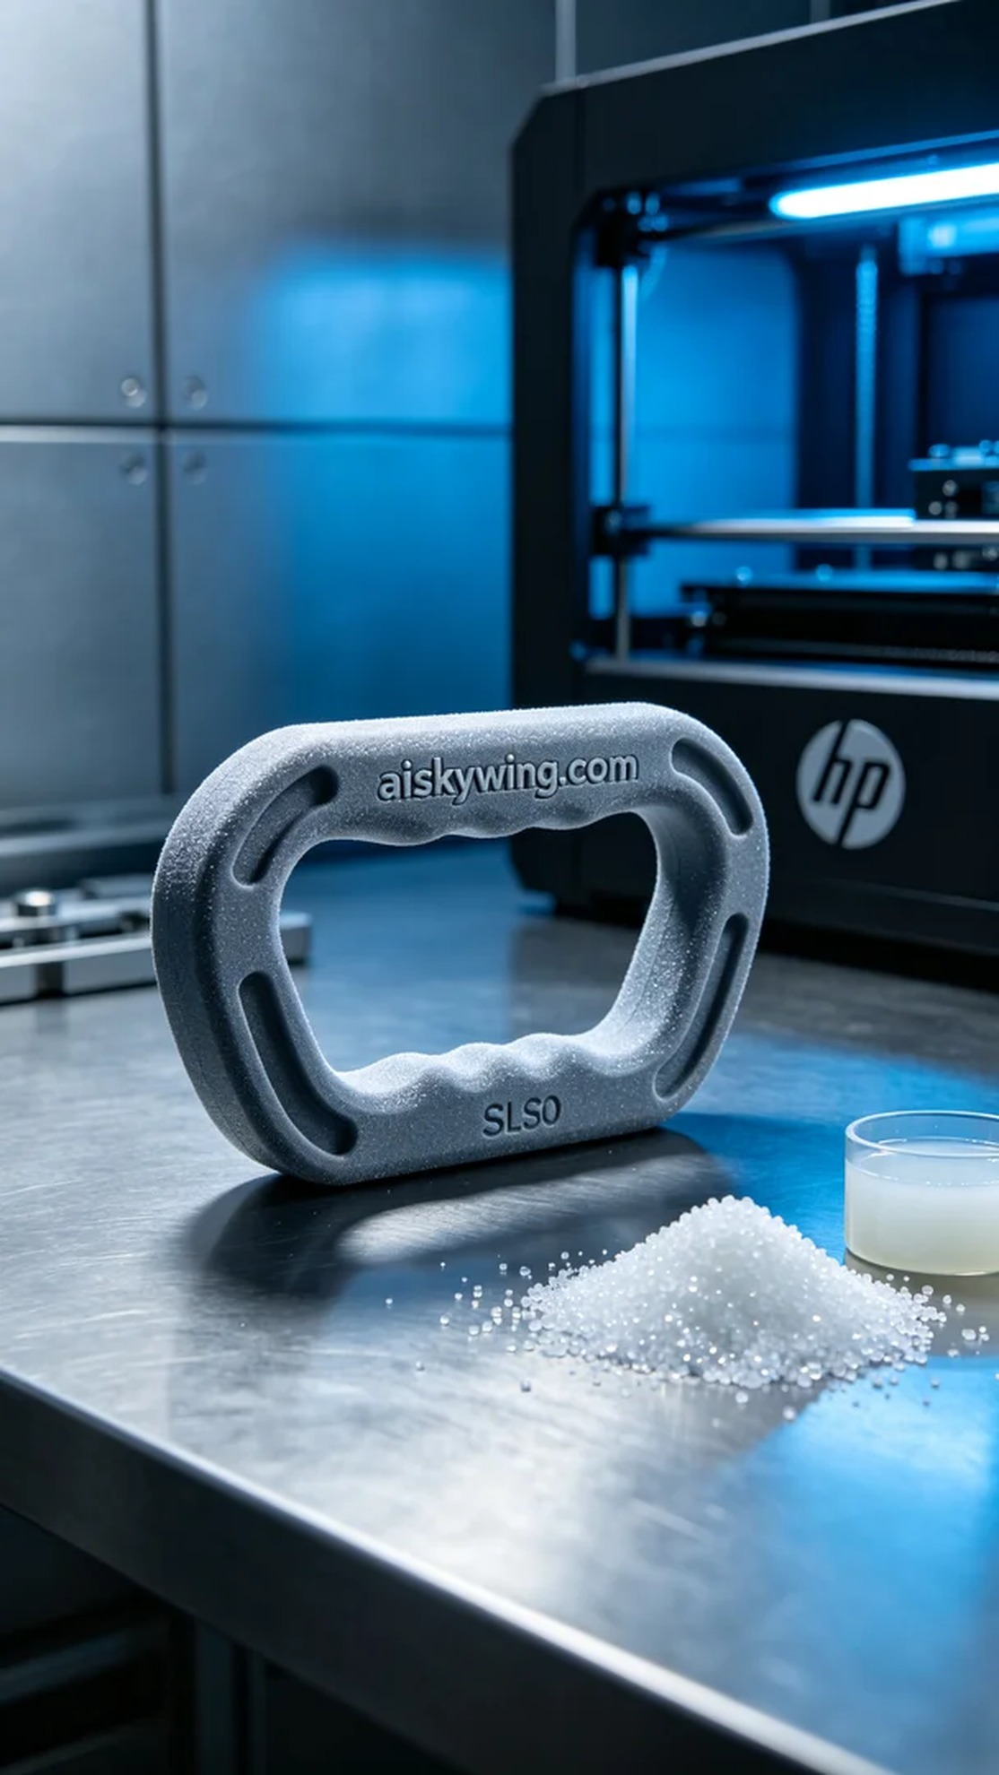
这次的工作源自Facebook上的一个请求，有人因为需要更好的健身器材握把而找上了我们。他们希望能定制一个握持更加舒适且轻量化的产品，以提升运动的效果和体验。于是，我们开始了这次的生产之旅。
首先，我们选择了SLS尼龙作为主要材料，因其优良的机械性能和耐用性。我们准备了HP品牌的3D打印机，设定了打印参数：层厚0.1毫米，打印温度180摄氏度，功率保持在80%，打印速度设定为每小时50毫米，以确保最终产品的高精度和强度。
打印过程中，HP打印机的运行稳定，整个设备运转流畅。我们始终保持对打印质量的监控，观察打印材料的层层叠加，确保每一层都能精确贴合。在半个小时后，第一次打印的握把雏形开始显现，令人振奋。
完成打印后，我们进入后处理工序。首先将成品和未成型的尼龙粉末进行清洗，去除表面多余的粉末。然后，对握把进行打磨，确保触感顺滑、不会刮伤手掌。随后，进行固化处理，以增加其强度和耐用性，最后进行全面检验，确保每个细节都达到标准。
最终，经过一系列精细的工序，健身器材握把完美呈现。这个过程不仅是一次生产，更是对品质的坚持和追求。
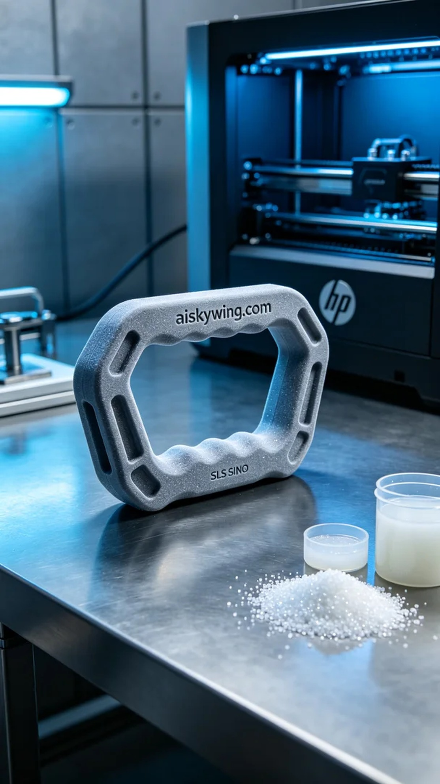
Aiskywing Industrial 3D Printing
Fitness equipment grip


