0596-冲浪板脚套3D打印生产记录
Surfboard foot strap
🖨️ SLS尼龙烧结
🖥️ 打印机: EOS
📦 材料: SLS尼龙
在生活的浪潮中，我们总要学会平衡。最近，有人希望我们制作一款冲浪板脚套，以解决他们在海浪中的稳定问题。
In the waves of life, we must learn to find balance. Recently, someone asked us to create a surfboard foot strap to address their stability issues in the waves.
________________________________________________________________________________
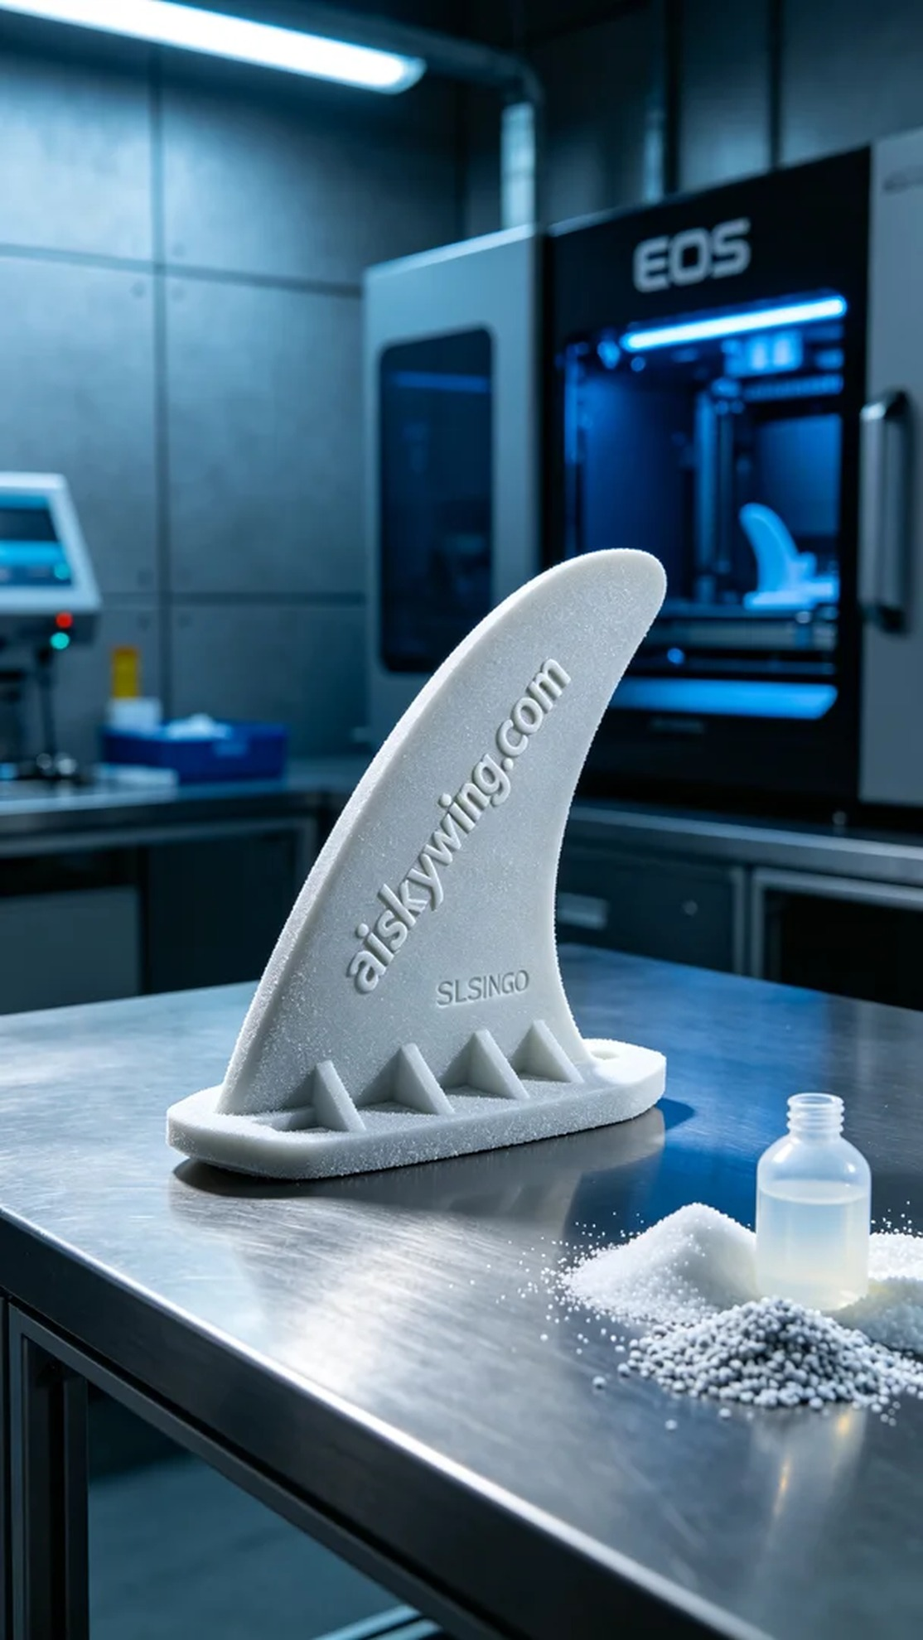
In the waves of life, we all have to learn to find balance. Recently, someone reached out to us to create a surfboard foot strap to address their stability issues while surfing.
The material we used is SLS nylon, known for its exceptional strength and toughness, making it ideal for high-stress applications like a surfboard foot strap. The printer we utilized is from the EOS brand, with a layer thickness set at 0.1mm, printing temperature at 190°C, power set at 60W, and a printing speed maintained at 20mm per hour. The entire printing process was expected to last about 6 hours to ensure precise layering.
During the printing process, the EOS printer operated smoothly, building up the complex structure of the foot strap layer by layer. We monitored the equipment in real time to ensure that temperature and power remained optimal. The sintering effect of each layer was clearly visible, with the surface showcasing a unique fine powder texture, light yet durable, exactly what we aimed for.
Once printing was completed, the foot strap underwent a series of post-processing steps. First, we placed it in a cleaning tank to remove any un-sintered powder on the surface. Then, we polished the edges with fine sandpaper for a smoother finish. Following that, we conducted a curing process to further enhance the material's strength. Finally, we performed a comprehensive inspection of the finished product to ensure it met design requirements and performance standards.
After meticulous processing, the surfboard foot strap was completed, both aesthetically pleasing and practical. Every detail reflects our dedication and professionalism.
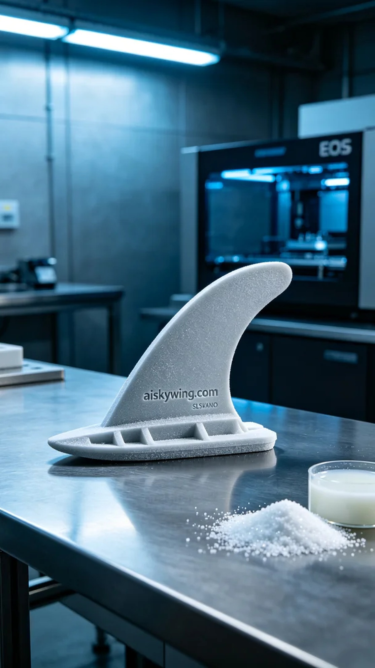
在社交媒体平台Instagram上，有人因为冲浪时脚部的滑动问题找上了我们，希望能制作一款冲浪板脚套，以增强他们的冲浪体验。这个脚套的设计要求极为严格，既要轻量又要有很好的抓地力，正好符合我们的3D打印技术。
我们使用的原材料是SLS尼龙，这种材料以其优异的强度和韧性而著称，特别适合于诸如冲浪板脚套这样的高强度应用。打印机采用的是EOS品牌的3D打印机，设置了层厚0.1mm，打印温度为190°C，功率设定为60W，打印速度保持在每小时20毫米，预计整个打印过程将持续约6小时，确保每一层都能精确成型。
在打印过程中，EOS打印机运转稳定，逐层构建出复杂的脚套结构。我们对设备进行实时监控，确保温度和功率始终保持在最佳状态。每层的烧结效果都能清晰可见，表面呈现出独特的细粉末纹理，轻巧而坚固，正是我们所期待的效果。
打印完成后，脚套需要经过一系列后处理工序。首先，我们将其放入清洗槽中，去除表面的未烧结粉末。然后，使用细砂纸对边缘进行打磨，使其更为光滑。接下来，进行固化处理，使材料的强度进一步提升。最后，我们对成品进行全面检验，确保其符合设计要求和使用性能。
经过一系列精细的工序，这款冲浪板脚套终于完成，既美观又实用。每一个细节都充分体现了我们的专业与努力。
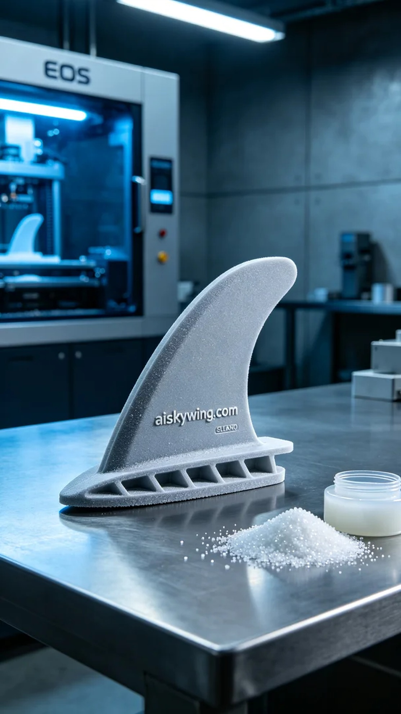
Aiskywing Industrial 3D Printing
Surfboard foot strap


