0597-安全帽内衬支架的3D打印记录
Safety helmet liner bracket
🖨️ SLS尼龙烧结
🖥️ 打印机: EOS
📦 材料: SLS阻燃尼龙
生活再难，也别停下脚步。就像接下这个安全帽内衬支架的单子，帮助有人解决产品设计中的问题，也是对自己的磨练。
No matter how difficult life gets, don't stop moving forward. Just like taking on this order for a helmet liner support, helping someone solve problems in product design is also a way to challenge myself.
________________________________________________________________________________
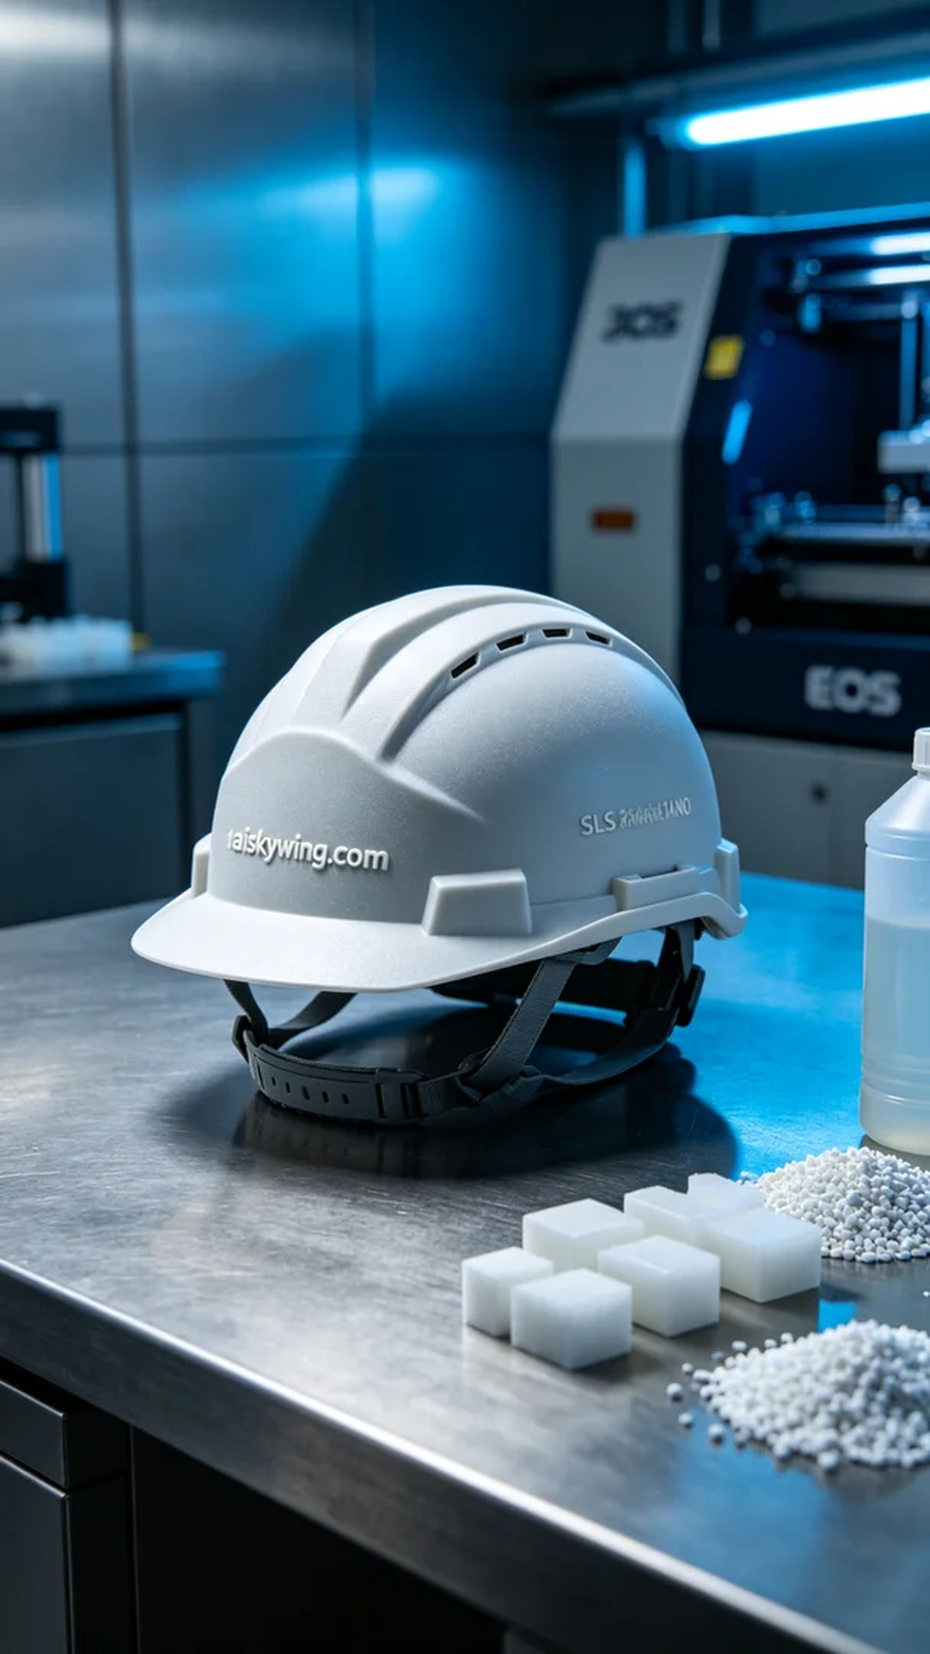
Recently, someone sought our help due to their design needs for a safety helmet liner bracket. This bracket is not only a functional requirement but also a part of safety equipment. After understanding their needs, we decided to use SLS technology for printing to fully leverage the excellent properties of nylon material.
We chose SLS flame-retardant nylon as the printing material. This material has good flame-retardant properties, achieving V0 level standards, and its matte surface texture not only meets practicality but also adds a touch of aesthetics. Before printing, we carefully set up the EOS printer, with a layer thickness of 0.1mm, printing temperature maintained at 190°C, power set at 70%, and speed configured for 500 grams per hour. The entire printing process was expected to take about 5 hours.
The key during the printing process lies in the stable operation of the equipment and quality monitoring. We monitored the printing status in real-time to ensure that each layer melted and fused uniformly. The high-precision control of the printer ensured that every detail was perfectly rendered, making the engraved text "aiskywing.com" on the surface of the bracket clearly visible without any defects.
Post-processing is equally important. After printing, we first cleaned to remove excess powder, then meticulously polished the surface for a smoother finish. Next, we performed a curing process to ensure the strength and durability of the material. Finally, we conducted strict inspections on the finished product to ensure it met quality standards and was delivered on time.
Through this printing production, we not only gained a high-quality safety helmet liner bracket but also improved our professional skills in every step, accumulating valuable experience for future work.
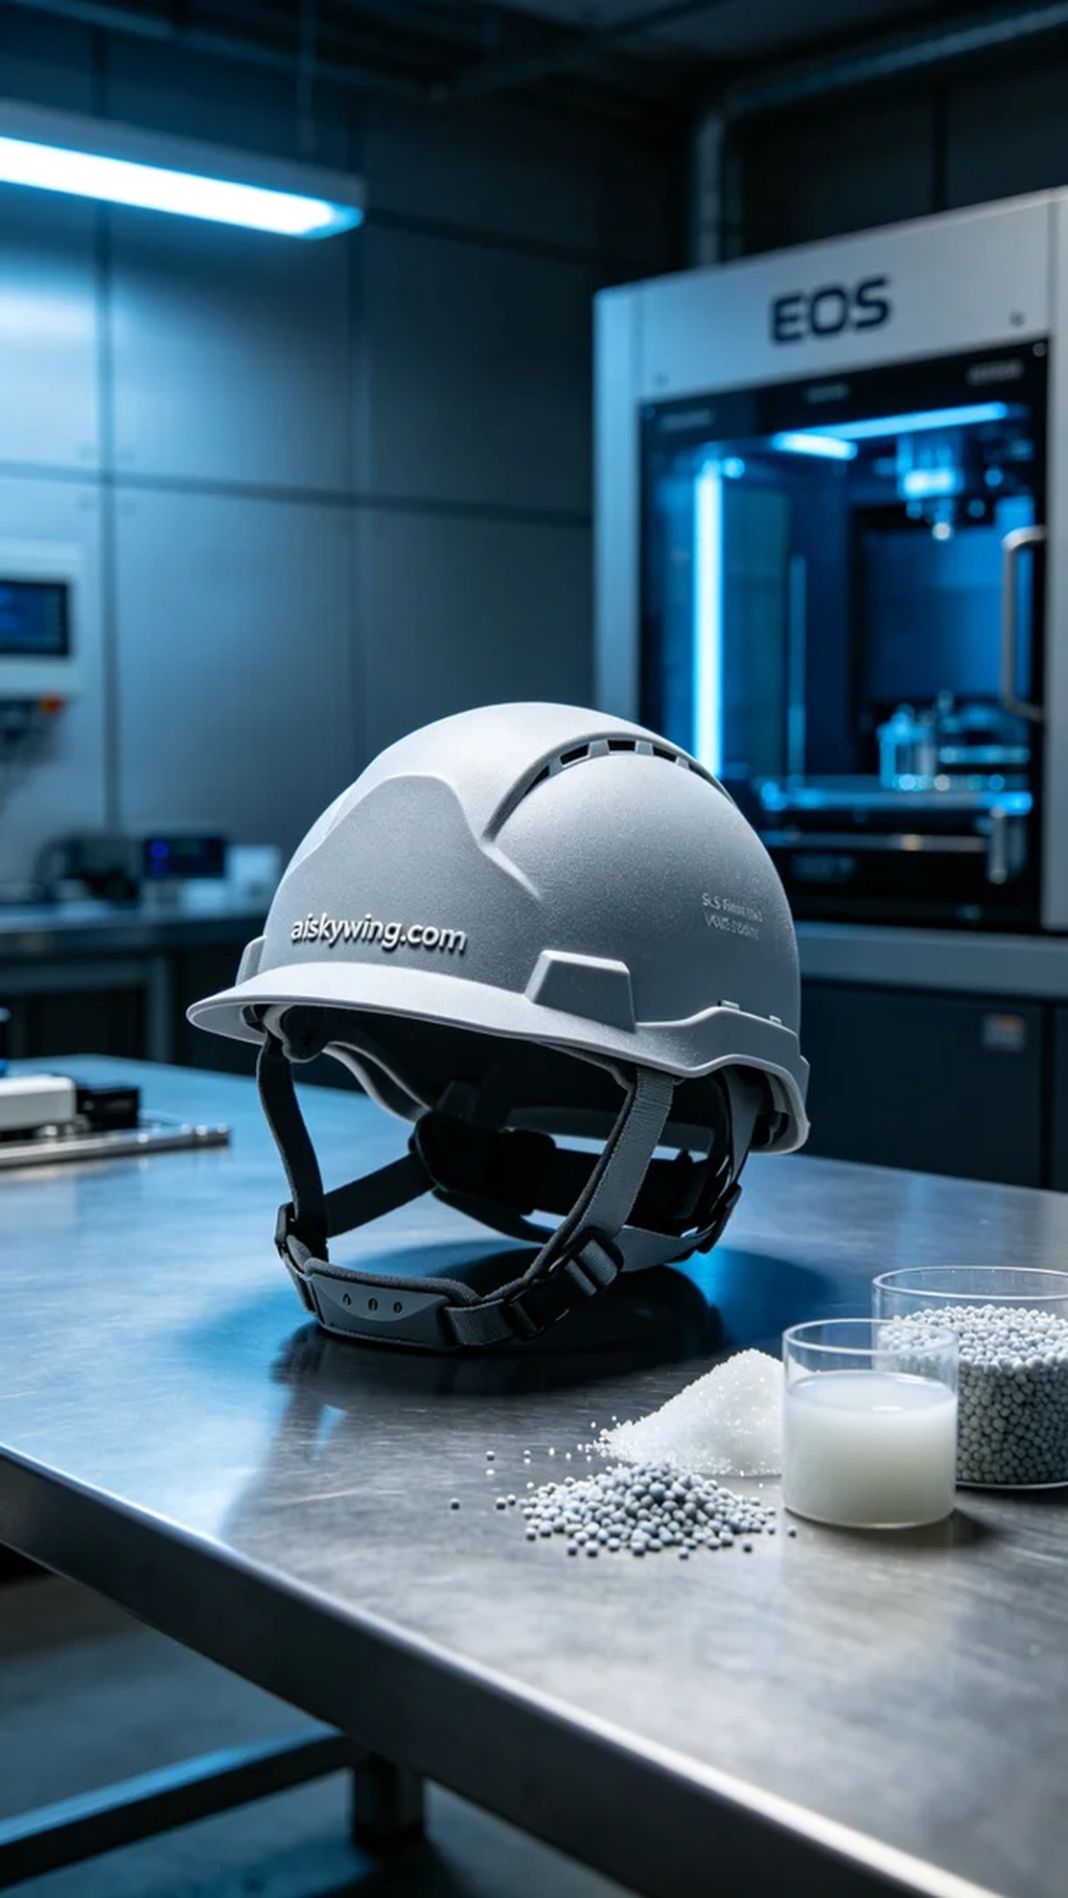
最近，有人因为安全帽内衬支架的设计需要，向我们寻求帮助。这个支架不仅是功能性的需要，更是安全防护的一部分。在了解他们的需求后，我们决定使用SLS技术进行打印，充分发挥尼龙材料的优良特性。
我们选择了SLS阻燃尼龙作为打印材料。这种材料具有良好的阻燃性能，达到V0级标准，表面磨砂质感，使成品不仅满足实用性，还具备一定的美观。在打印前，我们对EOS打印机进行了详细的设置，层厚设置为0.1mm，打印温度控制在190℃，功率为70%，速度设定为每小时500克，整个打印过程预计耗时约5小时。
打印过程中的关键在于设备的稳定运行和质量监控。我们实时监测打印状态，确保每一层都能均匀熔化并融合。打印机的高精度控制使得每个细节得以完美呈现，支架表面"aiskywing.com"的雕刻字样也清晰可见，没有出现任何瑕疵。
后处理工序同样重要。打印完成后，我们先进行了清洗，去除多余的粉末，然后通过细致的打磨使表面更加光滑。接下来进行了固化处理，以确保材料的强度和耐用性。最后，我们对成品进行了严格的检验，确保符合质量标准，及时交付。
经过这次打印生产，我们不仅收获了一款高质量的安全帽内衬支架，更在每个环节中提升了自己的专业技能，为以后的工作积累了宝贵的经验。
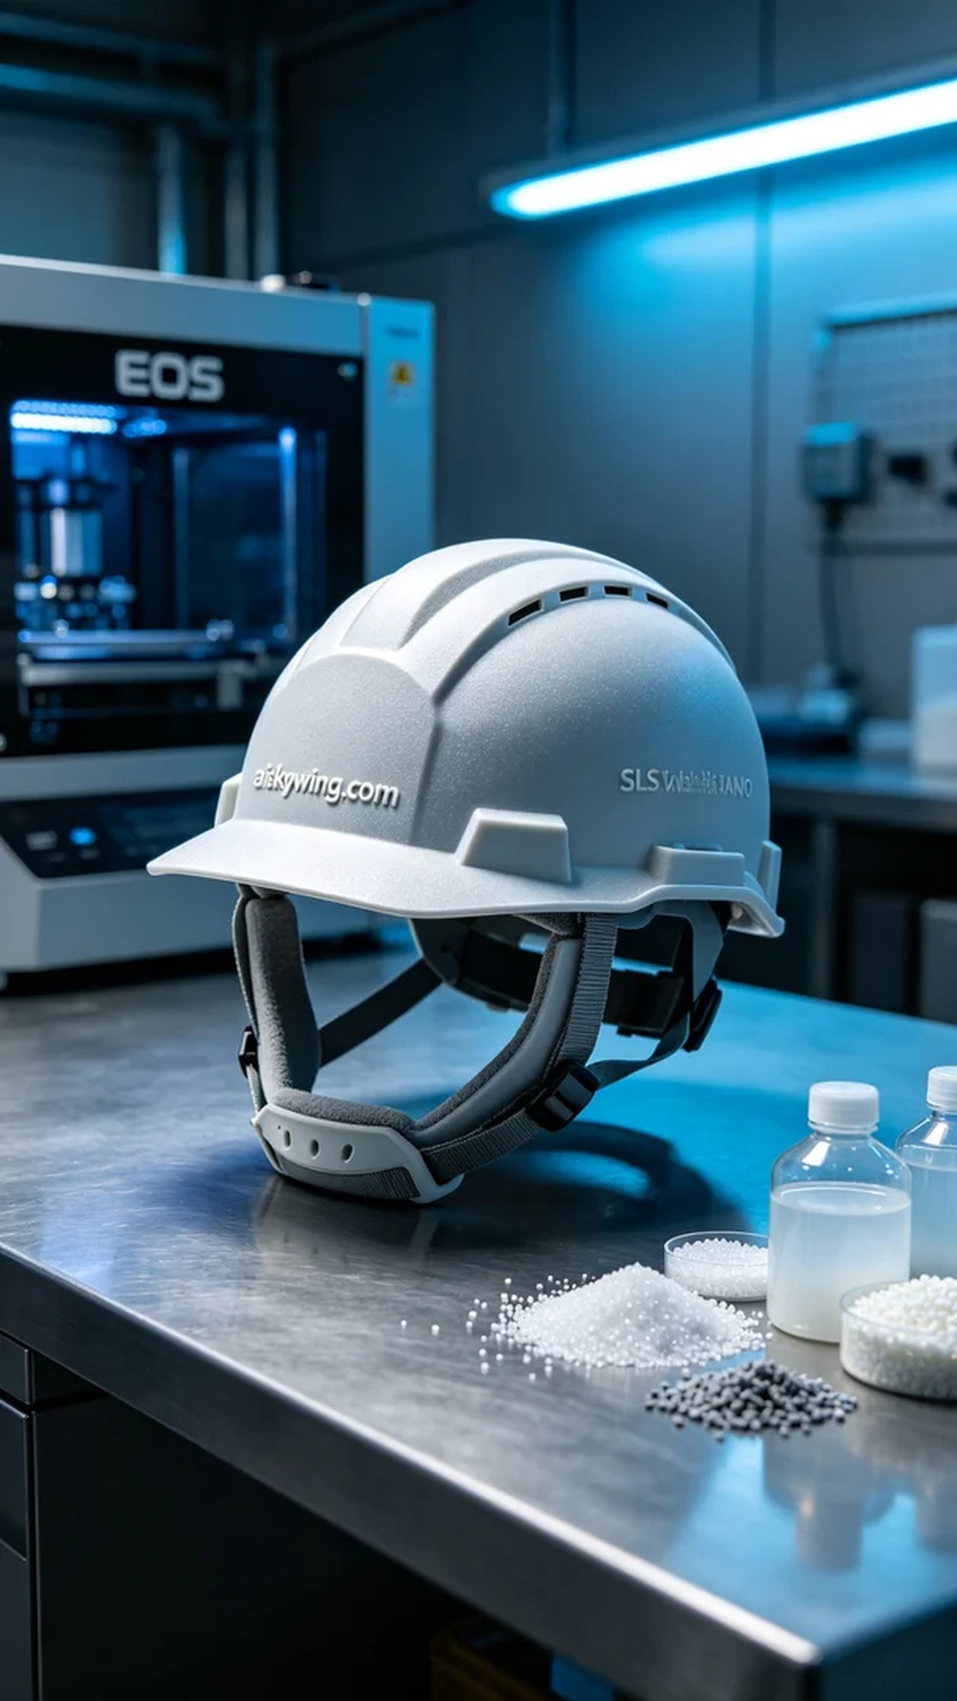
Aiskywing Industrial 3D Printing
Safety helmet liner bracket


