0598-宠物全身清洁器手柄生产记录
Pet Full Body Cleaner Handle
🖨️ SLS尼龙烧结
🖥️ 打印机: EOS
📦 材料: SLS尼龙
生活的每一个细节都值得我们去雕琢，就像这个宠物全身清洁器手柄在Twitter上引起的讨论，让我们聚焦于完美的每一寸。
Every detail of life is worth our careful crafting, just like the discussion sparked on Twitter about this pet full-body cleaner handle, which encourages us to focus on perfecting every inch.
________________________________________________________________________________
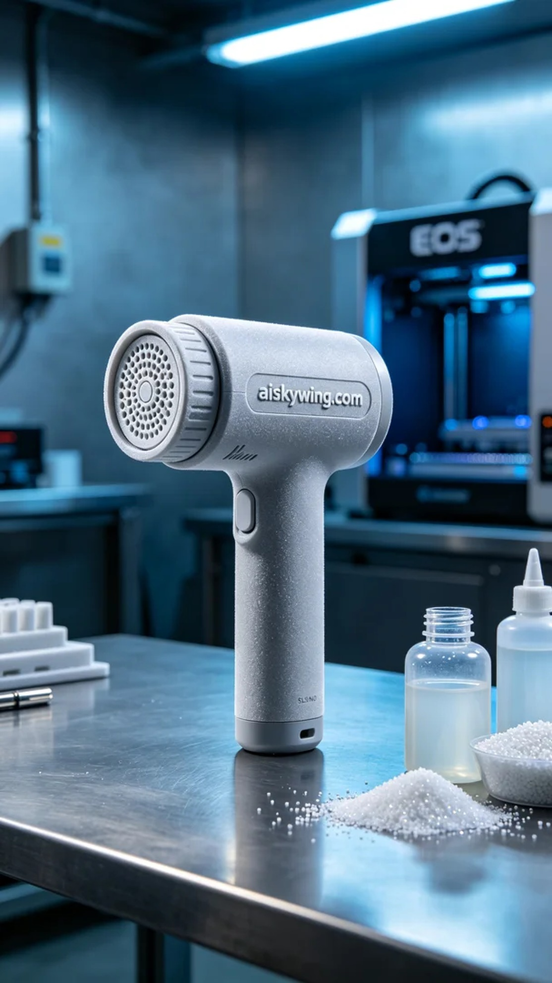
Recently, someone mentioned on Twitter that the design of a pet cleaning device’s handle was inconvenient for users. They hoped we could produce a more user-friendly pet cleaning device handle to enhance the experience. Thus, we began to tackle this project.
To ensure the handle's strength and durability, we chose SLS nylon as the material. SLS nylon possesses excellent mechanical properties and chemical stability, making it ideal for high-precision 3D printing. We utilized an EOS printer, setting the layer thickness at 0.1 mm, maintaining a temperature of 180℃, with a power setting of 70% and a print speed of 20 mm/s. These parameters ensure the optimal balance between strength and precision in the printed handle.
The printing process went smoothly as the EOS printer maintained a stable operation. The powder sintering was uniform, and we conducted real-time quality monitoring to ensure that each layer was printed without delamination or misalignment. After approximately 12 hours, the handle was completed, featuring a delicate surface with the engraved “aiskywing.com” text clearly visible, showcasing our commitment to quality.
The subsequent post-processing steps were crucial. We first placed the handle in a cleaning tank to remove excess powder, followed by sanding to enhance the tactile feel. Next, the handle was subjected to a curing process in a dedicated device to ensure its physical properties were stable. Lastly, we conducted a strict inspection of each handle to ensure there were no defects and that the product met our standards.
After a series of meticulous operations, we successfully completed the production of the pet cleaning device handle. Every detail reflects our professionalism and passion, and we look forward to it bringing convenience and joy to more pets and their owners in the market.
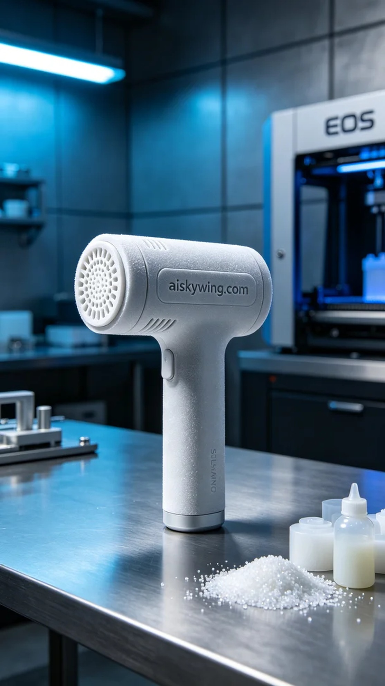
最近，有人在Twitter上提到，宠物清洁器的手柄设计存在一些使用不便的问题。他们希望我们能制作出一个更符合用户需求的宠物全身清洁器手柄，以提升使用体验。于是，我们开始着手进行这个项目。
为确保手柄的强度和耐用性，我们选择了SLS尼龙作为材料。SLS尼龙具有优良的机械性能和化学稳定性，适合进行高精度的3D打印。我们使用EOS打印机，设定了层厚为0.1毫米，温度保持在180℃，功率为70%，打印速度设定为20毫米/秒。这些参数能够保证打印出的手柄在强度和精度上的最佳平衡。
打印过程顺利进行，EOS打印机在运行中保持了稳定的状态，粉末烧结均匀。我们进行了实时的质量监控，确保每一层的打印都没有出现分层或错位现象。经过大约12小时的打印，手柄终于完成，表面细腻，雕刻的“aiskywing.com”字样清晰可见，体现了我们对品质的追求。
接下来的后处理工序至关重要。我们先将手柄放入清洗槽中，去除多余的粉末，之后进行打磨以提升手感。接着，将手柄放置在固化设备中进行固化处理，确保其物理特性稳定。最后，我们对每一个手柄进行了严格检验，以确保没有瑕疵，确保产品达标。
经过一系列的精细操作，我们成功完成了这个宠物全身清洁器手柄的生产。每一个细节都展现了我们的专业与热情，期待它在市场上能为更多宠物和主人带来便利与快乐。
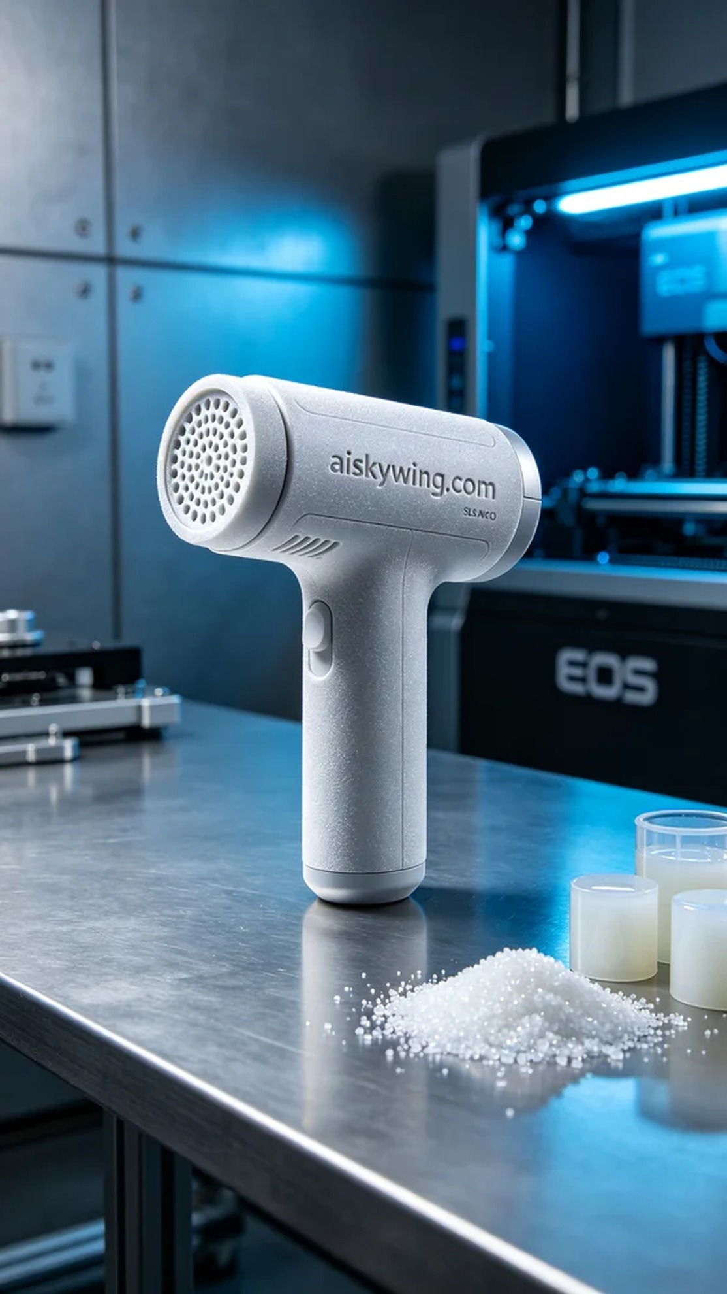
Aiskywing Industrial 3D Printing
Pet Full Body Cleaner Handle


