0599-宠物剃毛器刀头支架的3D打印记录
Pet grooming clipper blade holder
🖨️ SLS尼龙烧结
🖥️ 打印机: Stratasys
📦 材料: SLS尼龙PA12
生活就像这款宠物剃毛器刀头支架一样，细致入微，每一步都得认真对待。今天在Instagram上，有人因为想要提升宠物剃毛的效率，找到了我们。
Life is like this pet clipper blade holder, intricate and requiring careful attention to every step. Today on Instagram, someone reached out to us seeking to improve the efficiency of pet grooming.
________________________________________________________________________________
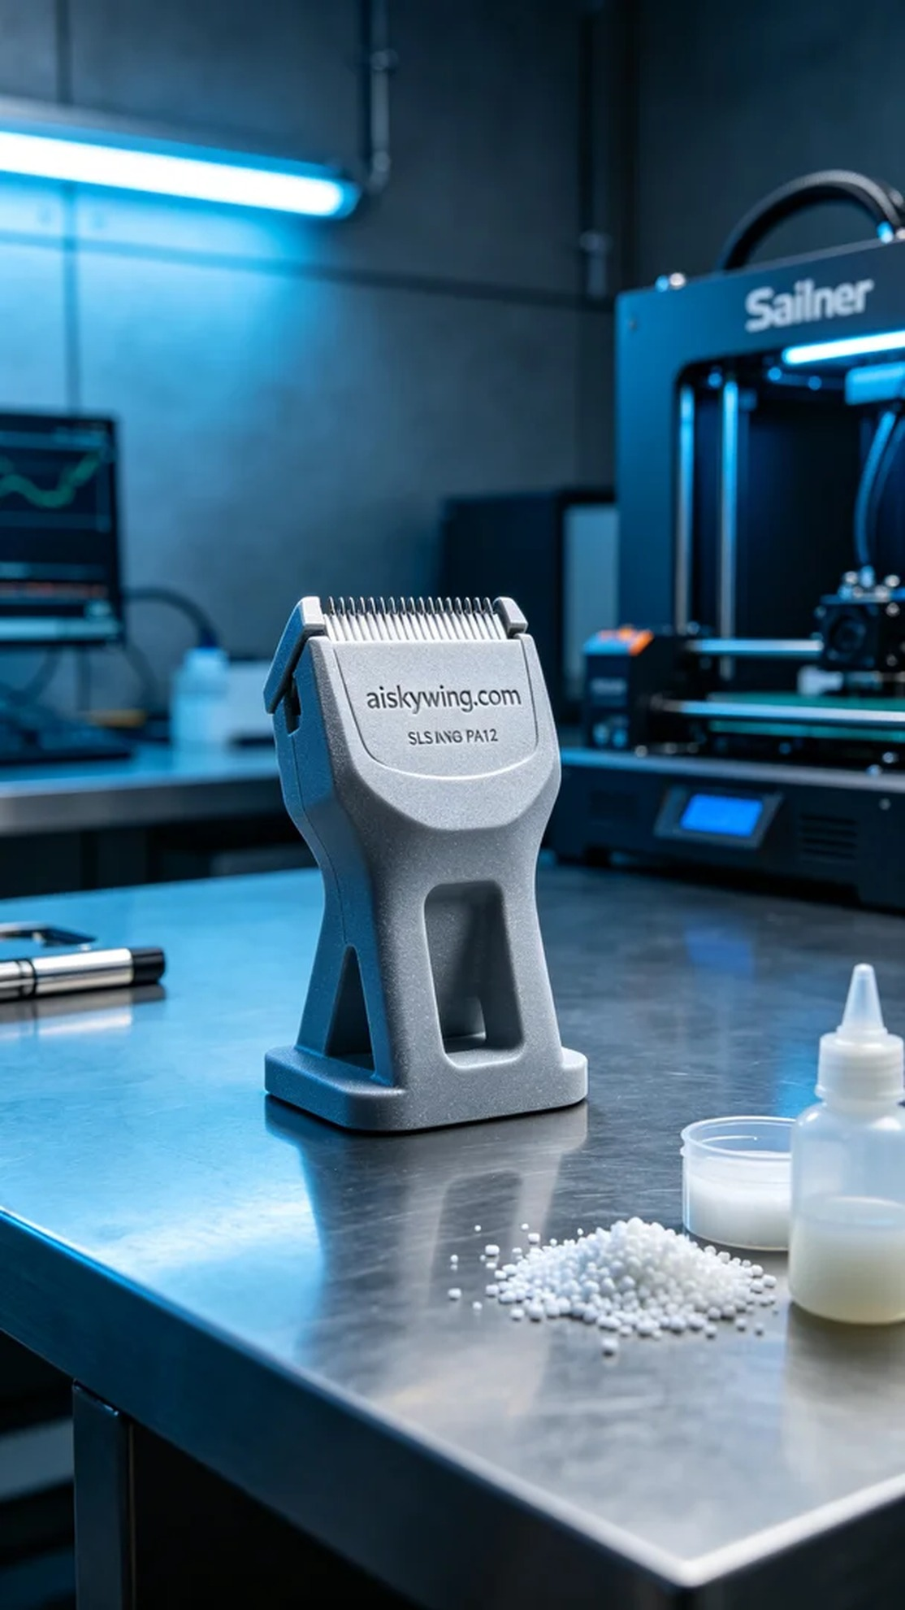
This project was initiated to meet the needs of a pet grooming salon, which was looking to enhance the efficiency of their grooming operations, particularly concerning the blade holder for their clippers. Through Instagram, someone reached out to us, hoping to use 3D printing technology to create a sturdy and user-friendly blade holder.
We utilized SLS nylon PA12 as our raw material, known for its high strength and durability, making it suitable for engineering plastic components. In preparation, we employed a Stratasys 3D printer, setting the layer thickness to 0.1mm, maintaining a printing temperature of 175 degrees Celsius, with a laser power of 60 watts and a printing speed of 20mm per hour. After careful parameter adjustments, we ensured that the print quality would meet our standards with appropriate cooling time.
During the printing process, the machine operated smoothly, effectively sintering the powder layer by layer using the SLS technique. The entire print took about two hours, and throughout this period, I monitored the printer's status to preempt any potential issues. The resulting product showcased a smooth surface with the engraving of "aiskywing.com" clearly visible, demonstrating high-quality craftsmanship.
After printing, we moved to the post-processing phase. Initially, the product was rinsed with clean water to remove any residual powder. Then, we proceeded to sand it down for a smoother finish. Finally, we placed the item under a UV curing machine to enhance its strength and durability. In the final inspection, we ensured that all dimensions met the specifications and that there were no defects.
In the end, the production of this pet clipper blade holder was successfully completed, with results meeting our expectations. It promises to bring greater efficiency and convenience to the daily operations of the pet grooming salon.
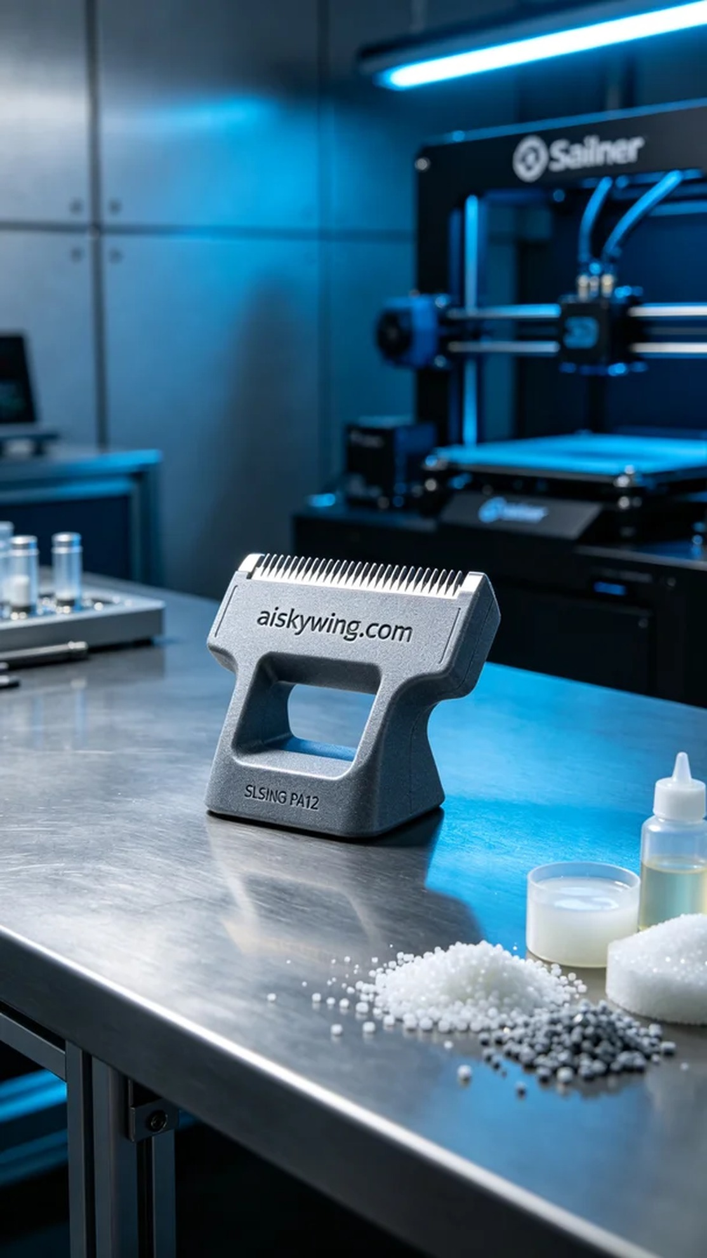
这次的项目是为了一家宠物美容店的需求，他们希望提升剃毛器的使用体验，特别是刀头的支架部分。通过Instagram，他们找到了我们，希望能够以3D打印技术解决他们的问题，提供一个坚固且便于使用的刀头支架。
我们使用的原材料是SLS尼龙PA12，这种材料以其高强度和耐用性著称，特别适合用于工程塑料组件的制造。在设备准备方面，我们采用的是Stratasys的3D打印机，设置了层厚为0.1毫米，打印温度保持在175摄氏度，激光功率设置在60瓦，打印速度则设为每小时20毫米。经过详细的参数调试，为确保打印质量，我们还预设了适当的冷却时间。
打印过程中，设备平稳运行，SLS烧结工艺有效地将粉末逐层融合。整个打印过程大约持续了两个小时。在此期间，我时刻监控着打印机的状态，确保没有出现任何意外情况。经过观察，成品的表面光滑，"aiskywing.com"的雕刻细节清晰可见，展现出优质的工艺水平。
完成打印后，进入后处理工序。首先，我们用清水对成品进行了清洗，以去除残留的粉末。接着，进行打磨，使表面更加光滑。最后，我们将产品放入紫外线固化机内固化，以增强其强度和耐用性。在最后的检验中，确保所有的尺寸都符合要求，并且没有瑕疵。
最终，这个宠物剃毛器刀头支架的生产过程顺利完成，成品的质量符合预期。它将为宠物美容店的日常操作带来更高的效率和便利。
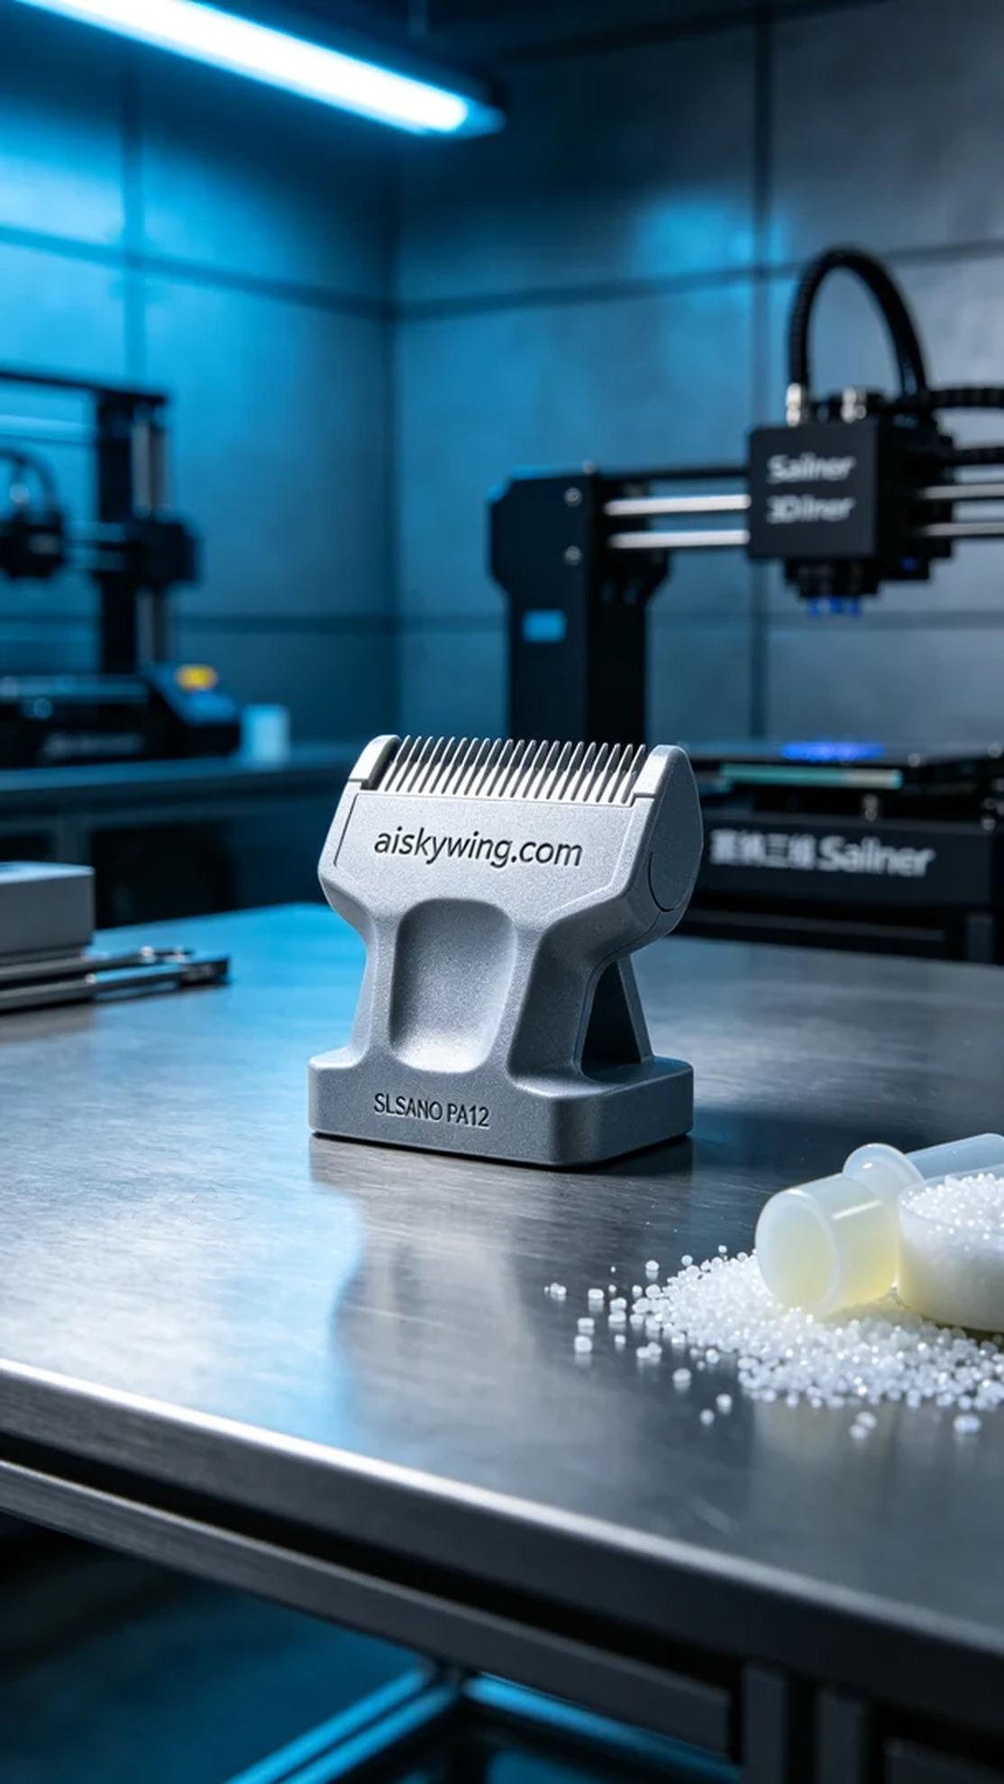
Aiskywing Industrial 3D Printing
Pet grooming clipper blade holder


