0600-宠物去毛刷手柄的3D打印记录
Pet Hair Removal Brush Handle
🖨️ SLS尼龙烧结
🖥️ 打印机: HP
📦 材料: SLS阻燃尼龙
生活的每一次尝试都是一次成长，就像有人找我们做这个宠物去毛刷手柄一样，面对挑战，我们总是乐于迎接。
Every attempt in life is a growth opportunity, just like when someone asks us to make a pet hair removal brush handle. When faced with challenges, we are always eager to embrace them.
________________________________________________________________________________
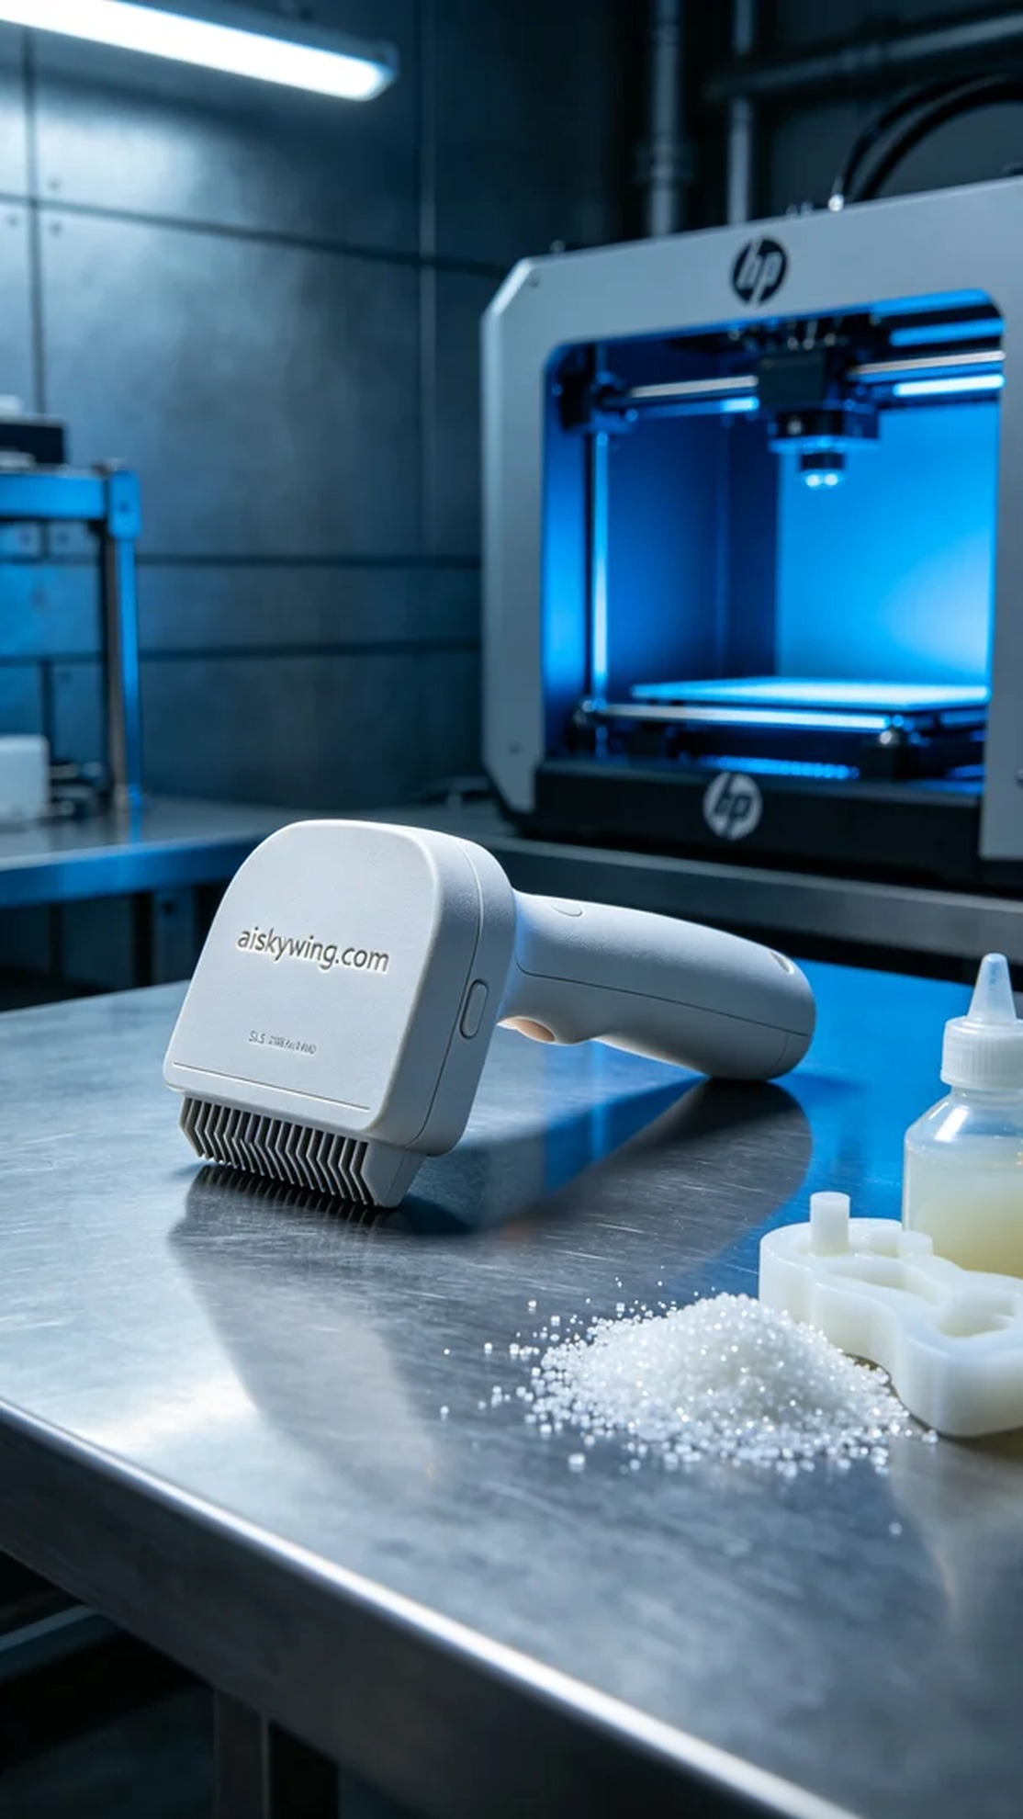
On Twitter, someone expressed their frustration with pet hair issues and sought a solution. Thus, we received an order for a pet hair brush handle, aiming to help them restore cleanliness and warmth at home.
To create the ideal product, we selected SLS flame-retardant nylon as the material. This material possesses excellent thermal resistance and flame-retardant properties, meeting V0 standards, with a matte finish that provides a premium feel. During the printing process, we utilized an HP brand 3D printer, setting the layer thickness to 0.1mm, printing temperature to 170 degrees Celsius, power to 500 watts, speed to 5mm per hour, and an estimated print time of 4 hours.
Throughout the printing process, the equipment operated smoothly, and the SLS technique ensured precise layering of the material. We constantly monitored the temperature and power of the device, ensuring stability and quality throughout the printing cycle. After each printing cycle, we conducted thorough checks to ensure every detail was flawless.
Upon completion of the printing, we entered the post-processing phase. First, we cleaned the printed part with cleaning fluid to remove uncured material. Next, we meticulously polished the surface to enhance both the feel and appearance. Finally, we placed it in a curing device to ensure its hardness and strength met our expectations. After final inspection, all details conformed to our strict quality standards.
In the end, we successfully completed the production of this pet hair brush handle, achieving excellent product quality and beautiful appearance, receiving satisfactory feedback. Each success is the best reward for our efforts.
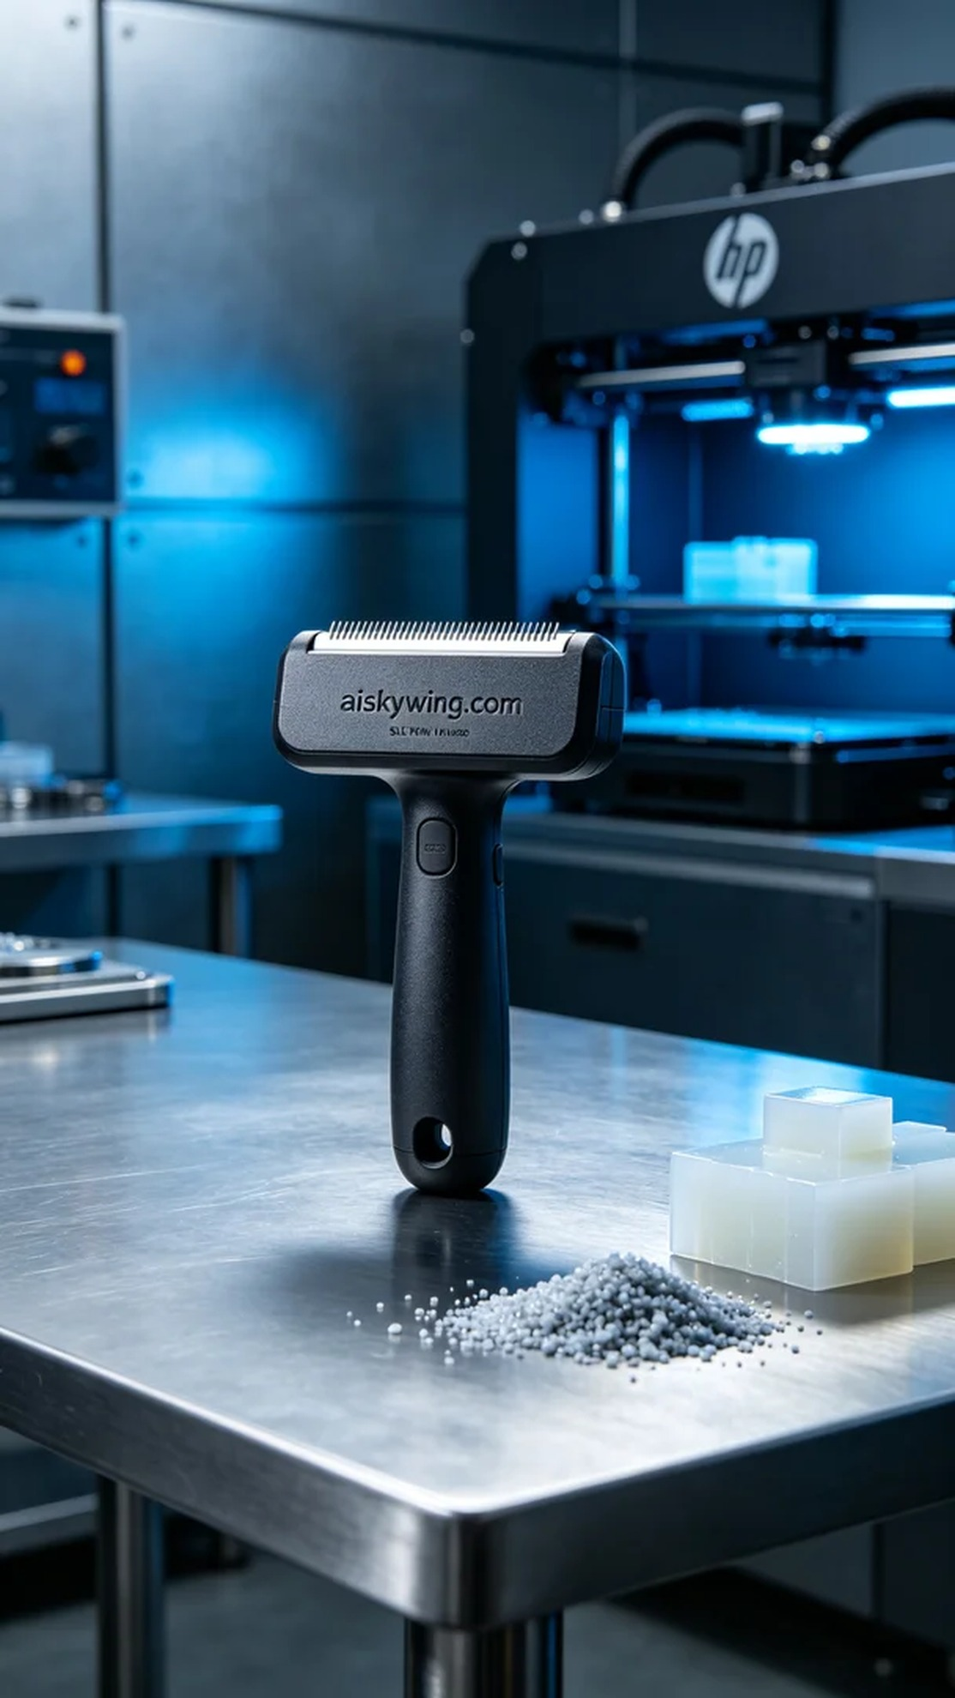
在Twitter上，有人因宠物掉毛问题苦恼，寻求解决方案。于是，我们接到了这个宠物去毛刷手柄的订单，目标是帮助他们恢复家的整洁与温馨。
为了打造出理想的产品，我们选择了SLS阻燃尼龙作为原材料。这种材料具有优越的耐热性和阻燃性能，符合V0级标准，表面还有磨砂质感，给人一种高级的触感。打印过程中，我们使用HP品牌的3D打印机，设定层厚为0.1毫米，打印温度为170摄氏度，功率500瓦，速度为每小时5毫米，预计打印时间为4小时。
打印过程中，设备运行平稳，SLS工艺确保了每层材料的精确堆叠。我们时刻监控设备的温度和功率，确保打印过程中的质量稳定。在每一个打印周期结束后，我们都进行详细检查，以确保每个细节都无懈可击。
打印完成后，我们进入了后处理环节。首先，用清洗液对打印件进行清洗，去除未固化的材料。接着，我们对表面进行细致打磨，以提升触感和美观度。最后，将其放入固化设备内，确保其硬度和强度达到预期标准。经过最终检验，所有细节符合我们严格的质量标准。
最终，我们顺利完成了这个宠物去毛刷手柄的制作，产品质量优良，外观精美，得到了满意的反馈。每一次成功都是对我们努力的最好回报。
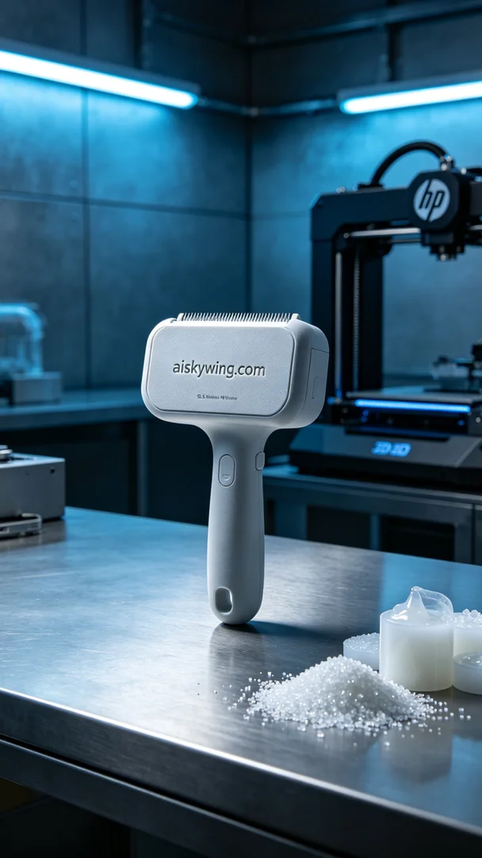
Aiskywing Industrial 3D Printing
Pet Hair Removal Brush Handle


