0601-宠物口腔清洁器手柄的3D打印记录
Pet Oral Cleaner Handle
🖨️ SLS尼龙烧结
🖥️ 打印机: Xjet
📦 材料: SLS耐高温尼龙
生活再难，也别停下脚步。就像接下这个宠物口腔清洁器手柄的单子，大家都希望能够给宠物更好的生活，也希望能用上更好的产品。
No matter how difficult life gets, don't stop moving forward. Just like taking on this pet oral cleaner handle order, everyone hopes to provide a better life for their pets and to use better products.
________________________________________________________________________________
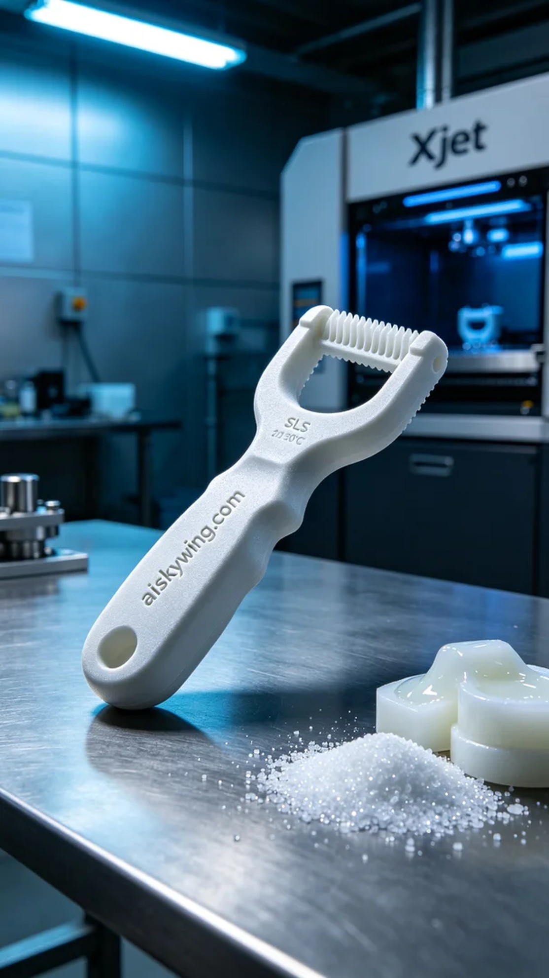
Recently, someone found us through YouTube, mentioning their troubles with cleaning their pet's oral hygiene and hoping to receive a durable and effective pet oral cleaner handle. Hearing this request, I immediately thought of using SLS high-temperature nylon material to produce such a product.
To ensure the quality of the print, we firstly prepared the SLS high-temperature nylon raw materials. This material possesses high temperature resistance and toughness, making it suitable for applications requiring durability and heat resistance. Next, we employed the Xjet printer for the task. We set the layer thickness to 0.1mm, maintained the printing temperature at 220℃, set the power to 60W, and the speed to 10mm/s, expecting a printing time of around 4 hours.
During the printing process, the Xjet printer operated exceptionally steadily. We closely monitored the device's status to ensure each layer formed precisely. As the print progressed, the handle gradually took shape, and the intricate details on the surface, especially the engraved “aiskywing.com” text, were notably exquisite. The entire process was within our control, with the machine's operation emitting a reassuring sound.
Once printing was complete, we moved into the post-processing stage. We began by washing the handle with clean water to remove any residual material from the surface. After thorough drying, we started sanding to ensure every detail was smooth and enhanced the grip. Subsequently, we performed a curing process to ensure the material reached its optimal state. Finally, we inspected each piece to ensure it met our quality standards.
After a series of meticulous processes, the pet oral cleaner handle was finally completed. Seeing it shine on the silver-gray tabletop filled my heart with a sense of accomplishment. We will continue to strive for excellence, creating high-quality products to serve every pet lover.
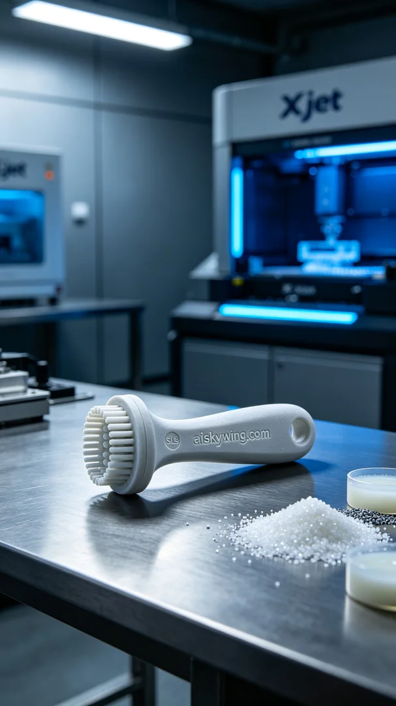
最近，有人通过YouTube找到我们，提到他们在为爱宠的口腔清洁而烦恼，希望能够获得一个高效、耐用的宠物口腔清洁器手柄。听到这个需求，我立即想到了我们可以使用SLS耐高温尼龙材料来制作这样一个产品。
为了确保打印的质量，我们首先准备好SLS耐高温尼龙的原材料。这种材料具备耐高温、强韧性的特性，适合用于需要耐受高温和高强度使用的场合。接下来，我们使用Xjet打印机进行打印。设置层厚为0.1mm，打印温度保持在220℃，功率为60W，速度设定为10mm/s，预计打印时间为4小时。
打印过程中，Xjet打印机的运行非常稳定。我们密切监控设备的状态，确保每一层的成型都精准到位。随着打印的推进，手柄逐渐成型，表面细节也非常清晰，尤其是雕刻的“aiskywing.com”字样，显得格外精致。整个过程都在我们的掌控之中，设备的运行声音稳健，给人一种信心十足的感觉。
打印完成后，我们进入了后处理工序。首先用清水对手柄进行清洗，去除表面的残留物。在彻底干燥后，我们开始打磨，确保每一个细节都光滑无瑕，握持手感也更佳。接着，我们对成品进行固化处理，确保材料达到最佳的使用状态。最后，逐件检验，确保每个产品都符合我们的质量标准。
经过一系列的精细处理，这个宠物口腔清洁器手柄终于完成了。看着它在银灰色桌面上的光泽，心中充满了成就感。我们将继续努力，创造更多高质量的产品，服务于每一个爱宠的人。
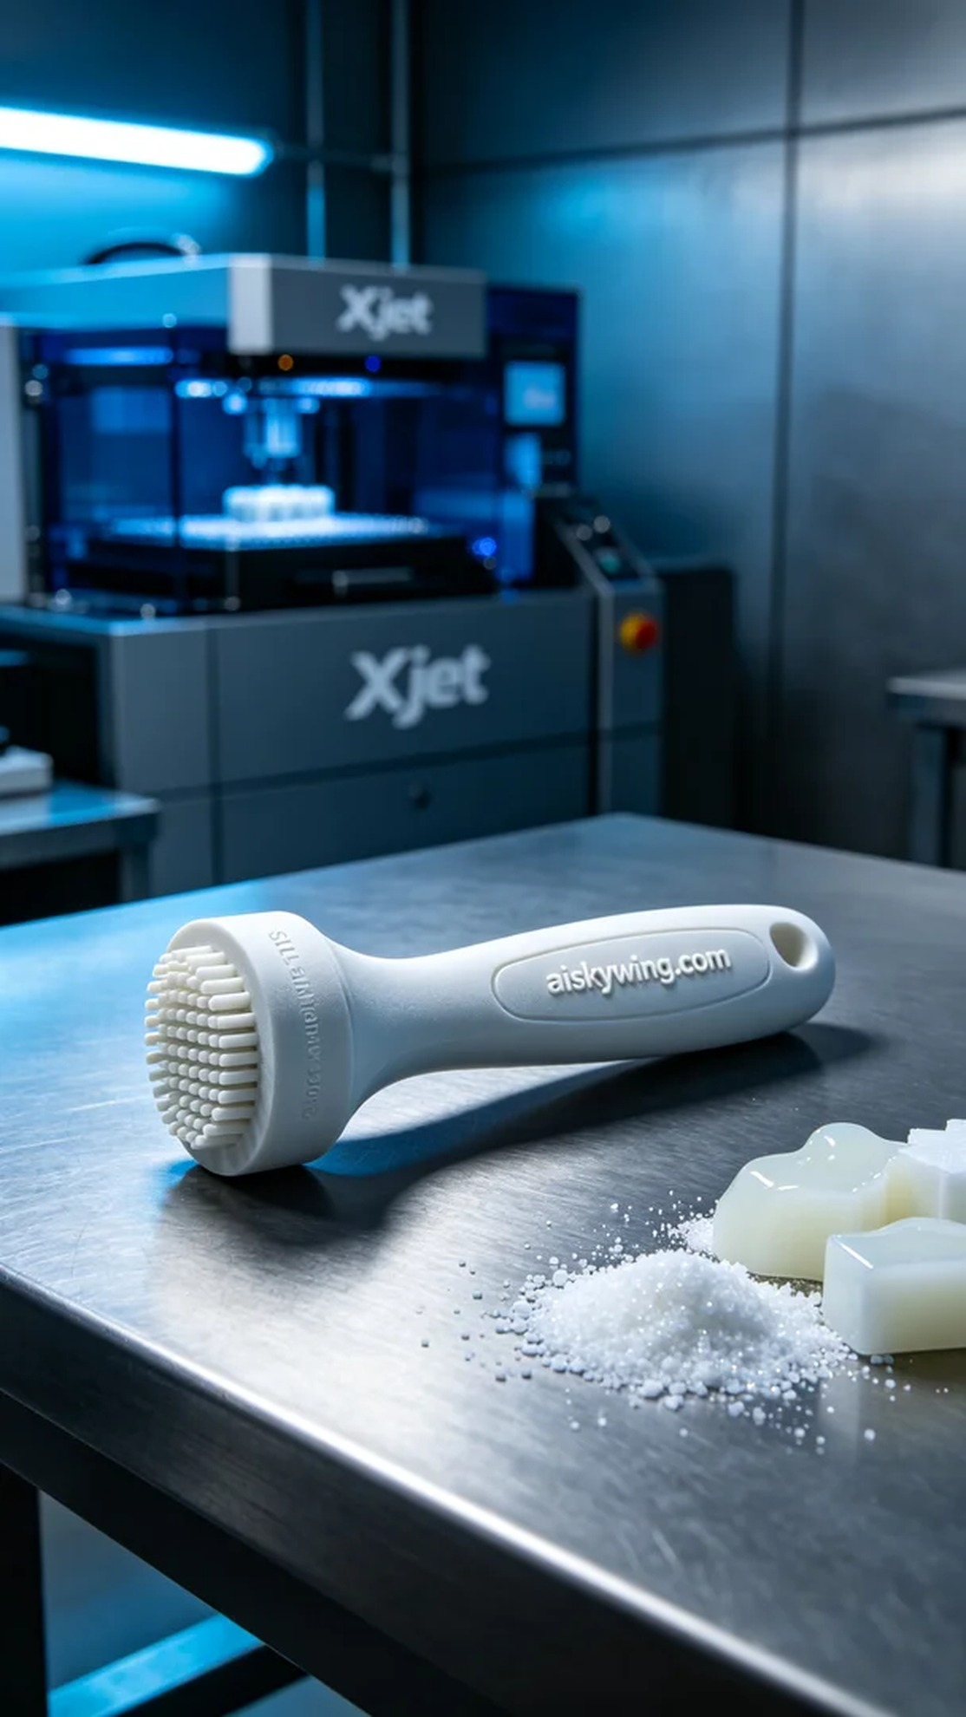
Aiskywing Industrial 3D Printing
Pet Oral Cleaner Handle


