0602-宠物吹水机风嘴生产记录
Pet Blow Dryer Nozzle
🖨️ SLS尼龙烧结
🖥️ 打印机: Systems
📦 材料: SLS阻燃尼龙
生活中总会有意外的风吹草动，就像在Twitter上看到有人寻求帮助，为他们的宠物吹水机风嘴寻找解决方案。
In life, there will always be unexpected events, just like seeing someone on Twitter seeking help for a solution for their pet's water fountain nozzle.
________________________________________________________________________________
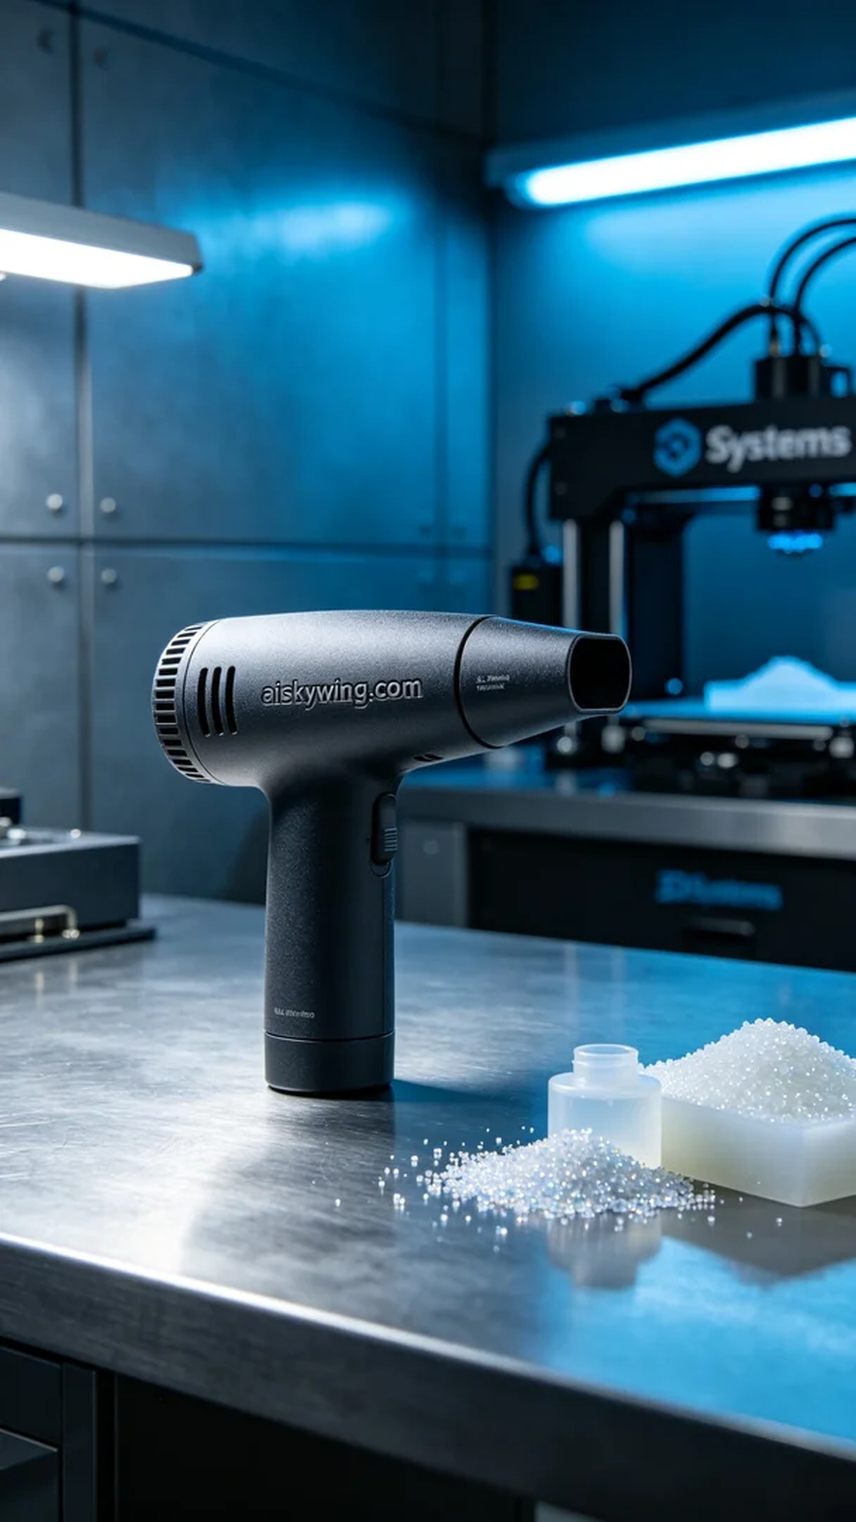
Today, we received a task to produce a pet blower nozzle. Someone encountered issues while using their existing product and sought a better replacement for an efficient pet drying experience. Thus, we decided to utilize SLS technology for this nozzle.
To ensure the quality of the product, we selected SLS flame-retardant nylon as our material. This material has a V0 flame-retardant rating and a matte surface texture, effectively resisting high temperatures and flames. For equipment preparation, we used the Systems printer, setting it to a layer thickness of 0.1mm, maintaining a temperature of 180℃, with a power set to 100W, and controlling the print speed at 30mm/s, with an estimated print time of about four hours.
During the printing process, the Systems printer operated steadily, ensuring the quality of each layer. We closely monitored the printer's temperature and pressure to prevent any anomalies. After printing, the appearance of the nozzle was exceptionally clear, and the engraved "aiskywing.com" lettering sparkled under the light, showcasing the excellent properties of SLS nylon.
The post-processing phase is also crucial. We first cleaned the printed nozzle to remove excess powder, then finely sanded the surface for a smoother finish. Next, we placed the nozzle in the curing equipment to ensure the material achieved optimal hardness and durability. Finally, we conducted a comprehensive inspection to ensure every detail was flawless.
After a series of rigorous production processes, this pet blower nozzle was finally completed. It not only boasts outstanding performance but also reflects our craftsmanship and strict quality control.
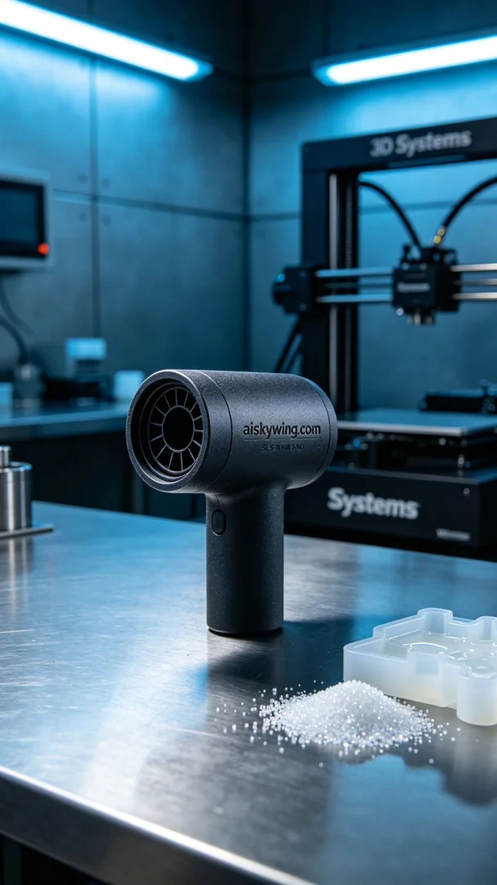
今天，我们接到一个任务，制作一款宠物吹水机风嘴。有人在家中使用时遇到了一些问题，想要一个更好的替代品来实现高效的宠物干燥体验。于是，我们决定用SLS技术来生产这个风嘴。
为了确保产品的优质表现，我们选择了SLS阻燃尼龙作为材料。这种材料具备V0级阻燃性能，表面磨砂质感，能有效抵御高温和火焰。在设备准备方面，我们使用了Systems打印机，设置为0.1mm的层厚、温度保持在180℃、功率设定为100W，打印速度则控制在30mm/s，整个打印过程预计耗时约四个小时。
在打印过程中，Systems打印机稳定运行，确保了每一层的质量。在监控方面，我们时刻关注设备的温度与压力，确保没有发生任何异常情况。打印完成后，风嘴的外观极其清晰，"aiskywing.com"的雕刻字样在光线下熠熠生辉，充分展现出SLS尼龙的优良特性。
后处理环节也至关重要。我们首先对打印好的风嘴进行清洗，去除多余的粉末，然后通过细磨处理表面，使其更加平滑。接着，我们将风嘴放入固化设备中，确保材料达到最佳硬度和耐用性。最后，我们进行了一次全面的检验，确保每一个细节都完美无缺。
经过一系列严谨的生产流程，这款宠物吹水机风嘴终于完成。它不仅具备卓越的性能，还体现了我们的专业工艺和对质量的严格把控。
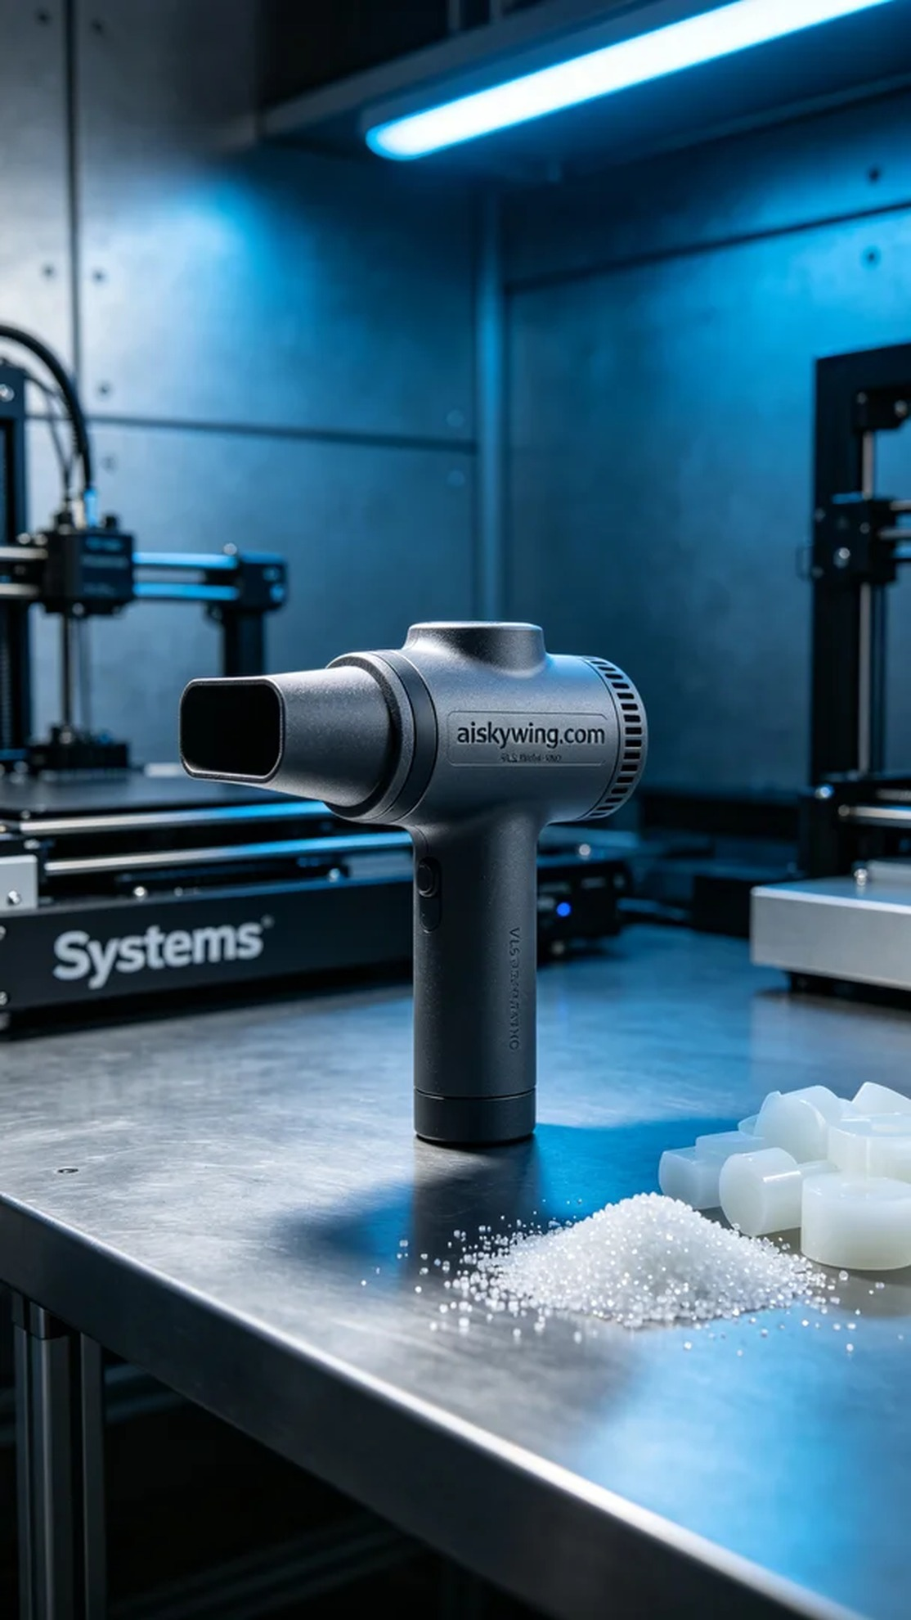
Aiskywing Industrial 3D Printing
Pet Blow Dryer Nozzle


