0603-宠物喂药器外壳生产记录
Pet Medication Dispenser Shell
🖨️ SLS尼龙烧结
🖥️ 打印机: Stratasys
📦 材料: SLS尼龙PA12
生活中总会遇到挑战，就像有人在Instagram上找到我们，希望解决宠物喂药器外壳的问题。我们很高兴能够接下这个项目。
In life, we often encounter challenges, just like when someone found us on Instagram, hoping to solve the issue with a pet medication dispenser shell. We are excited to take on this project.
________________________________________________________________________________
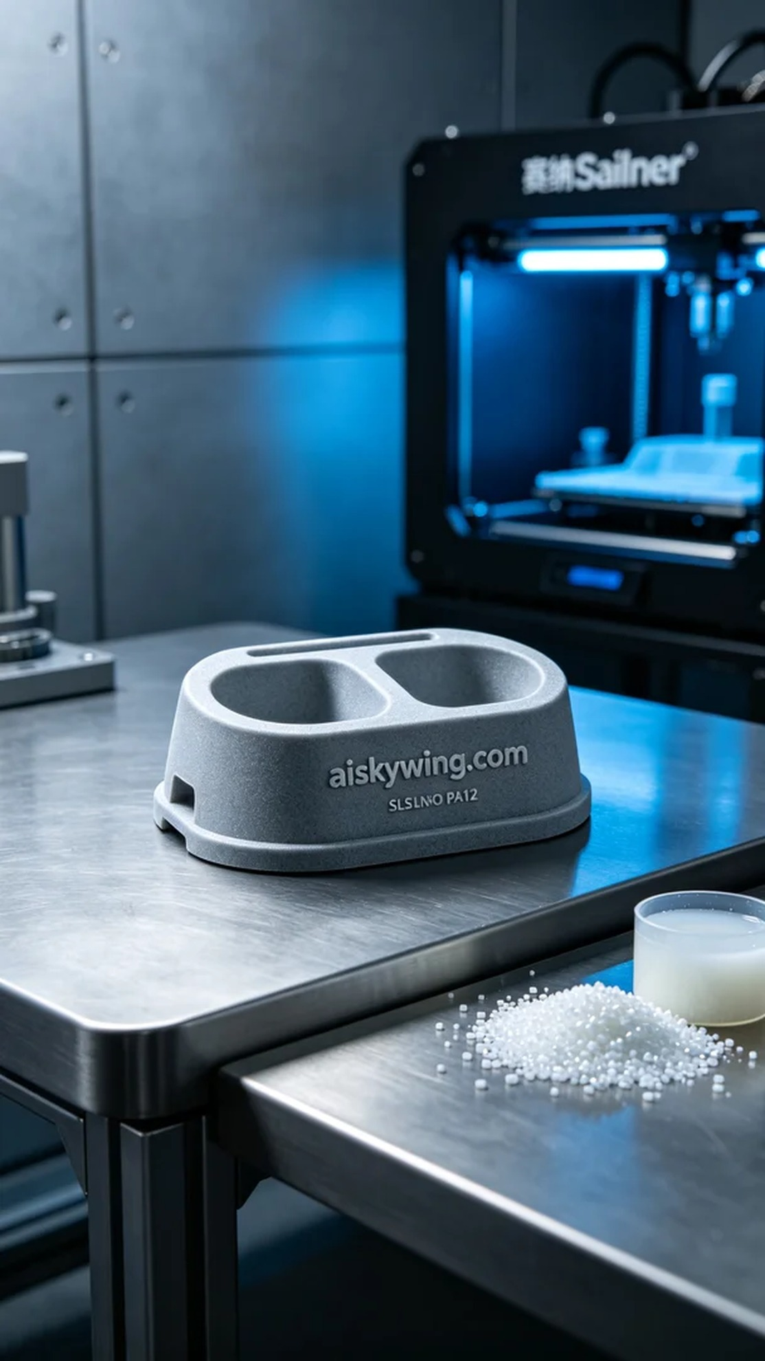
Every challenge in life brings an opportunity, as someone found us on Instagram seeking a solution for their pet medication dispenser shell. We were excited to take on this project.
The project began with the selection of SLS Nylon PA12 as the primary material. This material offers high strength and excellent chemical resistance, making it perfect for long-term use. We prepared our Stratasys 3D printer and set the optimal printing parameters: a layer thickness of 0.1 mm, a printing temperature of 170°C, a power setting of 120 watts, a print speed of 30 mm/s, and an estimated printing time of 8 hours.
During the printing process, the machine operated smoothly, with real-time monitoring of the quality at each layer. The temperature and power settings were maintained at their optimal levels, ensuring that the material melted sufficiently for tight layer bonding. After several hours of printing, the contours of the finished product began to emerge, filling us with anticipation.
Post-processing is a critical step in our production process. First, we cleaned the printed shell to remove any uncured material from the surface. Next, we employed sanding techniques to enhance its smoothness, ensuring a comfortable feel in hand. Subsequently, we performed a curing process to increase the shell's durability and conducted a thorough inspection to ensure that all product specifications met our expectations.
With each step of the process completed, we finally achieved a high-quality pet medication dispenser shell. This was not just a successful printing experience; it was the culmination of our team's collaborative efforts.
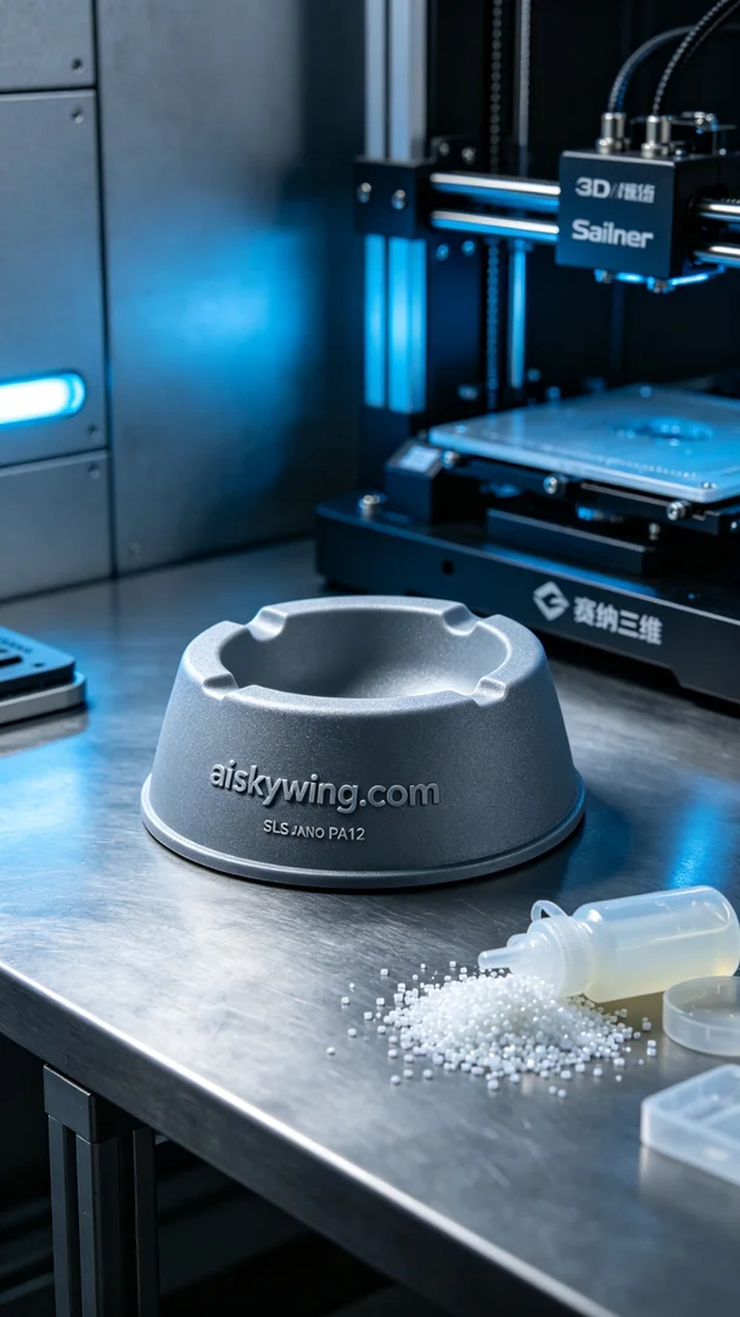
这次的项目源自于Instagram上的一位爱宠人士，他们希望我们能帮助解决宠物喂药器外壳的设计问题。因为宠物用药一直是个难题，设计一个能让喂药过程更轻松的外壳是他们的目标。我们对此感到非常认同，于是便展开了生产工作。
我们选用的是SLS尼龙PA12作为原材料，这种材料具备高强度和优良的耐化学性，适合长期使用的产品需求。在准备工作中，我们使用了Stratasys的3D打印机，设置了合适的打印参数：层厚为0.1毫米，打印温度保持在170°C，功率设定为120瓦，打印速度为30毫米每秒，预计打印时间为8小时。
在打印过程中，机器运转得相当平稳，我们对每一层的质量进行了实时监控。温度和功率的设置保持在最佳状态，确保材料的充分熔融，层与层之间的结合紧密。经过几个小时的打印，我们终于看到了成品的轮廓，心中不禁感到一阵期待。
后处理工序是我们制作流程中的关键步骤。首先，我们将打印好的外壳进行清洗，去掉表面的未固化材料。接着，通过打磨工艺提升其表面的光滑度，确保手感舒适。随后，我们还进行了固化处理，以增强外壳的耐用强度，最后进行了全面的检验，确保产品的各项指标都达到了预期。
随着每一步工序的完成，我们终于得到了这款高品质的宠物喂药器外壳。这不仅是一次成功的打印经历，也是我们团队共同努力的结晶。
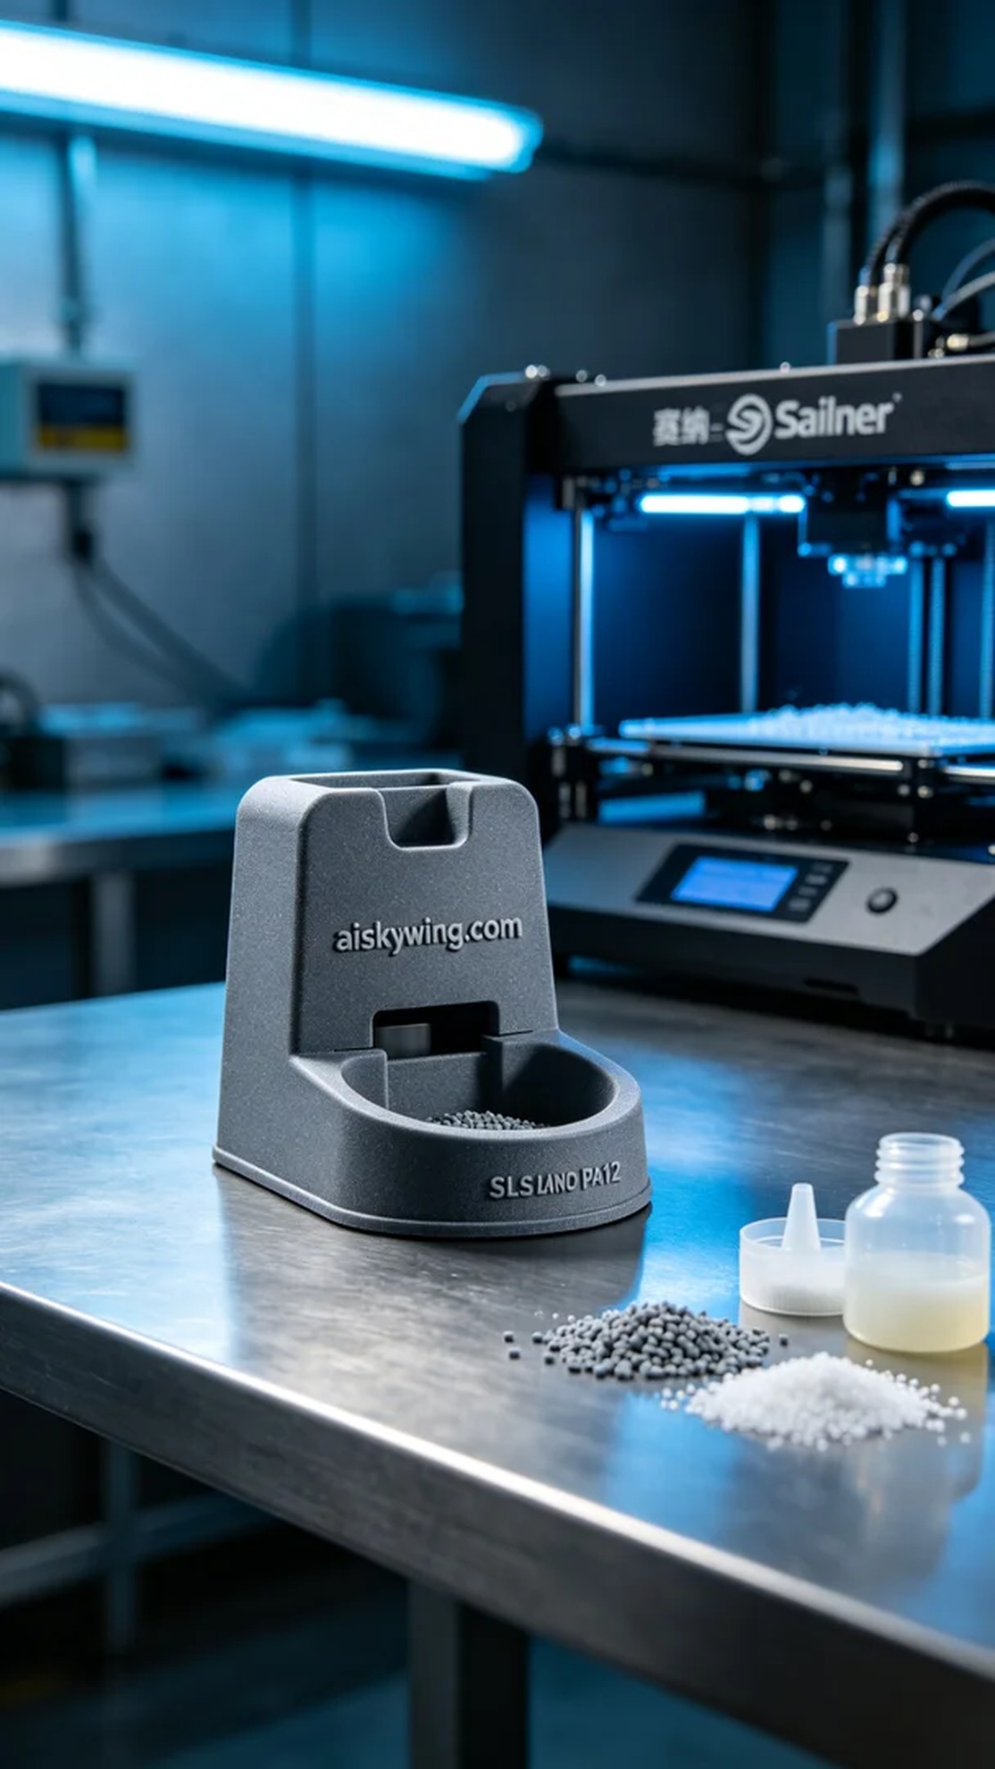
Aiskywing Industrial 3D Printing
Pet Medication Dispenser Shell


