0609-宠物嘴套支架3D打印生产记录
Pet Muzzle Holder
🖨️ SLS尼龙烧结
🖥️ 打印机: Voxeljet
📦 材料: SLS阻燃尼龙
生活就像3D打印，每一步都要精准到位。今天，我们接到了一个关于宠物嘴套支架的订单，Instagram上有人发愁寻找合适的解决方案。
Life is like 3D printing, where every step must be precise. Today, we received an order for a pet muzzle holder, as someone on Instagram is struggling to find a suitable solution.
________________________________________________________________________________
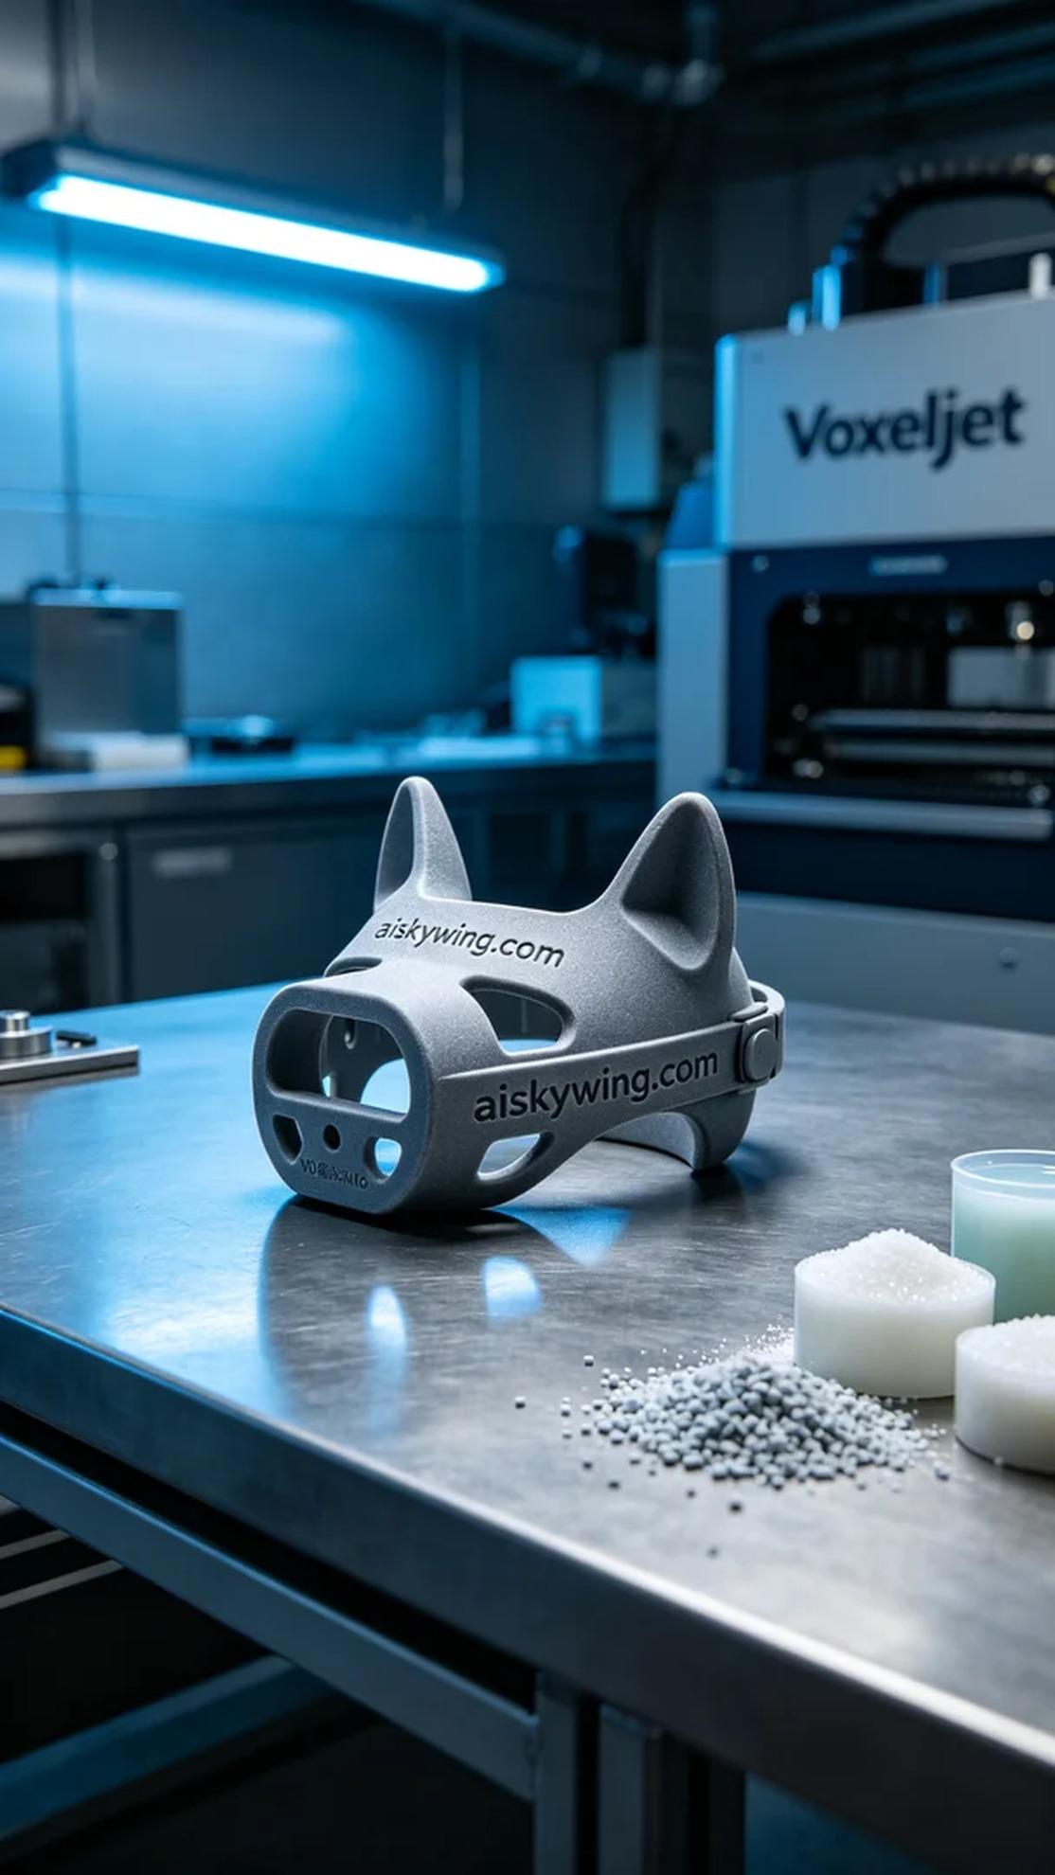
Life is like 3D printing; every step needs to be precise. Today, we received an order for a pet muzzle bracket because someone found it difficult to find a suitable solution on Instagram.
For this task, we chose SLS flame-retardant nylon as the primary material. This material not only possesses a V0 level flame-retardant property but also offers excellent wear resistance and strength, making it suitable for everyday use. We prepared the Voxeljet 3D printer, setting the layer thickness to 0.1 mm, maintaining the print temperature at 180 degrees Celsius, adjusting the power to 200 watts, and setting the print speed to 20 mm per hour, with an expected total print time of 8 hours.
During the printing process, the machine's operation was incredibly stable. We closely monitored the print quality to ensure that each layer bonded to the standard, avoiding any potential errors. The entire printing process utilized dry powder, so there were no adhesion or deformation issues, and we successfully completed the bracket print.
After printing, we conducted detailed post-processing steps. First, we removed the printed item from the printer and cleaned it to remove any uncured material. Next, we used sanding tools to polish it, ensuring every corner was smooth and free from burrs. Finally, we placed the bracket in a curing chamber to ensure its performance fully met the standards, and after thorough quality inspection, we confirmed it was ready for delivery.
Through a series of meticulous processes, we successfully created a satisfactory pet muzzle bracket for the pet owner, hoping it will enhance their beloved pet's experience.
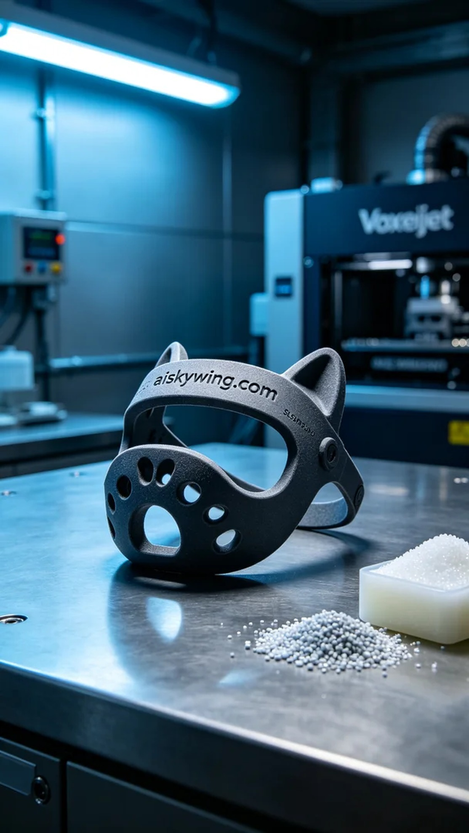
为了解决用户在使用宠物嘴套时的不适问题，某位爱宠人士在Instagram上找到我们，希望我们能提供一个合适的解决方案。于是，我们决定为他制作一个宠物嘴套支架，确保它在使用时更加舒适和稳固。
我们选择了SLS阻燃尼龙作为主要材料。这种材料不仅具备V0级的阻燃性能，还具有良好的耐磨性和强度，适合日常使用。为了确保打印质量，我们准备了Voxeljet打印机，设定了每层厚度0.1毫米，打印温度保持在180摄氏度，功率调至200瓦，打印速度为每小时20毫米，预计打印总时间为8小时。
在打印过程中，设备的运行状态非常稳定。我们严密监控了打印质量，确保每一层的结合都达到标准，避免任何可能的误差。整个打印过程使用的是干燥的粉末，所以没有出现粘连或变形的现象，最终顺利完成了支架的印制。
完成打印后，我们进行了详细的后处理工序。首先，将打印件从打印机中取出，进行清洗，以去除表面的未固化材料。接着，使用磨砂工具进行打磨，确保每个角落都光滑无毛刺。最后，将支架置于固化槽中进行固化，确保其性能完全达到标准，最终经过质量检验，确认合格后准备发货。
经过一系列精细的工序，我们成功为这位宠物主人制作了满意的宠物嘴套支架，期待它能给他们的爱宠带来更好的使用体验。
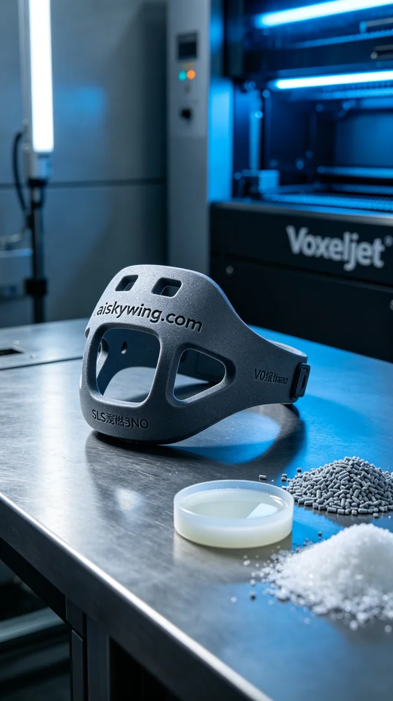
Aiskywing Industrial 3D Printing
Pet Muzzle Holder


