0610-宠物尿垫固定架生产日志
Pet Urine Pad Holder
🖨️ SLS尼龙烧结
🖥️ 打印机: HP
📦 材料: SLS尼龙
生活就像3D打印，有时需要一点耐心和坚持。最近，有人因宠物的尿垫问题找上我们，要求制作一个宠物尿垫固定架。
Life is like 3D printing; sometimes it requires a bit of patience and perseverance. Recently, someone approached us regarding an issue with pet pee pads, requesting the creation of a pet pee pad holder.
________________________________________________________________________________
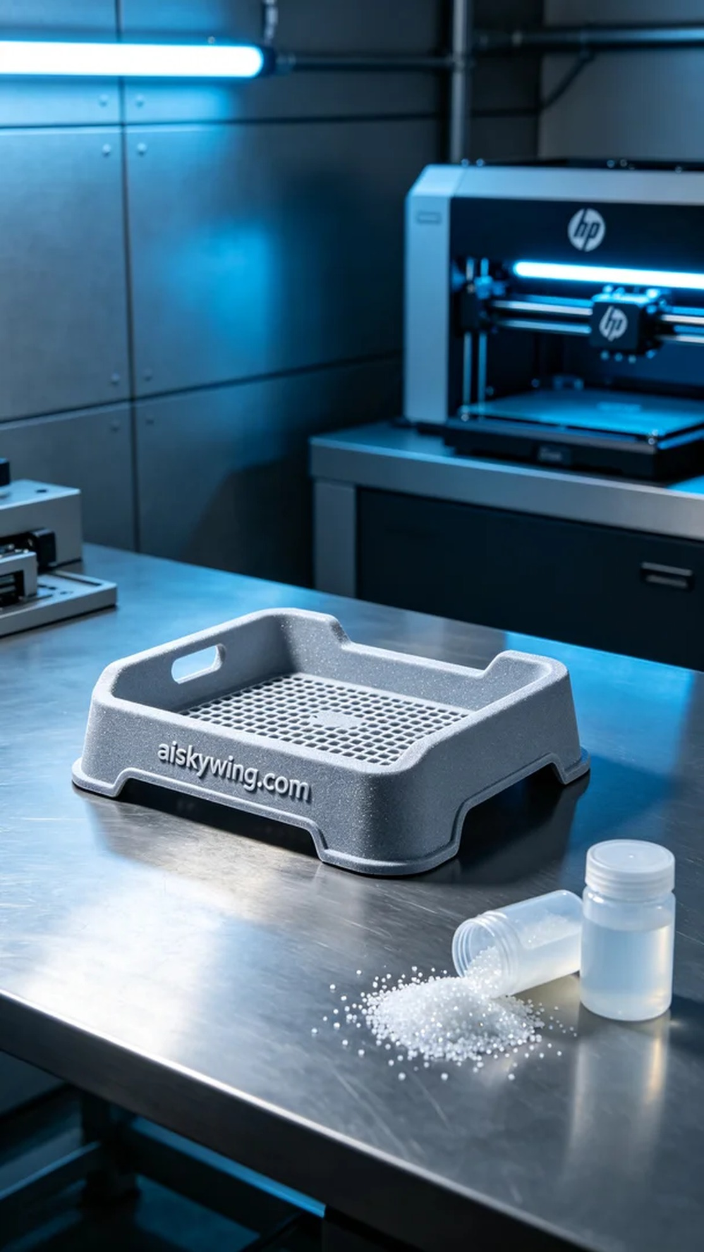
Life is much like 3D printing; sometimes it takes a bit of patience and perseverance. Recently, someone approached us for a solution to their pet's pee pad issue, requesting a pet pee pad holder.
To address the challenges that some households face when using pet pee pads, we took on the task of creating a pet pee pad holder. This holder needs to be stable while also being lightweight and durable for easy use and cleaning.
For this production, we utilized SLS nylon, known for its strength and durability, making it ideal for high-use products. We chose the HP 3D printer for the job, setting the layer thickness to 0.1 mm, maintaining a temperature of 180°C, with a power setting of 75% and a print speed of 50 mm per hour, estimating a total print time of about 6 hours.
During the printing process, the HP printer operated steadily, ensuring that each layer of powder sintering was uniformly applied. Throughout the process, we continuously monitored the equipment's performance to maintain the expected print quality, checking the surface of the finished product for any noticeable defects after each layering.
Once the printing was complete, the post-processing steps were equally essential. We began by cleaning the printed piece to remove any excess powder. Then, we utilized sanding tools to smooth the surface further, followed by curing to ensure structural integrity. After all steps were completed, we conducted a thorough inspection of the holder to confirm its quality met our standards.
In the end, this pet pee pad holder was completed on schedule, and its exquisite craftsmanship and functionality received positive recognition. We look forward to it bringing convenience and comfort to more families.
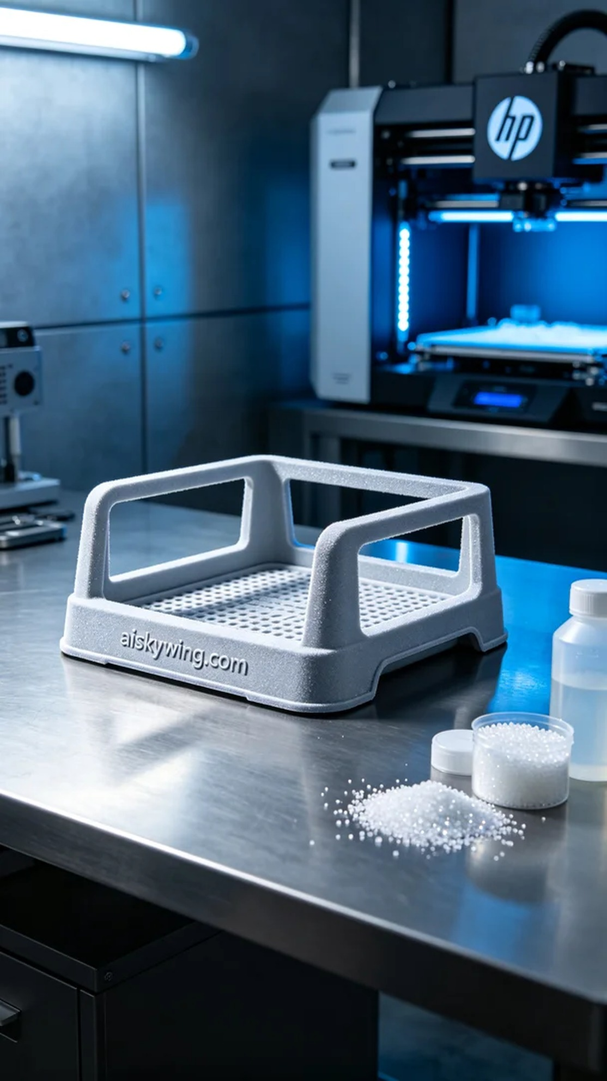
为了满足某些家庭在使用宠物尿垫时遇到的困扰，我们接到了制作宠物尿垫固定架的任务。这个架子不仅需要稳固，还要兼具轻量化和耐用性，以方便使用和清理。
此次生产我们采用了SLS尼龙，这种材料具有良好的强度和耐用性，适合用于高频次使用的产品。我们选择HP的3D打印机进行打印，设置了层厚为0.1毫米，温度保持在180℃，功率为75%，打印速度设定在每小时50毫米，预计打印时间为6小时。
在打印过程中，HP打印机稳定地运行，确保每一层的粉末烧结都均匀到位。整个过程中，我们随时监控设备运行情况，确保打印品质符合标准。在每次打印完成后，我们会迅速检查成品表面，确保无明显缺陷。
打印完成后，后处理工序也至关重要。首先，我们将打印件进行清洗，以去除多余的粉末。接着，使用打磨工具对表面进行打磨，使其更加光滑，最后进行固化处理，确保其结构强度达标。完成所有步骤后，我们对固定架进行了仔细检验，确认其质量达到预期。
最终，这个宠物尿垫固定架如期完成，其精致的做工与强大的功能性得到了认可。我们期待它能够为更多家庭带来便利和舒适。
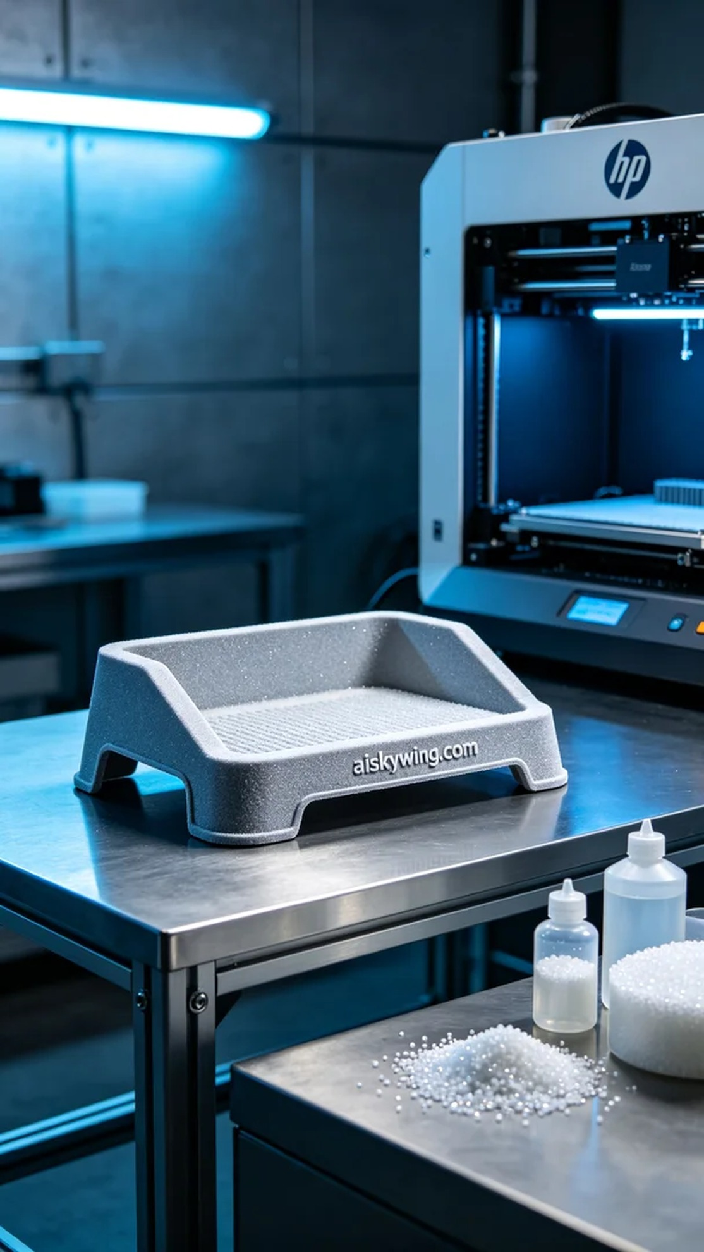
Aiskywing Industrial 3D Printing
Pet Urine Pad Holder


