0611-宠物慢食器隔板的3D打印记录
Pet slow feeder divider
🖨️ SLS尼龙烧结
🖥️ 打印机: Stratasys
📦 材料: SLS尼龙PA12
生活就像3D打印，每一步都需要耐心和坚持。有人在YouTube上看到我们制作的宠物慢食器隔板，向我们求助，希望解决宠物进食过快的问题。
Life is like 3D printing; every step requires patience and perseverance. Someone saw the pet slow feeder divider we made on YouTube and reached out to us for help, hoping to solve the problem of their pet eating too quickly.
________________________________________________________________________________
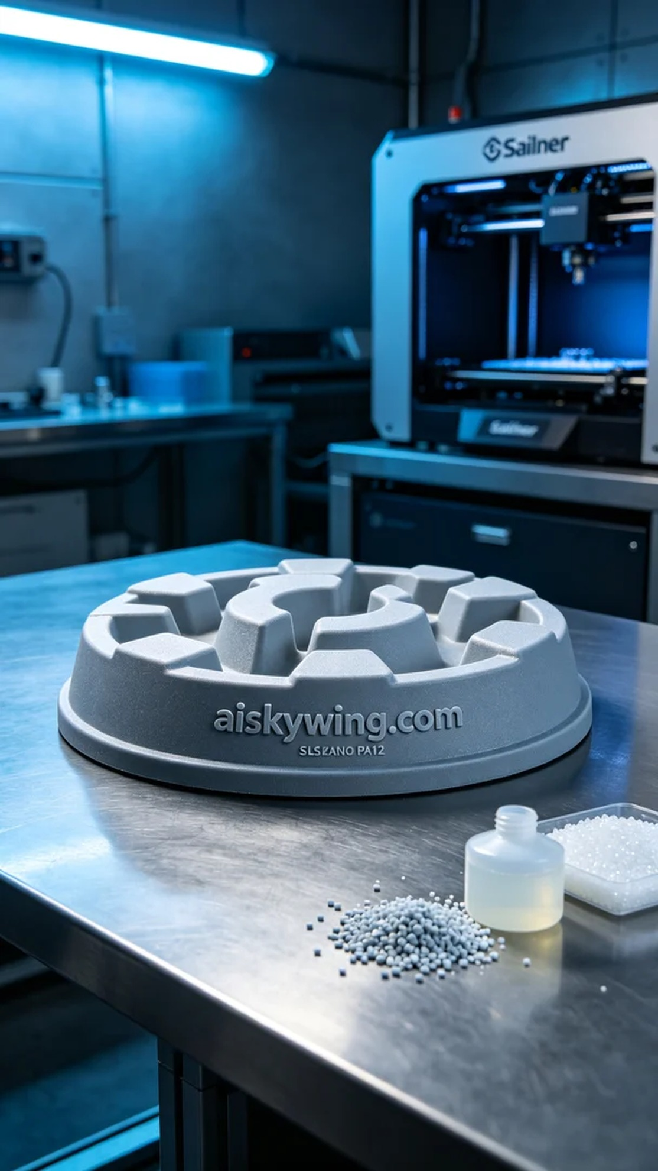
Life is like 3D printing; it requires patience and perseverance at every step. Someone found us on YouTube, seeking help with a pet slow feeder divider to solve the problem of their pet eating too fast.
We received an interesting project where someone approached us on YouTube about their pet eating too quickly and requested a pet slow feeder divider. This product not only helps pets enjoy their food slowly but also aids in digestion. Upon taking the order, I immediately thought of using SLS nylon PA12 material and producing it with a Stratasys printer.
In preparing the material, we opted for high-quality SLS nylon PA12, known for its high strength and excellent wear resistance, while the matte surface provides a pleasant tactile feel. For the equipment, we used a Stratasys printer and set the parameters as follows: layer thickness of 0.1mm, temperature at 180°C, power set to 30W, printing speed at 50mm/s, with an estimated printing time of 6 hours. These parameters ensured the stability of quality and the perfection of details throughout the printing process.
During the printing process, the device operated smoothly. We monitored the print quality in real-time to ensure each layer adhered properly. As time went by, the print head moved continuously, gradually forming the desired pet slow feeder divider. With the completion of the last layer, I felt excited to see the final result.
Post-processing is also crucial. After printing, we first cleaned the product to remove any uncured powder from the surface, followed by sanding to ensure smooth edges. Next, we placed the product in a curing chamber to enhance the material's strength. Finally, after a strict inspection to confirm there were no defects, the divider was perfectly presented to us.
Through this project, we not only addressed the issue of pets eating too quickly, but we also highlighted the charm and practicality of 3D printing in every detail. Ultimately, the successful completion of the pet slow feeder divider brought me a sense of accomplishment in my work.
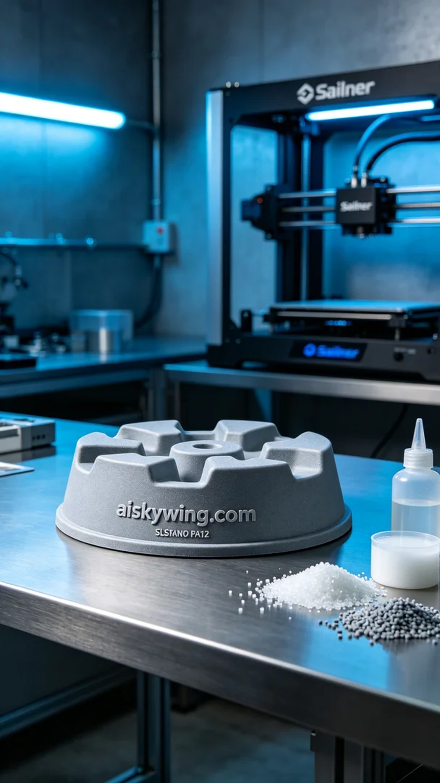
我们接到一个有趣的项目，有人因为宠物进食过快的问题在YouTube上找到我们，希望能帮助他们制作一款宠物慢食器隔板。这种产品不仅能让宠物慢慢享受食物，还能促进消化。接到这个订单，我立即想到了采用SLS尼龙PA12材料，通过Stratasys打印机进行打印。
在准备材料时，我们选择了优质的SLS尼龙PA12，这种材料以其高强度和优良的耐磨性而著称，表面磨砂感也能带来很好的触感。设备方面，我们使用的是Stratasys打印机，设定的打印参数为：层厚0.1mm，温度180°C，功率为30W，打印速度为50mm/s，预计打印时间为6小时。这些参数确保了打印过程中质量的稳定性和细节的完美呈现。
打印过程中，设备运转得相当顺利。我们实时监控打印质量，确保每一层都能牢牢粘合。随着时间的推移，打印头在不断移动，逐渐形成了我们所需的宠物慢食器隔板。随着最后一层的完成，我的心中满是期待，想看看成品的效果。
后处理工序也是至关重要的。打印完成后，我们首先对产品进行清洗，去除表面的未固化粉末，然后进行打磨，以确保边缘光滑。接下来，将产品放入固化箱中进行固化，这个过程可以进一步增强材料的强度。最终，经过严格检验，确认没有瑕疵后，这款隔板完美地呈现在我们面前。
通过这次项目，我们不仅解决了宠物进食过快的问题，更在每一个细节中体现了3D打印的魅力与实用性。最终，宠物慢食器隔板的顺利完成让我感受到工作中的成就感。
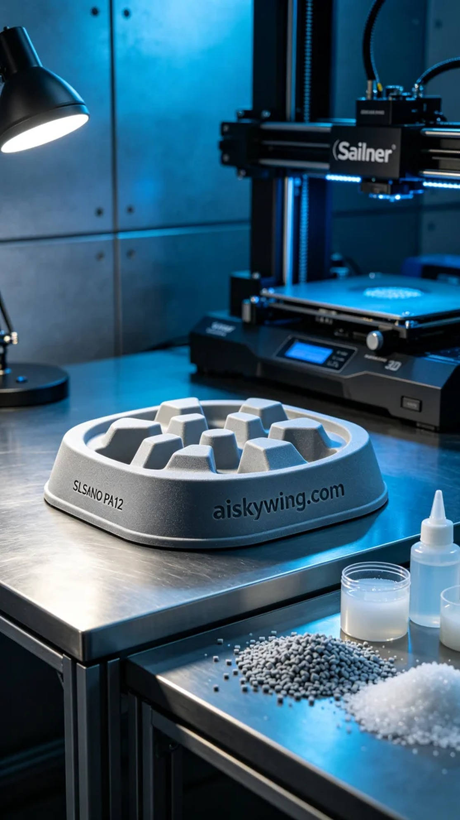
Aiskywing Industrial 3D Printing
Pet slow feeder divider


