0612-宠物护毛素瓶盖的3D打印记录
Pet Fur Conditioner Bottle Cap
🖨️ SLS尼龙烧结
🖥️ 打印机: HP
📦 材料: SLS阻燃尼龙
生活就像3D打印，每一层都需要坚持和努力。有人在YouTube上看到我们的作品，特意找上门，想要制作一个宠物护毛素瓶盖。
Life is like 3D printing; every layer requires persistence and effort. Someone saw our work on YouTube and specifically reached out to us, wanting to create a pet conditioner bottle cap.
________________________________________________________________________________
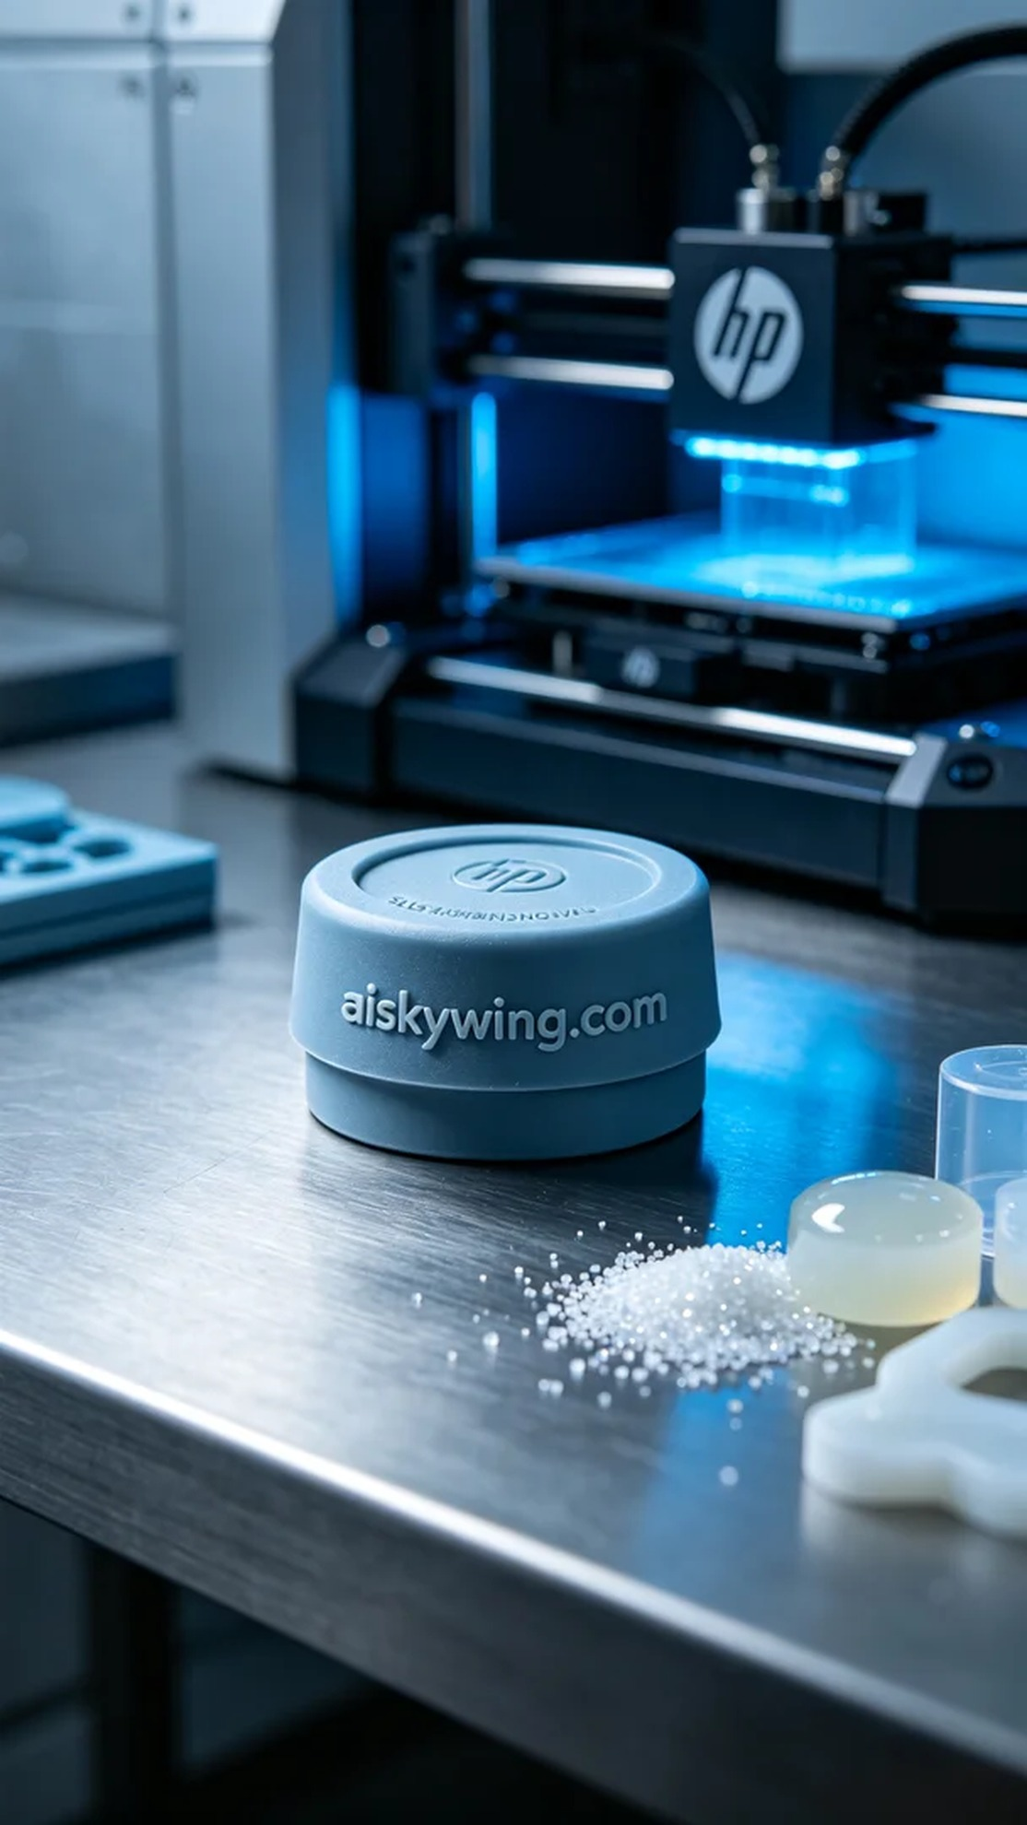
Life is a lot like 3D printing; every layer requires perseverance and effort. Someone saw our work on YouTube and reached out, wanting to create a pet conditioner cap.
For this job, we decided to produce a pet conditioner cap based on the needs expressed. They wanted a product that was durable and fire-resistant, so we confirmed the use of the HP brand 3D printer to achieve the best results.
We chose SLS flame-retardant nylon as the raw material. This material not only has a V0 flame retardant rating but also provides a matte finish that reflects cold industrial lighting well. For the printing parameters, we set a layer thickness of 0.1 mm, a printing temperature of 170℃, a power setting of 75%, a printing speed of 40 mm/s, and an estimated total print time of 4 hours and 30 minutes.
During the printing process, the HP printer performed exceptionally well. We continuously monitored the printer’s operation to ensure each layer was formed flawlessly. The uniformity of the material, the temperature of the nozzle, and the feed status were all under our scrutiny, maintaining consistent print quality and striving for perfection.
After printing, we followed detailed post-processing steps. First, we placed the finished product in a cleaning tank, using a specialized solution to remove any residual powder from the surface. Next, we sanded the edges to ensure the cap was smooth and free of burrs. Finally, we carried out a curing process to ensure the product's physical properties remained stable, only allowing it to leave the workshop once it passed inspection.
Through this meticulous process, the final pet conditioner cap showcased our commitment to quality and pursuit of excellence, and we look forward to providing quality products for more pets.
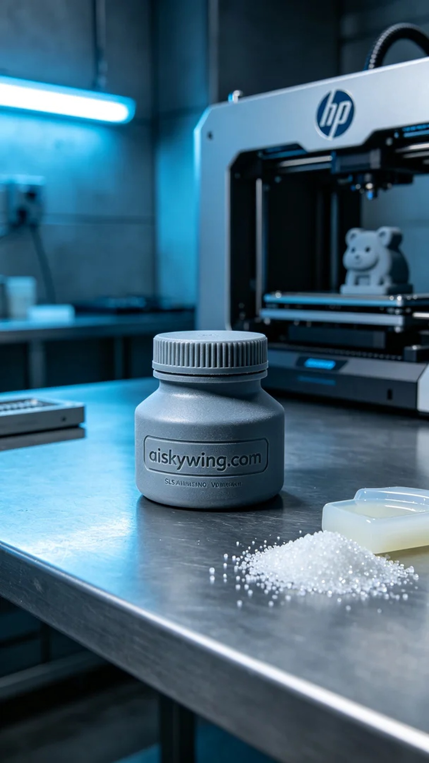
这次制作的宠物护毛素瓶盖是基于有人看到我们的3D打印作品而来。他们希望能通过SLS尼龙的特性，获得一个既耐用又具备防火能力的产品。在与他们沟通后，我们确定了使用HP品牌的3D打印机进行生产，以达到最佳的效果。
原材料方面，我们选择了SLS阻燃尼龙。这种材料不仅具备V0级阻燃特性，而且在成型后具有磨砂的质感，能够很好地反射工业环境下的冷光。打印参数方面，我们设定了层厚0.1毫米，打印温度为170℃，功率设定为75%，打印速度调整为40毫米/秒，整个打印预估时间为4小时30分钟。
在打印过程中，HP打印机的表现相当稳定。我们时刻监控设备运行情况，确保每一层都能够顺利成型。材料的均匀性、喷嘴的温度和供料状态都在我们的监控之内，确保打印质量始终如一，力求做到完美。
打印完成后，我们进行了详细的后处理工序。首先，将成品放入清洗槽中，使用专用溶液清洗去除表面残留的粉末。接着，进行打磨处理，确保瓶盖的边缘光滑无毛刺。最后，我们对成品进行固化处理，确保其物理性能稳定，检验合格后方可出厂。
经过一系列的精细操作，最终的宠物护毛素瓶盖展现出了我们对于质量的坚持与追求，期待能为更多宠物提供优质的产品。
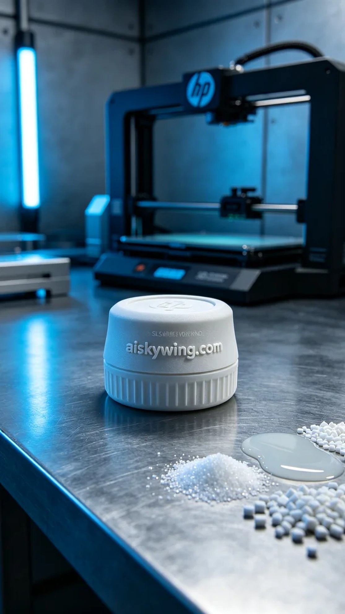
Aiskywing Industrial 3D Printing
Pet Fur Conditioner Bottle Cap


