0613-宠物指甲剪外壳制作日志
Pet Nail Clipper Shell
🖨️ SLS尼龙烧结
🖥️ 打印机: Stratasys
📦 材料: SLS阻燃尼龙
在这个快节奏的时代，面对挑战我们要勇往直前。最近，有人找我们定制了一款宠物指甲剪外壳，目的是为了提升宠物护理的安全性。
In this fast-paced era, we must forge ahead in the face of challenges. Recently, someone approached us to customize a shell for pet nail clippers, aimed at enhancing the safety of pet grooming.
________________________________________________________________________________
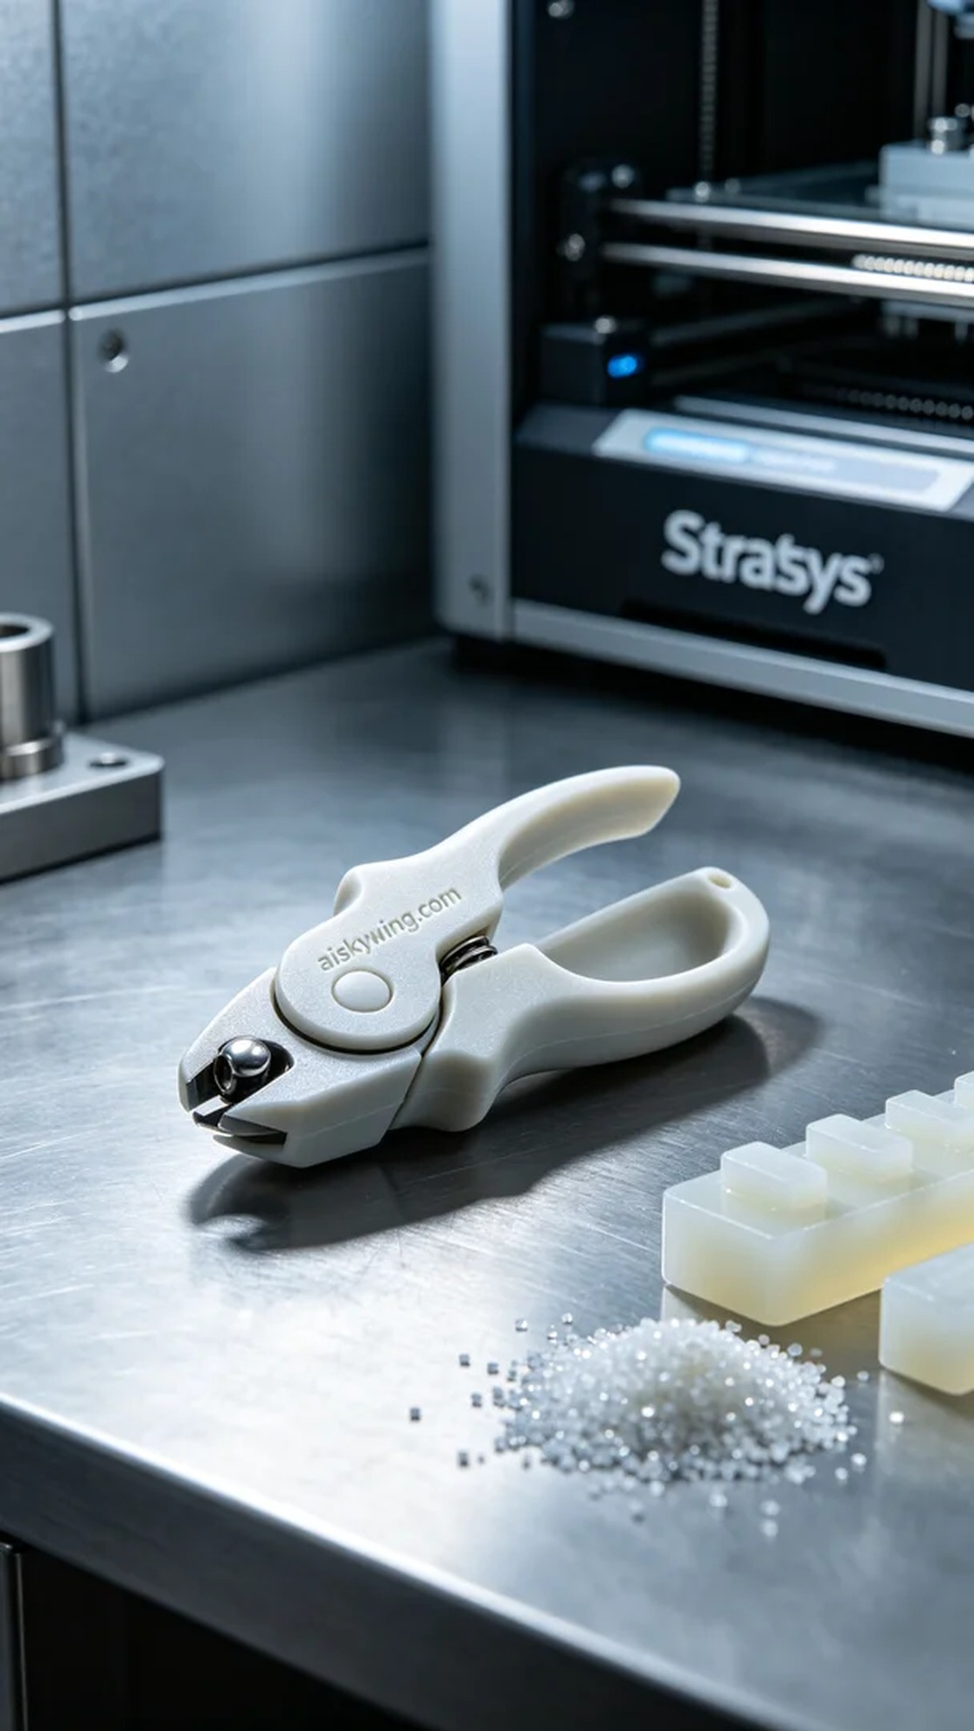
In this fast-paced world, we must forge ahead when facing challenges. Recently, someone approached us for a customized pet nail clipper shell, aiming to enhance the safety of pet grooming.
On Twitter, someone mentioned their struggle to find a safe and reliable pet nail clipper shell in the market. After understanding their needs, they chose us to create a high-quality pet nail clipper shell through 3D printing, ensuring a better grooming experience for their pets.
For this project, we selected SLS flame-retardant nylon as the primary material. This material features excellent flame-retardant properties, achieving V0-level standards, making it suitable for pet care products. We used a Stratasys brand 3D printer, setting the parameters to a layer thickness of 0.1mm, a printing temperature of 180°C, a laser power of 30 watts, and a print speed of 50mm per second, with an estimated total printing time of about 4 hours.
The printing process went smoothly. Once the device was activated, the laser sintered the nylon powder layer by layer, forming a sturdy shell. We continuously monitored the operation of the equipment, ensuring that the quality of each layer's fusion met our standards and conducted multiple checks at critical points throughout the printing to ensure product quality remained impeccable.
The post-processing stage was equally important. First, we cleaned the completed shell to remove excess powder. Next, we conducted a meticulous sanding process to ensure a smooth surface without sharp edges, preventing any harm to pets. Subsequently, we performed a curing process to enhance its strength and durability, followed by stringent quality control inspections to ensure that each product met high standards.
Through the implementation of this project, we successfully delivered a high-quality pet nail clipper shell that not only met usage requirements but also improved safety. This once again demonstrates the immense potential and application value of 3D printing technology in everyday life.
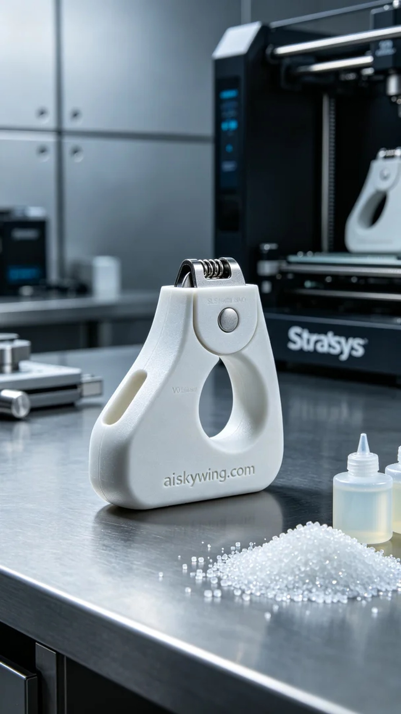
在Twitter上，有人提到他们在市场上难以找到既安全又可靠的宠物指甲剪外壳。经过了解，他们选择了我们，想通过3D打印技术制作出一款高质量的宠物指甲剪外壳，以确保在给宠物修剪指甲时能够有更好的使用体验。
这次项目中，我们选用了SLS阻燃尼龙作为主要材料。该材料具有优异的阻燃性能，达到V0级标准，适合用于宠物护理产品。打印过程中，我们使用了Stratasys品牌的3D打印机，设定的参数为层厚0.1毫米，打印温度为180°C，激光功率为30瓦，打印速度保持在50毫米每秒，预计总打印时间大约为4小时。
打印过程非常顺利。设备启动后，激光逐层烧结尼龙粉末，形成坚固的外壳。我们全程监控设备的运行状况，确保每一层的融合质量达到标准，并在打印的关键节点进行了多次检查，确保产品质量无可挑剔。
后处理阶段同样重要。首先，我们对打印完成的外壳进行清洗，以去除多余的粉末。接着，我们进行了一次细致的打磨，确保表面光滑且无锋利边缘，避免对宠物造成伤害。随后，对外壳进行固化处理，以增强其强度和耐用性，最后进行了严格的品控检验，确保每一件产品都符合高标准。
通过这次项目的实施，我们成功地交付了一款高质量的宠物指甲剪外壳，既满足了使用需求，也提升了安全性。这再次证明了3D打印技术在日常生活中的巨大潜力和应用价值。
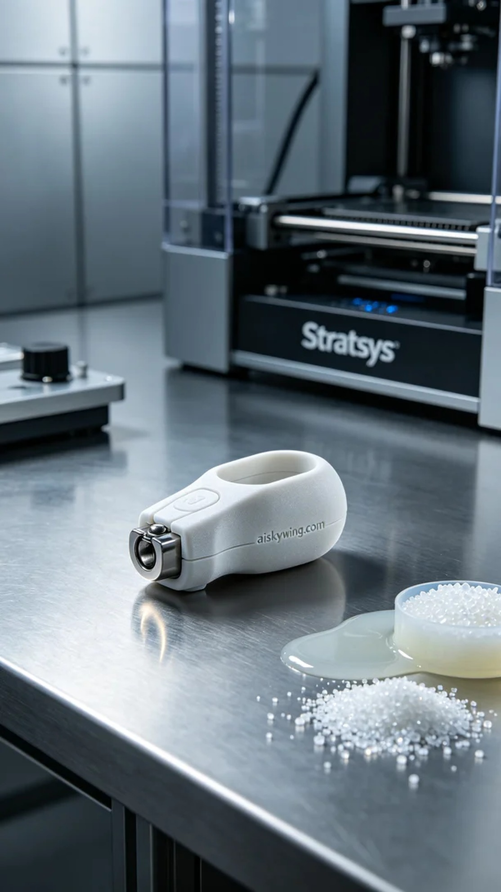
Aiskywing Industrial 3D Printing
Pet Nail Clipper Shell


