0614-宠物指甲锉手柄的3D打印生产记录
Pet Nail File Handle
🖨️ SLS尼龙烧结
🖥️ 打印机: Rize
📦 材料: SLS尼龙
生活总会给我们带来各种挑战，像有人在LinkedIn上提到的宠物指甲锉手柄的需求，让我倍感责任重大。
Life always brings us various challenges, and the demand for pet nail file handles mentioned by someone on LinkedIn makes me feel a great sense of responsibility.
________________________________________________________________________________
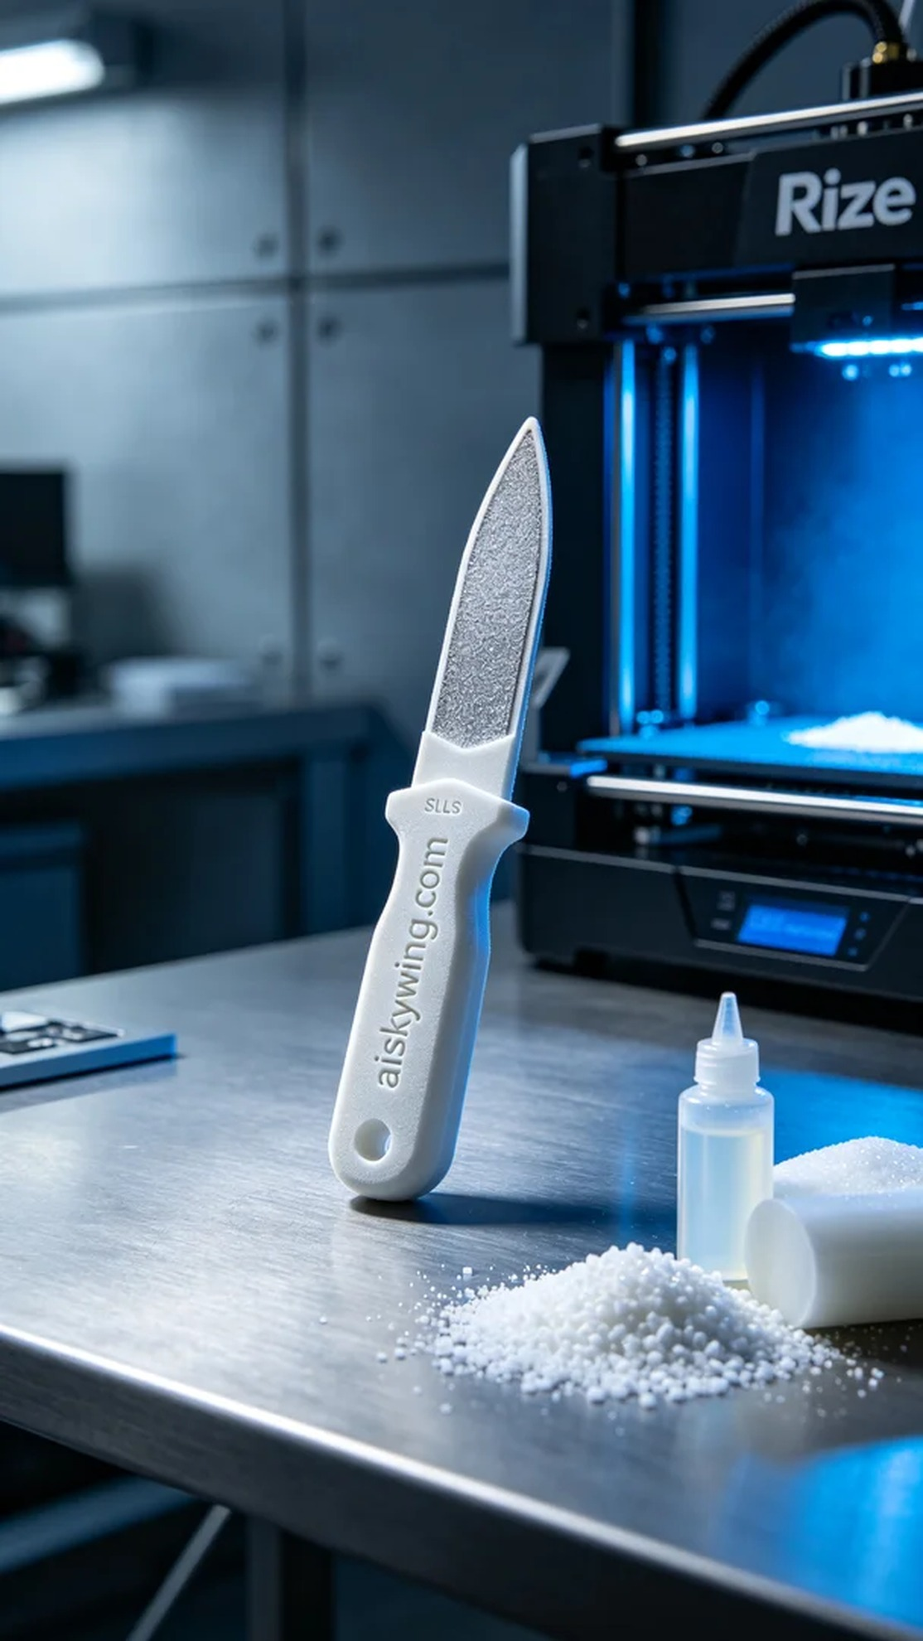
Life always throws challenges our way. Someone reached out to us on LinkedIn, mentioning that the current pet nail file handles on the market lack user-friendliness and that there’s room for improvement. Thus, we decided to use SLS nylon technology to create a more comfortable and durable pet nail file handle, aiming for excellence in both functionality and aesthetics.
For the material preparation, we selected high-quality SLS nylon, known for its excellent wear resistance and impact strength, making it ideal for tool products. Using a Rize printer, we set the layer thickness to 0.1mm, printing temperature at 200°C, power at 80%, printing speed at 25mm/s, with an estimated print time of 3 hours to ensure every detail is accurately represented.
The printing process went smoothly, thanks to the stable performance of the Rize printer, which significantly increased production efficiency. Throughout the printing, we continuously monitored the device's operating status, ensuring that temperature and print speed remained stable, and made timely adjustments to avoid any defects. The resulting handle showed exquisite powder sintering textures on its surface, enhancing its tactile appeal.
In the post-processing phase, we first cleaned the printed handles to remove any uncured materials, followed by sanding to improve surface smoothness. Next, we placed the handles in a curing device to enhance their strength and durability. Finally, a comprehensive quality inspection was conducted to ensure that every detail met the standards.
Ultimately, the pet nail file handle was successfully completed, being both aesthetically pleasing and practical, fully meeting user needs and showcasing the endless possibilities of 3D printing technology.
有人在LinkedIn上找到我们，指出目前市面上的宠物指甲锉手柄设计不够人性化，用户体验有待提升。于是，我们决定使用SLS尼龙技术，制作一个更加舒适、耐用的宠物指甲锉手柄，力求在功能和美观上都做到最好。
在原材料准备方面，我们使用的是高品质的SLS尼龙，具备优良的耐磨性和抗冲击能力，非常适合用于工具类产品。选择了Rize打印机，设置层厚为0.1mm，打印温度控制在200°C，功率设置在80%，打印速度为25mm/s，预计打印时间为3小时，确保每个细节都能精准呈现。
打印过程顺利进行，Rize打印机的稳定性能大大提高了生产效率。在打印过程中，我们持续监控设备的运行状态，确保温度和打印速度的稳定，及时调整，避免出现任何瑕疵。同时，打印出来的手柄表面呈现出细腻的粉末烧结纹理，极具质感。
后处理阶段首先进行清洗，将未固化的材料彻底去除，接着进行打磨，以提升表面光滑度。随后，将手柄放入固化设备进行加固，提高其强度和耐用性。最后，我们进行了全面的质量检验，确保每一个细节都达到标准。
最终，这个宠物指甲锉手柄得以顺利完成，既美观又实用，充分满足了用户的需求，展现出3D打印技术的无限可能。
Aiskywing Industrial 3D Printing
Pet Nail File Handle

