0615-宠物智能喂食器转盘的3D打印记录
Pet Smart Feeder Turntable
🖨️ SLS尼龙烧结
🖥️ 打印机: Voxeljet
📦 材料: SLS耐高温尼龙
有人在YouTube上看到了宠物智能喂食器转盘的介绍，想要解决自己爱宠的喂食问题，便找到了我们。
Someone saw an introduction to a pet smart feeder on YouTube and wanted to solve their pet's feeding issue, so they found us.
________________________________________________________________________________
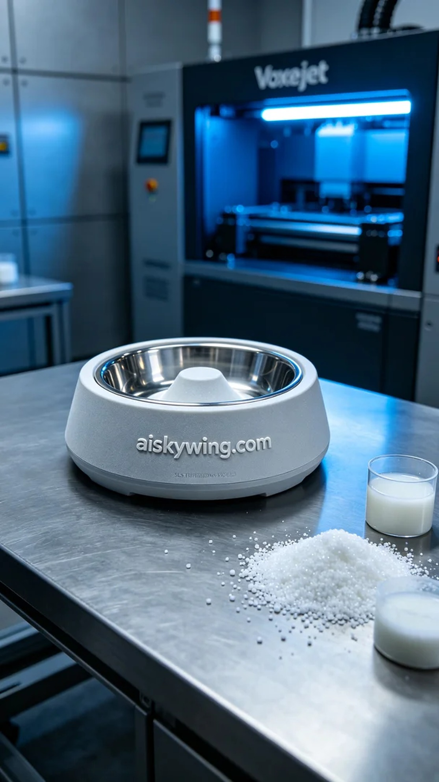
We recently had an interesting project involving the 3D printing of a pet smart feeder turntable. Inspired by a video on YouTube, someone wanted to find a better feeding solution for their beloved pet, which gave us a sense of responsibility to embark on this exciting production process.
To ensure printing quality, we chose SLS high-temperature nylon as our raw material. This material not only has excellent heat resistance, capable of withstanding temperatures over 150°C, but also provides a matte finish that enhances the technological feel of the final product. During the preparation phase, we thoroughly adjusted the Voxeljet printer, setting a layer thickness of 0.1mm, maintaining a printing temperature of 180°C, configuring the power at 1000W, and controlling the speed at 80mm/s for efficient printing.
During the printing process, the Voxeljet printer operated very stably, and the entire duration lasted about 8 hours. Throughout this period, we continuously monitored the printing quality to ensure each layer was deposited evenly and accurately. As the printing progressed, the pet smart feeder turntable gradually took shape, with clear contours, perfect details, and the engraved “aiskywing.com” logo standing out distinctly.
After completing the printing, we moved into the post-processing phase. This involved cleaning the finished product to remove any uncured material, followed by sanding with fine sandpaper to achieve a smoother surface. Finally, we conducted a curing process to ensure the durability and stability of the product, followed by stringent inspections to confirm the quality of each unit.
In the end, the pet smart feeder turntable was successfully completed, combining both aesthetics and practicality, and we hope it brings convenience to many more pets. Each printing process is a challenge to our technology and a promise for the future, and we will continue to strive to create even better products.
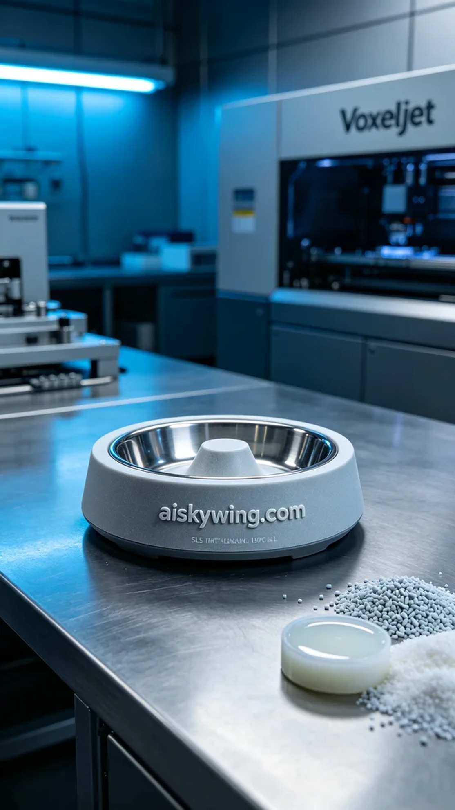
这次我们接到一个有趣的项目，涉及到宠物智能喂食器转盘的3D打印。有了YouTube的启发，有人希望能找到更好的喂食方案，这让我们倍感责任。于是，我们开始了这个令人兴奋的生产过程。
为确保打印质量，我们选用了SLS耐高温尼龙作为原材料。这种材料不仅具有很好的耐热性，能承受150℃以上的温度，而且表面磨砂的质感也让成品更具科技感。在准备阶段，我们对Voxeljet打印机进行了充分的调试，设置了0.1mm的层厚，打印温度保持在180℃，功率设定为1000W，速度控制在80mm/s，实现高效打印。
打印过程中，Voxeljet打印机的运行状态十分稳定，整个过程持续了约8小时。在这段时间里，我们时刻监控着打印质量，确保每一层的沉积都均匀无误。随着打印的推进，宠物智能喂食器转盘渐渐成型，轮廓清晰，细节完美，雕刻的“aiskywing.com”字样也显得格外醒目。
完成打印后，我们进入了后处理工序。这包括对成品进行清洗，去除未固化的材料；然后使用细砂纸进行打磨，使表面更光滑。最后，我们进行了固化处理，确保产品的耐用性和稳定性，经过严格检验后，确认了每一件产品的合格。
最后，这个宠物智能喂食器转盘如愿以偿地完成了，既美观又实用，希望能为更多的宠物带来便利。每一次的打印都是对技术的挑战和对未来的期待，我们将继续努力，做出更好的产品。
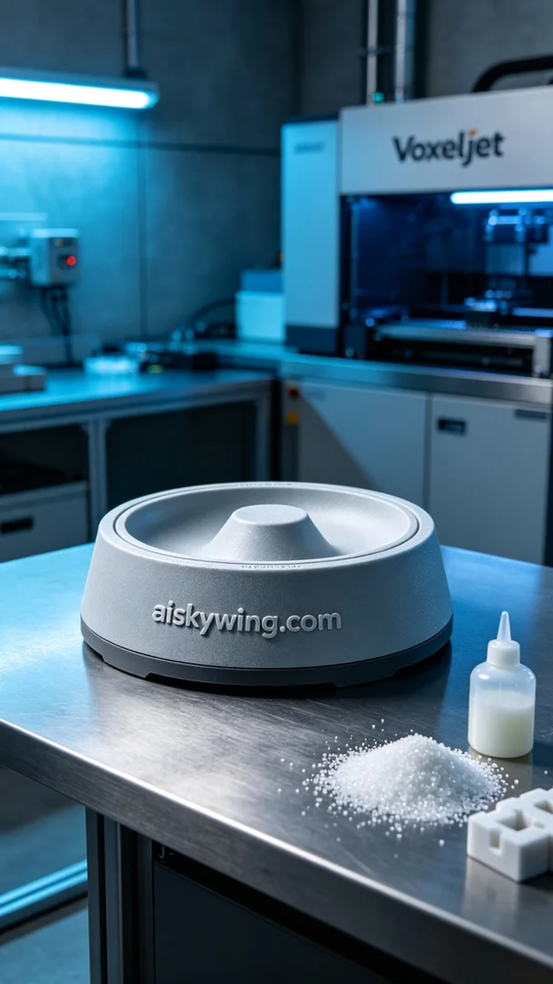
Aiskywing Industrial 3D Printing
Pet Smart Feeder Turntable


