0616-宠物梳子手柄的3D打印记录
Pet comb handle
🖨️ SLS尼龙烧结
🖥️ 打印机: Rize
📦 材料: SLS耐高温尼龙
在WhatsApp上，有人找到我，说想要制作一个宠物梳子手柄。生活中总有一些细节值得我们去坚持和完善。
On WhatsApp, someone reached out to me, expressing a desire to create a handle for a pet comb. There are always certain details in life that are worth our effort to persist and improve.
________________________________________________________________________________
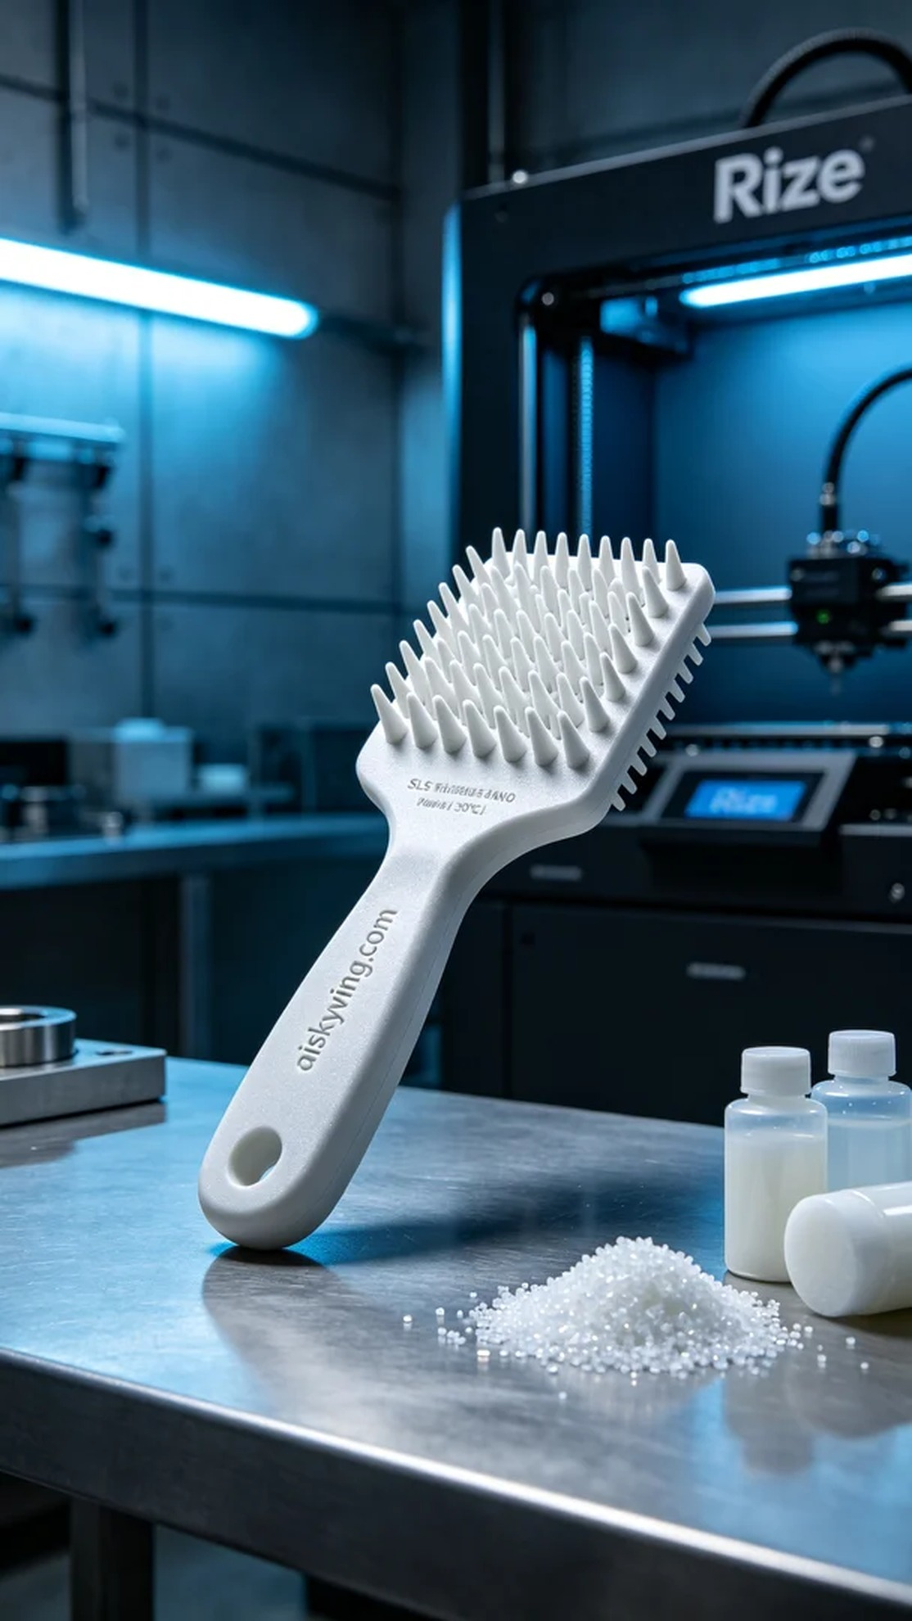
This time, the project was a pet comb handle, and someone reached out to me looking to create a product that is both beautiful and functional. After discussing their needs, it was clear they had high expectations for the materials and design, wanting the handle to have good temperature resistance and a sanded texture.
We chose SLS high-temperature nylon as the primary material. This material can withstand temperatures up to 150℃ and provides a smooth yet durable surface, ideal for long-term use. Preparations included cleaning the printer and getting the raw materials ready. Using the Rize brand 3D printer, we set the print parameters: layer thickness at 0.1mm, print temperature at 200℃, power at 80W, print speed controlled at 60mm/s, with an estimated printing time of 5 hours.
The printing process went smoothly, with the device running steadily. Quality monitoring showed excellent print quality, and we kept a close eye on the adhesion of each layer to ensure no bubbles formed. At the same time, we observed the material's flow to ensure even distribution during the heating process.
In the post-processing stage, we first cleaned the printed handle to remove any excess material. Next, we sanded the handle’s surface to achieve a smoother finish. Finally, we cured the handle to enhance its physical properties, conducting strict quality checks to ensure every detail met our high standards.
In the end, the pet comb handle was successfully printed, both aesthetically pleasing and functional. Every detail was carefully honed, reflecting our dedication to craftsmanship and persistence in our work.
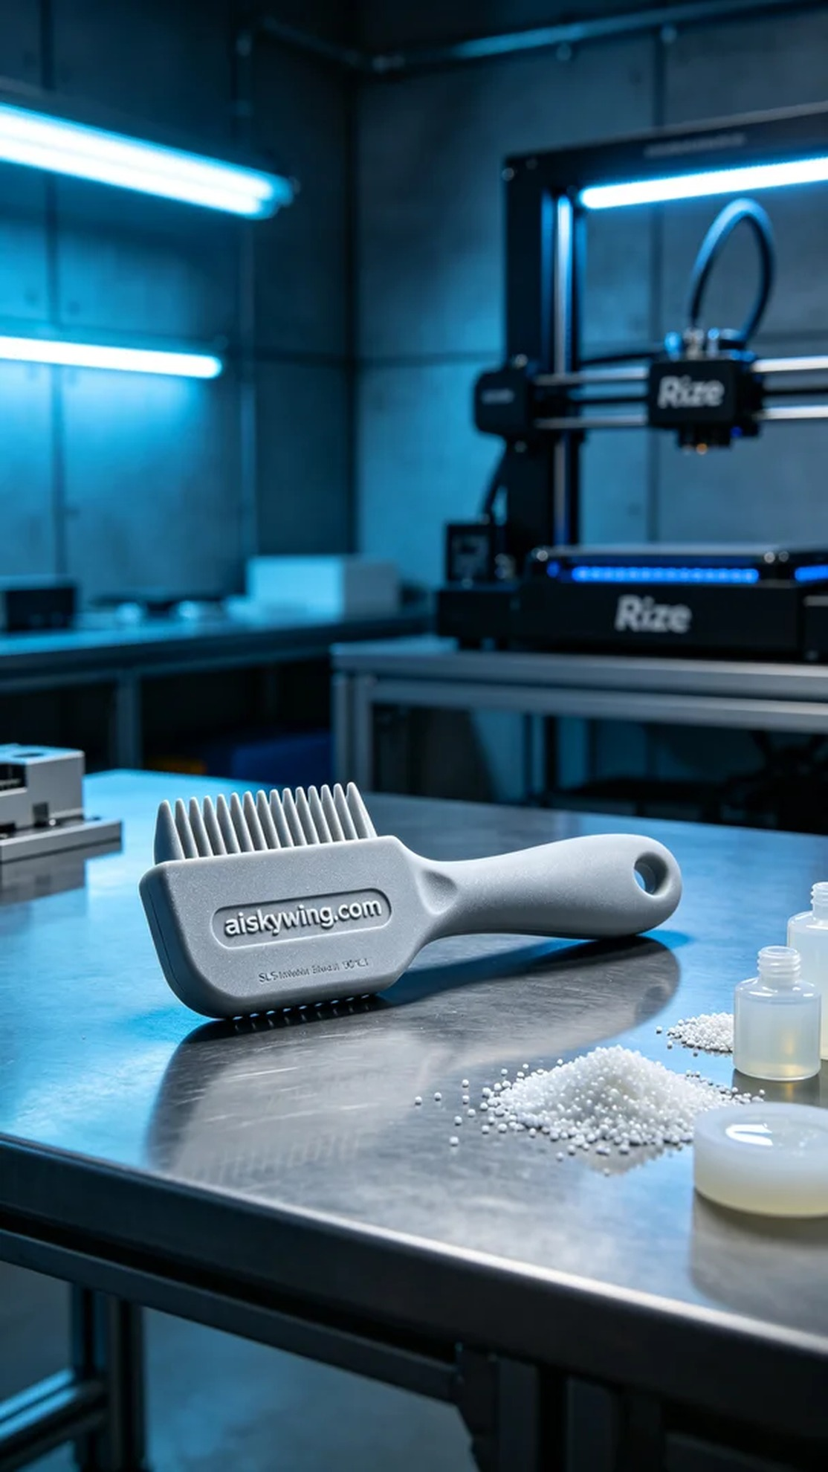
这次的项目是一个宠物梳子手柄，有人希望我们能为他们定制一个既美观又实用的产品。经过沟通，他们明确表示对材料和设计有较高的要求，希望手柄具备良好的耐温性和磨砂质感。
我们选择了SLS耐高温尼龙作为主要材料。这种材料耐温可达150℃以上，表面光滑且坚固，非常适合长时间的使用。准备工作包括清洗打印机和准备原料，使用Rize品牌的3D打印机，设置打印参数：层厚0.1mm，打印温度为200℃，功率为80W，打印速度控制在60mm/s，预计打印时间为5小时。
打印过程相对顺利，整个设备在运行中保持稳定，监控显示打印质量良好。我们注意到每一层的结合情况，确保没有气泡产生，同时观察材料的流动性，确保它们在热处理中能够均匀分布。
在后处理阶段，我们首先对打印好的手柄进行了清洗，确保去除表面的多余材料。接着使用砂纸对手柄进行打磨，使其表面更为光滑。最后，我们对手柄进行了固化，以增强其物理性能，并进行了严格的质量检验，确保每个细节都符合要求。
最终，这个宠物梳子手柄成功打印完成，既美观又实用。每个细节都经过精心打磨，正是我们对工艺的追求和坚持的体现。
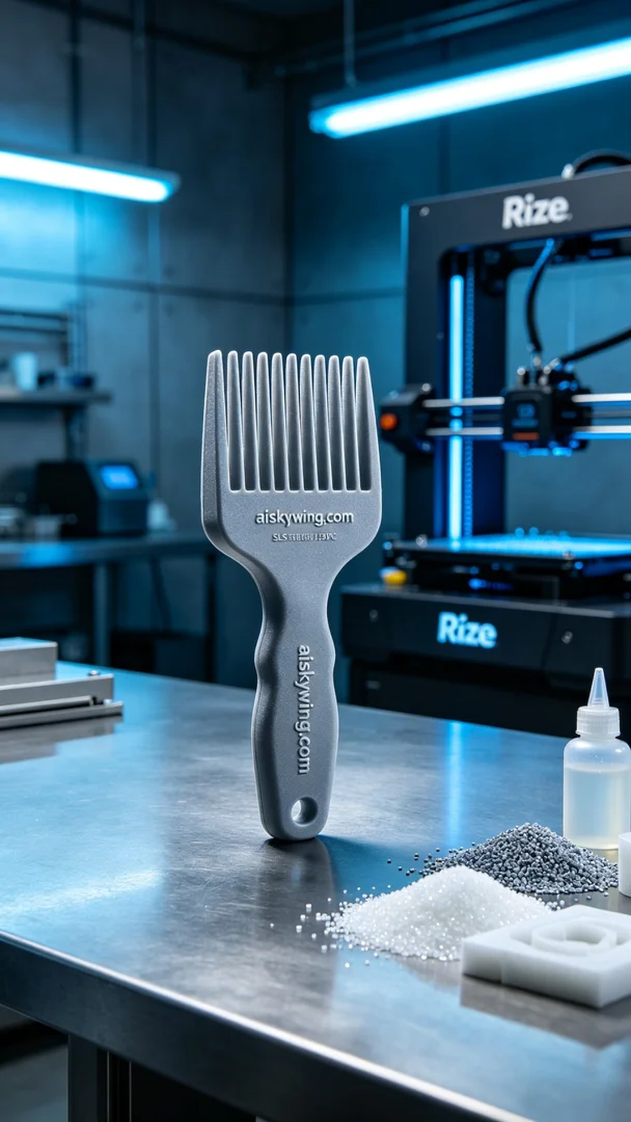
Aiskywing Industrial 3D Printing
Pet comb handle


