0617-宠物梳子针板的3D打印生产记录
Pet comb needle board
🖨️ SLS尼龙烧结
🖥️ 打印机: Voxeljet
📦 材料: SLS耐高温尼龙
生活中总会遇到各种难题，正如有人在TikTok上寻求我们帮助，做这个宠物梳子针板的事情。
In life, we will always encounter various challenges, just like someone seeking our help on TikTok with making this pet comb needle board.
________________________________________________________________________________
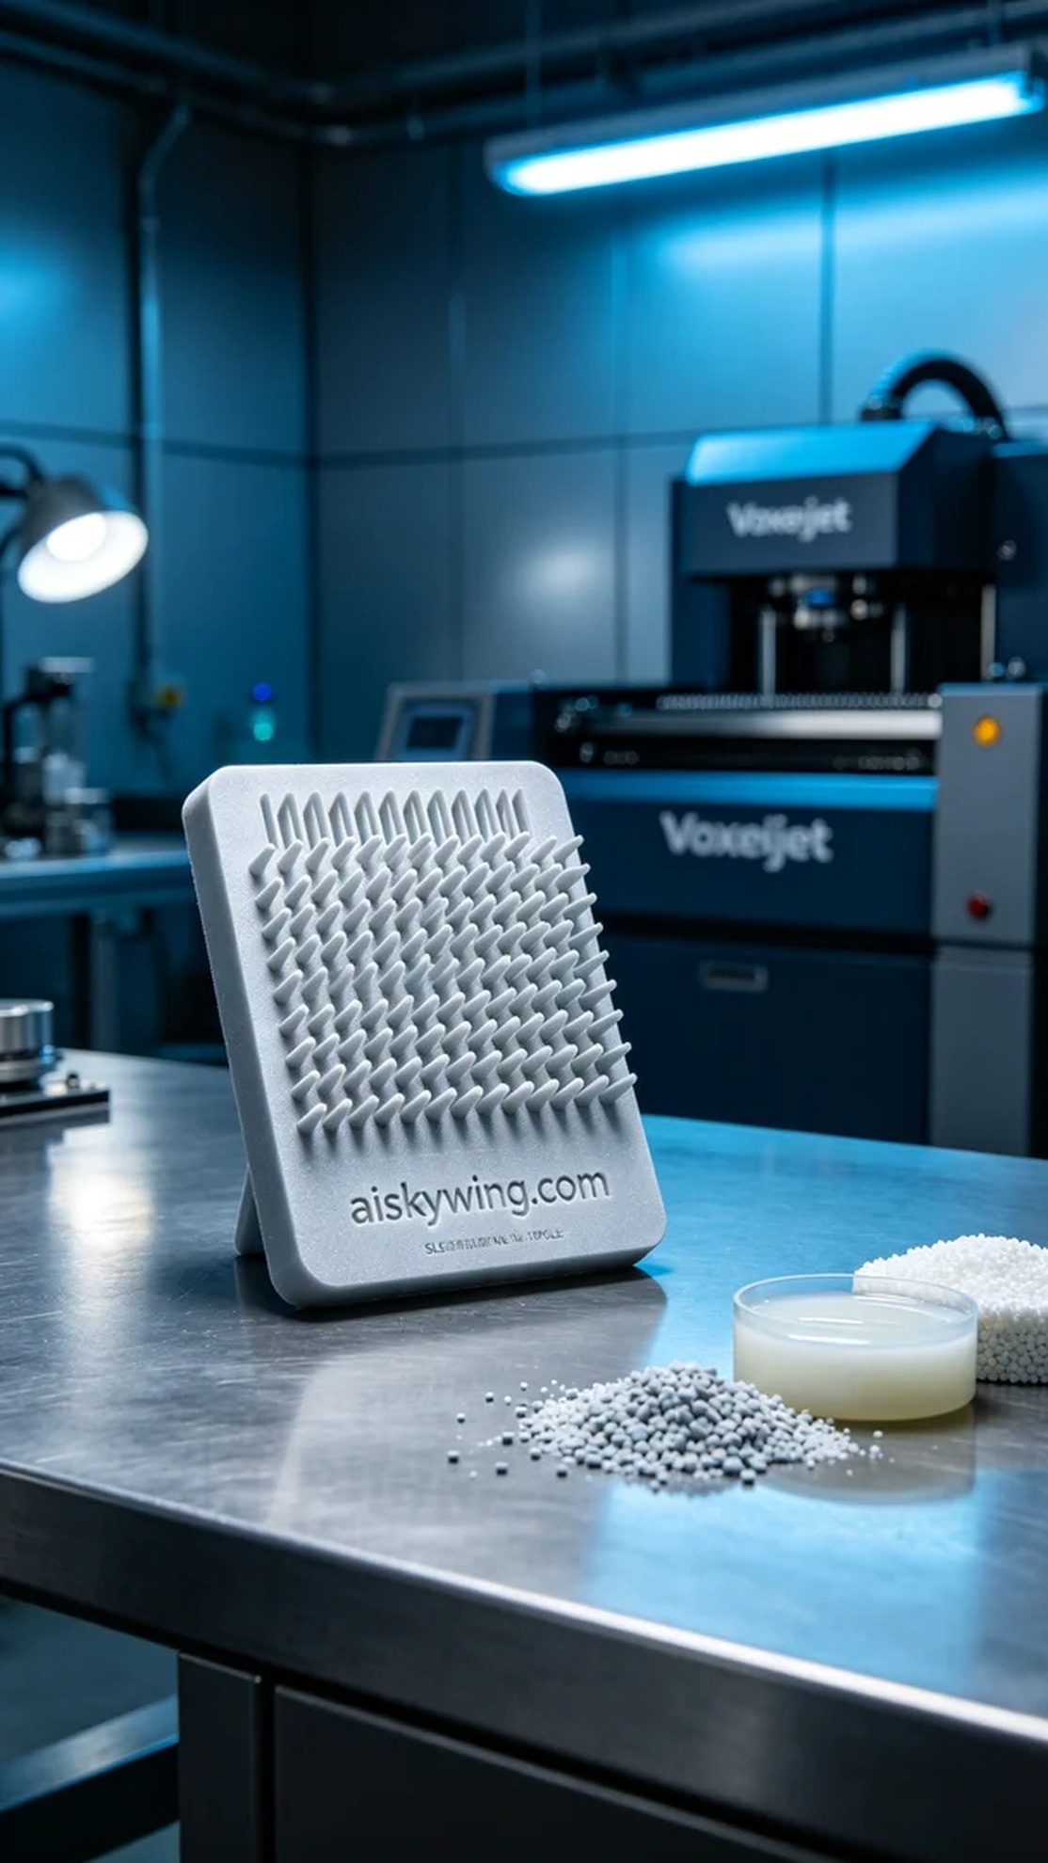
Recently, someone approached us seeking to optimize their pet brush design, specifically requesting a durable and high-temperature-resistant pet brush needle board. After discussion, we decided to use SLS high-temperature nylon to ensure the strength and durability of the final product.
We prepared SLS high-temperature nylon as the raw material. This material maintains excellent performance even at high temperatures, with a heat resistance exceeding 150℃ and a matte surface texture, ideal for intricate product requirements. We used a Voxeljet printer, setting parameters to a layer thickness of 0.1 mm, a printing temperature of 200℃, a laser power of 30W, and a printing speed of 5 cm per hour, with an estimated printing time of about 8 hours.
During the printing process, the Voxeljet operated steadily, with the laser melting the nylon powder layer by layer to form a robust structure. We continuously monitored the equipment's status, ensuring every detail met expectations, particularly in temperature and laser power control, making timely adjustments to avoid printing flaws.
Once printing was complete, the post-processing steps commenced without delay. We first removed the product from the printer and cleaned it to eliminate any un-fused nylon powder on the surface. Next, we performed sanding to ensure every edge was smooth, preventing any potential harm to pets during use. Finally, after a curing step, we ensured the material's performance reached its optimal state and conducted a final inspection to confirm that the product was free of defects.
The production process went smoothly, and the final product's quality met our expectations. This pet brush needle board is not only aesthetically pleasing but also guarantees practicality, perfectly showcasing the charm of 3D printing.
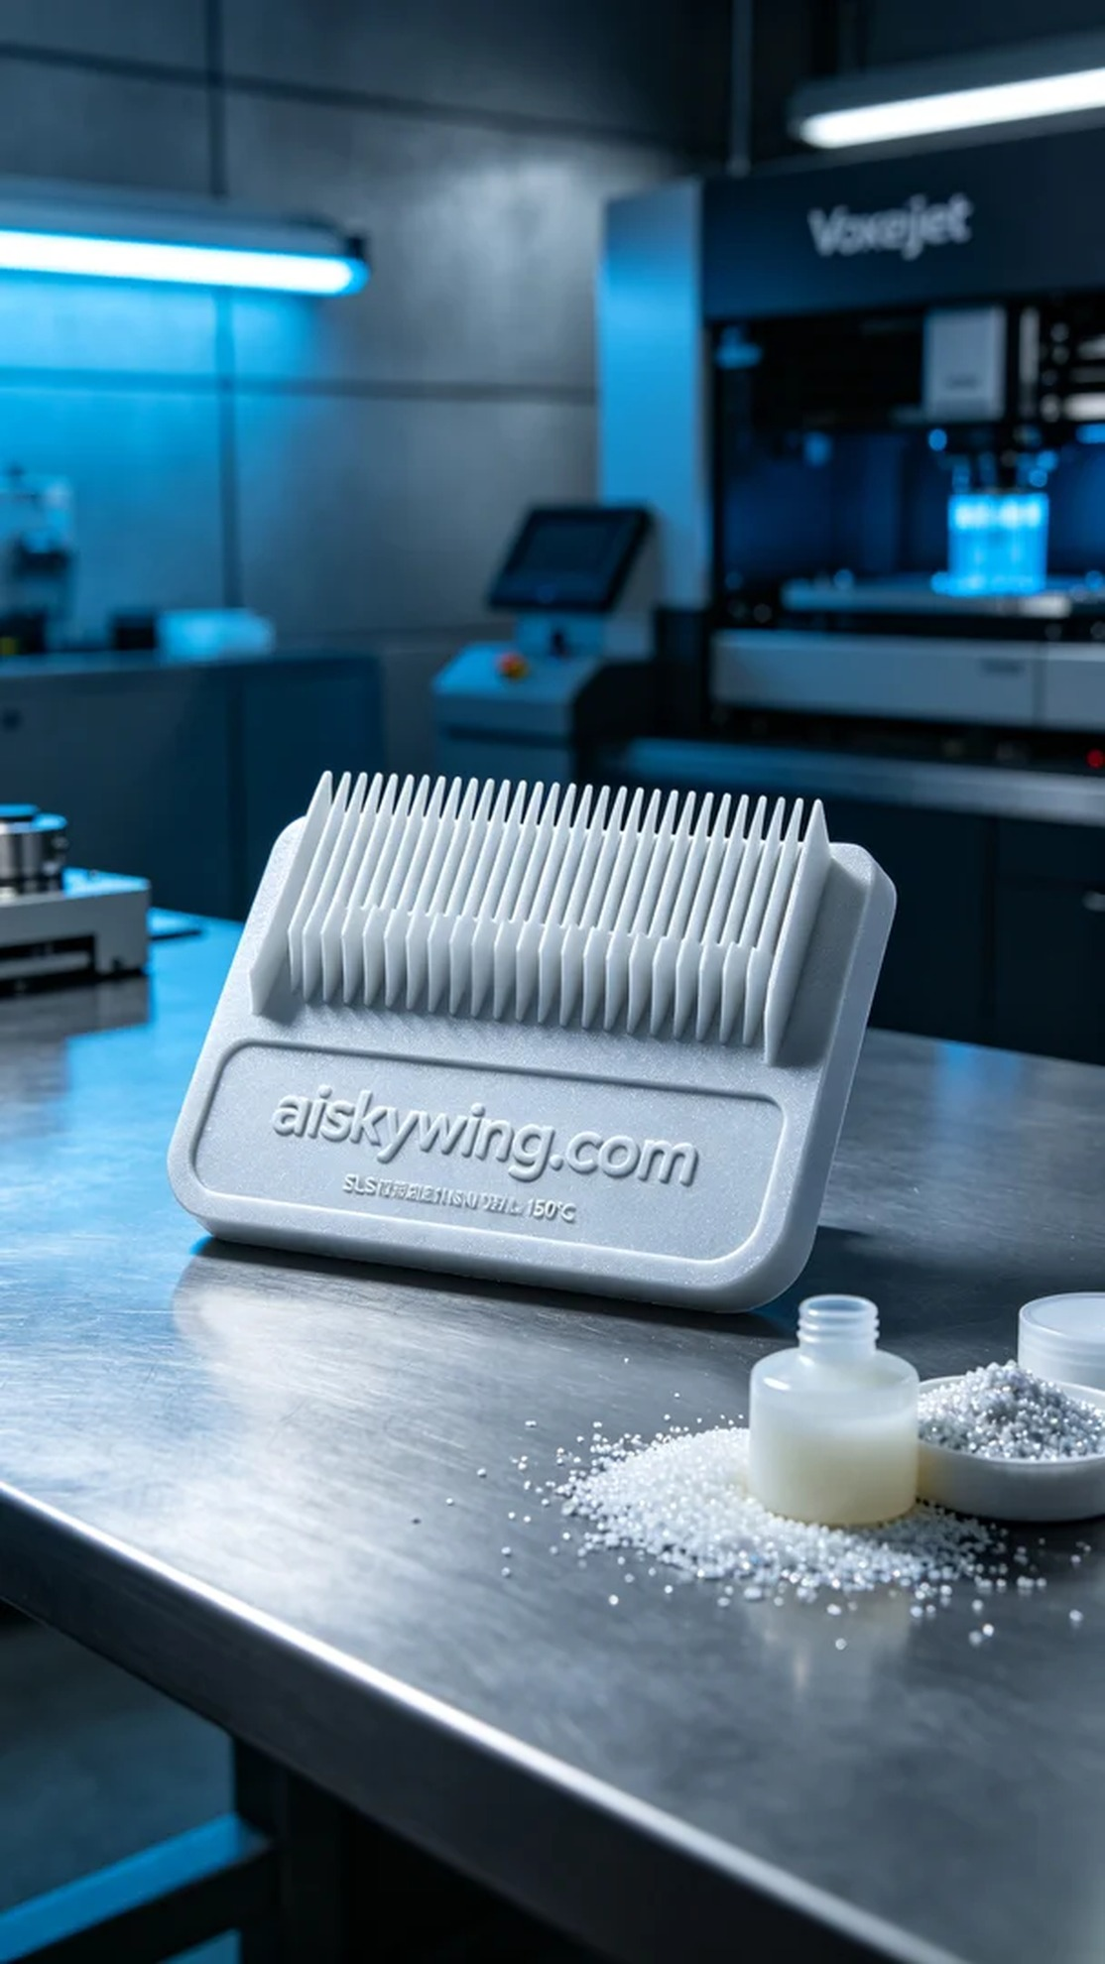
在最近的一个项目中，有人因为想要优化宠物梳子的设计而找到我们，具体需求是制作一款耐高温、耐用的宠物梳子针板。经过讨论，我们决定使用SLS耐高温尼龙，确保成品的强度和耐久性。
我们准备了SLS耐高温尼龙作为原材料，这种材料在高温下依然保持良好的性能，耐温可达150℃以上，表面磨砂质感，适合精细的产品需求。使用的打印机是Voxeljet，参数设置为层厚0.1毫米，打印温度为200℃，激光功率为30W，打印速度设定为每小时5厘米，预计打印时间大约为8个小时。
在打印过程中，Voxeljet设备稳定运行，激光逐层熔化尼龙粉末，形成坚固的结构。我们时刻监控设备状态，确保每个细节都符合预期，特别是在温度和激光功率控制方面，及时调整以避免打印瑕疵。
完成打印后，后处理工序马不停蹄。我们首先将成品从打印机中取出，并进行清洗，去除表面未熔化的尼龙粉末。接着，进行打磨处理，确保每个边角光滑，避免对宠物使用时造成伤害。最后，经过固化步骤，确保材料性能达到最佳状态，并进行最终检验，确认产品没有缺陷。
这次的生产过程顺利，最终成品的质量如我们预期。这个宠物梳子针板不仅外观精美，更在实用性上得到了保障，完美展示了3D打印的魅力。
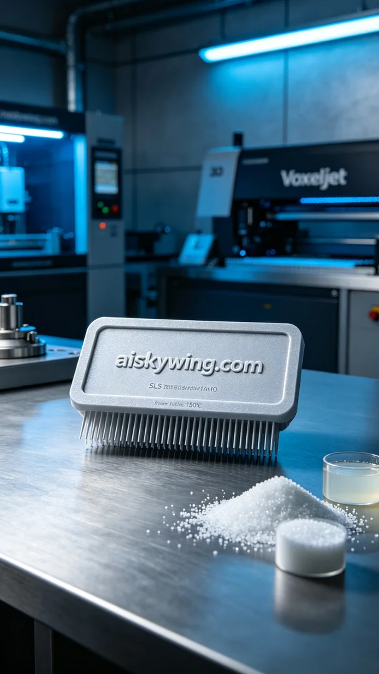
Aiskywing Industrial 3D Printing
Pet comb needle board


