0618-宠物水盆支架的3D打印记录
Pet Water Bowl Stand
🖨️ SLS尼龙烧结
🖥️ 打印机: Xjet
📦 材料: SLS阻燃尼龙
在这不断追求创新的时代，3D打印像是一扇通往未来的窗。有人因爱宠需要而找我们，要求制作这个宠物水盆支架。
In this era of continuous pursuit of innovation, 3D printing is like a window to the future. Some people come to us out of love for their pets, requesting the creation of a pet water bowl stand.
________________________________________________________________________________
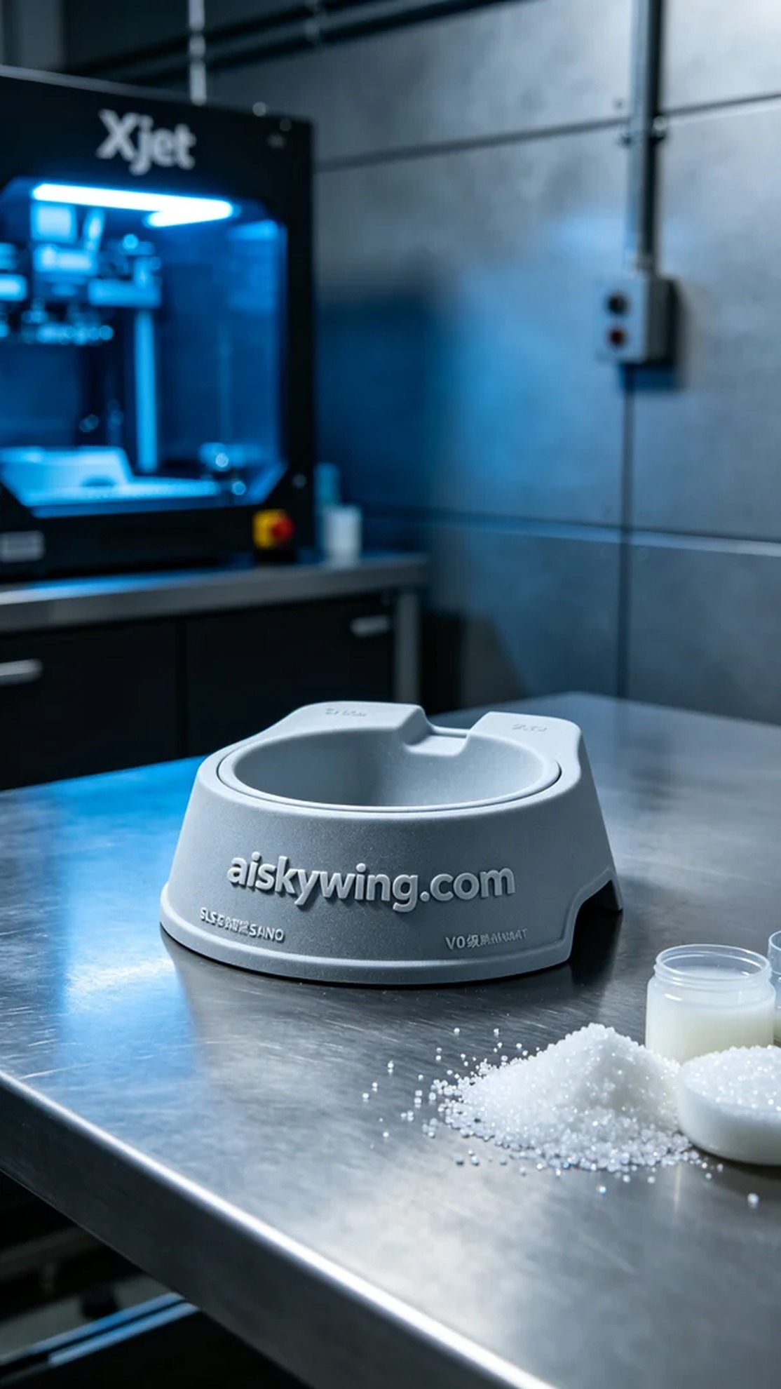
Someone discovered us through YouTube, seeking a solution for their pet who always refuses to drink water. They wanted us to create a suitable and beautiful pet water bowl stand that could fit various settings and styles.
We chose SLS flame-retardant nylon as the raw material. This material not only has good strength and durability but also features V0 level flame resistance, making it ideal for industrial environments. To ensure print quality, we used the Xjet 3D printer, setting the layer thickness to 0.1mm, print temperature at 200 degrees Celsius, power at 80%, and print speed at 60mm per second, with an estimated print time of 8 hours.
The 3D printing process went smoothly, and the stability of the Xjet device gave us peace of mind. Throughout the printing process, we closely monitored quality, observing the melting and solidification of the material to ensure each layer printed seamlessly and accurately.
After printing, we carried out necessary post-processing steps. First, the finished product was placed in a cleaning tank where a specialized cleaning solution was used to remove surface powder. Next, we sanded the surface to ensure smoothness. Then, it was sent to the curing chamber for UV light exposure to enhance its strength, followed by a comprehensive inspection to ensure the product met all requirements.
After a series of steps, we successfully produced the pet water bowl stand, resolving the issue of pet hydration and bringing great convenience to our client. This process makes us appreciate the endless possibilities that 3D printing offers.
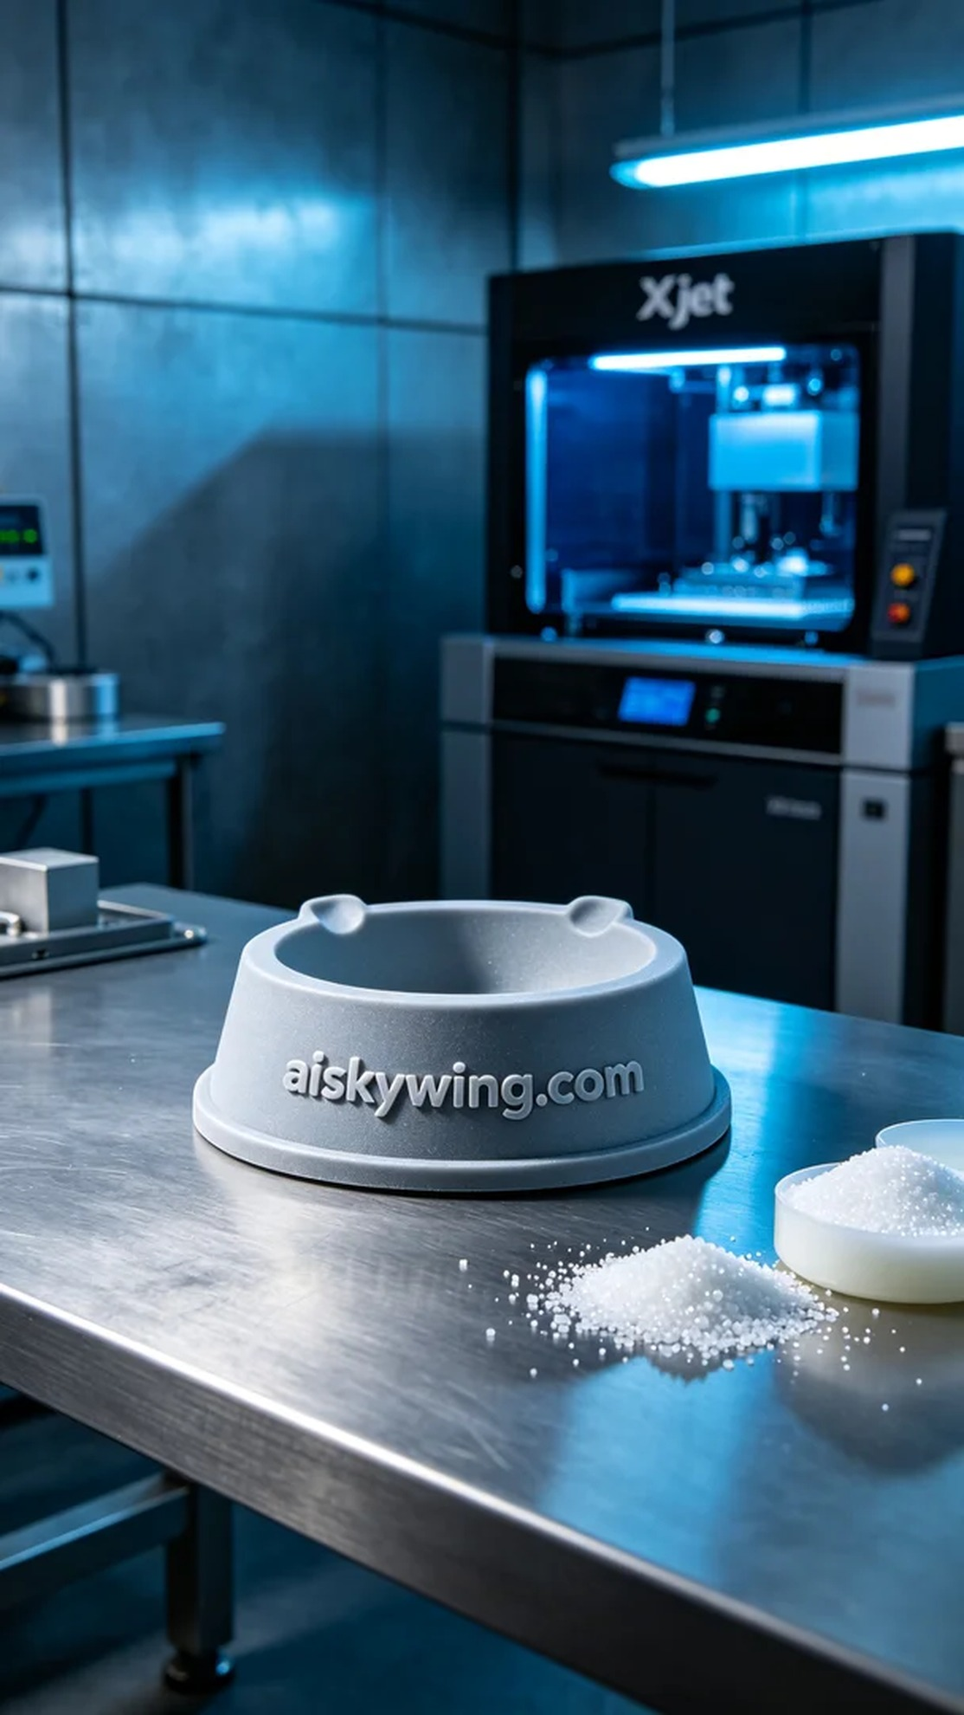
有人通过YouTube了解到我们，因家中的宠物总是不愿意喝水，寻找一个合适的水盆支架来解决这个问题。他们希望我们能够制作一个既实用又美观的宠物水盆支架，可以适配不同场景和风格。
我们选择了SLS阻燃尼龙作为原材料，这种材质不仅具有良好的强度和耐用性，还具备V0级阻燃特性，非常适合工业环境使用。为了确保打印质量，我们使用Xjet 3D打印机，设置层厚为0.1毫米，打印温度控制在200摄氏度，功率为80%，打印速度保持在60毫米每秒，预计打印时间为8小时。
3D打印过程顺利进行，Xjet的设备稳定性让我们倍感安心。在整个打印过程中，我们时刻关注质量监控，观察材料的融化和固化情况，确保每一层的打印都能无缝对接，精准无误。
完成打印后，我们进行了必要的后处理工序。首先将成品放入清洗槽中，使用专门的清洗液去除表面粉末。接着进行打磨，确保表面光滑。然后，将其送入固化室，经过UV灯照射加固，最后进行全面检验，确保产品完全符合要求。
经过一系列步骤，我们成功制作出了这个宠物水盆支架，解决了宠物饮水的问题，同时也为客户带来了极大的便利。这样的过程，让我们感受到3D打印带来的无限可能。
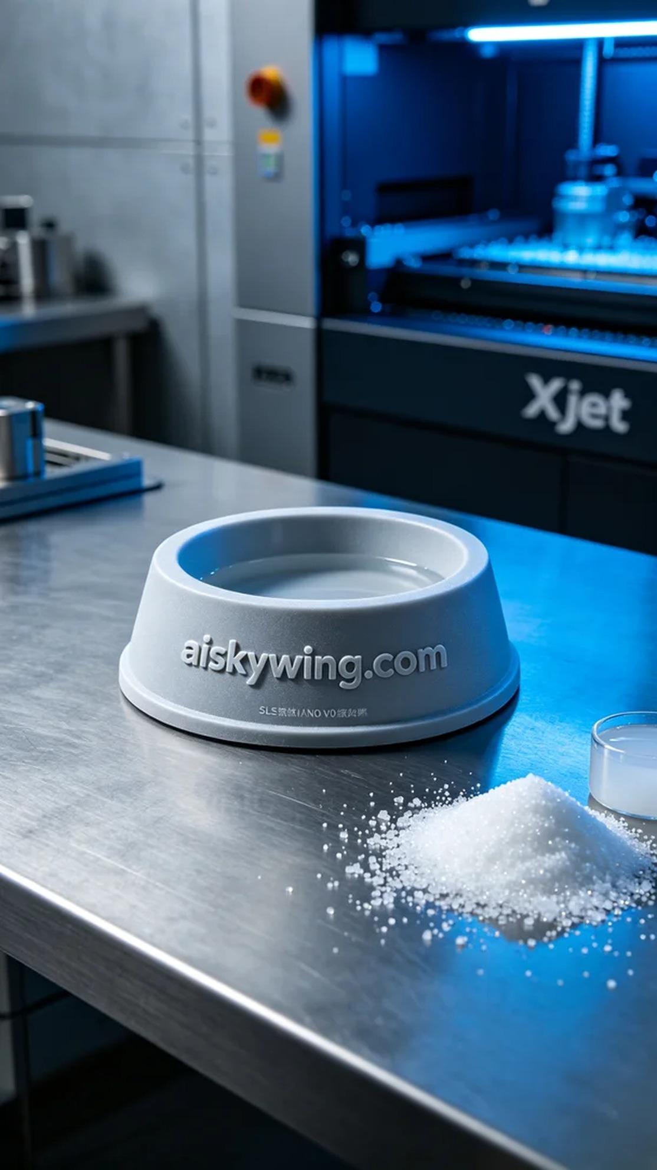
Aiskywing Industrial 3D Printing
Pet Water Bowl Stand


