0619-AGV小车RFID天线支架的生产记录
AGV Cart RFID Antenna Bracket
🖨️ SLS尼龙烧结
🖥️ 打印机: Mimaki
📦 材料: SLS尼龙PA12
生活再难，也别停下脚步。就像有人在TikTok上寻求帮助，找上我们来制作这个AGV小车RFID天线支架。
No matter how tough life gets, don't stop moving forward. Just like someone sought help on TikTok and came to us to create this RFID antenna bracket for the AGV cart.
________________________________________________________________________________
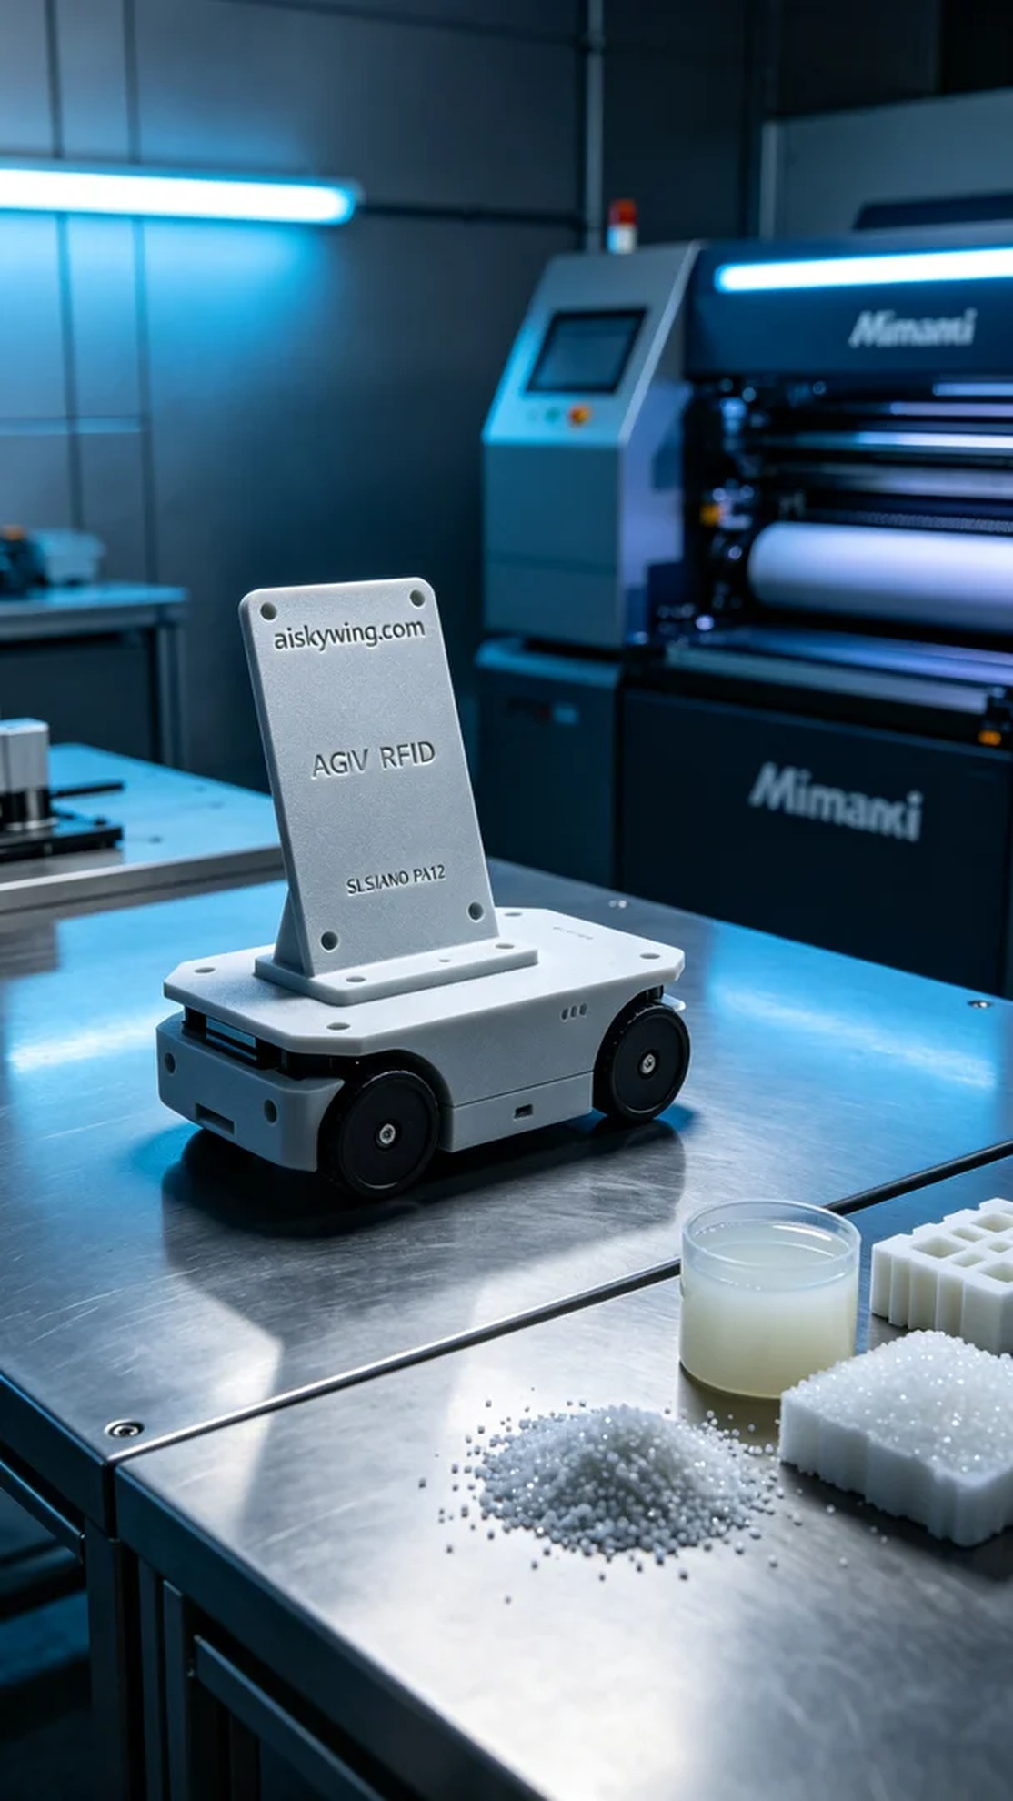
Life can be tough, but we must keep moving forward. Just like someone reached out to us on TikTok for help in creating an AGV car RFID antenna bracket.
For this project, we carefully selected SLS Nylon PA12 as the printing material. This type of material boasts excellent mechanical properties and heat resistance, making it ideal for industrial applications. Using the Mimaki brand 3D printer, we set the printing parameters to a layer thickness of 0.1 mm, a printing speed of 30 mm per second, a temperature of 180 degrees Celsius, and maximum power to ensure the material was fully melted. After several trials, we decided to set the printing time to 6 hours to allow ample time for post-processing.
During the printing process, the Mimaki printer operated smoothly, and everything ran like clockwork. We continuously monitored the print quality, checking for any nozzle blockages and observing the progress in real-time through monitoring software. When the print was complete, we were pleased to see that the antenna bracket had a smooth surface and the engraving of "aiskywing.com" was clear, which brought us a sense of relief.
Post-processing is crucial to ensuring product quality. After printing, we placed the bracket in a cleaning tank, using a specialized cleaning solution to remove any uncured resin. Next, we sanded the bracket to ensure an even smoother surface. The curing step was also essential, as we used UV lamps to ensure full polymerization of the material. Finally, we closely inspected the finished product to ensure every detail met our standards.
After all these meticulous steps, the AGV car RFID antenna bracket was finally completed. Seeing it shine on the industrial table under the light filled us with a deep sense of accomplishment.
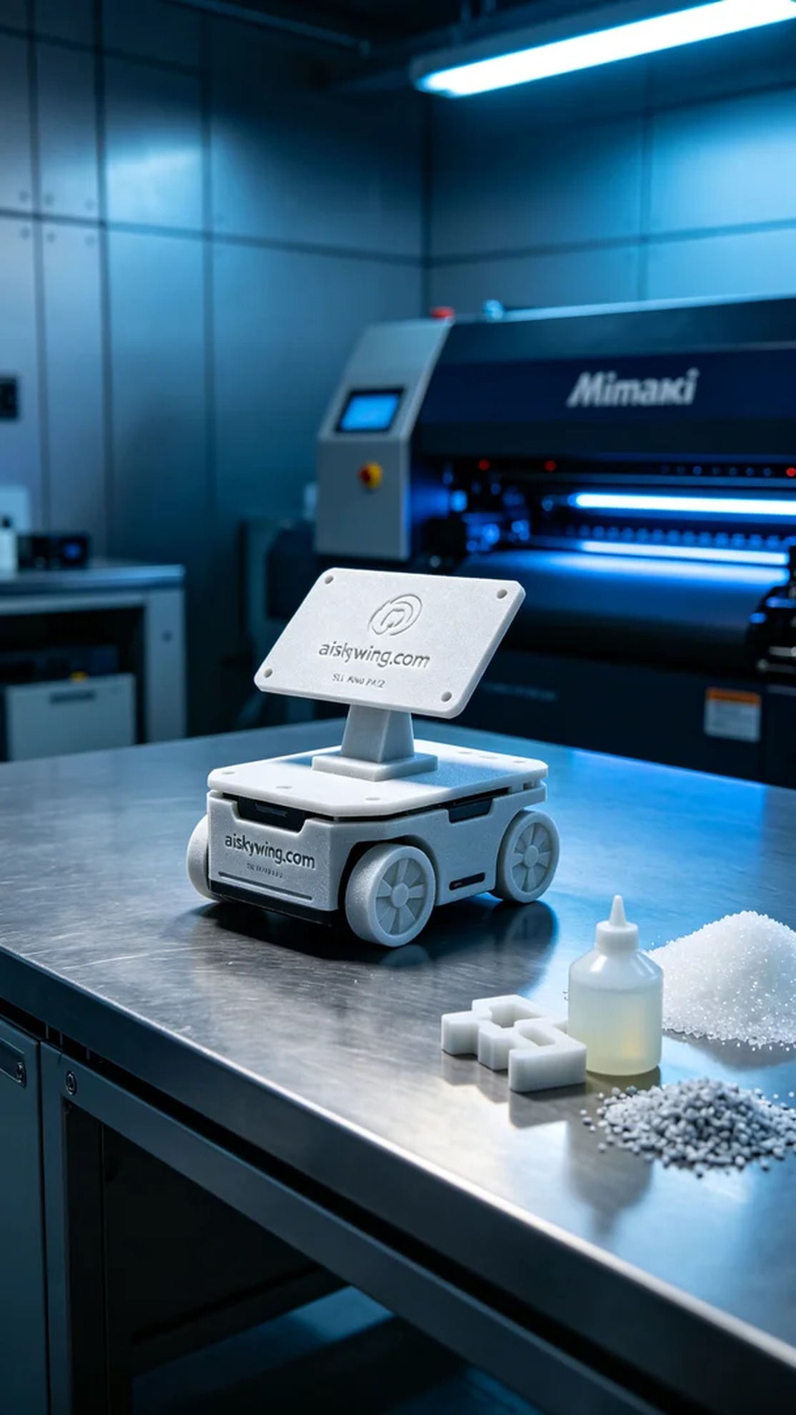
我们接到一个有趣的项目，有人因为需要提升AGV小车的智能识别能力，找上我们设计和生产一个RFID天线支架。这个支架不仅要满足功能需求，还要在美观和工业设计上有所讲究，因此我们决定采用SLS尼龙PA12材料来进行打印。
在准备工作中，我们仔细挑选了SLS尼龙PA12作为打印材料。这种材料具有优良的机械性能和耐热性，非常适合工业应用。我们使用Mimaki品牌的3D打印机，设置的打印参数是层厚0.1毫米，打印速度为30毫米每秒，温度保持在180摄氏度，功率则调至最大以确保材料充分熔融。经过几次试验，我们决定将打印时间设定为6小时，以便给产品留下足够的空间进行后续处理。
打印过程中，我们的Mimaki打印机运转平稳，整个打印过程像是时钟一样精准。我们始终关注打印质量，定期检查喷嘴是否堵塞，并通过监控软件实时观察进度。在打印完成的那一刻，我们看到天线支架的表面光滑，"aiskywing.com"的雕刻清晰可见，心里不禁松了一口气。
后处理是确保产品质量的重要环节。打印完成后，我们先将支架放入清洗槽，使用专业的清洗剂去除未固化的树脂。接着，我们对支架进行打磨，确保表面更加光滑。固化步骤也必不可少，我们使用UV灯照射，确保材料完全聚合。最后，我们对成品进行了仔细检验，确保每一个细节都符合我们的标准。
经过这一系列精细的工序，AGV小车RFID天线支架终于顺利完成。看到它在工业桌面上与光线交相辉映，内心充满成就感。
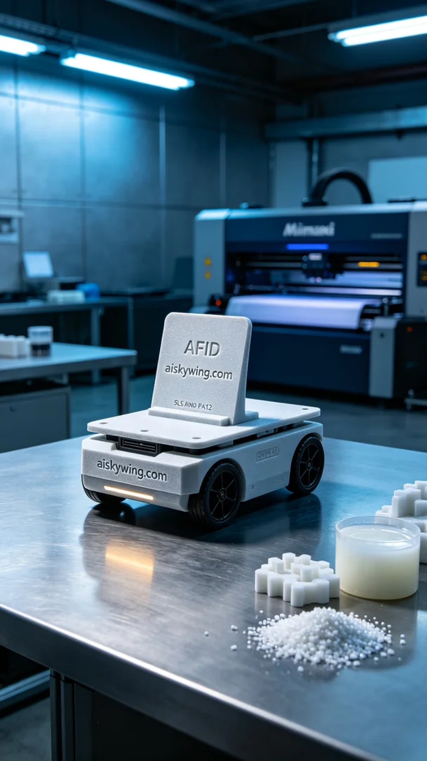
Aiskywing Industrial 3D Printing
AGV Cart RFID Antenna Bracket


