0620-AGV小车扬声器支架的生产记录
AGV Cart Speaker Bracket
🖨️ SLS尼龙烧结
🖥️ 打印机: EOS
📦 材料: SLS尼龙
生活就像3D打印，层层加厚，才能成就梦想。有人因想要提升AGV小车的音质和便携性，找到了我们。
Life is like 3D printing, building up layer by layer to achieve dreams. Some have come to us in search of improving the sound quality and portability of AGV carts.
________________________________________________________________________________
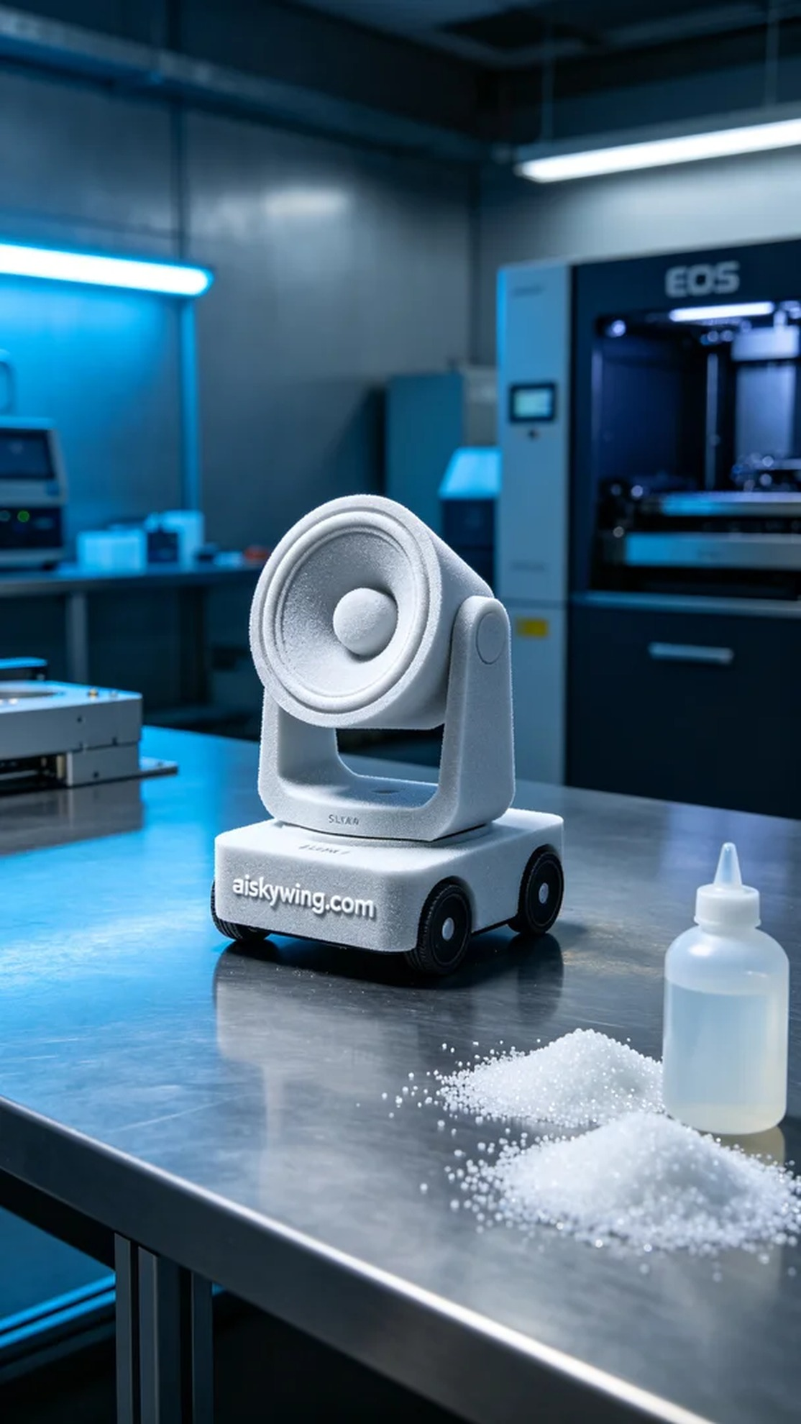
Life is like 3D printing, layer by layer, building up to achieve dreams. Someone reached out on Twitter, looking for a more stable and lightweight stand for their AGV cart speaker. They were facing the challenge that existing stands weren't sturdy enough, affecting the cart's performance. Thus, we decided to utilize SLS nylon material to meet their needs.
To ensure optimal printing results, we prepared our EOS brand 3D printer. We chose SLS nylon for its lightweight characteristics and excellent durability. For the parameters, we set a layer thickness of 0.1mm, printing temperature at 170°C, laser power at 40 watts, printing speed at 30mm/s, and an estimated total printing time of 10 hours.
The printing process went smoothly with the EOS printer operating steadily. We monitored the equipment in real-time to ensure that each layer was printed accurately. Due to the properties of SLS nylon, the resulting product featured fine textures formed during the sintering process, making it both aesthetically pleasing and functional.
After printing, we conducted a series of post-processing steps. We first cleaned the printed part to remove excess powder, then lightly sanded the surface to achieve a smooth finish. Finally, we performed a curing treatment to enhance the strength and durability of the stand, followed by a thorough inspection to ensure each stand met our quality standards.
After a meticulous series of operations, the AGV cart speaker stand was finally completed. It was not only lightweight but also sturdier, perfectly meeting the requirements. This production experience deepened our understanding of the synergy between materials and processes.
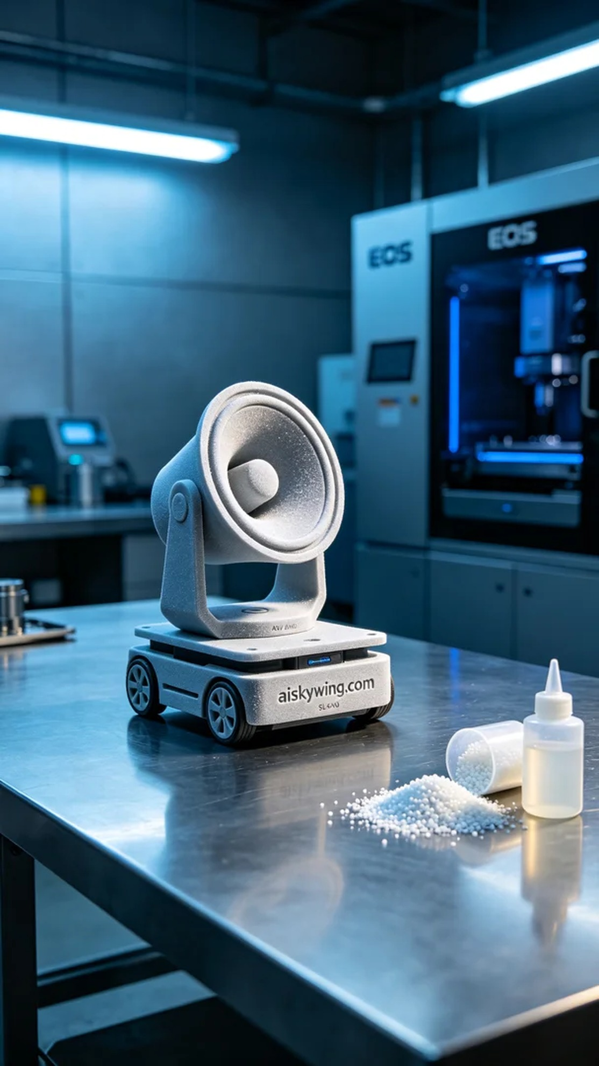
我们接到一个来自Twitter的询问，有人希望找到一个更稳定、轻巧的支架，以支持他们的AGV小车扬声器。他们遇到的问题是，现有的支架不够牢固，影响了小车的性能。因此，我们决定采用SLS尼龙材质来解决他们的需求。
为了确保打印效果，我们准备了EOS品牌的3D打印机。在材料方面，我们选择了SLS尼龙，这种材料不仅轻便，还具有优良的韧性和耐久性。参数方面，我们设置了层厚为0.1毫米，打印温度控制在170摄氏度，激光功率为40瓦，打印速度为30毫米/秒，预计总打印时间为10小时。
打印过程顺利，EOS打印机运行稳定。我们实时监控设备的工作状态，确保每一层都精准无误。由于SLS尼龙的特性，打印过程中产生的粉末在烧结时形成了细致的纹理，使得最终产品既具美观又具功能性。
打印完成后，我们进行了一系列后处理工序。首先是对打印件进行清洗，去除表面多余的粉末，接着用砂纸轻轻打磨，使得支架表面光滑。最后进行固化处理，以增强支架的强度和耐用性，最后检验确保每个支架都符合我们的质量标准。
经过一系列的精细操作，AGV小车扬声器支架终于完成。它不仅轻量化，更加坚固，完美地满足了需求。这次生产经历让我们更深入地理解了材料和工艺的结合。
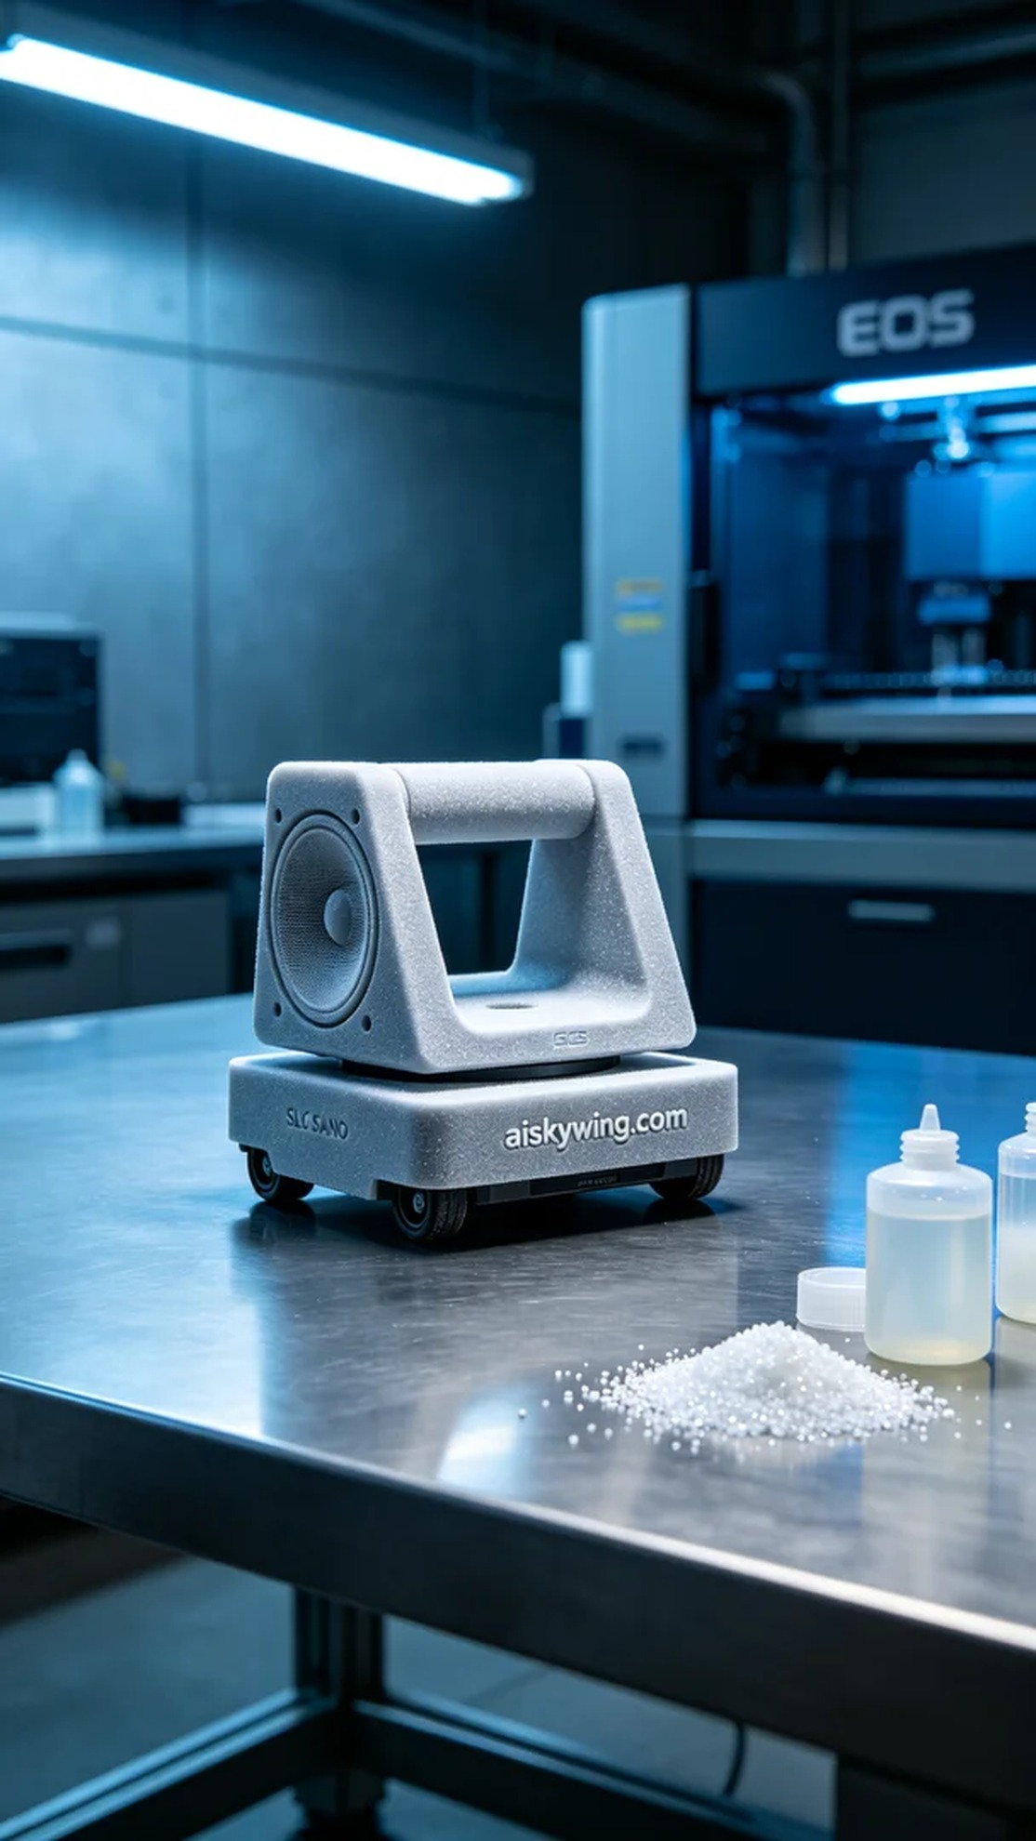
Aiskywing Industrial 3D Printing
AGV Cart Speaker Bracket


