0621-AGV小车指示灯支架生产记录
AGV trolley indicator light bracket
🖨️ SLS尼龙烧结
🖥️ 打印机: Mimaki
📦 材料: SLS尼龙PA12
生活就像3D打印，有时需要重新调整方向。最近有人找我们制作AGV小车指示灯支架，解决他们的实际问题。
Life is like 3D printing; sometimes it requires a change in direction. Recently, someone approached us to create a bracket for AGV cart indicator lights to solve their practical problem.
________________________________________________________________________________
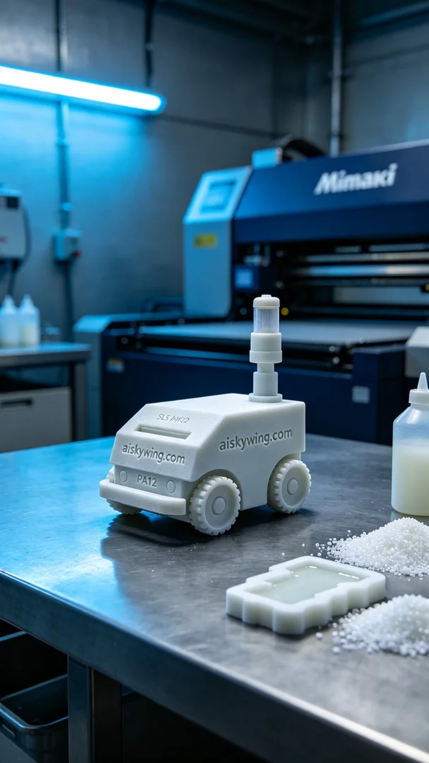
Life is like 3D printing; sometimes you need to adjust your direction. Recently, someone reached out to us on Facebook to create an AGV light bracket to solve their practical problem.
For this project, we chose SLS nylon PA12 as the raw material. This material is known for its high strength and durability, making it ideal for industrial applications. We utilized a Mimaki 3D printer, setting the layer thickness to 0.1mm, printing temperature at 180 degrees Celsius, power to 700 watts, and a printing speed of 50mm per second. These parameters ensure precision and strength in the print.
The printing process went smoothly, with the Mimaki printer operating in good condition. The entire process took about six hours, during which we continuously monitored the print quality to ensure uniform deposition for every layer. Upon completion, the bracket showed remarkable detail, with the "aiskywing.com" engraving clearly visible.
For post-processing, we first cleaned the bracket to remove excess powder. Then, we sanded the surface for a smoother touch. During curing, we ensured the bracket maintained its hardness under appropriate environmental conditions, followed by a comprehensive inspection to confirm all dimensions and surface quality met the requirements.
Completing this project deepened our understanding of the charm and utility of 3D printing. Each creation enhances our skills and experiences in this field.
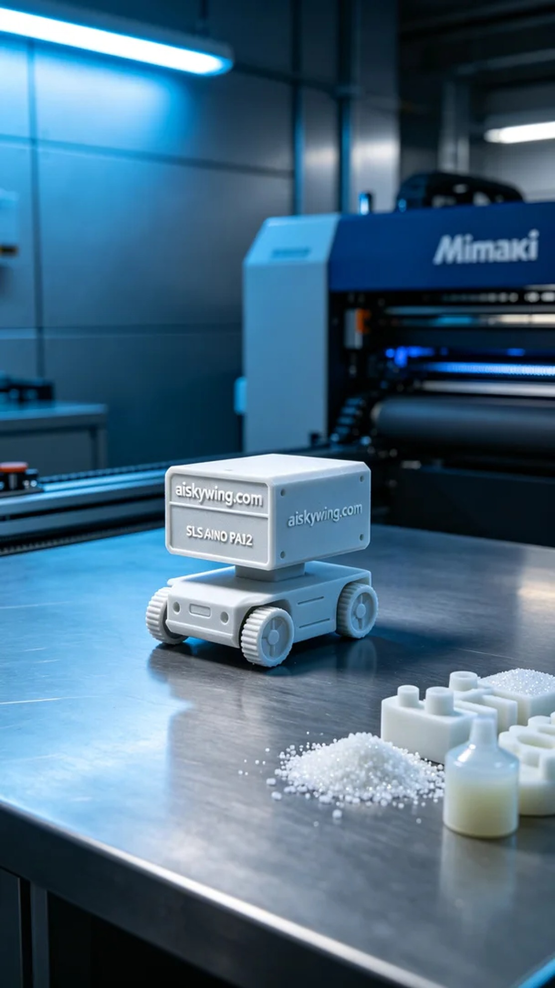
这次的制作源于Facebook上的一则求助消息，有人遇到在工业环境中需要稳定的指示灯支架的问题。经过沟通，我们决定为他们打造一个AGV小车指示灯支架，既要确保功能性，也要考虑到外观设计。
为了满足这个需求，我们选用了SLS尼龙PA12作为原材料。这种材料具有高强度和耐久性，非常适合工业用途。接着，我们使用Mimaki品牌的3D打印机进行打印，设置层厚为0.1毫米，打印温度控制在180摄氏度，功率700瓦，打印速度为50毫米每秒。这些参数能够有效保证打印件的精度和强度。
打印过程顺利，Mimaki打印机的运行状态良好，整个打印过程持续了大约6小时。在此期间，我们不断监控打印质量，确保每一层的沉积都均匀到位。打印完成后，支架的表面细节非常清晰，"aiskywing.com"字样清楚可见。
在后处理环节，我们首先将支架进行清洗，以去除多余的粉末。随后对表面进行打磨，使得其触感更加光滑。固化过程中，我们确保支架在适当的环境条件下保持硬度，最后还进行了全面检查，确保所有的尺寸和表面质量符合要求。
完成此项目后，AGV小车指示灯支架的生产流程让我们更加深刻地理解了3D打印的魅力与实用。每一次的制作，都在不断提升我们的技术和经验。
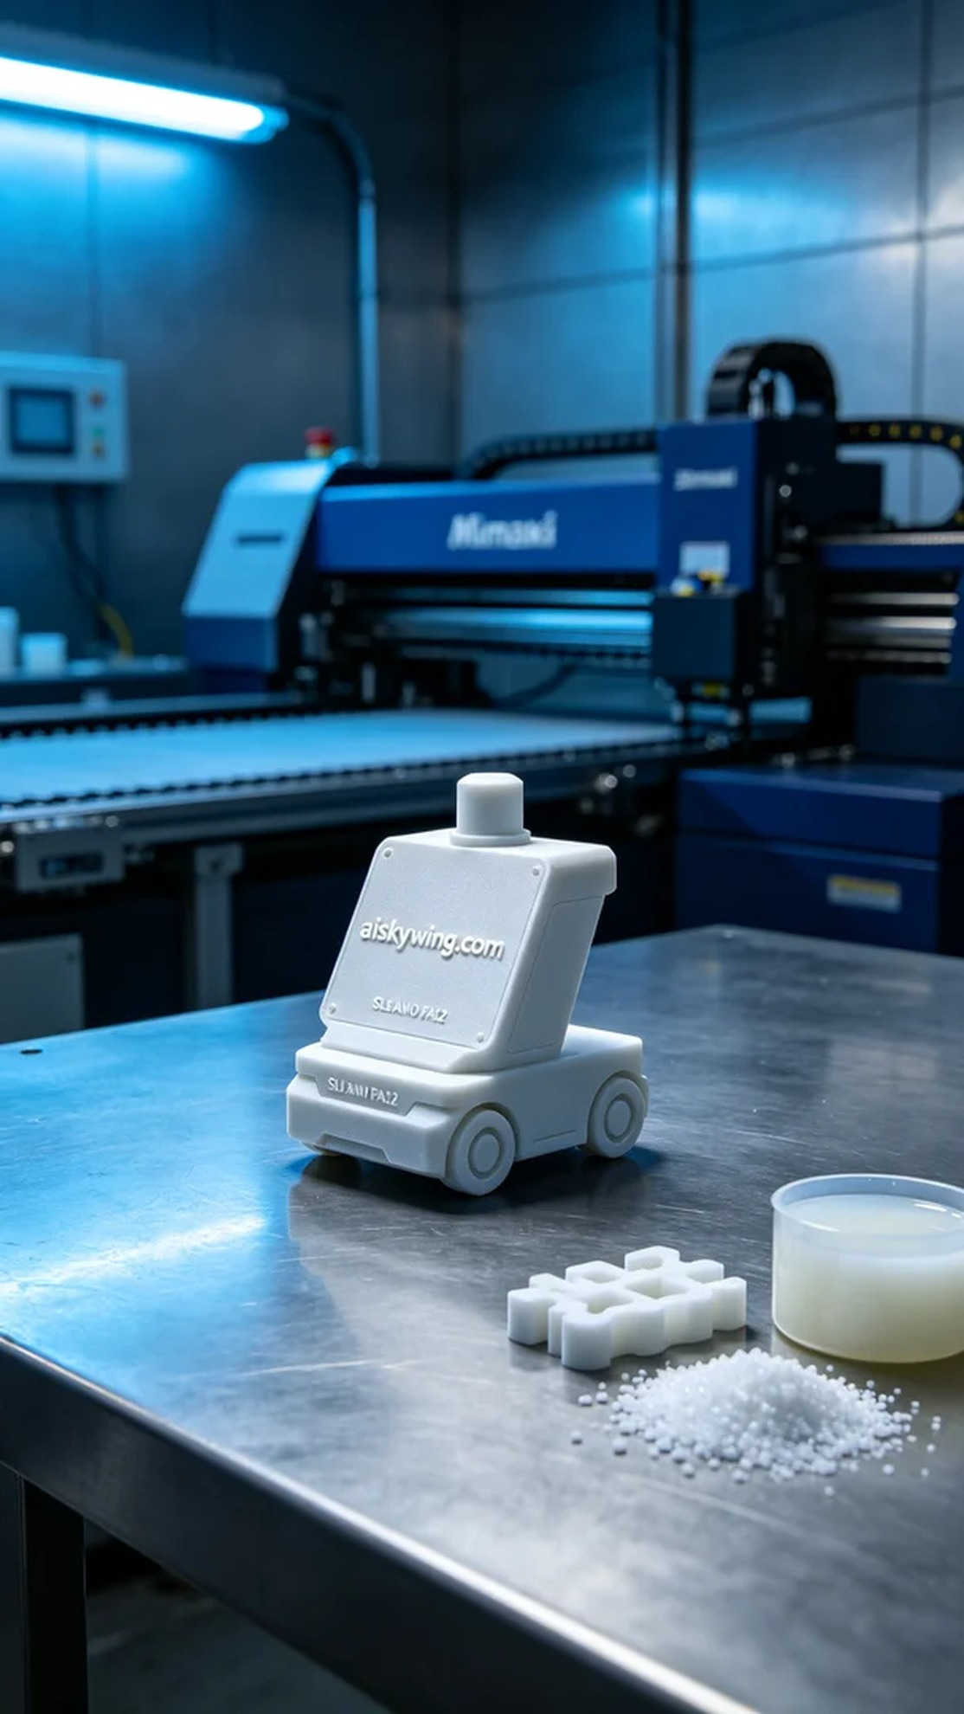
Aiskywing Industrial 3D Printing
AGV trolley indicator light bracket


