0622-AGV小车控制器外壳生产记录
AGV cart controller casing
🖨️ SLS尼龙烧结
🖥️ 打印机: Systems
📦 材料: SLS阻燃尼龙
在Twitter上，有人说希望我们能帮助他们解决AGV小车控制器外壳的难题，听到这，我立刻想到了我们的3D打印工艺。
On Twitter, someone mentioned that they hope we can help them solve the problem of the AGV cart controller casing. Upon hearing this, I immediately thought of our 3D printing technology.
________________________________________________________________________________
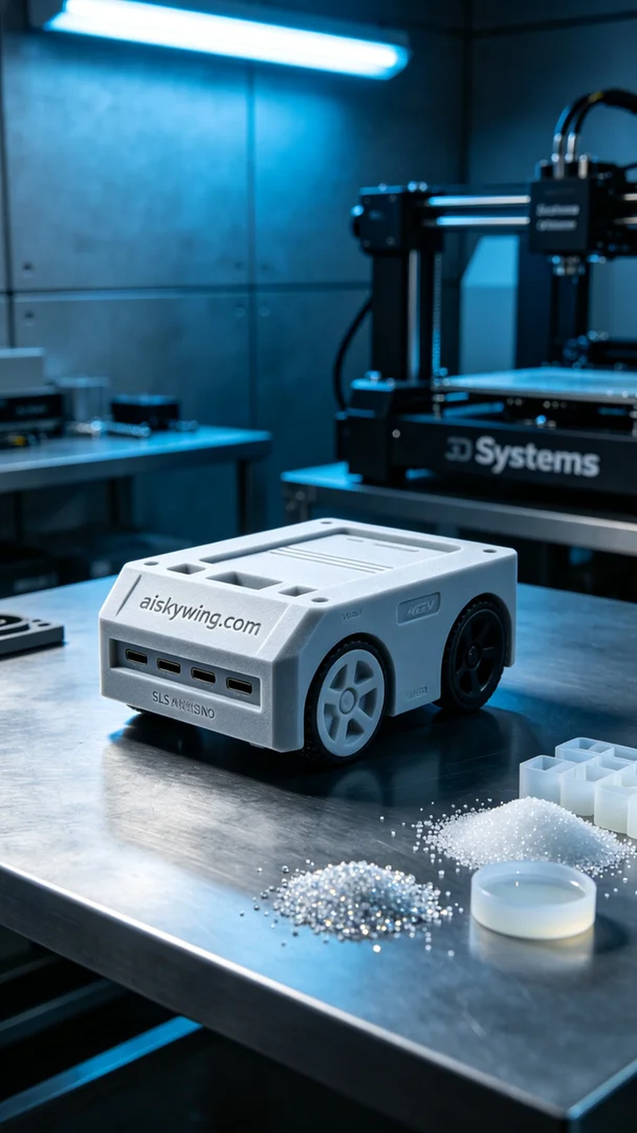
Recently, someone reached out on Twitter, looking for assistance with their AGV cart controller shell. Upon hearing this, I thought of our 3D printing capabilities and potential solutions.
For this project, we opted for SLS flame-retardant nylon. This material is not only lightweight but also provides excellent flame resistance, making it ideal for industrial applications.
We prepared the Systems 3D printer, setting the layer thickness to 0.1mm, maintaining a printing temperature of 190 degrees Celsius, with a power setting of 80% and a print speed of 15mm per second. This combination ensures that the printed part has both strength and a smooth surface finish.
As the printing progressed, the Systems printer operated smoothly, melting the powder layer by layer until the AGV cart controller shell was formed. We monitored the device's performance closely to ensure every layer was placed accurately. After several hours, the shell was complete, and the overall quality was impressive, with the frosted surface and the engraved "aiskywing.com" text clearly visible.
In the post-processing stage, I began by cleaning the printed part to remove excess powder, followed by sanding the edges with fine sandpaper to achieve a smooth finish. Then, the shell was placed in a curing chamber to ensure it met the V0 flame-retardant standard. After thorough inspection, the final product was packaged and ready for delivery.
After meticulous production and finishing, the AGV cart controller shell was ready, perfectly matching the requirements and combining aesthetics with functionality.
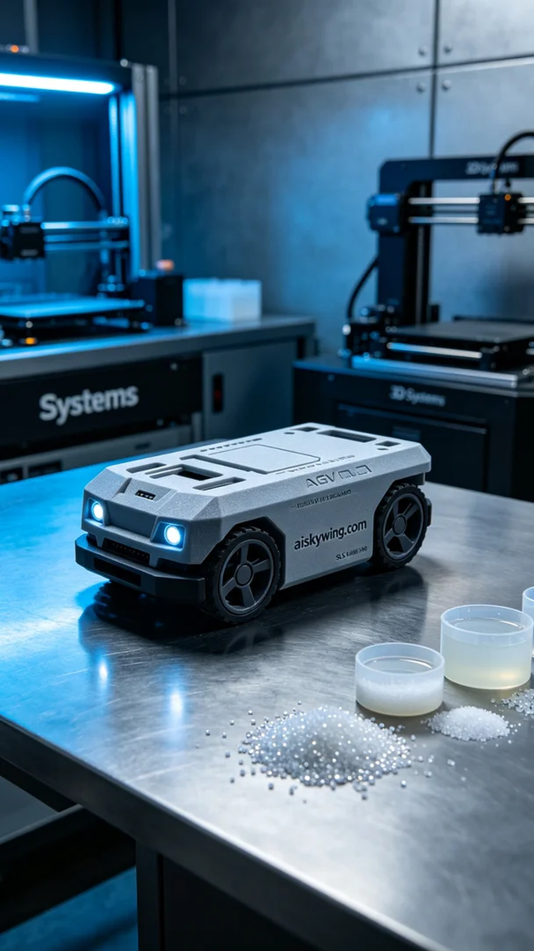
这次的任务是为一个朋友打印AGV小车控制器外壳。他们遇到的问题是需要一款既耐用又阻燃的外壳，以适应工业环境。经过沟通，我们决定采用SLS阻燃尼龙，这材料不仅轻便，还具备优秀的阻燃性能，非常适合这个项目。
在准备工作时，我们选择了Systems品牌的3D打印机。为了确保打印质量，我设定了层厚为0.1毫米，打印温度控制在190摄氏度，功率设置为80%，打印速度保持在15毫米每秒。这样的参数组合可以有效提升打印件的强度和表面光滑度。
打印过程中，Systems打印机平稳运转，粉末逐层熔化，逐渐成型。我们时刻监控设备运行状态，确保每一层都能精准到位。经过几个小时的打印，AGV小车控制器外壳终于完成，整体质量令人满意，表面磨砂质感清晰可见，雕刻的“aiskywing.com”字样也显得尤为突出。
后处理工序上，我首先对打印件进行清洗，去除表面多余的粉末，然后使用细砂纸进行打磨，确保每个边角都光滑无瑕。接着，将外壳放入固化设备中，确保其强度达到V0级阻燃标准。最后，经过仔细检验，确认无误后，我将其打包，准备交付。
经过细致的制作和打磨，这款AGV小车控制器外壳终于呈现在我们眼前，完美契合了需求，既美观又实用。
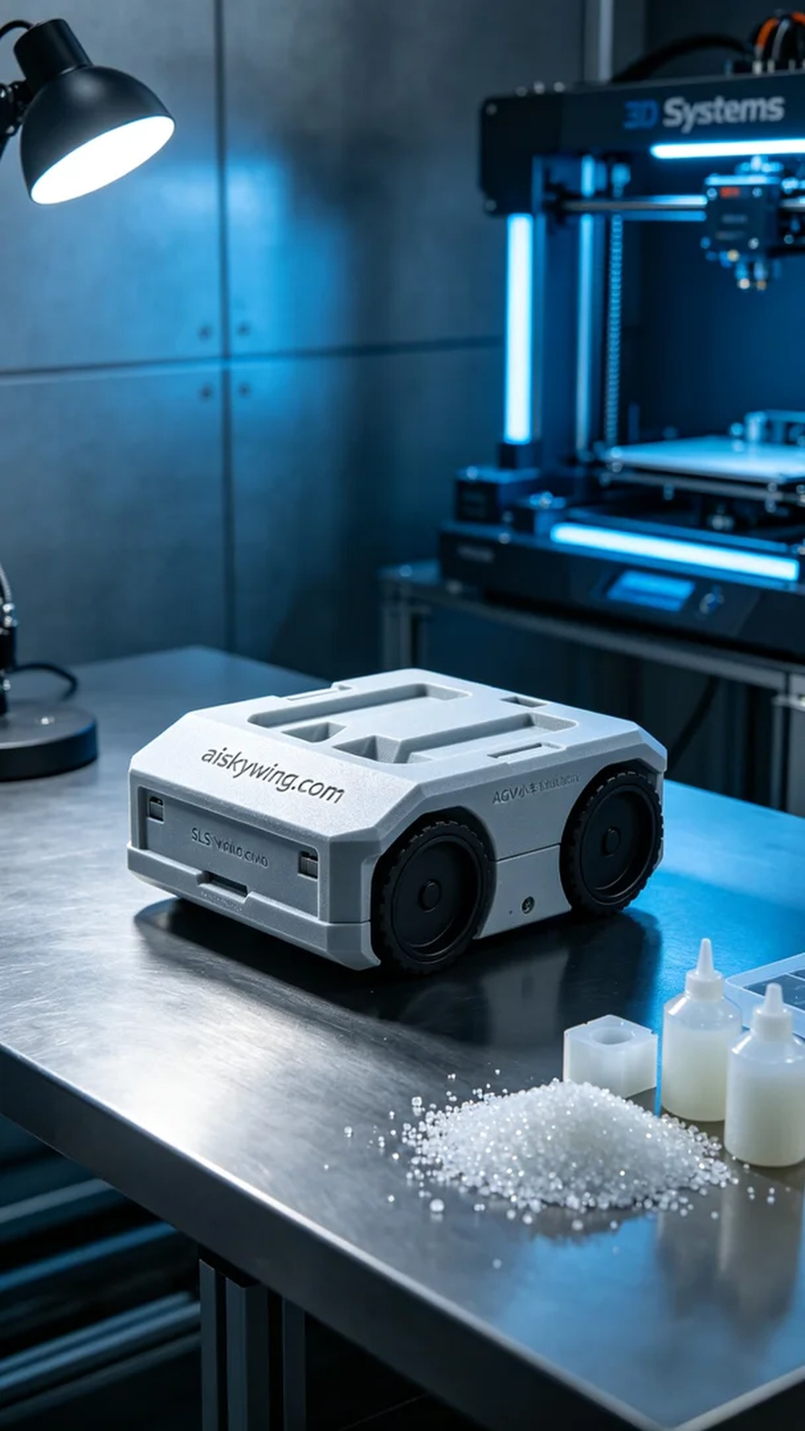
Aiskywing Industrial 3D Printing
AGV cart controller casing


