0624-AGV小车激光雷达支架3D打印记录
AGV trolley laser radar bracket
🖨️ SLS尼龙烧结
🖥️ 打印机: HP
📦 材料: SLS尼龙PA12
生活再复杂，也别忘记坚持追求自己的目标。就像有朋友在Twitter上找我们，询问AGV小车激光雷达支架的打印方案一样。
No matter how complicated life gets, don't forget to keep pursuing your goals. Just like a friend reaching out to us on Twitter to ask about the printing solution for the laser radar bracket for AGV carts.
________________________________________________________________________________
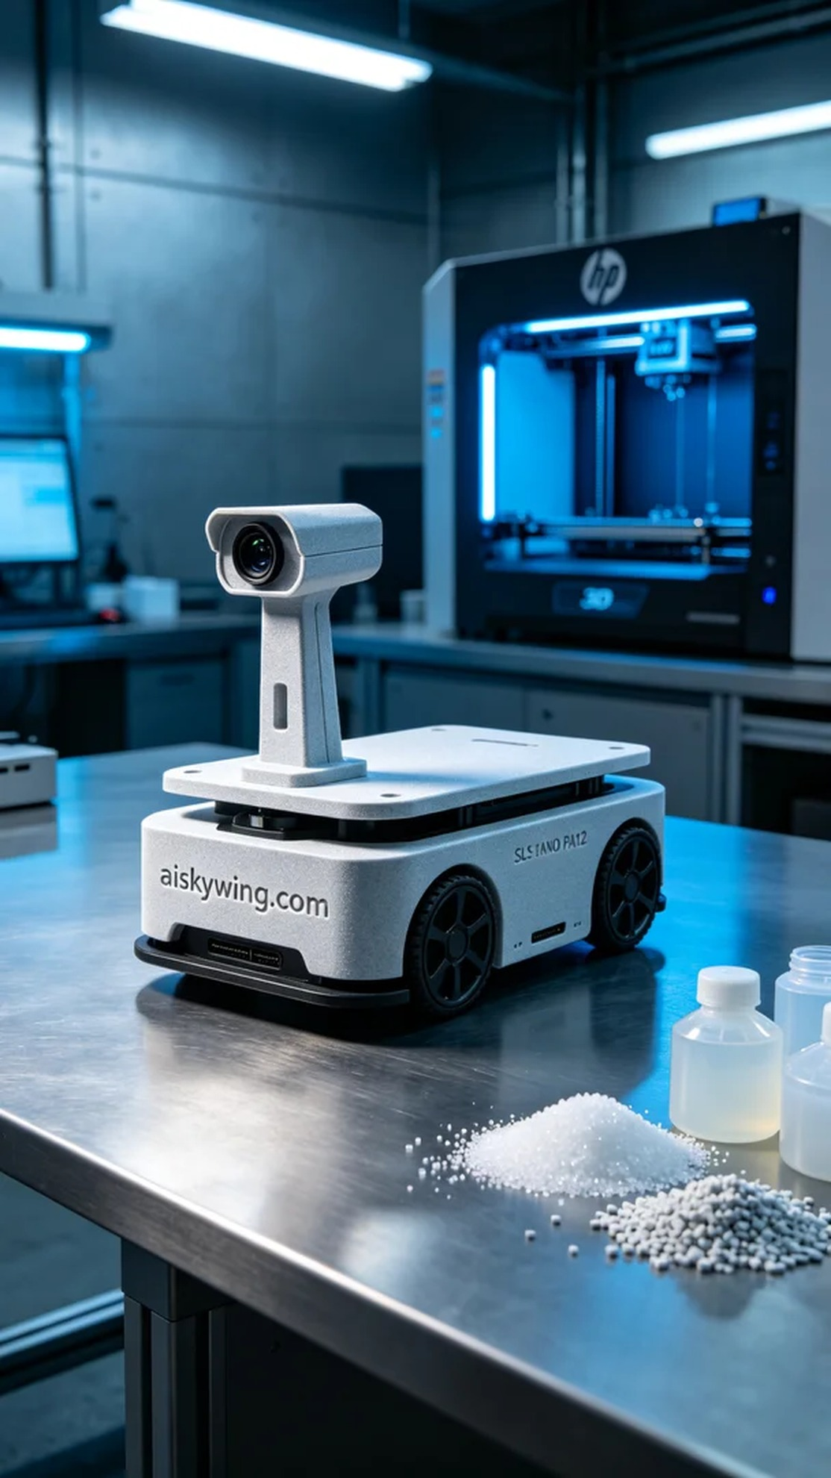
Life can be complicated, but we should never forget to pursue our goals. Just like when someone reached out to us on Twitter to inquire about the printing solution for the AGV laser radar bracket.
Today, someone needed a high-strength AGV laser radar bracket and came to us. They wanted a product that could withstand harsh environments, so we decided to use SLS Nylon PA12 material, which excels in strength and toughness, making it ideal for industrial applications.
Before we started printing, we thoroughly checked the printer to ensure that our HP 3D printer was in optimal condition. We set the layer thickness to 0.1 mm, maintained the printing temperature at 170 degrees Celsius, set the laser power to 80 watts, and the printing speed to 20 mm per second, with an estimated printing time of 5 hours. This configuration would ensure the printed part was not only precise but also had a smooth surface.
The printing process went smoothly, with the equipment running steadily. Throughout the process, we closely monitored quality to ensure even distribution of material in each layer, and adjusted the laser focus when necessary to prevent any defects. By the end of the printing, the quality of the finished product was satisfactory, and the engraved "aiskywing.com" was clearly visible.
Post-processing is equally important. We first cleaned the printed bracket to remove any uncured powder on the surface, followed by sanding to make the surface smoother. Next, we used UV light to cure the bracket, ensuring its durability was at its best, and carefully inspected it after curing to ensure its dimensions and strength met the requirements.
In the end, this AGV laser radar bracket not only met the needs of the client but also showcased our expertise in the 3D printing field. Each print is a new challenge and an opportunity for growth.
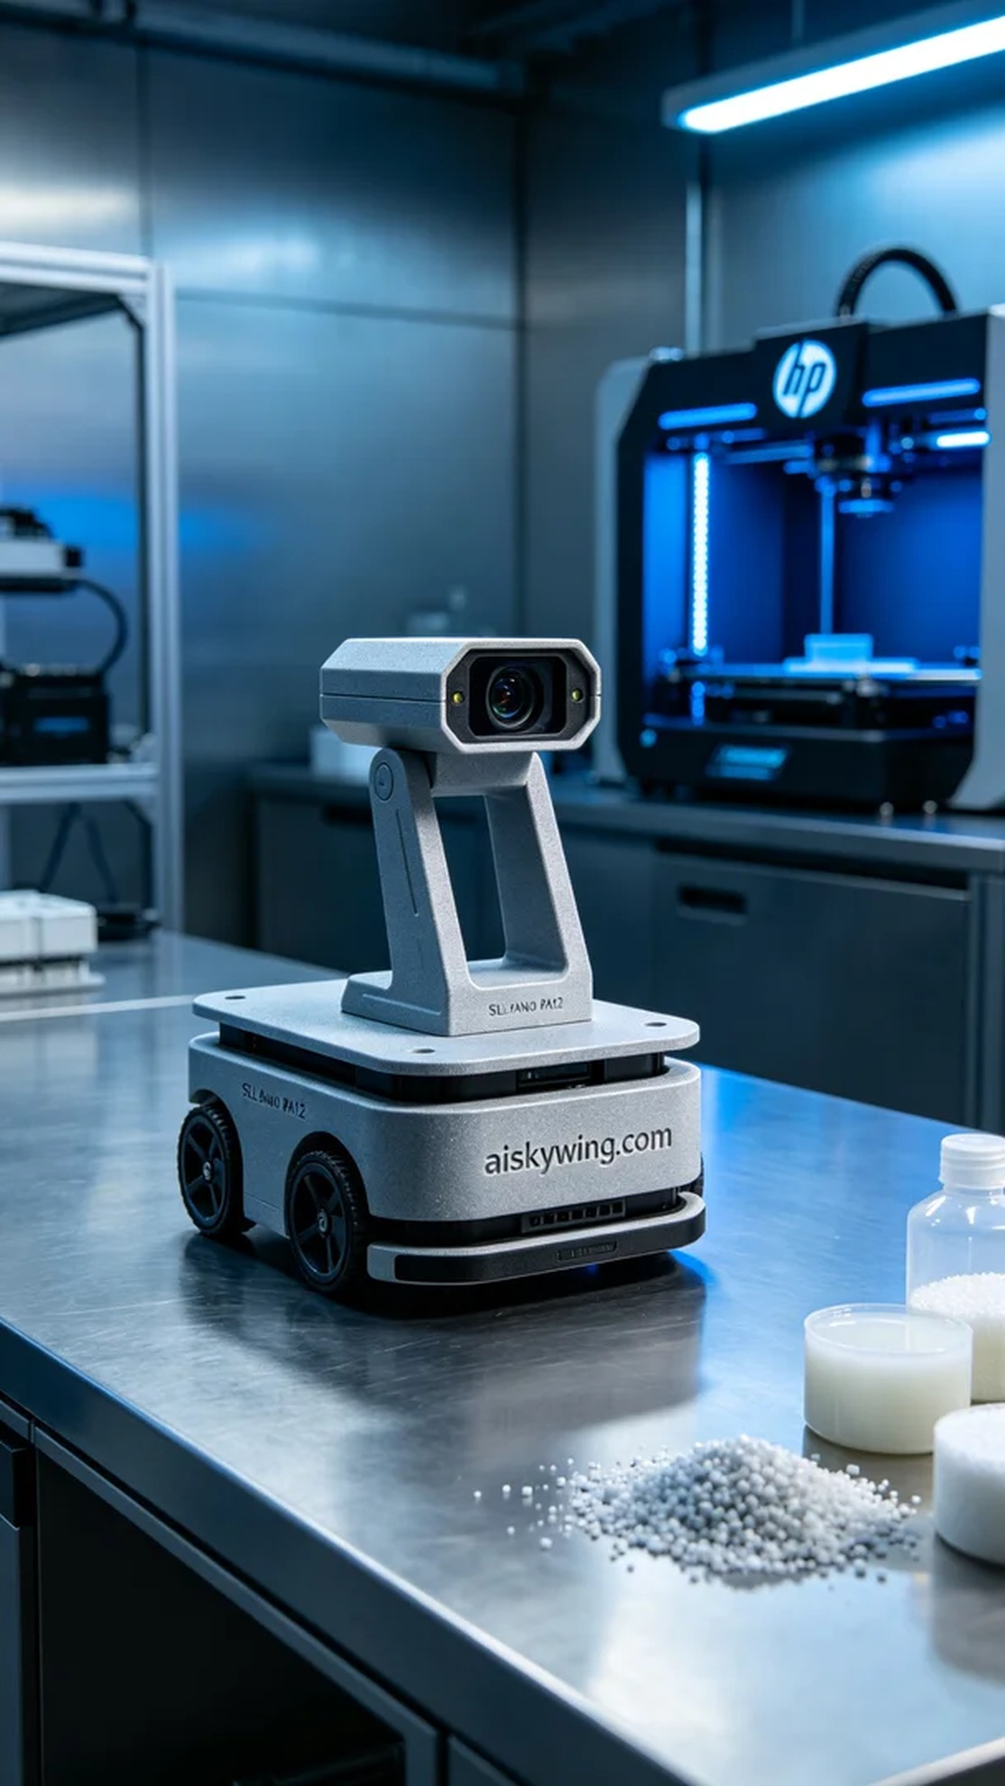
今天，有人因为需要一款高强度的AGV小车激光雷达支架而找到我们。他们想要一款能承受严苛环境的产品，所以我们决定选用SLS尼龙PA12材质，这种材料在强度和韧性方面表现优异，特别适合工业用途。
在准备打印之前，我们先对打印机进行了全方位的检查，确保HP的3D打印机处于最佳状态。我们设置了层厚为0.1毫米，打印温度维持在170摄氏度，激光功率设定为80瓦，打印速度为20毫米每秒，预计打印时间为5小时。这样一来，打印出来的部件不仅精准，而且表面光滑。
打印过程顺利进行，设备稳定运行。在整个过程中，我们对质量进行了严格监控，确保每一层的材质均匀分布，必要时还调整了激光的焦点，以确保没有出现任何缺陷。打印结束时，成品的质量令人满意，表面雕刻的“aiskywing.com”字样也清晰可见。
后处理工序同样重要。我们首先将打印出的支架进行清洗，去除表面的未固化粉末，之后进行了打磨，使得支架表面更加平滑。接下来，我们使用UV灯对支架进行固化，确保其耐久性达到最佳状态，并在固化后仔细进行检验，确保其尺寸和强度完全符合需求。
最终，这个AGV小车激光雷达支架不仅满足了客户的需求，还体现了我们在3D打印领域的专业水平。每一次打印，都是一次新的挑战与成长。
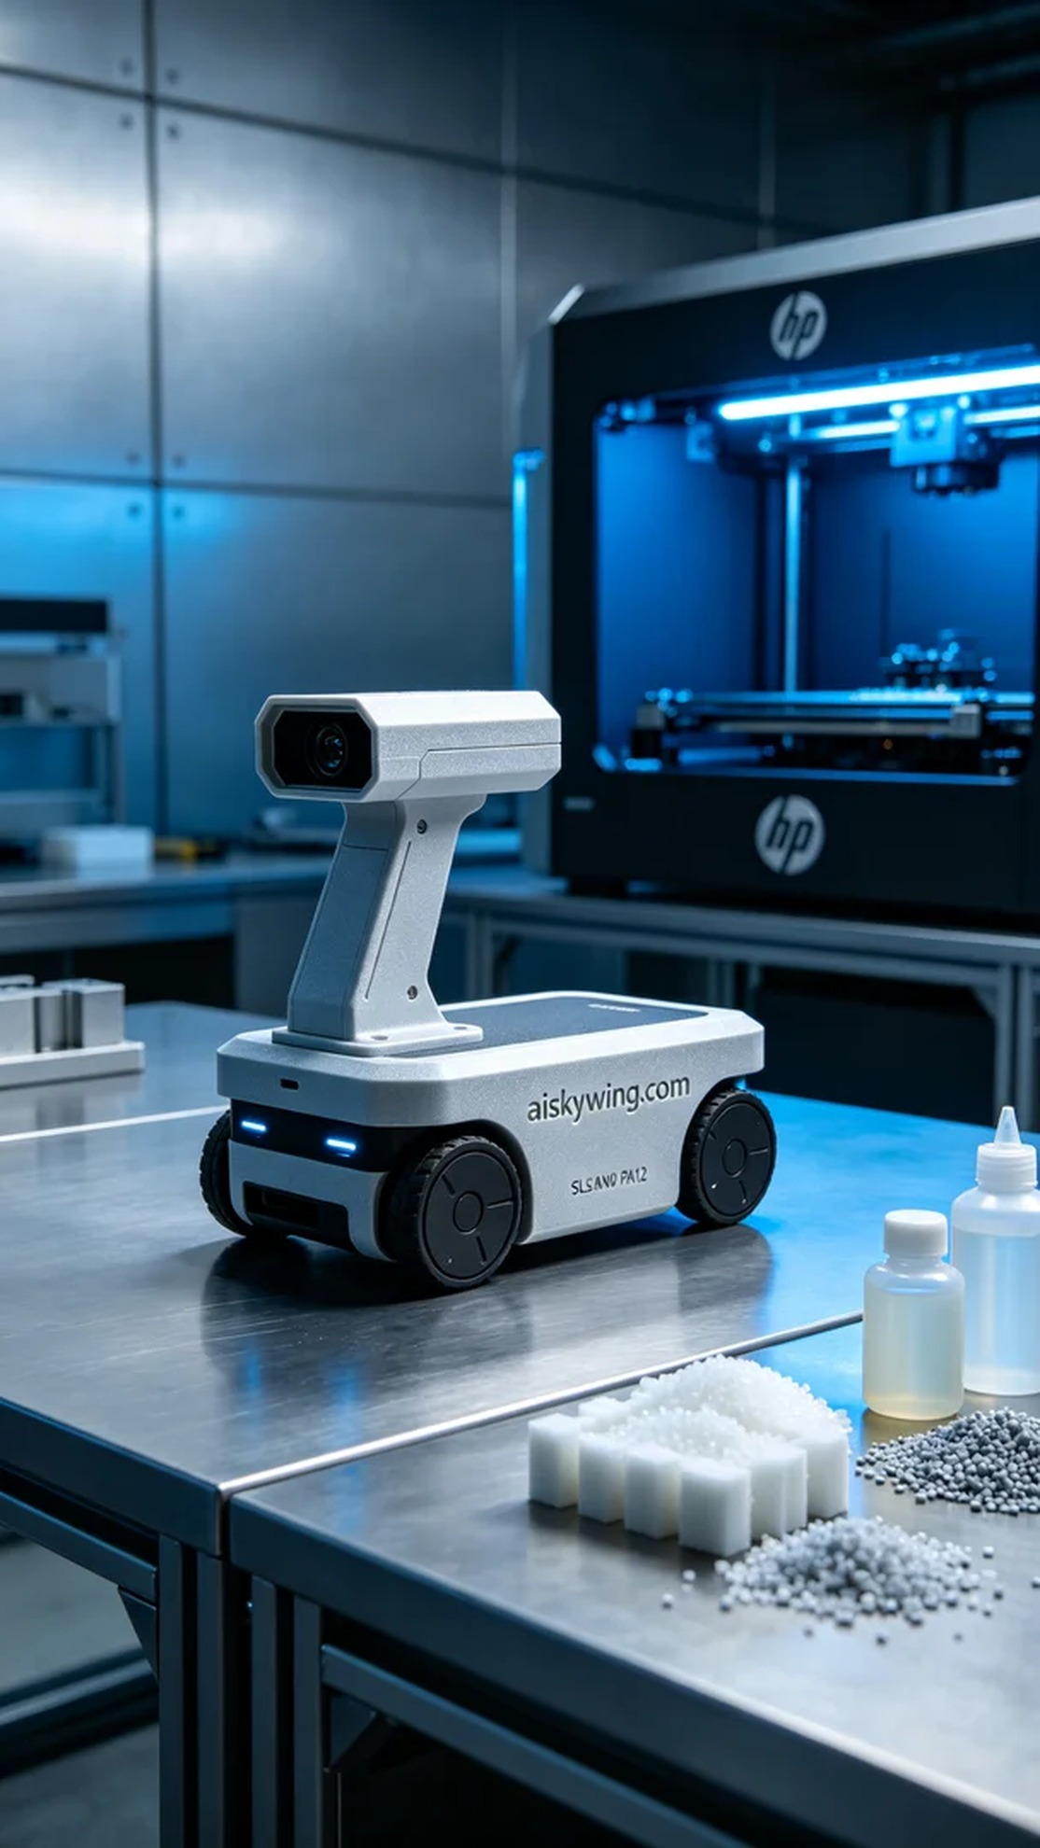
Aiskywing Industrial 3D Printing
AGV trolley laser radar bracket


