0625-AGV小车电池仓盖生产记录
AGV cart battery compartment cover
🖨️ SLS尼龙烧结
🖥️ 打印机: HP
📦 材料: SLS耐高温尼龙
生活就像3D打印，充满了无限可能。就像最近做的这个AGV小车电池仓盖，有人因为需求找到了我们，希望能解决他们的问题。
Life is like 3D printing, full of infinite possibilities. Just like the AGV battery compartment cover we recently made, someone reached out to us because of their needs, hoping we could solve their problem.
________________________________________________________________________________
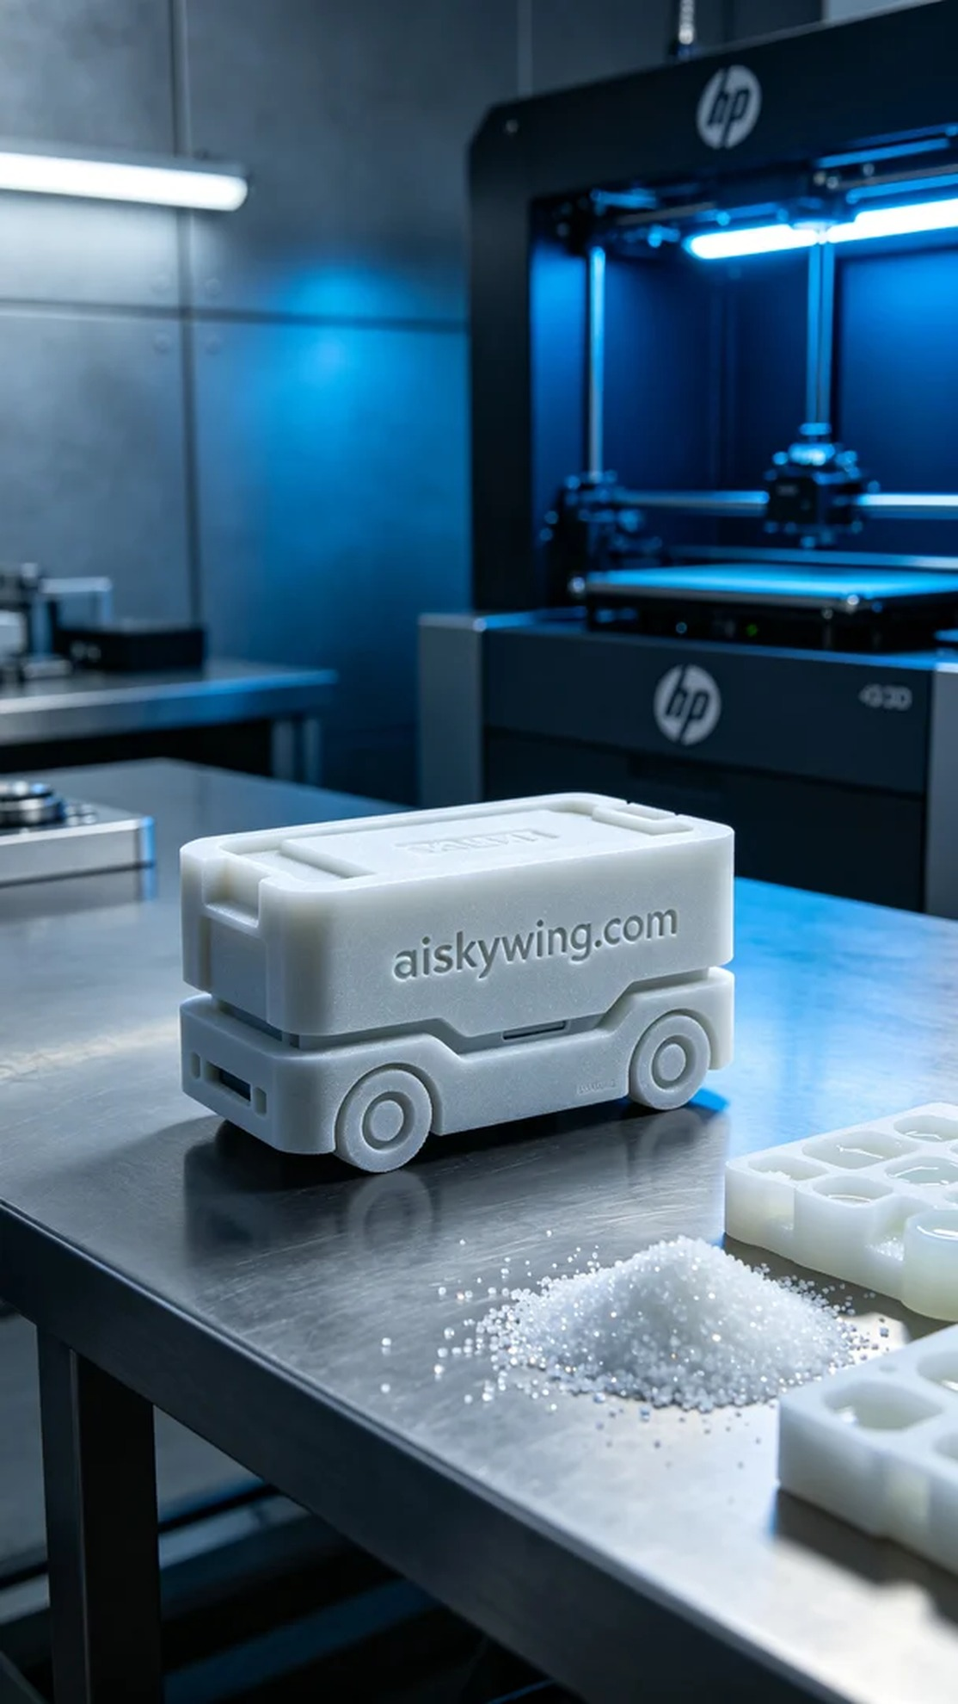
Recently, someone found us through TikTok, asking if we could print an AGV trolley battery cover. They were facing issues with production efficiency and insufficient material temperature resistance, so they hoped we could help solve these challenges.
Upon receiving the task, we chose SLS high-temperature nylon as the raw material. This material not only withstands temperatures above 150℃ but also has a matte surface suitable for industrial environments. To ensure the printing effect, we configured an HP 3D printer, setting the layer thickness to 0.1mm, printing temperature at 180℃, power at 50W, and printing speed at 15mm/s to guarantee the accuracy and quality of the final product.
The printing process went smoothly, with the HP printer performing stably. Each layer's formation was closely monitored to ensure there were no air bubbles or defects. We observed the printing progress in real-time, and as the machine quietly operated, the complete AGV trolley battery cover took shape. Every step needed careful attention, as it directly impacted the product's performance.
Once printing was completed, we moved into the post-processing phase. First, we cleaned the formed part with a cleaning agent to remove excess powder. Then, we proceeded with sanding to smoothen the surface. Next, we conducted a curing treatment to ensure the material's strength and stability. Finally, a thorough inspection was carried out to ensure every detail met the standards.
After a rigorous production process, the AGV trolley battery cover was successfully completed. The final product not only looks exquisite but also possesses superior performance, meeting the required demands. Every detail was achieved through our dedication.
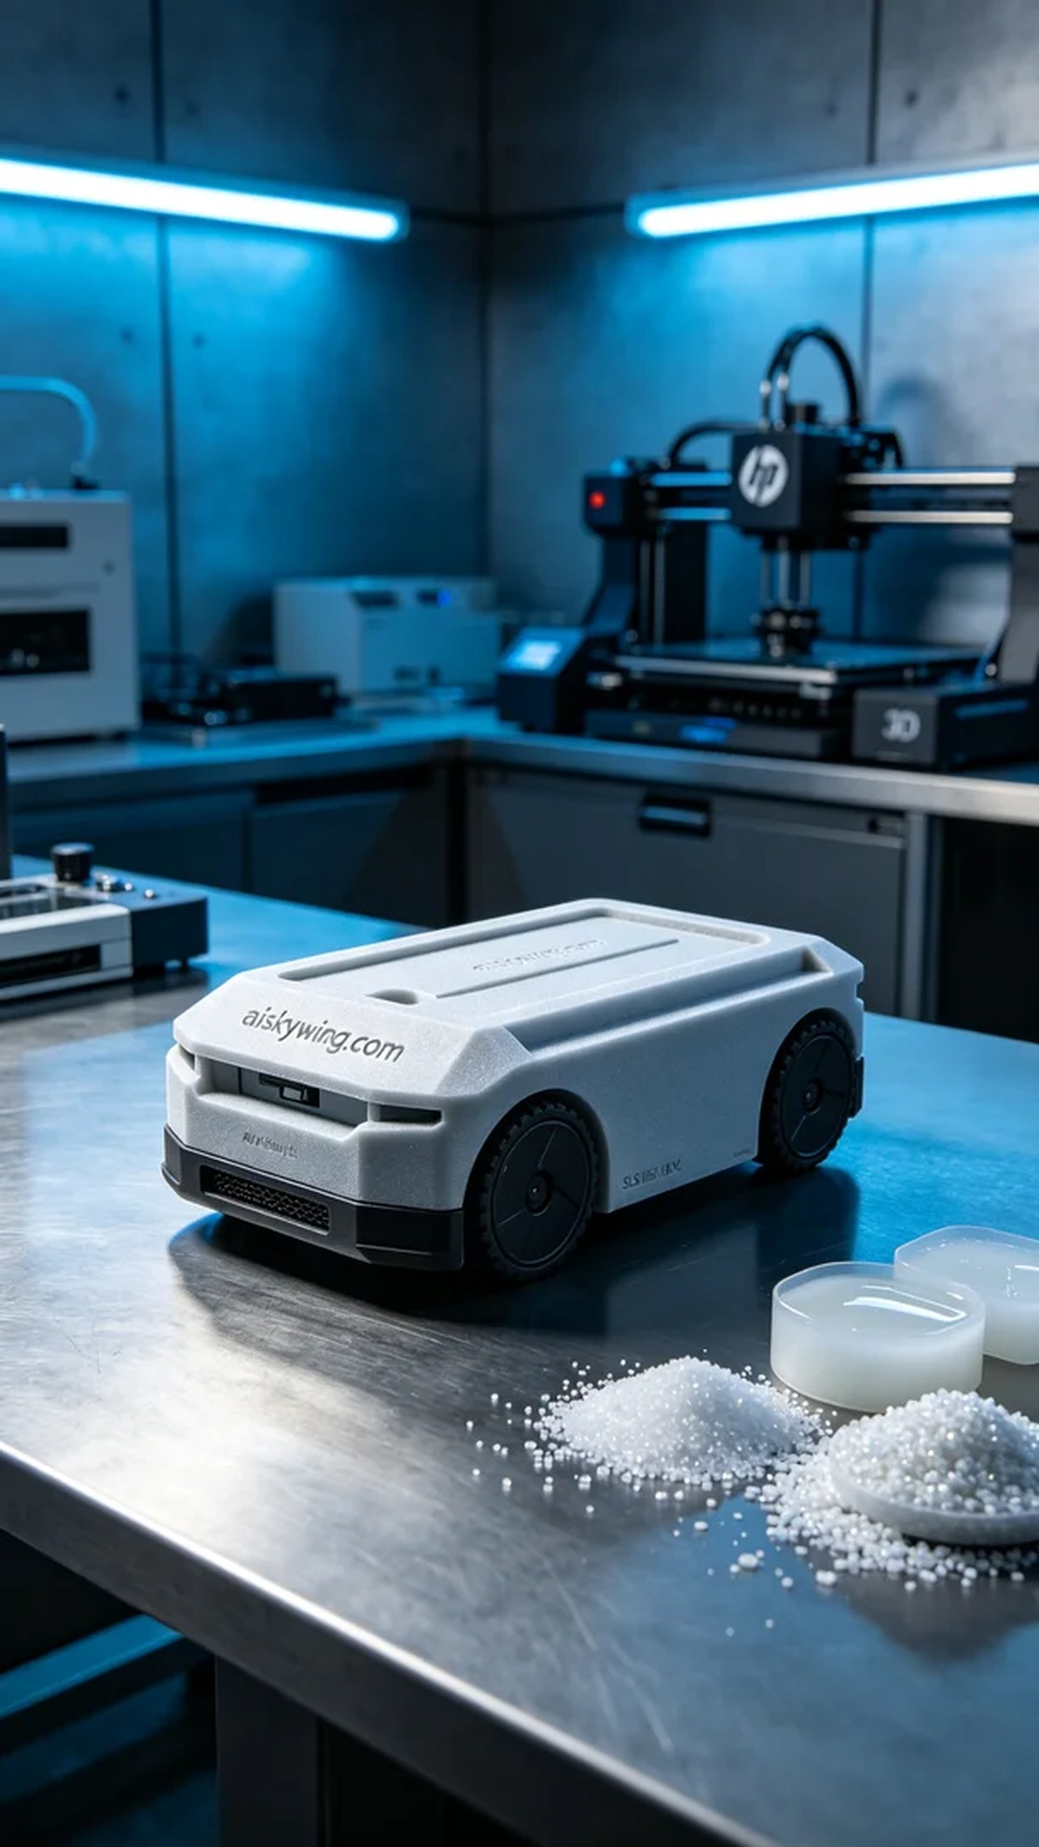
最近，有人通过TikTok找到了我们，询问能否打印一款AGV小车电池仓盖。他们遇到了生产效率不足、材料耐温不够的问题，因此希望我们能帮助他们解决这些挑战。
在接到任务后，我们选用了SLS耐高温尼龙作为原材料。这种材料不仅能够承受150℃以上的高温，而且表面磨砂质感，能够适应工业环境。为了确保打印效果，我们配置了HP品牌的3D打印机，设置层厚0.1mm，打印温度控制在180℃，功率为50W，打印速度定在15mm/s，这样能保证成品的精度和质量。
打印过程进行得相当顺利，HP打印机在运行中表现稳定。每一层的成型都得到严密监控，确保无气泡、无缺陷。我们实时观察着打印进度，随着机器的低声音，逐渐形成了完整的AGV小车电池仓盖。每一步都不能马虎，毕竟这关乎到产品的使用性能。
打印完成后，我们进入后处理环节。首先是用清洗剂对成型件进行清洗，去除多余的粉末。接着，进行打磨，使表面更加光滑。然后进行固化处理，确保材料的强度和稳定性。最后，进行全面检验，确保每一个细节都符合标准。
经过严谨的制作流程，AGV小车电池仓盖顺利完成，最终成品不仅外观精致，而且性能优越，满足了需求。每一个细节都在我们的用心下得以实现。
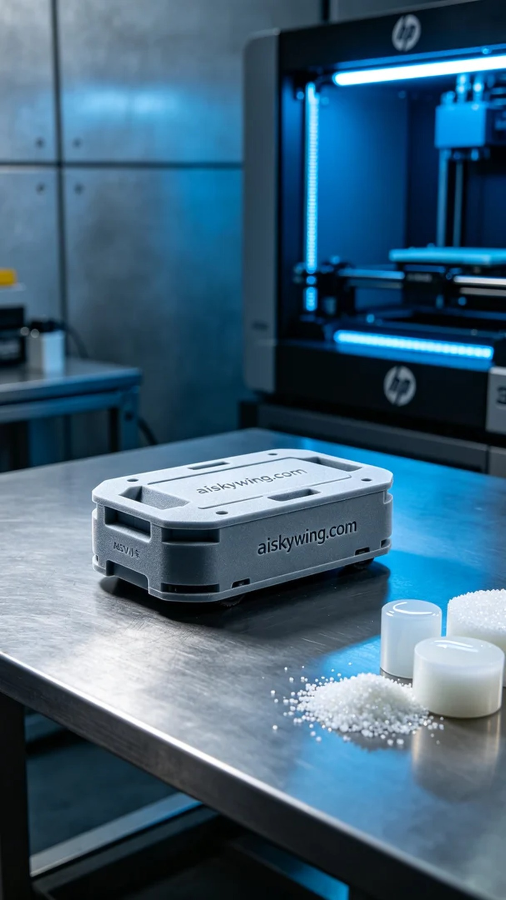
Aiskywing Industrial 3D Printing
AGV cart battery compartment cover


