0626-AGV小车电源模块外壳的3D打印记录
AGV cart power module shell
🖨️ SLS尼龙烧结
🖥️ 打印机: Xjet
📦 材料: SLS尼龙
生活再难，也别停下脚步。就像接下这个AGV小车电源模块外壳的单子，有人因为急需一款轻量化且精准的外壳找到我们。
No matter how difficult life gets, don't stop moving forward. Just like when we took on the order for the AGV cart power module casing, someone found us because they urgently needed a lightweight and precise casing.
________________________________________________________________________________
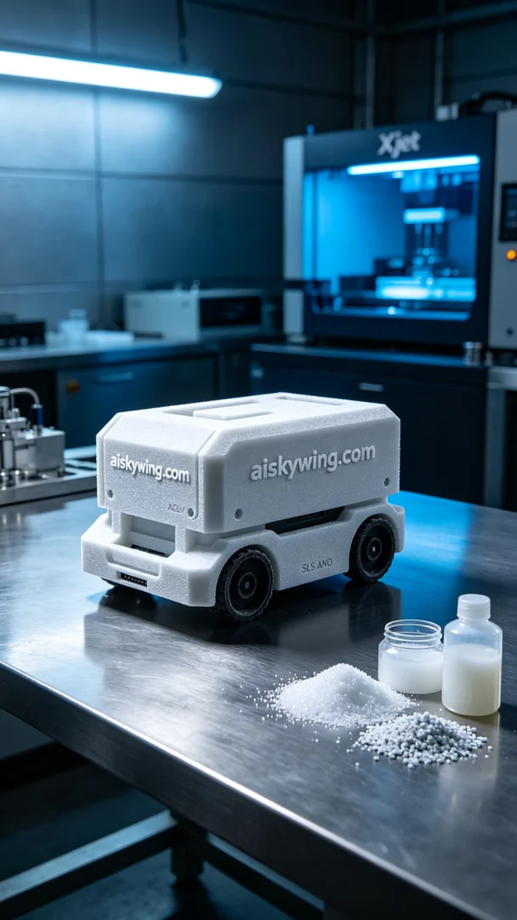
Life can be tough, but we shouldn't lose our pace. Just like receiving this order for the AGV cart power module housing, someone reached out to us for a lightweight and precise shell.
We opted for SLS nylon as the raw material due to its strength and durability, ideal for the AGV cart's operational demands. Before starting, we prepared an Xjet 3D printer and set the parameters: layer thickness of 0.1mm, printing temperature of 190℃, laser power of 50W, and a speed of 5mm/s. The entire printing process was expected to take around 8 hours.
During printing, the Xjet printer operated smoothly, revealing the fine details layer by layer. We periodically monitored the quality to ensure that every aspect met the design specifications. As the print progressed, the housing started to take shape, showcasing the fine sintered texture of the SLS nylon material—everything went smoothly and efficiently.
Once printing was complete, we carried out a series of post-processing steps. First, we removed the part and cleaned it to eliminate excess powder. Next, we sanded it down for a smoother surface finish. Finally, we cured the housing to enhance its strength and durability, ensuring it met the required standards for future use.
After a meticulous process, the AGV cart power module housing was finally completed. Its appearance and quality matched our expectations, leaving us with a sense of satisfaction. This printing experience not only advanced our technical skills but also deepened our understanding of the potential of 3D printing.
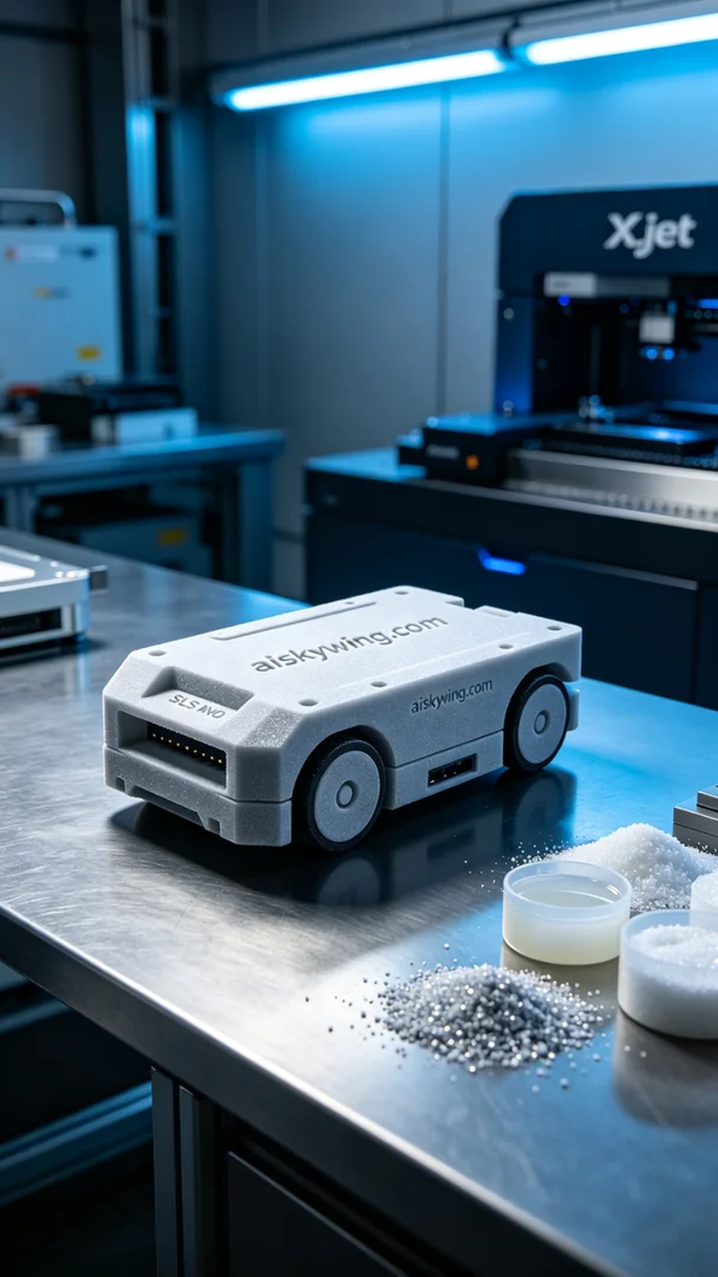
在LinkedIn上，有人因需要一款耐用且轻量的AGV小车电源模块外壳而联系到我们。他们希望能用SLS尼龙材料制造出一款高质量的外壳，以满足即将到来的项目需求。
我们选择了SLS尼龙作为原材料，因其强度和耐用性都能满足AGV小车的使用环境。开始之前，我们准备了一台Xjet 3D打印机，设置了各项参数：层厚0.1毫米，打印温度190℃，激光功率为50W，打印速度为5mm/s。整个打印过程预计需要8小时。
打印过程中，Xjet打印机稳定运行，每一层的细节都清晰可见。我们定期检查质量，确保每个细节符合设计要求。随着打印的推进，外壳逐渐成型，SLS尼龙材质的粉末烧结纹理也愈加明显，整个过程顺利而高效。
打印完成后，我们进行了一系列后处理工序。首先，我们将成品取出并进行清洗，以去除多余的粉末。接着进行打磨，使表面更加光滑。最后，我们对外壳进行了固化处理，以增强其强度和耐用性，确保满足后续的使用标准。
经过一系列精细工序，AGV小车电源模块外壳终于完工，外观和质量都达到了预期效果，让我们心里倍感欣慰。这次的打印经历不仅提升了我们的技术能力，也让我们对3D打印的潜力有了更深刻的认识。
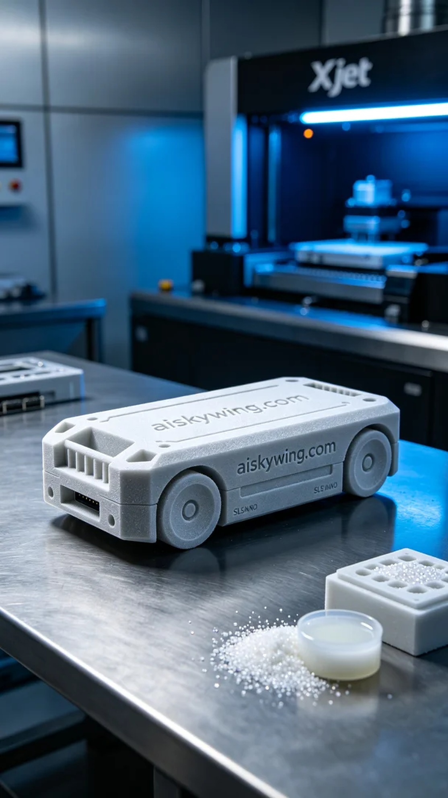
Aiskywing Industrial 3D Printing
AGV cart power module shell


