0628-AGV小车红外传感器支架生产记录
AGV Cart Infrared Sensor Bracket
🖨️ SLS尼龙烧结
🖥️ 打印机: EOS
📦 材料: SLS耐高温尼龙
在LinkedIn上，有人因为AGV小车红外传感器支架的需求找上我们，想要解决产品高温环境下的使用难题。
On LinkedIn, someone approached us regarding the demand for an infrared sensor bracket for AGV trolleys, seeking to solve the issue of product use in high-temperature environments.
________________________________________________________________________________
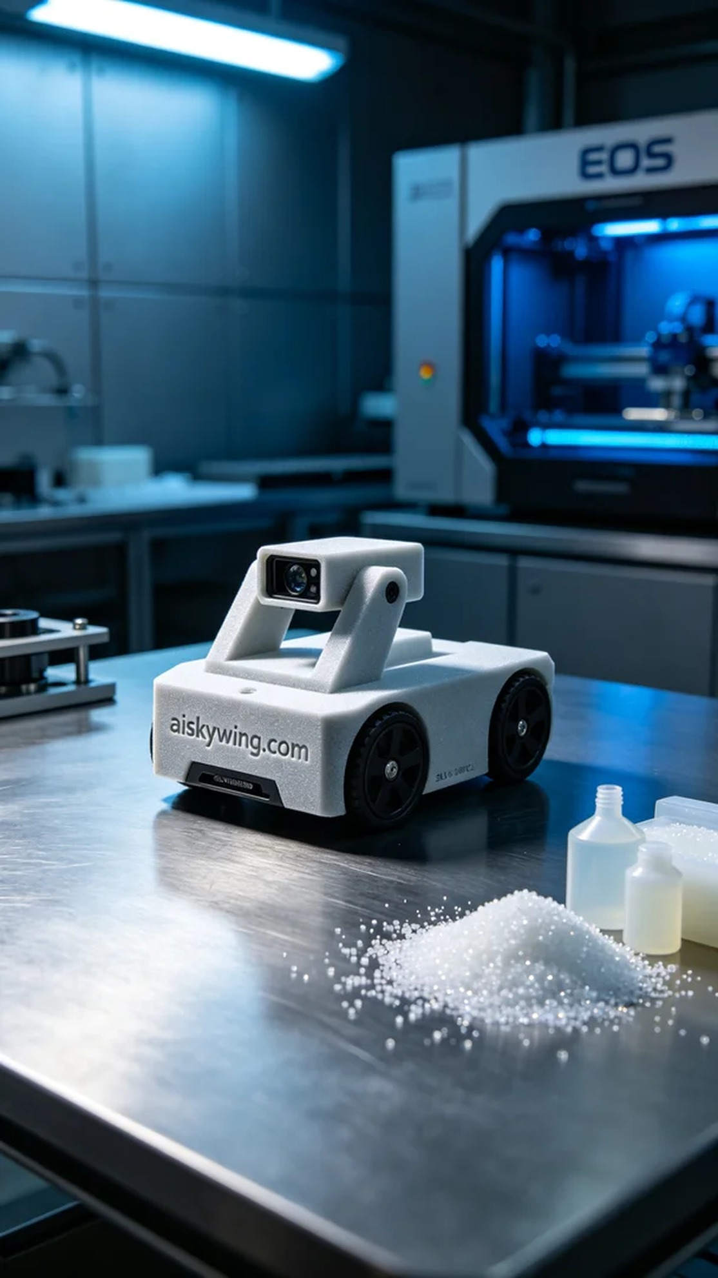
On LinkedIn, someone approached us with a need for an AGV trolley infrared sensor bracket, seeking a solution for the challenges faced in high-temperature environments.
To meet this demand, we utilized SLS high-temperature nylon material. This material has a temperature resistance exceeding 150℃, making it suitable for prolonged use in industrial settings. We meticulously prepared our EOS printer and set the printing parameters: a layer thickness of 0.1mm, a temperature of 190℃, a power of 50%, and a print speed of 30mm/s. These settings ensured that the printed components were both robust and precise.
During the printing process, the EOS printer operated very smoothly. We continuously monitored the print quality, checking the material flow and forming effects. After two hours of printing, we successfully completed the AGV trolley infrared sensor bracket, and the overall result met our expectations.
After printing, we entered the post-processing phase. The first step was to place the finished product in a cleaning tank, using a cleaning solution to remove any unmelted powder from the surface. Next, we performed sanding to enhance the smoothness and feel of the surface. Finally, we placed the bracket in a curing chamber to ensure its strength and temperature resistance met the requirements. After inspection, all parameters were within acceptable ranges.
Through this production run, we successfully addressed the need for the AGV trolley infrared sensor bracket, ensuring the quality and performance of the product, which instilled confidence for future usage.
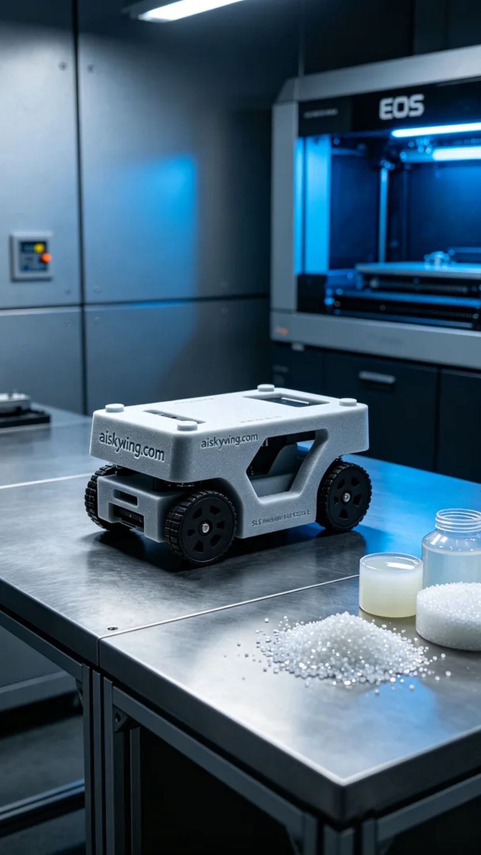
为了满足这项需求，我们使用了SLS耐高温尼龙材料。该材料的耐温性能超过150℃，适合在工业环境中长时间使用。我们对EOS打印机进行了周密准备，设置了打印参数：层厚0.1mm，温度190℃，功率为50%，打印速度为30mm/s。这些设置确保了打印出的部件既坚固又精确。
打印过程中，EOS打印机的运行状态非常稳定。我们随时监控打印质量，检查材料的流动性以及成型效果。经过两个小时的打印，我们成功完成了AGV小车红外传感器支架的制作，整体效果符合预期。
打印完成后，我们进入了后处理环节。首先将成品放入清洗槽，使用清洗液去除表面未融化的粉末。接着，我们进行了打磨，以提升表面的光滑度和手感。最后，将支架放入固化箱中固化，确保其强度和耐温性能达到要求。经过检验，所有参数均在合格范围内。
经过这次的生产，我们成功地解决了对AGV小车红外传感器支架的需求，产品的质量和性能都得到了保证，给后续的使用带来了信心。
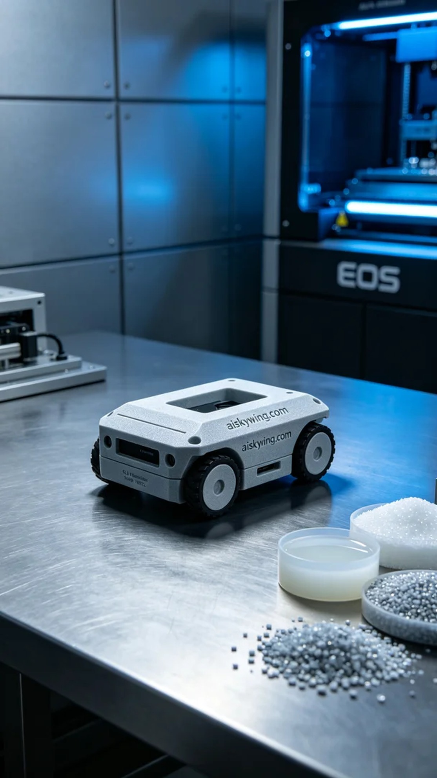
Aiskywing Industrial 3D Printing
AGV Cart Infrared Sensor Bracket


