0629-CT扫描仪外壳3D打印生产记录
CT scanner casing
🖨️ SLA光固化
🖥️ 打印机: Stratasys
📦 材料: SLA光固化树脂
生活再难，也别停下脚步。就像接下这个CT扫描仪外壳的单子，有人因为需要精密的产品而找到了我们。
No matter how difficult life gets, don’t stop moving forward. Just like when we took on the order for this CT scanner casing, some people found us because they needed precision products.
________________________________________________________________________________
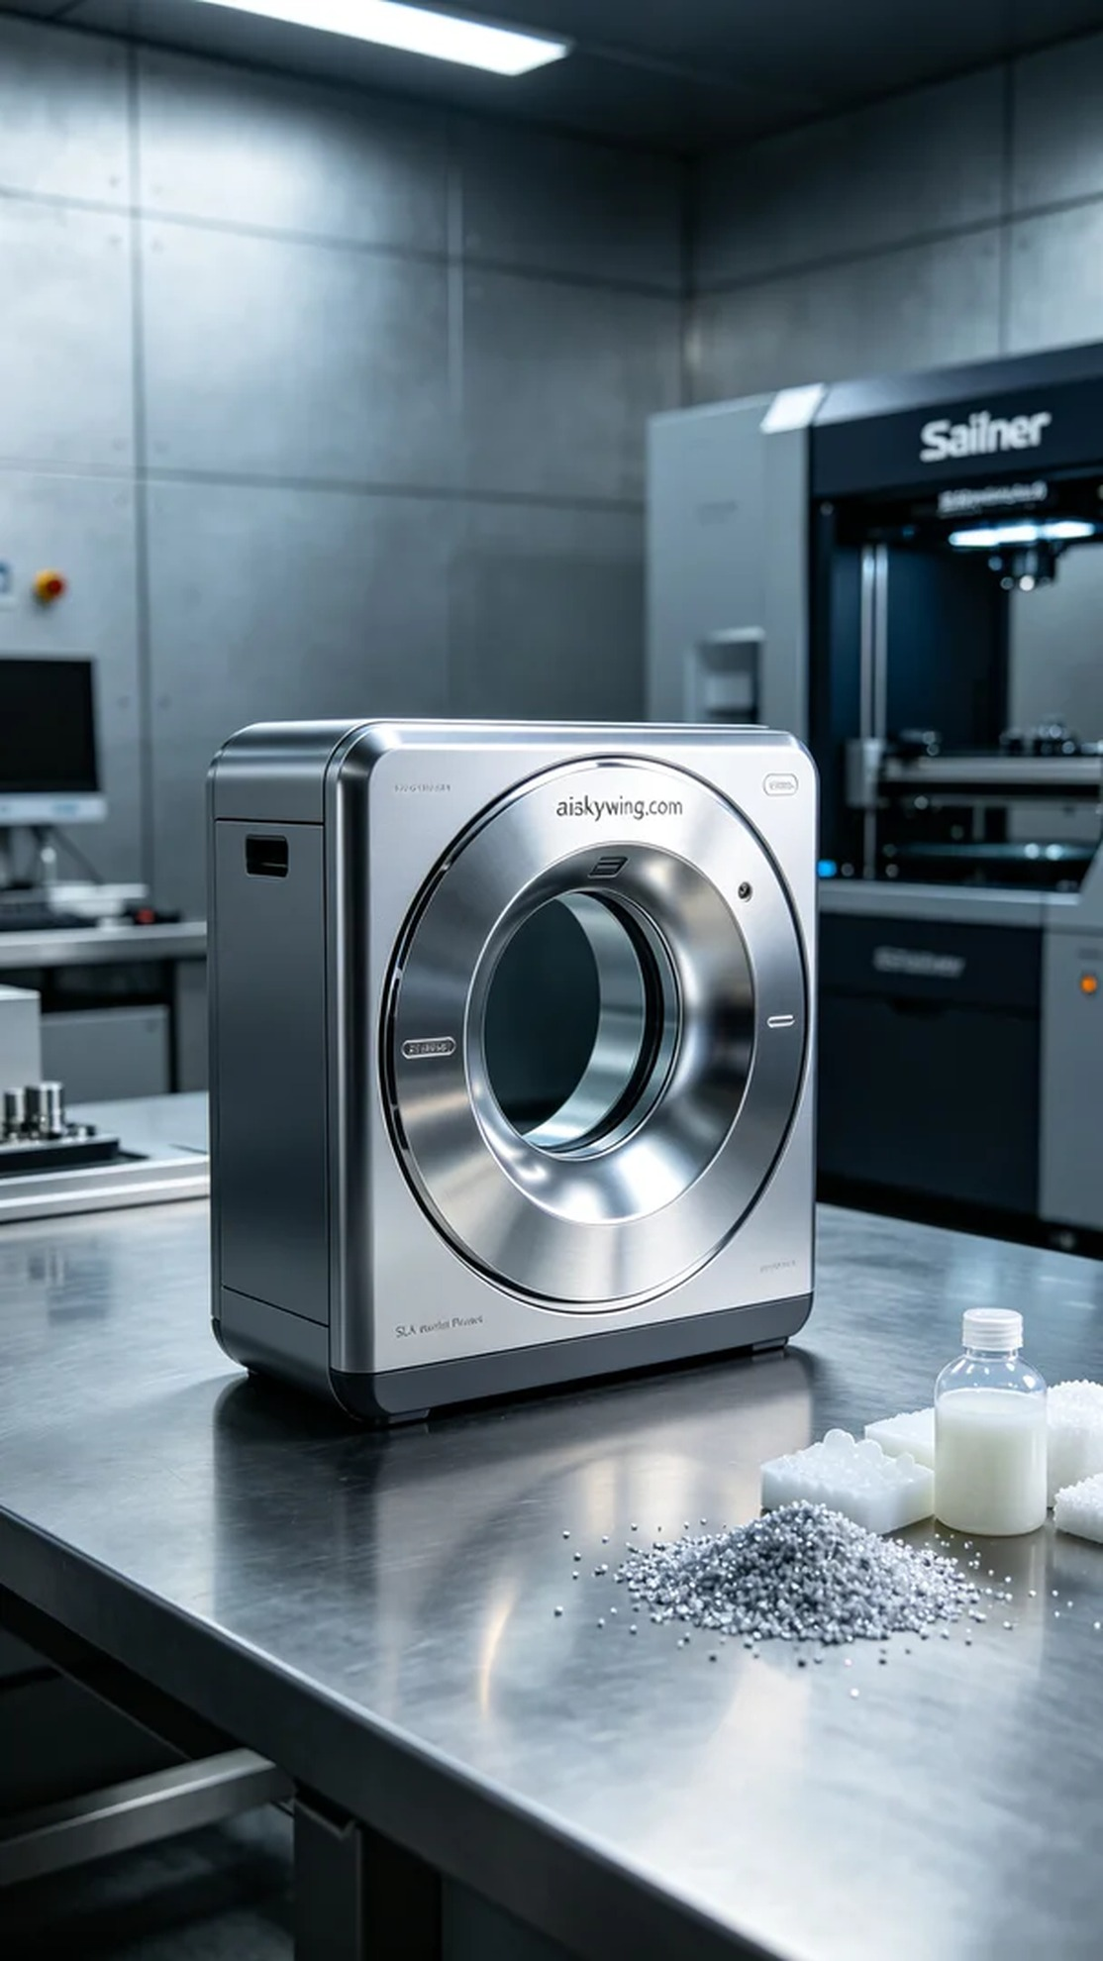
In today’s fast-paced world, someone approached us looking to enhance the quality of their medical equipment with a precise and durable CT scanner outer shell. This project not only challenged our technical skills but also showcased the immense potential of 3D printing in the medical field.
To produce the outer shell that met their requirements, we chose SLA photopolymer resin as the material. This resin is known for its excellent fluidity and curing strength, allowing for an extremely high level of detail. When configuring the Stratasys printer, we set the printing parameters to a layer thickness of 0.1 mm, maintained a temperature of 25°C, set the power to 1000mW, and a printing speed of 30mm/s. These parameters helped us achieve a good balance between detail and speed.
During the printing process, the Stratasys printer operated efficiently while we monitored the machine's status in real-time to ensure printing accuracy. As the machine hummed softly, we watched the resin solidify layer by layer, gradually forming the CT scanner outer shell. After each print, we meticulously inspected the surface and edges of the shell to ensure there were no defects.
Once printing was complete, we carried out a detailed post-processing procedure. First, the formed shell was placed into a cleaning tank, where we used isopropyl alcohol to wash away excess resin. Next, we sanded the surface to make it smoother, before curing it to enhance its strength and durability. In the inspection phase, we conducted strict quality checks on the shell to ensure it met the required standards.
This 3D printing project of the CT scanner outer shell was not only completed successfully but also enriched our experience. Looking at the exquisite outer shell, we truly know that this effort was worthwhile.
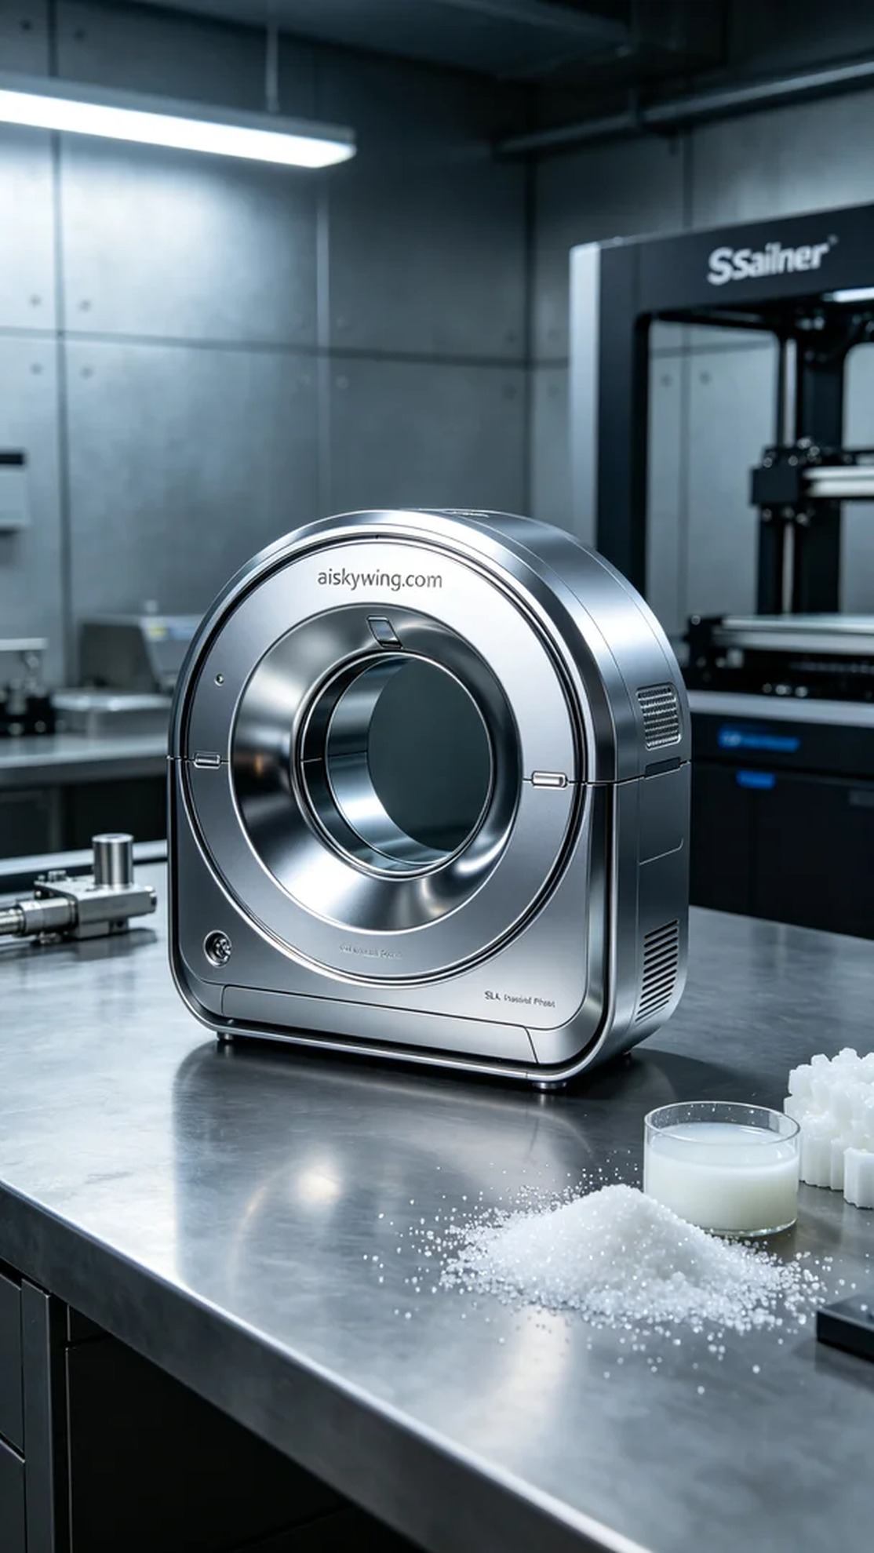
在如今这个快节奏的时代，有人因为想要提升医疗设备的外壳质量，找到我们，希望能制作出一个精密、耐用的CT扫描仪外壳。这个项目不仅挑战了我们的技术水平，也让我们看到了3D打印在医疗领域的巨大潜力。
为了确保生产出符合要求的外壳，我们选用了SLA光固化树脂作为材料。这种树脂具有良好的流动性和固化强度，能实现极高的细节表现。使用Stratasys打印机时，我们将打印参数设置为层厚0.1毫米，温度保持在25°C，功率设定为1000mW，打印速度为30mm/s。这些参数有助于我们在细节与速度之间取得良好的平衡。
在打印过程中，Stratasys打印机高效运转，我们实时监控设备状态，确保打印精度。伴随着机器的低声运转，可以看到树脂逐层固化，CT扫描仪外壳逐渐成型。每次打印结束后，我们都仔细检查外壳的表面和边缘，确保没有瑕疵。
完成打印后，我们进行了详细的后处理工序。首先将成型的外壳放入清洗槽中，使用异丙醇进行清洗，去除多余的树脂。接着，我们对外壳表面进行了打磨，使其更加光滑，最后进行固化处理，以提升其强度和耐用性。在检验环节，我们对外壳进行了严格的质量检测，确保其符合标准。
这次CT扫描仪外壳的3D打印项目，不仅顺利完成，还让我们积累了宝贵的经验。看着这个精致的外壳，我们深知，这份努力是值得的。
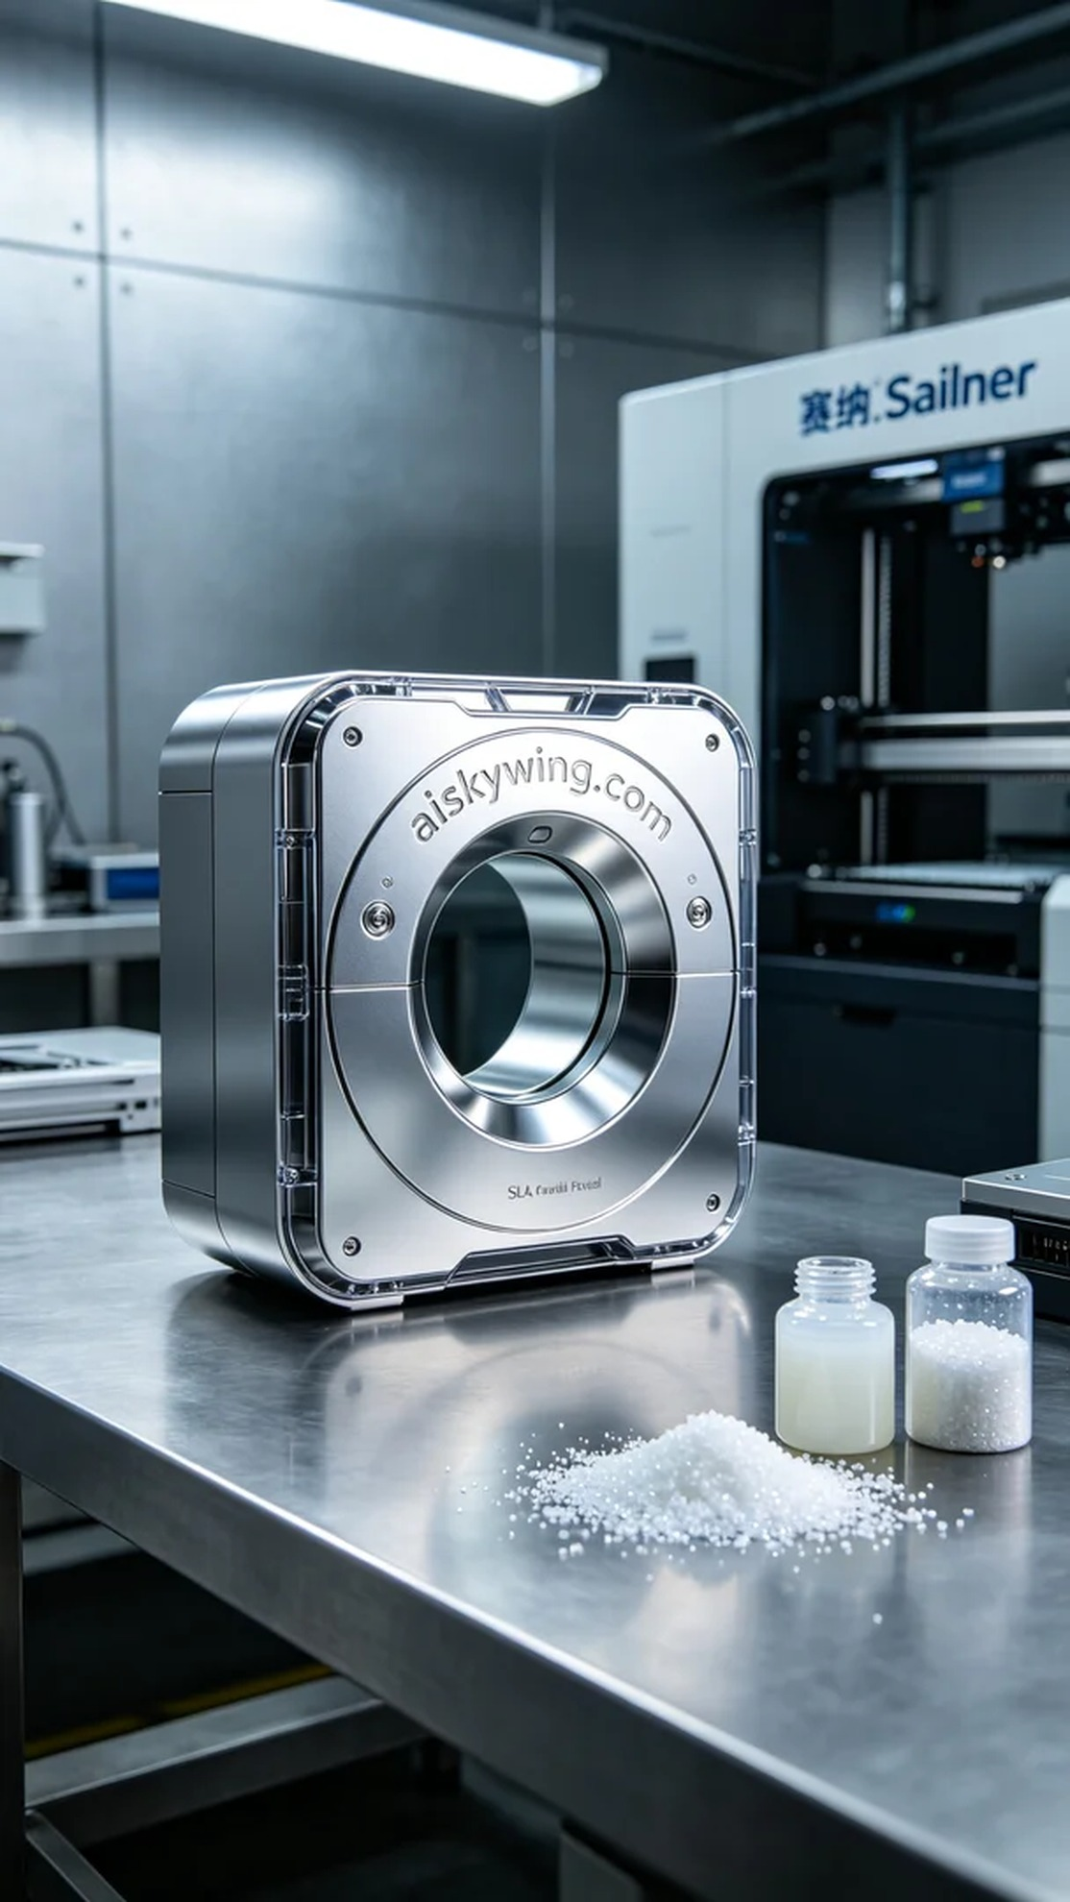
Aiskywing Industrial 3D Printing
CT scanner casing


