0630-X光机外壳3D打印生产记录
X-ray machine casing
🖨️ SLA光固化
🖥️ 打印机: Rize
📦 材料: SLA光固化树脂
在Twitter上，有人为了提升医疗设备的品质而找到了我们。于是我们开始了这个X光机外壳的制作，期待能为他们的事业助上一臂之力。
On Twitter, someone reached out to us to improve the quality of medical equipment. Thus, we started the production of this X-ray machine casing, hoping to lend a helping hand to their事业.
________________________________________________________________________________
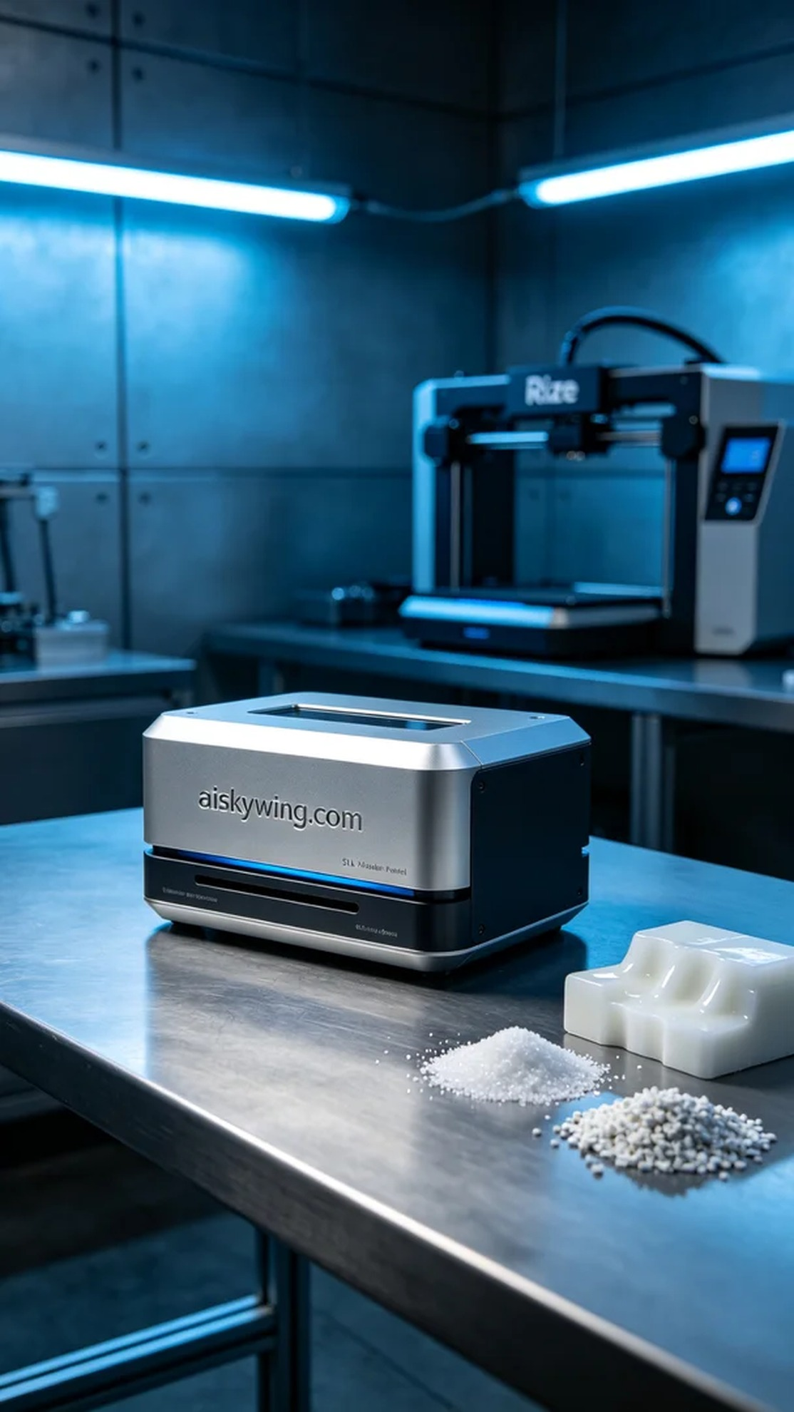
Today, we printed an X-ray machine casing for a medical device company. Someone reached out on Twitter expressing their desire to enhance the aesthetic and functionality of their equipment, particularly the accuracy and material performance of the casing. To meet their requirements, we decided to use SLA (Stereolithography) technology for production.
To ensure a smooth printing process, we prepared high-quality SLA photopolymer resin as our main material. This resin boasts excellent detail representation and a smooth surface, making it ideal for manufacturing complex structures. During the setup, we thoroughly checked the Rize printer and adjusted the printing parameters: layer thickness of 0.05mm, printing temperature at 25°C, laser power set to 100mW, and speed adjusted to 50mm/s, with an estimated printing time of about 5 hours.
The printing process went as expected. As the Rize printer operated in an orderly fashion, we constantly monitored the print quality to ensure that every layer bonded perfectly. Visual inspections and data feedback indicated that the details of the casing were becoming increasingly clear, and the surface finish was satisfying.
After completing the print, we moved on to the post-processing stage. First, we placed the printed casing in a cleaning tank to remove any excess resin using a specialized solvent. Once cleaned, we meticulously sanded the casing to ensure a smooth surface. Finally, we placed the casing in a curing device for additional hardening to ensure material strength and stability. After rigorous inspection, the casing met the desired standards.
In the end, the production of this X-ray machine casing was a success, showcasing the charm of high technology while contributing to the improvement of medical equipment. We look forward to the next project, continuing to create better results.
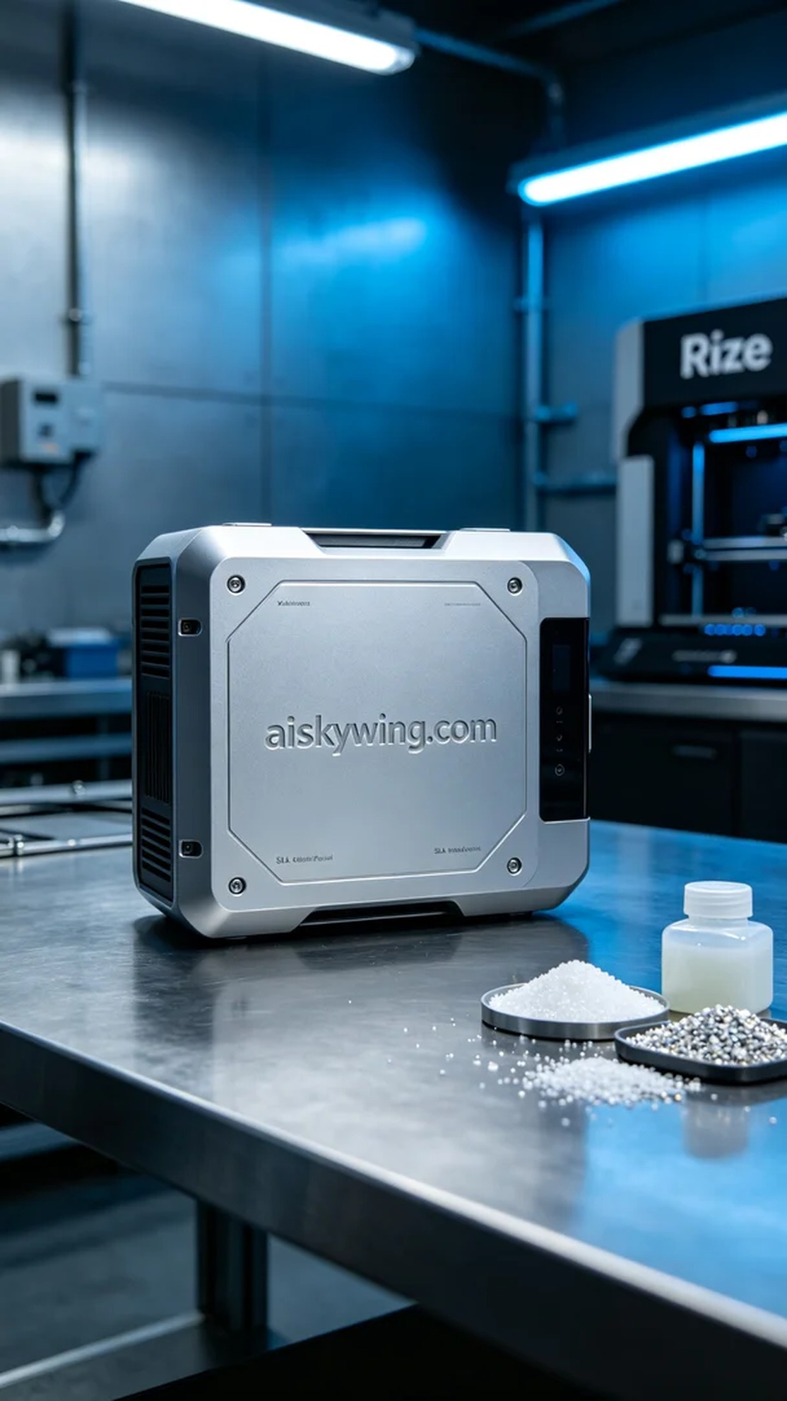
今天，我们为一个医疗设备公司打印了一个X光机外壳。有人在Twitter上提到他们希望提升设备的外观和功能，特别是外壳的精度和材料性能。为了满足他们的要求，我们决定使用SLA光固化工艺进行制作。
为了确保打印的顺利进行，我们准备了高品质的SLA光固化树脂作为原材料。这种树脂具有极佳的细节表现力和表面光滑度，适合制造复杂结构的外壳。在准备过程中，我们也对Rize打印机进行了详细检查，设定了适当的打印参数：层厚0.05毫米、打印温度25°C、激光功率为100mW、速度设置为50mm/s，预计打印时间大约是5小时。
打印过程如预期顺利。随着Rize打印机的有序运作，我们时刻监控着打印质量，确保每一层都能完美结合。视觉检查和数据反馈表明，外壳的细节越来越清晰，表面效果也令人满意。
完成打印后，我们进入后处理环节。首先，将打印好的外壳放入清洗槽中，使用专用溶剂清洗去除多余的树脂。清洗完成后，我们对外壳进行了细致的打磨，以确保表面平滑。最后，我们将外壳放入固化设备中进行进一步硬化，确保材料的强度和稳定性。经过严格的检验，外壳达到了预期的标准。
最终，这个X光机外壳的制作圆满结束，不仅展现了高科技的魅力，也为医疗设备的提升贡献了一份力量。期待下一次的项目，让我们继续创造更好的成绩。
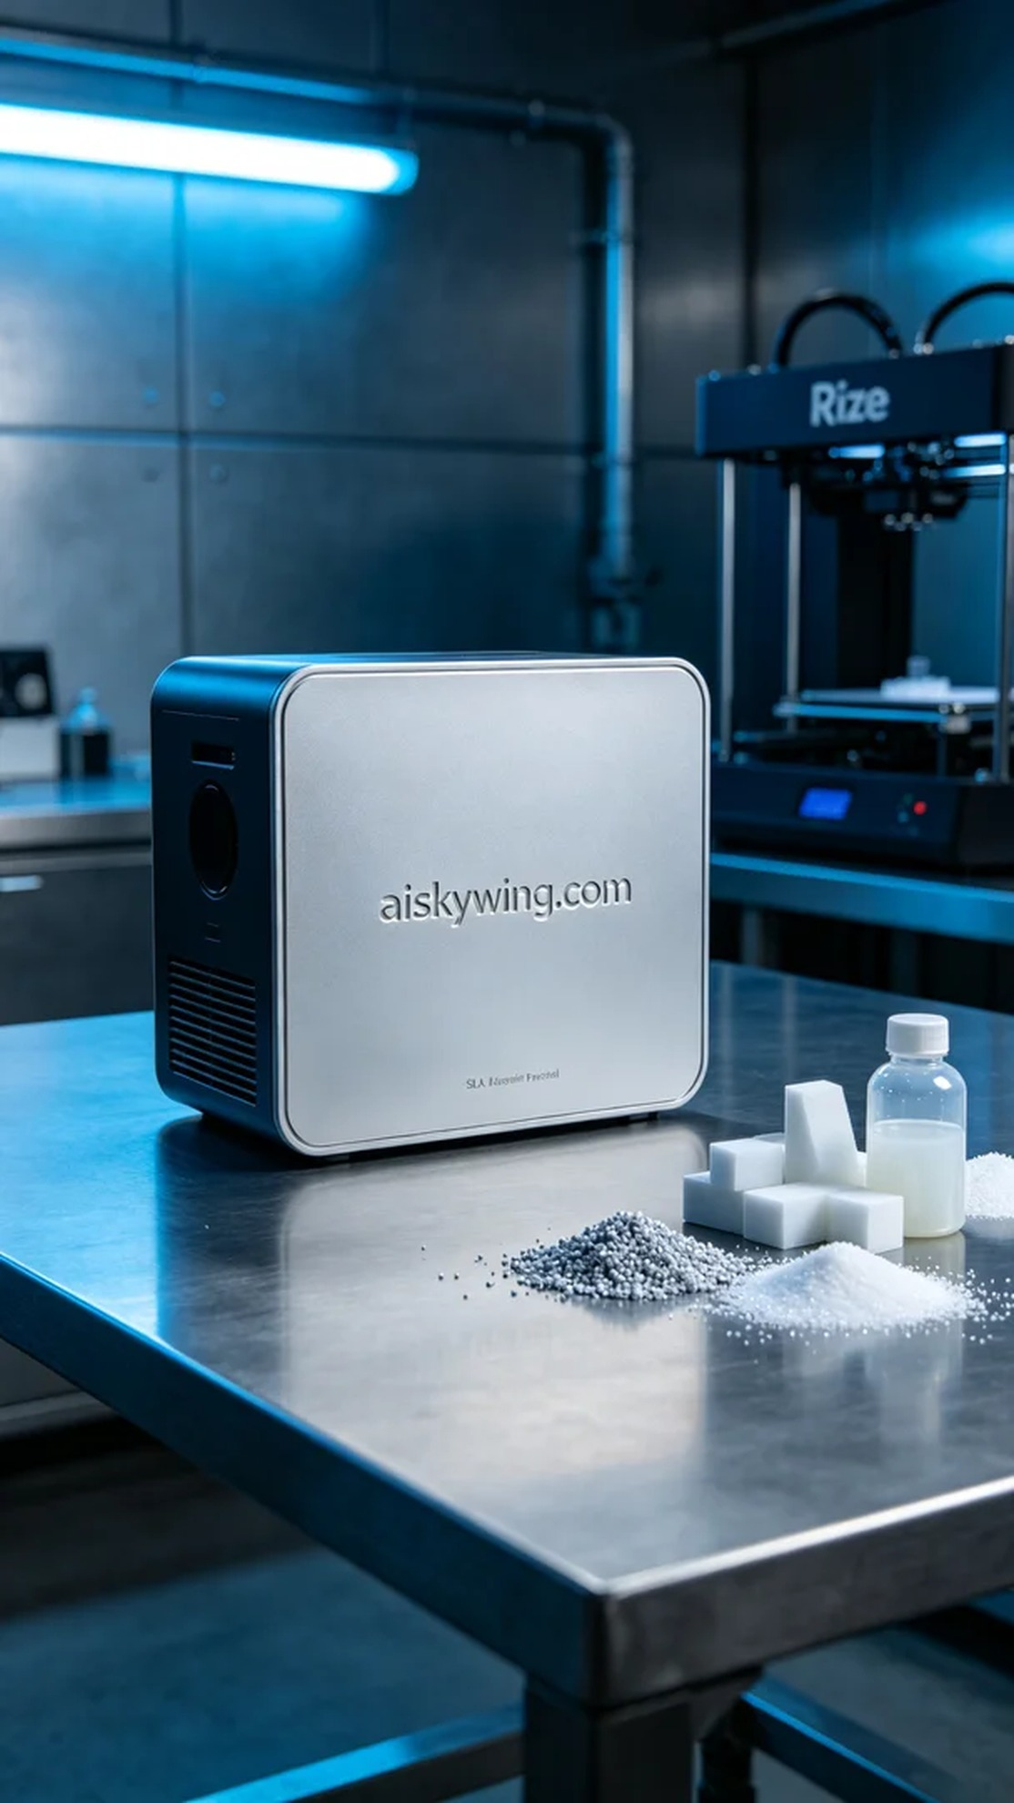
Aiskywing Industrial 3D Printing
X-ray machine casing


