0631-假肢接受腔的3D打印生产记录
prosthetic socket
🖨️ SLA光固化
🖥️ 打印机: EOS
📦 材料: SLA光固化树脂
生活总有不如意，但我们不能放弃努力。就像在TikTok上看到的那样，这个假肢接受腔需要我们的帮助，才能给人们带去希望。
生活总有不如意，但我们不能放弃努力。就像在TikTok上看到的那样，这个prosthetic socket需要我们的帮助，才能给人们带去希望。
________________________________________________________________________________
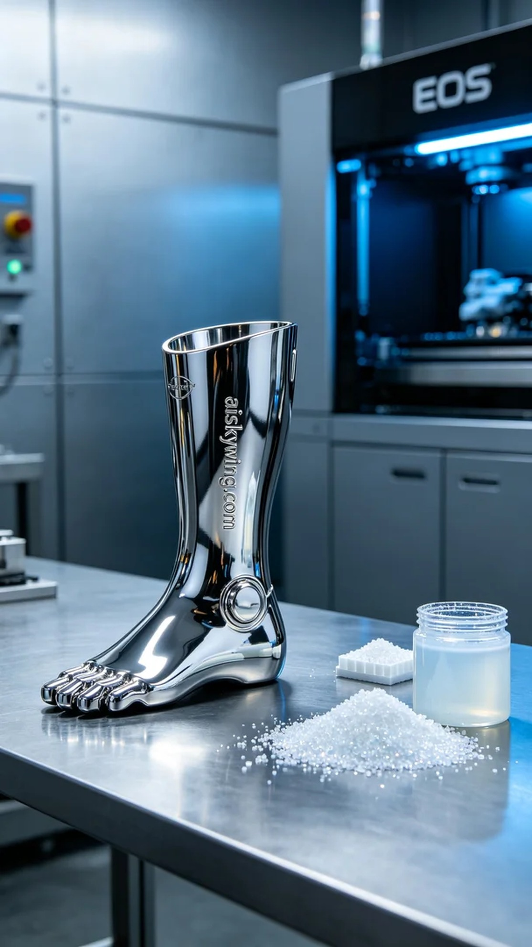
This task originated from a video I saw on TikTok, where someone had suffered an accident and lost a limb. They sought our help to customize a prosthetic socket to help them regain their confidence and vitality in life.
We chose SLA photopolymer resin as the material, which has excellent molding precision and surface smoothness, making it suitable for producing a prosthetic socket. The printing device is the EOS 3D printer, set with a layer thickness of 50 microns, a temperature maintained at 25 degrees Celsius, a power of 30 watts, a printing speed of 40 millimeters per second, and an estimated printing time of about 8 hours.
During the printing process, the machine operated smoothly as the SLA photopolymer resin cured layer by layer under ultraviolet light. We monitored the printing quality closely to ensure that each layer adhered correctly and met standards. The device's online monitoring system also helped us identify potential issues in a timely manner, making the entire process run smoothly.
After printing, we moved on to the post-processing stage. First, we placed the finished product in a cleaning device, using isopropyl alcohol to remove uncured resin, followed by sanding to ensure a smooth surface. Finally, we placed the product in a UV curing chamber to ensure its strength and stability, and after completion, we conducted a thorough inspection to ensure every detail met expectations.
Ultimately, after a series of rigorous processes, this prosthetic socket emerged perfectly, bringing new hope and courage to those in need. We are well aware that it’s these efforts that make life better, and we will continue to move forward.
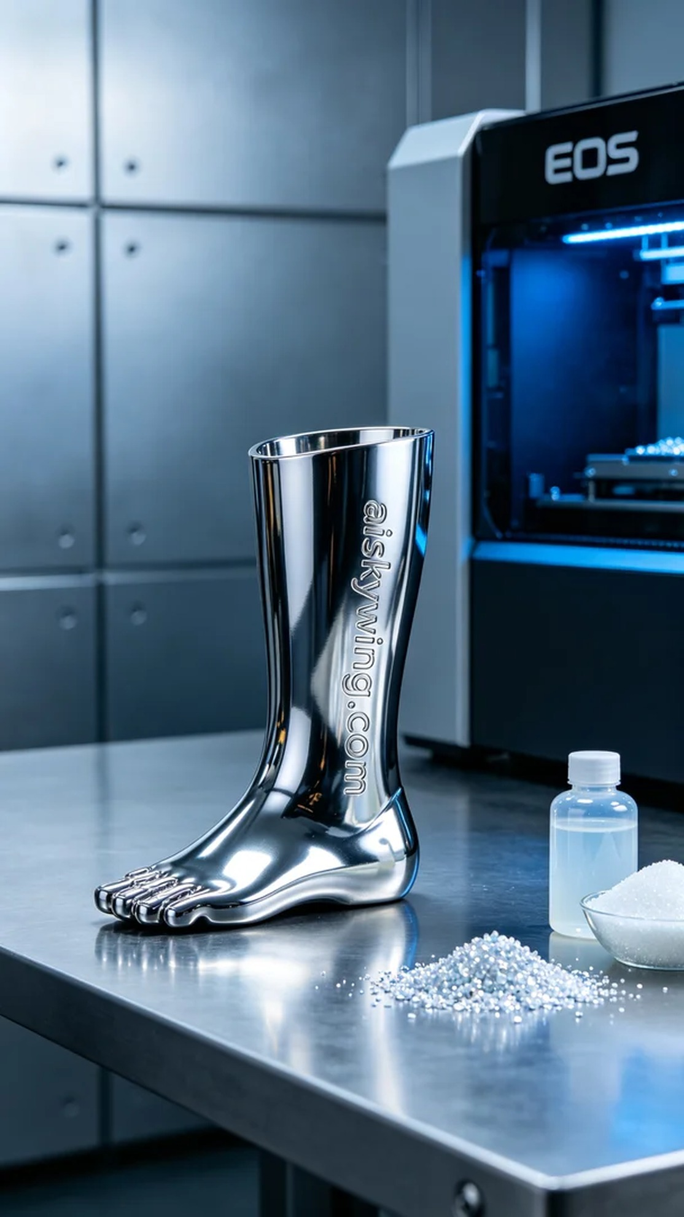
这次的任务源自于一段在TikTok上看到的视频，里面有人因为意外失去了一条肢体。他们希望能通过我们来定制一个假肢接受腔，以帮助他们重拾生活的信心和活力。
我们选择使用SLA光固化树脂作为原材料，这种材料具有优异的成型精度和表面光滑度，适合制作假肢接受腔。打印设备则是EOS的3D打印机，设定层厚为50微米，温度维持在25摄氏度，功率为30瓦，打印速度保持在40毫米每秒，预计打印时间为约8小时。
在打印过程中，机器平稳运行，SLA光固化树脂在紫外线照射下逐层固化。我们时刻监控打印质量，确保每一层的附着力和精度达到标准。设备的在线监测系统也帮助我们及时发现可能的问题，使得整个过程顺利进行。
打印完成后，我们进入后处理阶段。首先将成品放入清洗设备，使用异丙醇清洗去除未固化的树脂，随后进行打磨，以确保表面光滑。最后，我们将成品放入UV固化箱进行固化，确保其强度和稳定性，完成后再进行严谨的检验，确保每一个细节都符合预期。
最终，在经过一系列严格的工艺流程后，这个假肢接受腔完美呈现，为需要它的人带来了新的希望与勇气。我们深知，正是这些努力让生活更美好，继续前行。
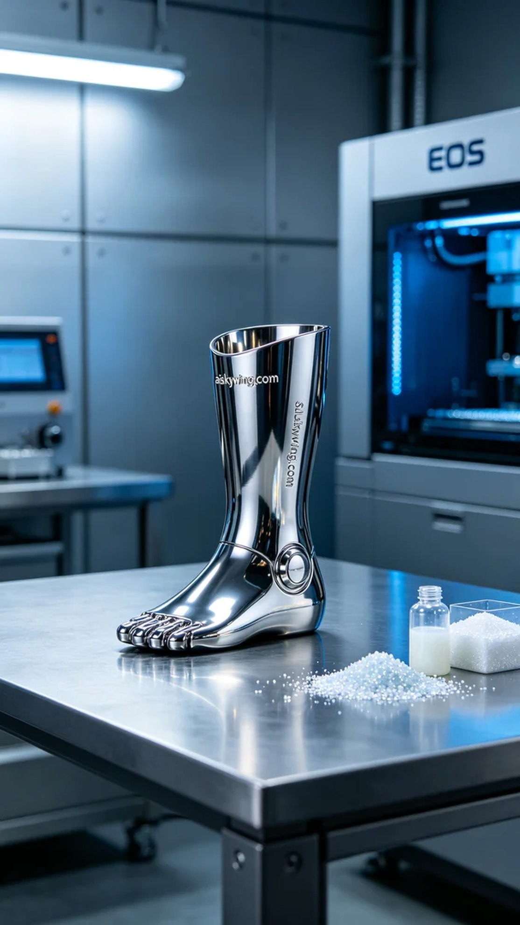
Aiskywing Industrial 3D Printing
prosthetic socket


