0632-光疗仪灯罩生产记录
Light therapy device lampshade
🖨️ SLA光固化
🖥️ 打印机: Voxeljet
📦 材料: SLA光固化树脂
人生有时如同3D打印，要耐心对待每一个细节。最近，有人想要我们为他们制作一个光疗仪灯罩，用于改善皮肤问题。
Life is sometimes like 3D printing; we must be patient with every detail. Recently, someone asked us to create a light therapy lamp shade for them to improve their skin issues.
________________________________________________________________________________
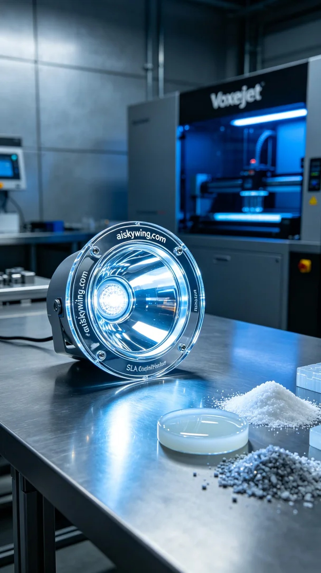
Life can sometimes be like 3D printing, requiring patience and attention to detail. Recently, someone approached us to create a light therapy device cover aimed at improving skin issues.
In the preparation phase, we chose SLA photopolymer resin as the material. This resin has exceptional transparency and gloss, allowing light to transmit effectively. For ensuring print quality, we utilized a Voxeljet printer, setting the layer thickness to 0.05mm, maintaining a printing temperature of 25℃, with a power setting of 150mW/cm² and a speed of 50mm/s. The estimated printing time was 6 hours.
During the printing process, the Voxeljet printer operated steadily, and we closely monitored the equipment's temperature and power to ensure uniformity in resin curing. As the printing progressed, the contours of the cover gradually appeared, and the engraved text “aiskywing.com” became increasingly clear.
Upon completion of the print, we began the post-processing steps. The printed cover was first washed in isopropyl alcohol to remove uncured resin, ensuring a clean surface. Next, we polished it to enhance the tactile feel and appearance. Finally, it was cured under UV light to ensure structural stability and durability, followed by a thorough inspection to confirm there were no defects.
In the end, after a series of meticulous efforts, the light therapy device cover was successfully completed, both aesthetically pleasing and functional, and we hope it meets the needs of that friend in achieving better skin health.
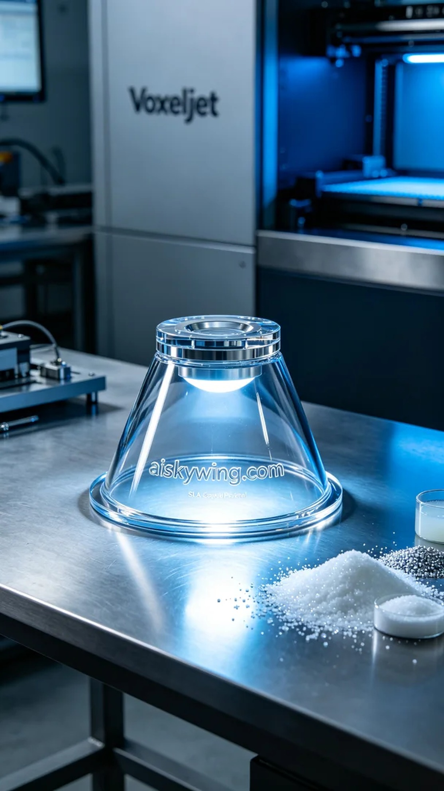
我们接到一位朋友的请求，因在YouTube上看到有关光疗的介绍，希望能为他们定制一个光疗仪灯罩。这个产品不仅追求美观，更需要具备良好的性能，以实现其光疗效果。
在准备阶段，我们选用了SLA光固化树脂作为材料。这种树脂具有极高的透明度和光泽，能够有效传导光线。为了确保打印品质，我们使用Voxeljet打印机，设置层厚为0.05毫米，打印温度保持在25℃，功率设定为150mW/cm²，打印速度为50mm/s，预计打印时间为6小时。
打印过程中，Voxeljet打印机稳定运行，整个过程我们密切监控设备的温度和功率，确保树脂在固化时的均匀性。随着打印的推进，灯罩的轮廓逐渐显现，表面雕刻的“aiskywing.com”字样也逐渐清晰可见。
完成打印后，我们开始了后处理工序。首先将打印好的灯罩在异丙醇中清洗，以去除未固化的树脂，保证表面干净。接着进行打磨，提升表面的触感和外观。最后，通过UV灯进行固化，确保其结构的稳定性和耐用性，最后进行检查，确认无瑕疵。
最终，经过一系列精细的工作，光疗仪灯罩成功完成，既美观又实用，期待它能满足那位朋友的需求，帮助他们实现更好的皮肤状态。
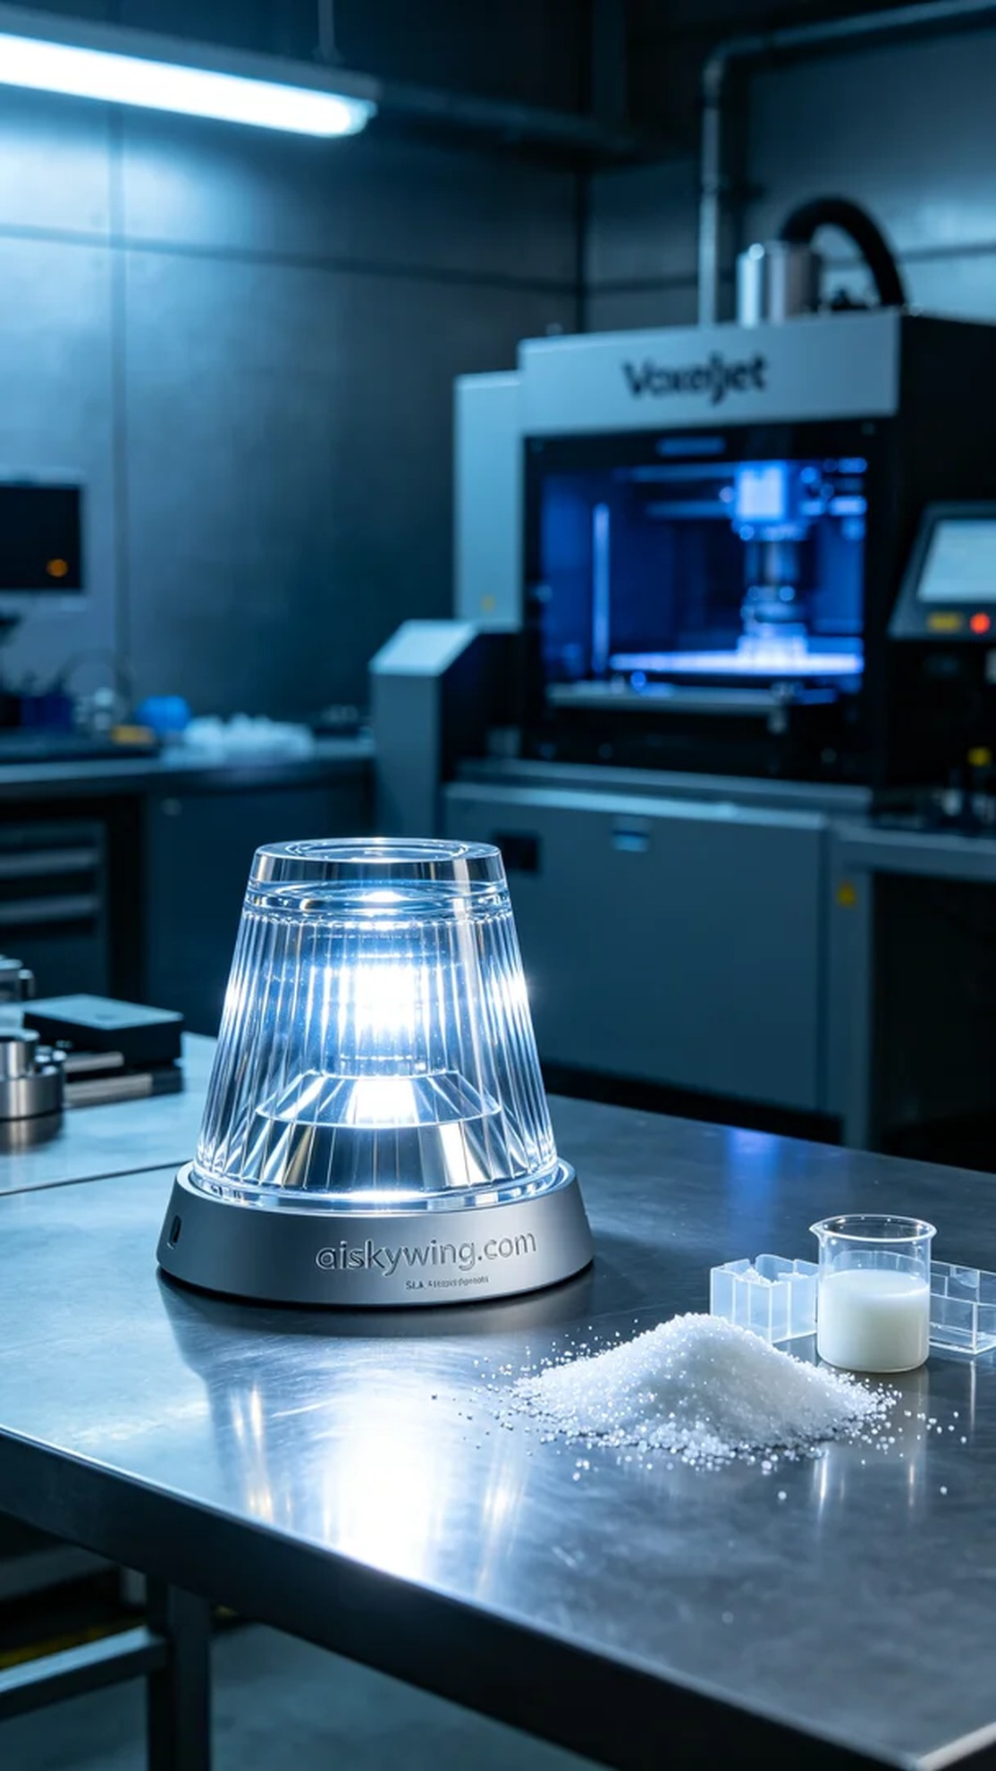
Aiskywing Industrial 3D Printing
Light therapy device lampshade


