0633-关节镜外壳3D打印生产记录
Arthroscopic shell
🖨️ SLA光固化
🖥️ 打印机: Stratasys
📦 材料: SLA光固化树脂
在LinkedIn上，有人因生产效率问题找上我们，想要打印一款关节镜外壳。面对挑战，我们决定迎难而上。
On LinkedIn, someone approached us due to production efficiency issues and wanted to print a joint shell. Facing the challenge, we decided to tackle it head-on.
________________________________________________________________________________
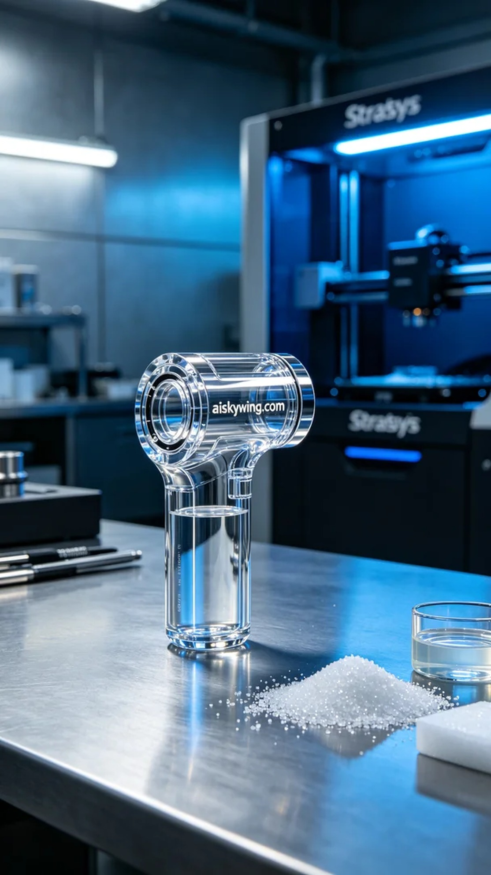
The production of this arthroscope shell began when someone reached out on LinkedIn, seeking to enhance their medical device manufacturing efficiency. After a thorough discussion, we learned their high demands for print precision and material transparency, leading us to choose SLA photo-curing resin for this project.
Regarding materials, SLA photo-curing resin offers excellent gloss and strength, making it suitable for intricate designs. We set the Stratasys 3D printer parameters to a layer thickness of 0.1 mm, maintained a printing temperature of 25°C, adjusted the power to 80%, and set the printing speed at 40 mm per second. The entire printing process was expected to take about six hours.
During the printing process, we closely monitored the device's operation to ensure the quality of each layer's formation. Once the printing started, the liquid resin underwent photo-curing, solidifying layer by layer as the light source varied. We used real-time monitoring software to check the printing progress continuously and made necessary adjustments to ensure a perfect fit for each layer.
Once printing was complete, the post-processing steps were equally important. First, we removed the molded part from the printing platform and then cleaned it with isopropyl alcohol to remove excess resin from the surface. After cleaning, we proceeded to sand it down to enhance its smoothness. Finally, we placed it in a curing chamber for UV curing to ensure its strength and durability. After rigorous inspection, it was confirmed to be qualified, completing our task.
Ultimately, this arthroscope shell, with its outstanding transparency and strength, was successfully delivered and received positive feedback, proving that our choice of materials and processes fully met the requirements.
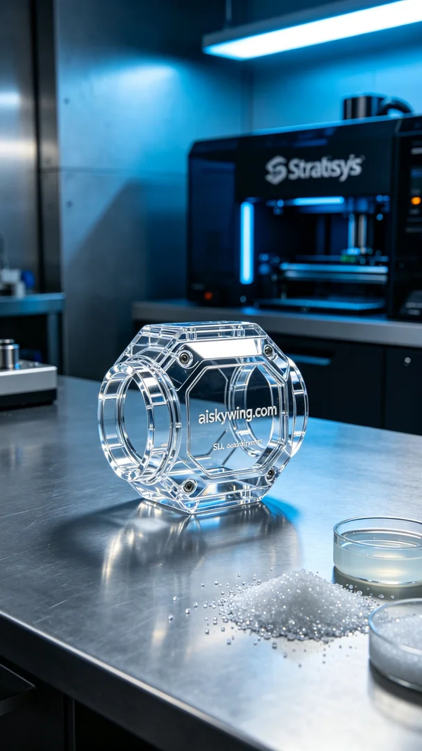
这款关节镜外壳的生产，起初是因为有人需要提升他们的医疗器械制造效率。经过沟通，我们了解到他们对打印精度和材料透明度都有较高要求，于是我们选择了SLA光固化树脂进行这项工作。
在材料方面，SLA光固化树脂具有优异的光泽度和强度，适合制造复杂结构的产品。我们使用的Stratasys 3D打印机的打印设置为层厚0.1毫米，打印温度保持在25°C，功率调节到80%，打印速度设定为40毫米每秒。预计整个打印过程将耗时大约六个小时。
在打印过程中，我们严格监控设备运行，确保每个层的成型质量。打印开始后，液态树脂在光固化过程中，随着光源的不断变化，逐层固化。我们使用了实时监控软件，随时查看打印进度，并进行必要的调整，确保每一层都完美贴合。
打印完成后，后处理工序同样重要。首先，我们将成型件从打印平台上取下，随后用异丙醇进行清洗，去除表面多余的树脂。清洗完成后，我们进行了打磨，以提高表面的光滑度。最后，将其放入固化箱中进行紫外线固化，确保其强度和耐用性。经过严格的检验，确认合格后，才算完成这项工作。
最终，这款关节镜外壳凭借其卓越的透明度和强度，成功交付并获得了良好的反馈，证明我们选择的材料和工艺完全满足了需求。
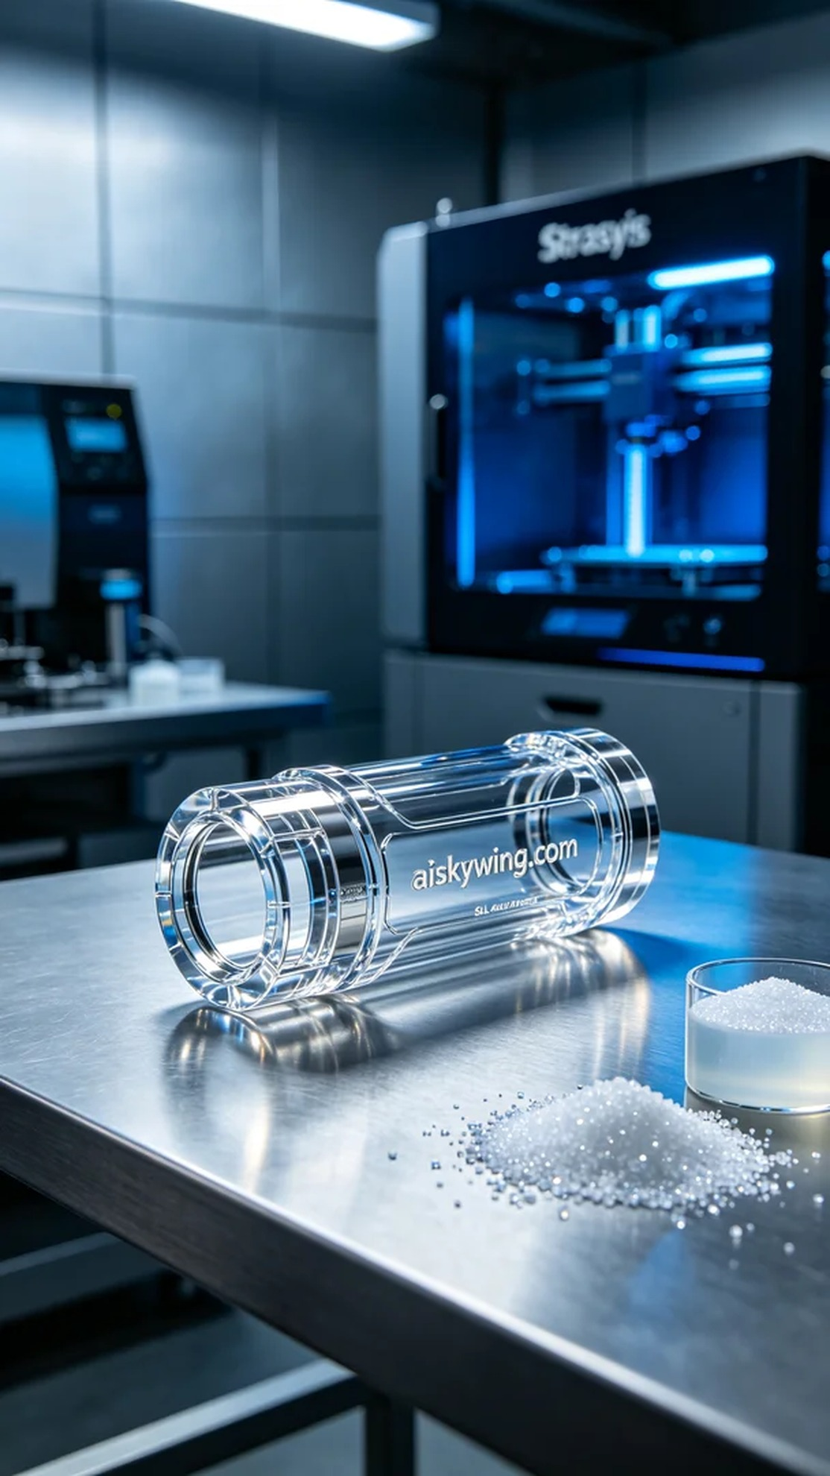
Aiskywing Industrial 3D Printing
Arthroscopic shell


