0634-内窥镜外壳的3D打印记录
Endoscope casing
🖨️ SLA光固化
🖥️ 打印机: Stratasys
📦 材料: SLA光固化树脂
生活再难，也别停下脚步。就像接下这个内窥镜外壳的单子，有人因为它遇到了技术瓶颈，希望能得到解决方案。
No matter how difficult life gets, don't stop moving forward. Just like taking on this order for an endoscope shell, someone has encountered a technical bottleneck and hopes to find a solution.
________________________________________________________________________________
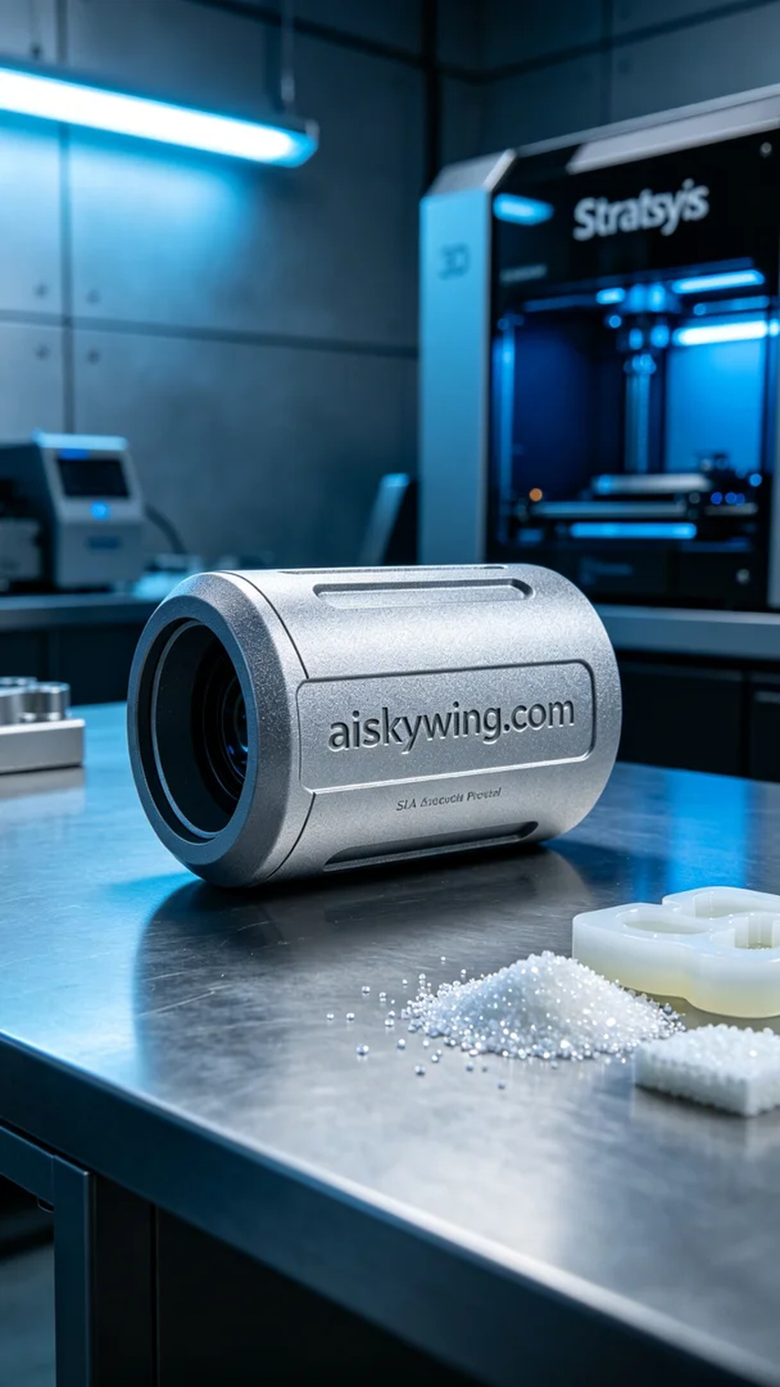
On Facebook, someone reached out for help regarding the design of an endoscope shell. They faced technical challenges and hoped to find a solution through 3D printing technology. We accepted this challenge and prepared to begin the printing process.
We chose SLA photopolymer resin as the printing material. This type of resin offers excellent flowability and molding capabilities, ideal for intricate printing requirements. To optimize the printing results using the Stratasys 3D printer, we set the parameters: layer thickness of 0.05 mm, printing temperature maintained at 25 degrees Celsius, laser power at 250 milliwatts, printing speed at 50 mm per second, with an estimated printing time of approximately 4 hours.
During the printing process, the equipment operated smoothly, and we monitored every aspect closely. We checked the adhesion of each printed layer to ensure there were no warps or bubbles appearing. As time passed, the endoscope shell gradually took form, showcasing a high-tech appearance.
After printing, we carried out detailed post-processing procedures. First, the molded shell was placed in a cleaning tank, using an ultrasonic cleaner to remove excess resin. After cleaning, the shell was removed and allowed to air dry in a well-ventilated area. Subsequently, we sanded the surface with fine-grit sandpaper to ensure a smooth, delicate touch, and finally cured it under UV light to enhance its hardness and durability. After thorough inspection, the quality of the shell received unanimous approval.
In the end, we successfully completed the endoscope shell, exceeding expectations and showcasing the infinite potential of 3D printing technology.
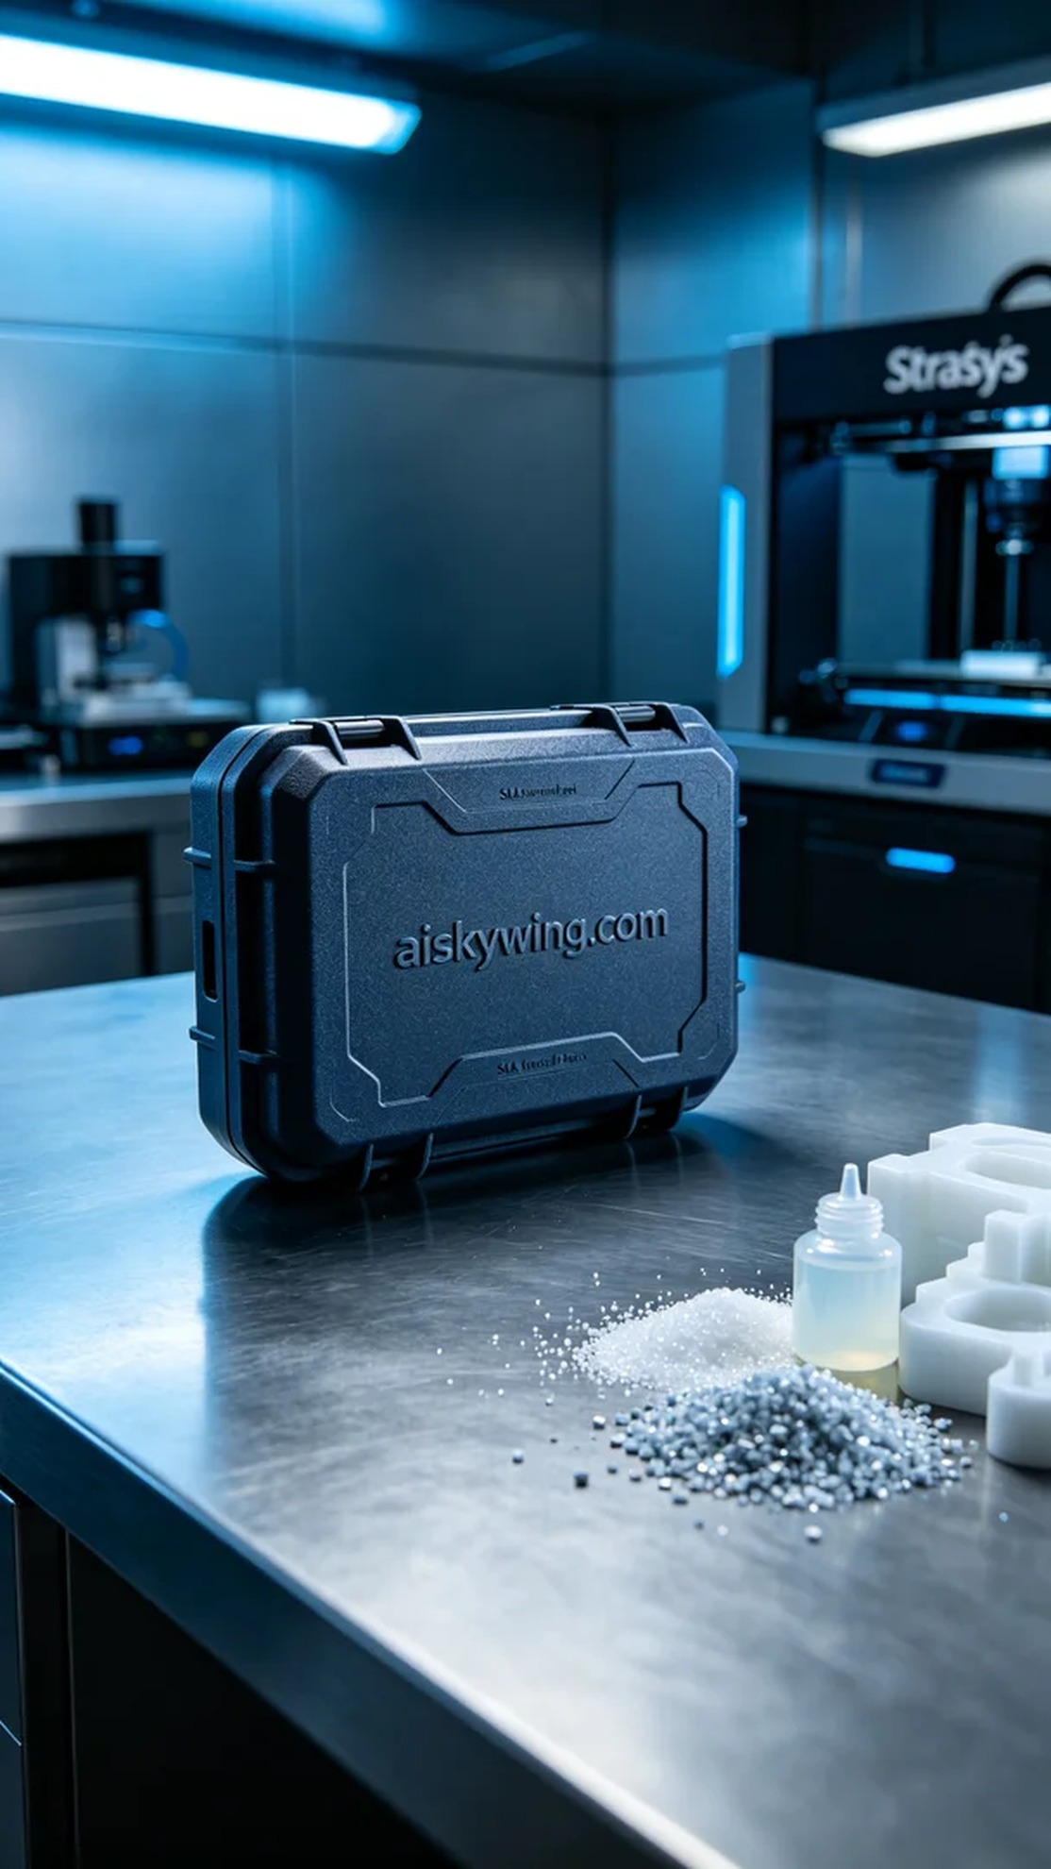
在Facebook上，有人因为内窥镜外壳的设计问题，寻求我们的帮助。他们希望能借助3D打印技术，制作出一个精确且高质量的外壳，以解决现有产品的不足之处。我们接下了这个挑战，准备开始打印过程。
我们选用了SLA光固化树脂作为打印材料。这种树脂具有很好的流动性和成型能力，能够满足精细化的打印需求。为了确保打印效果的最佳化，使用Stratasys 3D打印机时，我们设置了打印参数：层厚为0.05毫米，打印温度保持在25度，激光功率为250毫瓦，打印速度为50毫米每秒，预计打印时间大约为4个小时。
打印的过程中，设备稳定运行，整个打印过程都在我们的监控之下。我们随时检查打印层的附着情况，确保没有翘边或气泡的出现。随着时间的推移，内窥镜外壳逐渐成型，外观也愈发清晰，给人一种高科技的质感。
打印完成后，我们进行了详细的后处理工序。首先，将成型的外壳放入清洗槽中，使用超声波清洗机去除多余的树脂。清洗完成后，外壳被取出并放置在通风良好的地方，自然晾干。随后，使用磨砂纸对表面进行打磨，确保手感细腻光滑，最后将其放入UV灯下进行固化，以增强其硬度和耐久性。经过严格检验，外壳的质量得到了我们的一致认可。
最终，我们成功地将这个内窥镜外壳制作完成，超出了预期，既满足了用户的需求，也展现了3D打印技术的无限可能。
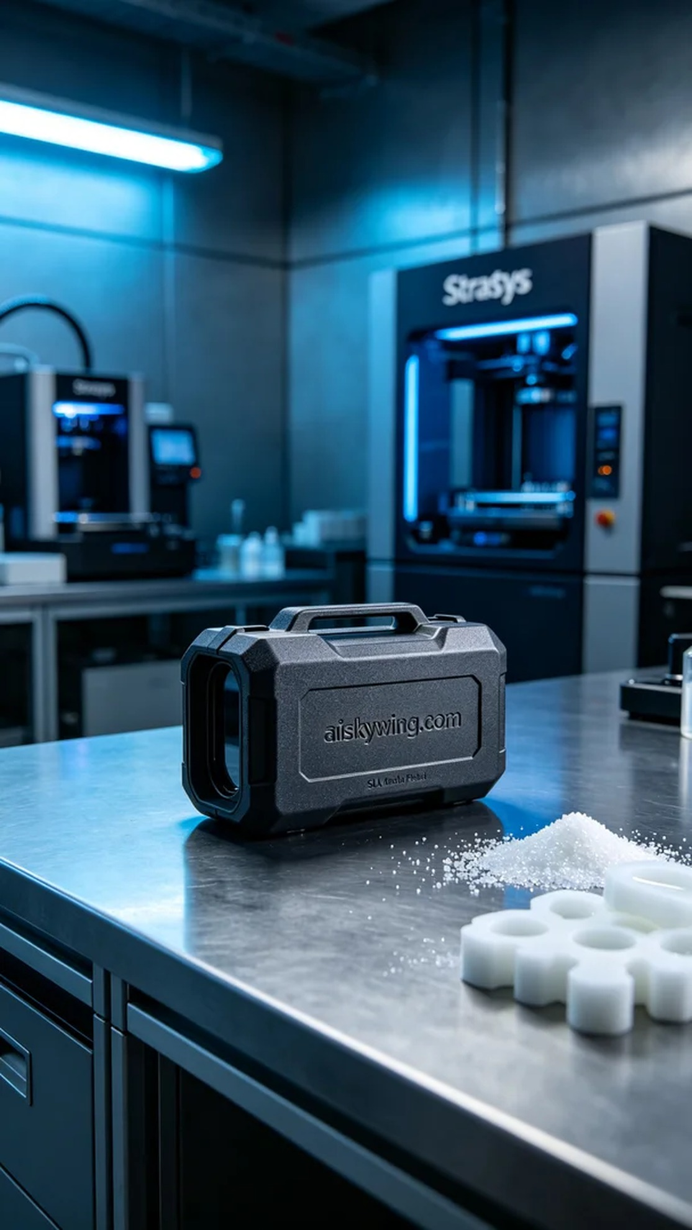
Aiskywing Industrial 3D Printing
Endoscope casing


