0635-冷疗仪外壳3D打印生产记录
Cryotherapy device shell
🖨️ SLA光固化
🖥️ 打印机: HP
📦 材料: SLA光固化树脂
生活就是一场不断的尝试与坚持，正如我们接下这个冷疗仪外壳的项目，迎接每一次挑战。
Life is a continuous journey of trying and persevering, just like when we took on the project for this cryotherapy device shell, embracing every challenge that comes our way.
________________________________________________________________________________
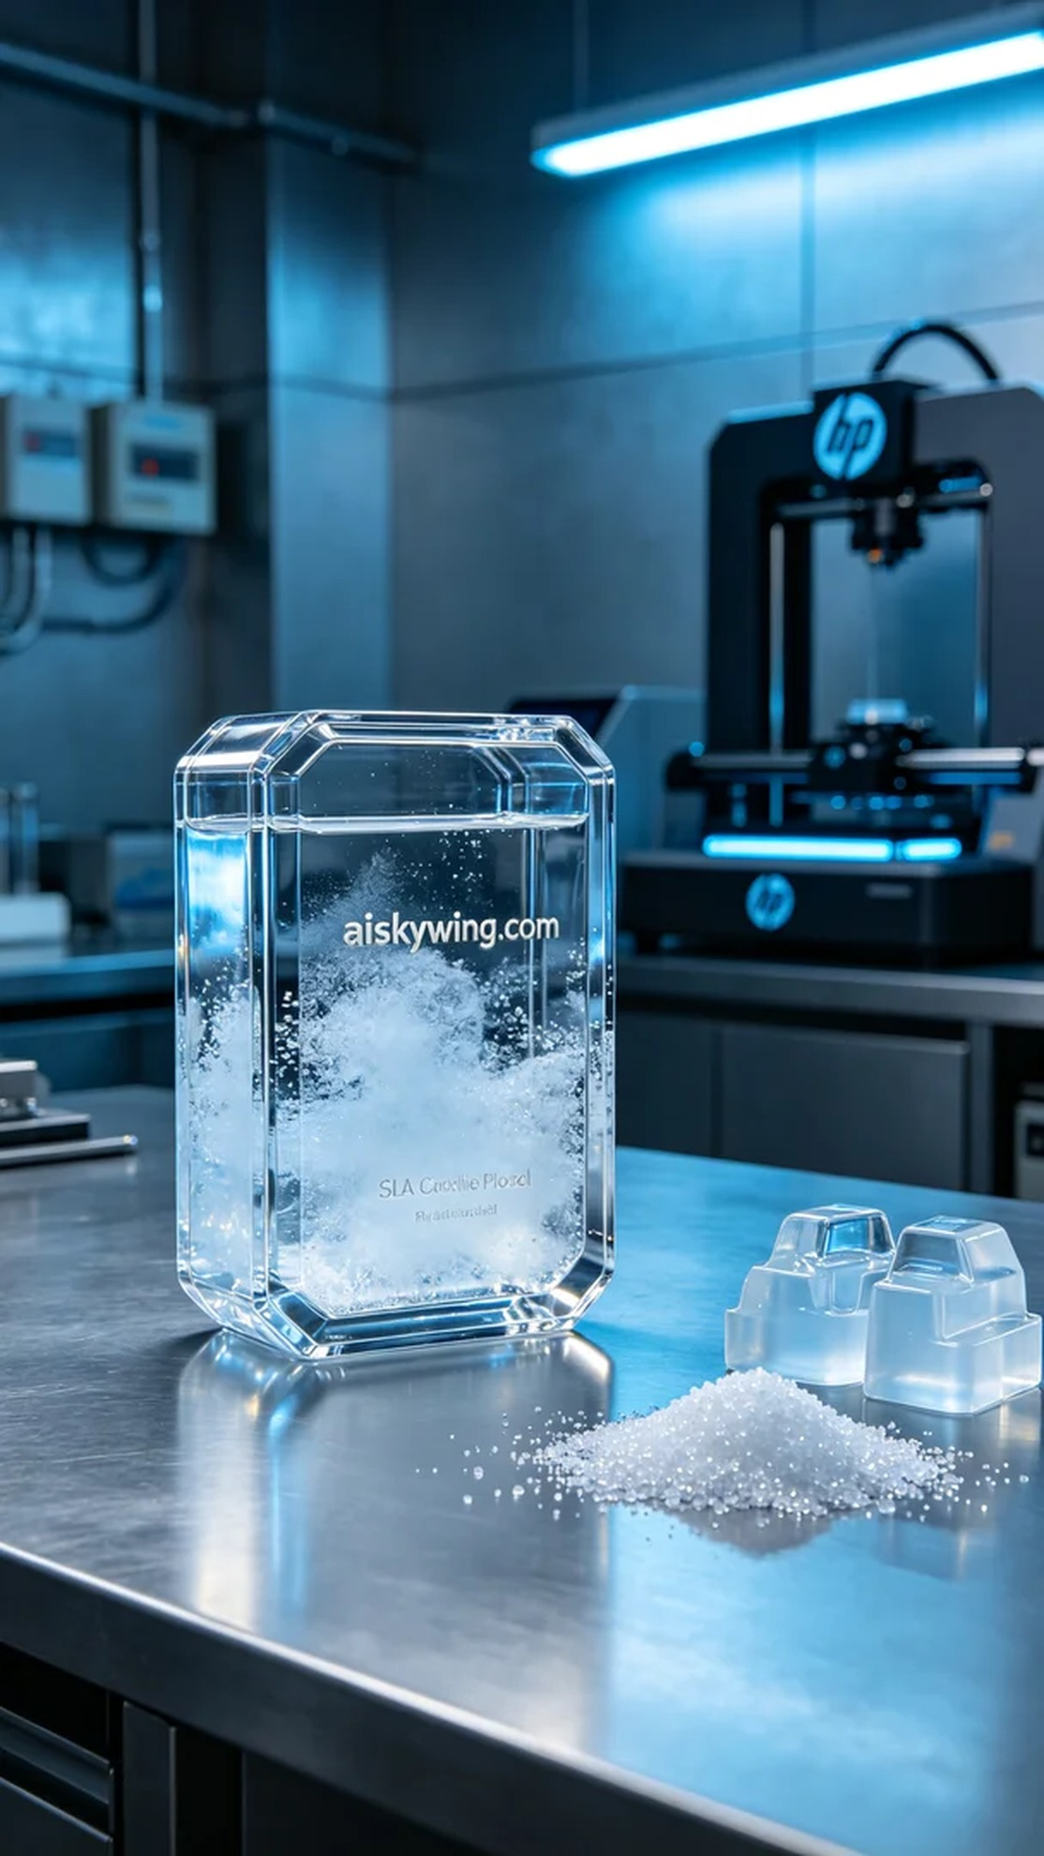
Life is a journey of constant trials and persistence, much like our endeavor with the cold therapy device shell project, facing each challenge head-on.
On the social platform Facebook, someone reached out to us with a need for a cold therapy device shell design. They required a product that was both aesthetically pleasing and functional to meet the market's demand for high-quality cold therapy equipment. We immediately set to work to ensure every detail met their expectations.
We chose SLA photopolymer resin as our printing material, known for its excellent clarity and strength, perfect for creating glossy product shells. For this project, we utilized an HP brand 3D printer, and after adjustments, we set the layer thickness to 0.05mm, maintained a printing temperature of 25 degrees Celsius, set the power to 80%, and a print speed of 60mm/s, with an estimated printing time of 8 hours.
The printing process went smoothly with stable equipment operation. Throughout the printing, I kept a close watch on the progress to ensure each layer cured as expected. After a few hours of operation, the cold therapy device shell gradually took shape, its crystal-clear surface shining beautifully under the lights.
Once printing was complete, we began the post-processing steps. First, we placed the finished product in a cleaning station, soaking it in isopropyl alcohol to remove any uncured resin from the surface. Next, we sanded the shell with fine-grit sandpaper to ensure a smooth finish, followed by UV curing in a box to enhance the durability and strength of the shell. Finally, we conducted a thorough quality inspection to ensure each shell met our standards.
Through this production process, the cold therapy device shell not only fulfilled the requirements but also showcased our professionalism and technical expertise in the field of 3D printing. Every detail reflects our dedication to quality.
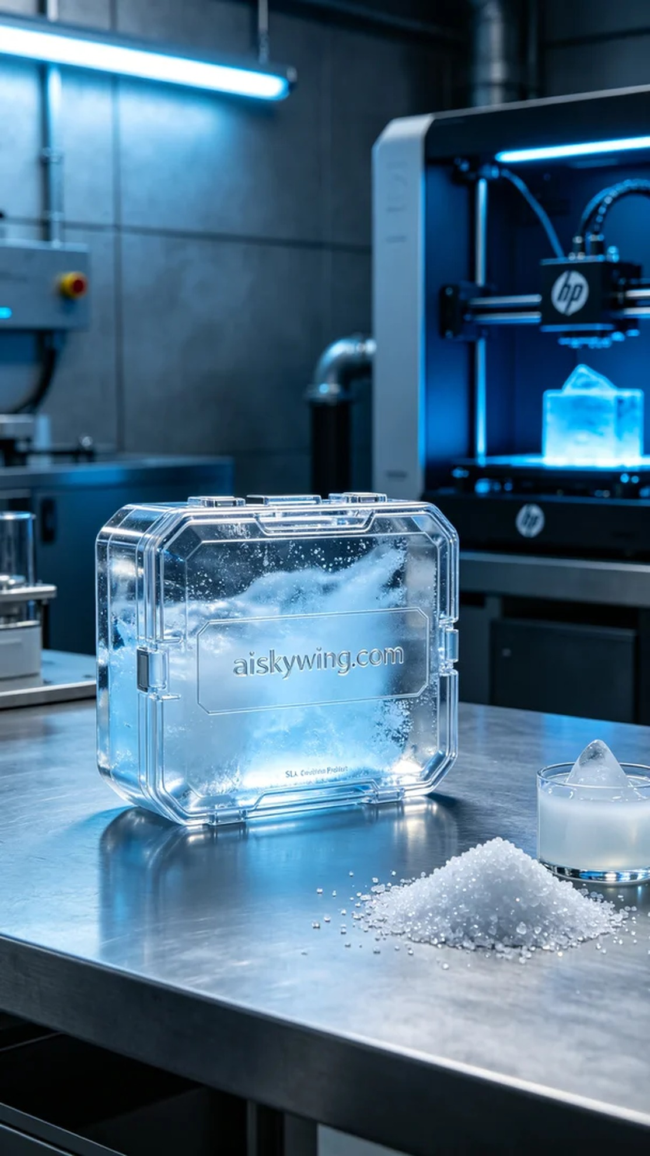
在社交平台Facebook上，有人因为对冷疗仪外壳的设计需求而找到了我们。他们需要一个既美观又实用的外壳，以满足市场上对高质量冷疗设备的需求。我们立刻着手准备，确保每个细节都能达到预期的标准。
我们选用了SLA光固化树脂作为打印材料，这种材料具有优良的透明度和强度，适合制作高光泽的产品外壳。设备方面，我们使用的是HP品牌的3D打印机，经过调试后设置了层厚0.05mm，打印温度保持在25摄氏度，功率设定为80%，打印速度为60mm/s，预计打印时间为8小时。
打印过程相对顺利，设备运行稳定。在打印的过程中，我始终保持对进度的监控，确保每层的固化效果都如预期。经过几小时的运作，冷疗仪外壳逐渐成型，晶莹剔透的表面在灯光的照射下显得格外迷人。
完成打印后，后处理工序便开始了。我们首先将成品放入清洗槽中，用异丙醇进行浸泡，去除表面的未固化树脂。接着，采用细砂纸对外壳进行打磨，确保表面光滑，再将其放入UV固化箱内进行固化，增强外壳的耐用性和强度。最后，我们进行了严格的质量检验，确保每个外壳都符合标准。
通过这次的制作过程，冷疗仪外壳不仅达到了客户的要求，还展示了我们在3D打印领域的专业性与技术水平。每一个细节都凝聚了我们的心血。
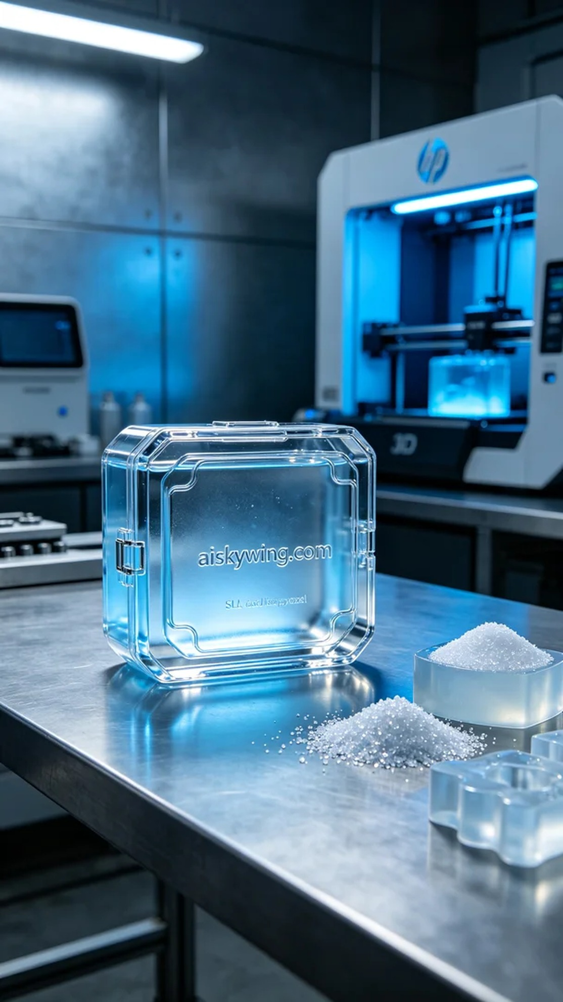
Aiskywing Industrial 3D Printing
Cryotherapy device shell


