0636-助听器外壳3D打印生产记录
Hearing aid shell
🖨️ SLA光固化
🖥️ 打印机: Mimaki
📦 材料: SLA光固化树脂
在WhatsApp上，有人因为助听器外壳的定制需求找到我们。这让我想起，人生中有些声音虽微弱，却依然值得我们去倾听与关注。
On WhatsApp, someone reached out to us with a custom request for a hearing aid shell. This reminded me that some voices in life, though faint, are still worth listening to and paying attention to.
________________________________________________________________________________
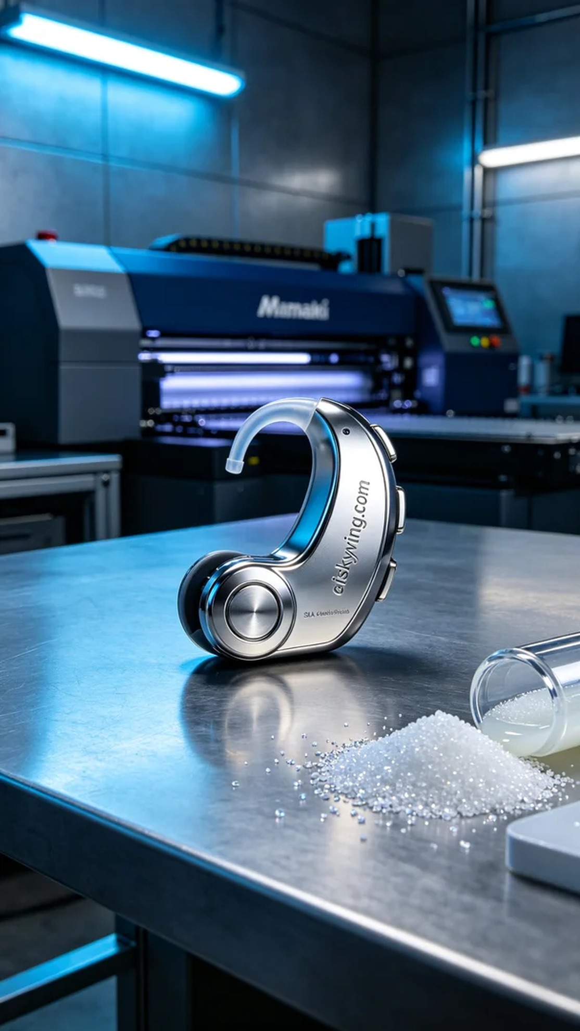
On WhatsApp, someone reached out to us with a custom request for a hearing aid shell. This reminded me that some voices in life may be faint, yet they deserve our attention and care.
The demand for this hearing aid shell stemmed from a desire for personalized products. Someone wished to have a shell that is not only aesthetically pleasing but also practical for better protection of the hearing aid. To achieve this goal, we decided to use SLA photopolymer resin for 3D printing, ensuring the best detail and quality.
We chose the Mimaki brand 3D printer, setting the printing parameters to a layer thickness of 0.1 mm, a temperature of 25°C, a laser power of 50 milliwatts, and a printing speed of 30 mm per second, estimating a total printing time of about 6 hours. These parameters ensure each layer forms accurately and efficiently while maintaining a smooth surface finish.
During the actual printing process, the Mimaki printer ran steadily, with the liquid photopolymer resin solidifying layer by layer under the laser's exposure. Throughout the process, we monitored the print quality closely to ensure that no bubbles or defects appeared, allowing every detail to be clearly presented.
Once printing was complete, we immediately proceeded with post-processing. First, we washed the finished product in isopropyl alcohol to remove excess resin from the surface. Next, we used fine sandpaper to polish the shell for improved smoothness, followed by curing it in a UV machine to ensure the material's strength and durability. After a thorough inspection, the hearing aid shell was successfully completed, meeting our expectations.
In the end, with the successful printing of this hearing aid shell, we not only fulfilled someone's expectations but also took a solid step forward in our technical journey. Each print is a new experience and a chance for growth.
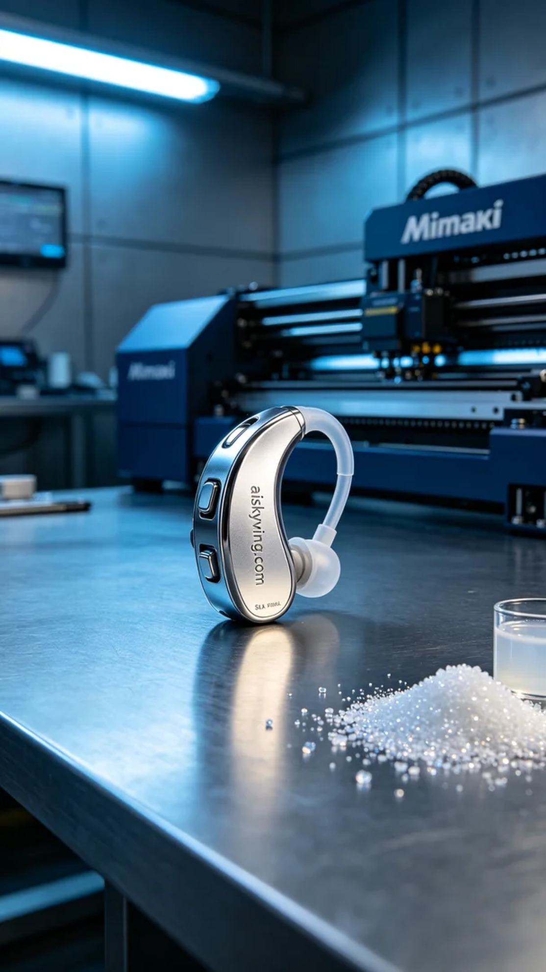
首先，这个助听器外壳的需求源于对个性化产品的渴望。有人希望能拥有一个既美观又实用的外壳，以便更好地保护助听器。为了实现这一目标，我们决定使用SLA光固化树脂进行3D打印，确保细节和质量达到最佳状态。
我们选择了Mimaki品牌的3D打印机，设置打印参数为层厚0.1毫米，温度设定在25°C，激光功率为50毫瓦，打印速度控制在30毫米每秒，预估打印时间约为6个小时。这些参数能确保每一层都精准高效地成型，同时保持良好的表面光滑度。
在实际打印过程中，Mimaki打印机稳稳运行，液态光敏树脂在激光的照射下逐层固化。设备运行时，我们全程监控打印质量，确保没有出现任何气泡或其他缺陷，使得每个细节都能清晰呈现。
完成打印后，我们立即进行后处理。首先将成品在异丙醇中进行清洗，清除表面多余的树脂。接着，使用细砂纸进行打磨，以提升表面光滑度，最后在UV固化机中进行固化，确保材料的强度和耐用性。经过严格的检验后，这个助听器外壳顺利完成，达到了预期的效果。
最终，随着这个助听器外壳的成功打印，我们不仅实现了有人心中的期待，更让我们在技术上又迈出了坚实的一步。每一次打印，都是一次新的体验与成长。
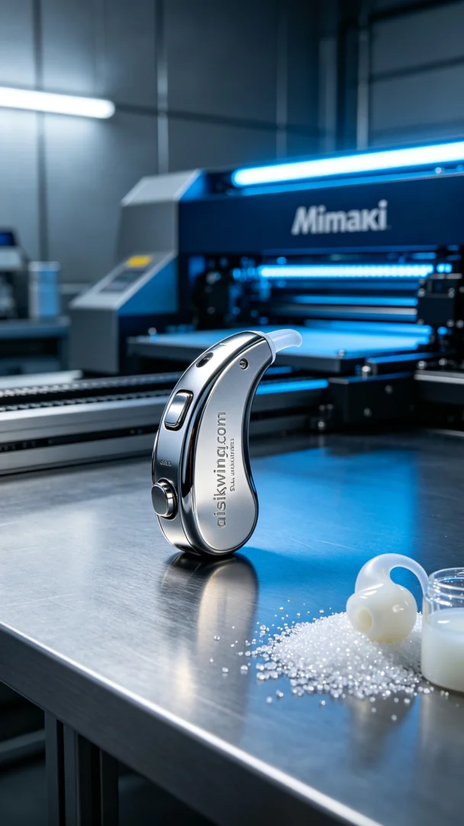
Aiskywing Industrial 3D Printing
Hearing aid shell


