0637-助行器支架3D打印生产记录
Walker frame
🖨️ SLA光固化
🖥️ 打印机: Rize
📦 材料: SLA光固化树脂
生活再难，也别停下脚步。就像接下这个助行器支架的单子，面对技术的挑战，我们绝不能退缩。
No matter how difficult life gets, don't stop moving forward. Just like taking on this order for the walker frame, we must not back down in the face of technical challenges.
________________________________________________________________________________
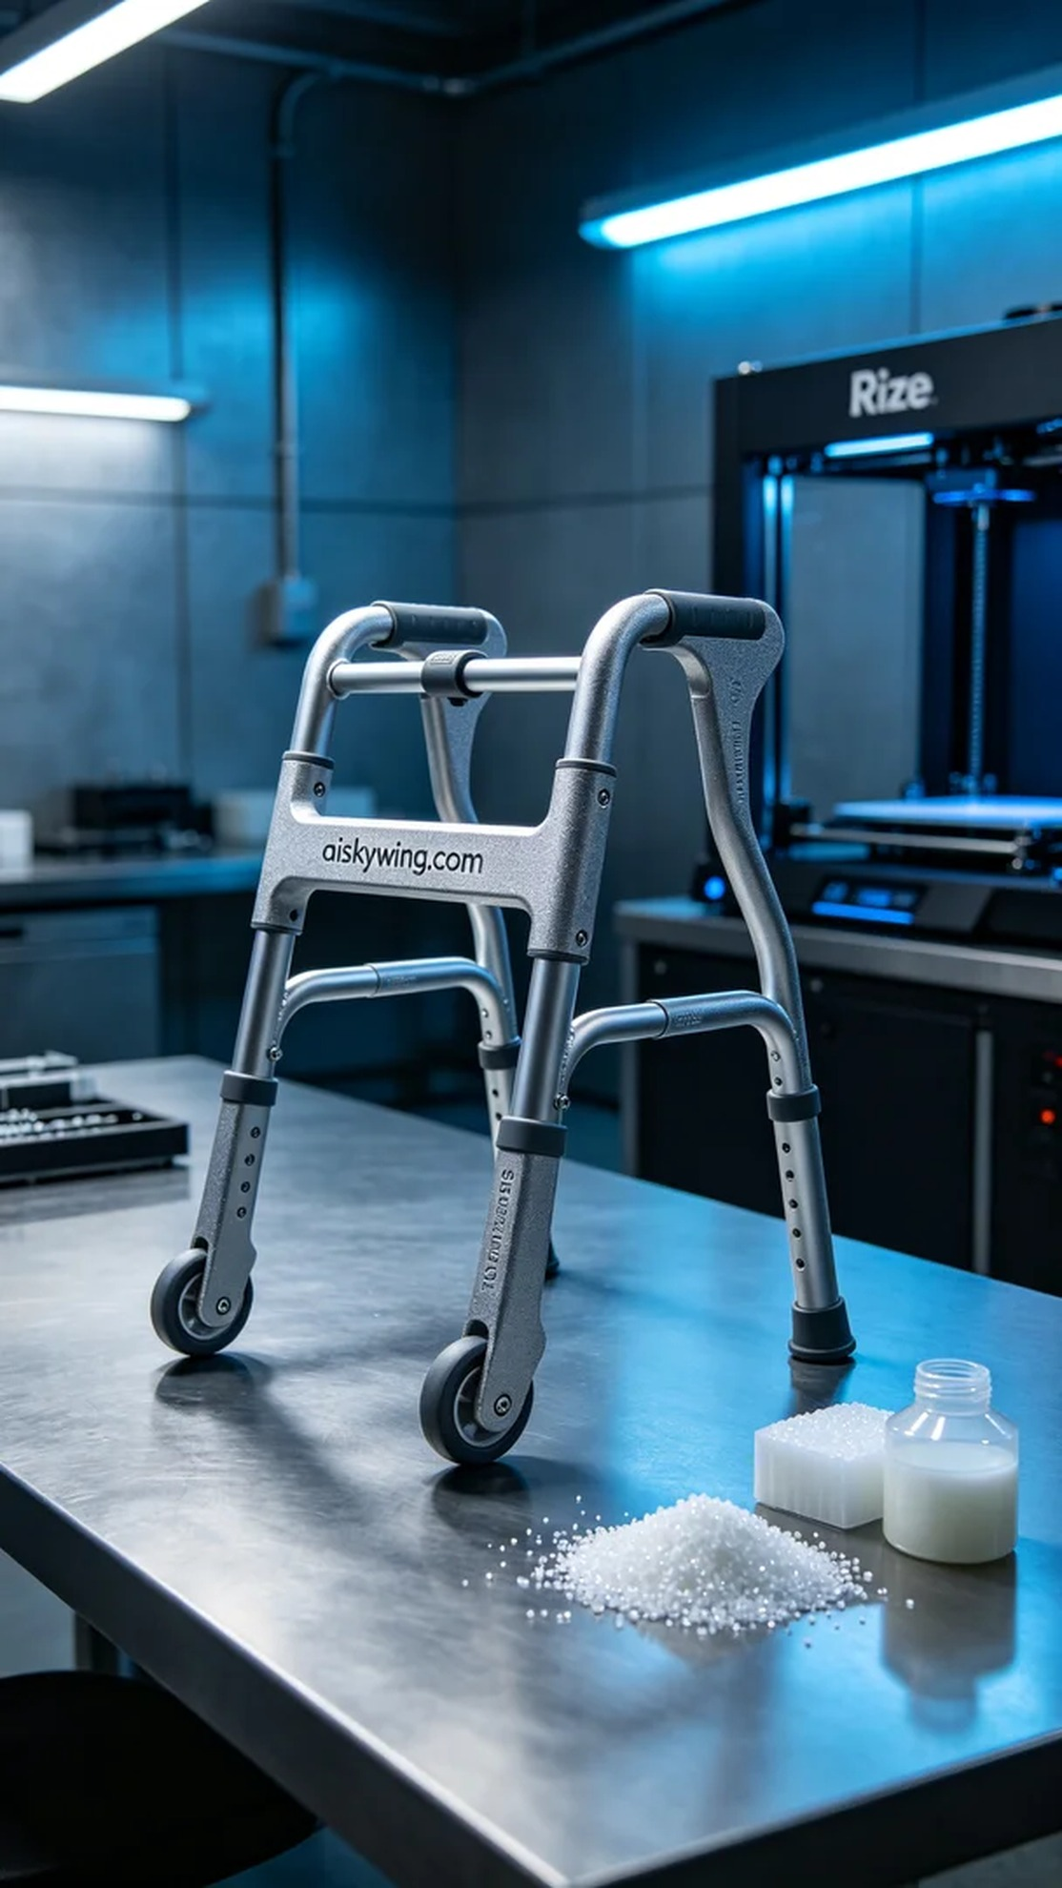
Life can be tough, but we must not stop moving forward. Taking on the task of printing a walker support reminds me that we cannot shy away from technological challenges.
On Twitter, someone reached out for help in creating a stable and durable walker support. This need prompted me to utilize our 3D printing technology, and I decided to use the Rize printer for this task.
We selected SLA photopolymer resin as the material due to its excellent precision and smooth surface, making it suitable for functional product manufacturing. The printing parameters were set to a layer thickness of 0.1 mm, printing temperature at 25°C, power adjusted to 70%, and printing speed maintained at 80 mm per second, with an estimated print time of around 4 hours.
During the printing process, the machine operated smoothly, and the Rize printer captured every detail with precision. We continuously monitored the quality to ensure that every aspect met the expected standards, and there were no defects. Upon completion, the product's surface was smooth, with the engraved “aiskywing.com” clearly visible, exuding an industrial feel.
Post-processing was equally important. We first placed the finished product in the cleaning tank to remove any excess resin, ensuring a clean surface free of residues. Next, we conducted meticulous sanding to enhance the tactile quality and finally performed curing to ensure the product's strength and durability. After strict inspection, the final product met all requirements and could be confidently used.
In the end, the production of the walker support was successfully completed, and everyone involved expressed satisfaction with the collaboration. Through continuous exploration and practice, we believe that technology will bring more convenience to life.
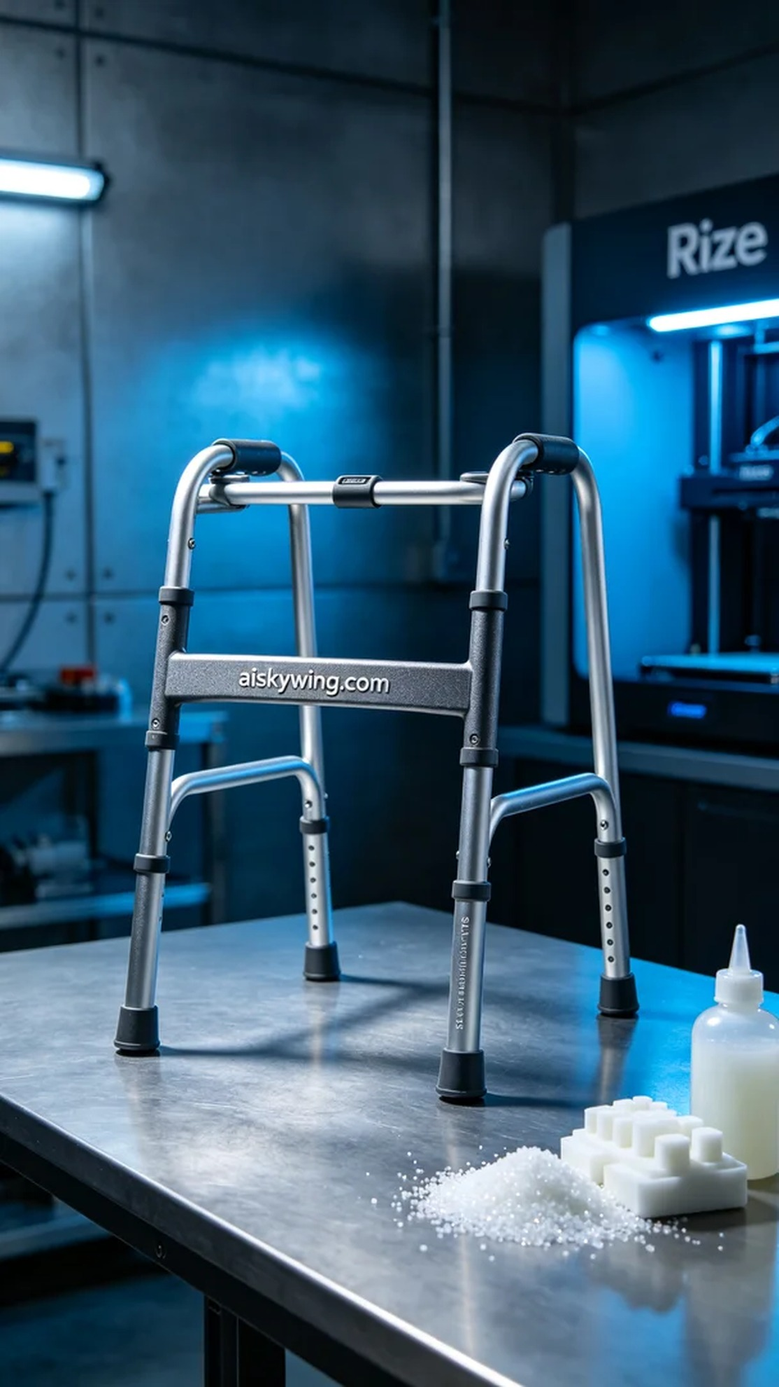
在Twitter上，有人因身体不便寻求帮助，希望能设计出一个稳固、耐用的助行器支架。这个需求让我想到了我们的3D打印技术，决定用Rize打印机来完成这个任务。
我们选择了SLA光固化树脂作为原材料，因其优良的精度和表面光滑度，适合用于功能性产品的生产。打印的参数设置为：层厚0.1毫米，打印温度设定为25℃，功率调整至70%，打印速度保持在80毫米每秒，预估打印时间约为4小时。
打印过程中，设备运行平稳，Rize打印机的每一层都记录着细致的变化。我们实时监控质量，确保每个细节都达到预期标准，没有任何缺陷出现。打印完成后，成品的表面光洁，雕刻的“aiskywing.com”字样清晰可见，充满了工业感。
后处理工序同样重要。我们首先将成品放入清洗槽中，用专用溶剂去除多余的树脂，确保表面干净无残留。接着，进行细致的打磨，使得表面触感更加细腻，最后进行固化处理，以保证产品的强度和耐用性。经过严格的检验，成品符合所有要求，可以放心使用。
最终，助行器支架的生产顺利完成，大家对这次的合作感到满意。通过不断探索和实践，我们相信技术会为生活带来更多的便利。
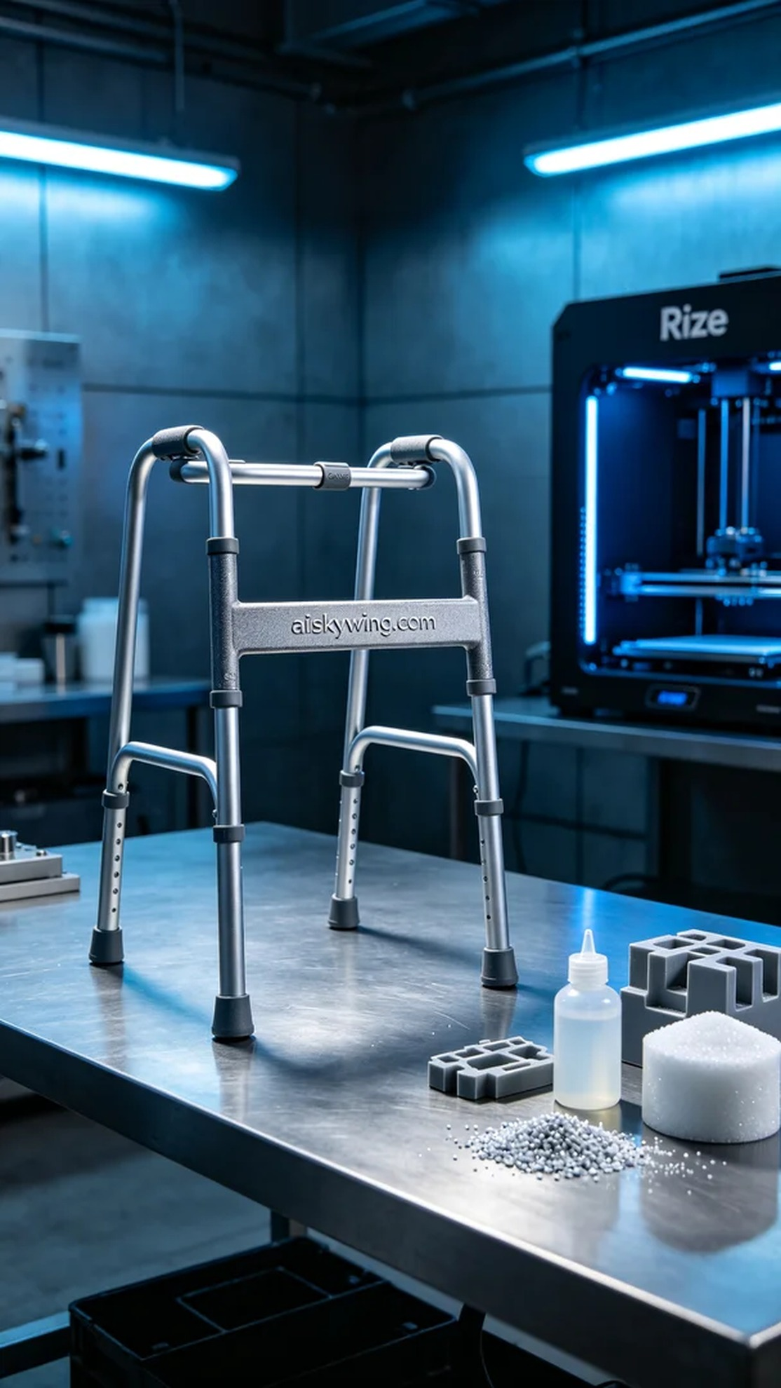
Aiskywing Industrial 3D Printing
Walker frame


