0639-医用PCR管架的3D打印记录
Medical PCR tube rack
🖨️ SLA光固化
🖥️ 打印机: Stratasys
📦 材料: SLA光固化树脂
在Instagram上，有人因为寻找高质量的医疗器械而找到我们。我们最近接到了制作医用PCR管架的任务。
On Instagram, someone found us while searching for high-quality medical equipment. We recently received a task to produce medical PCR tube racks.
________________________________________________________________________________
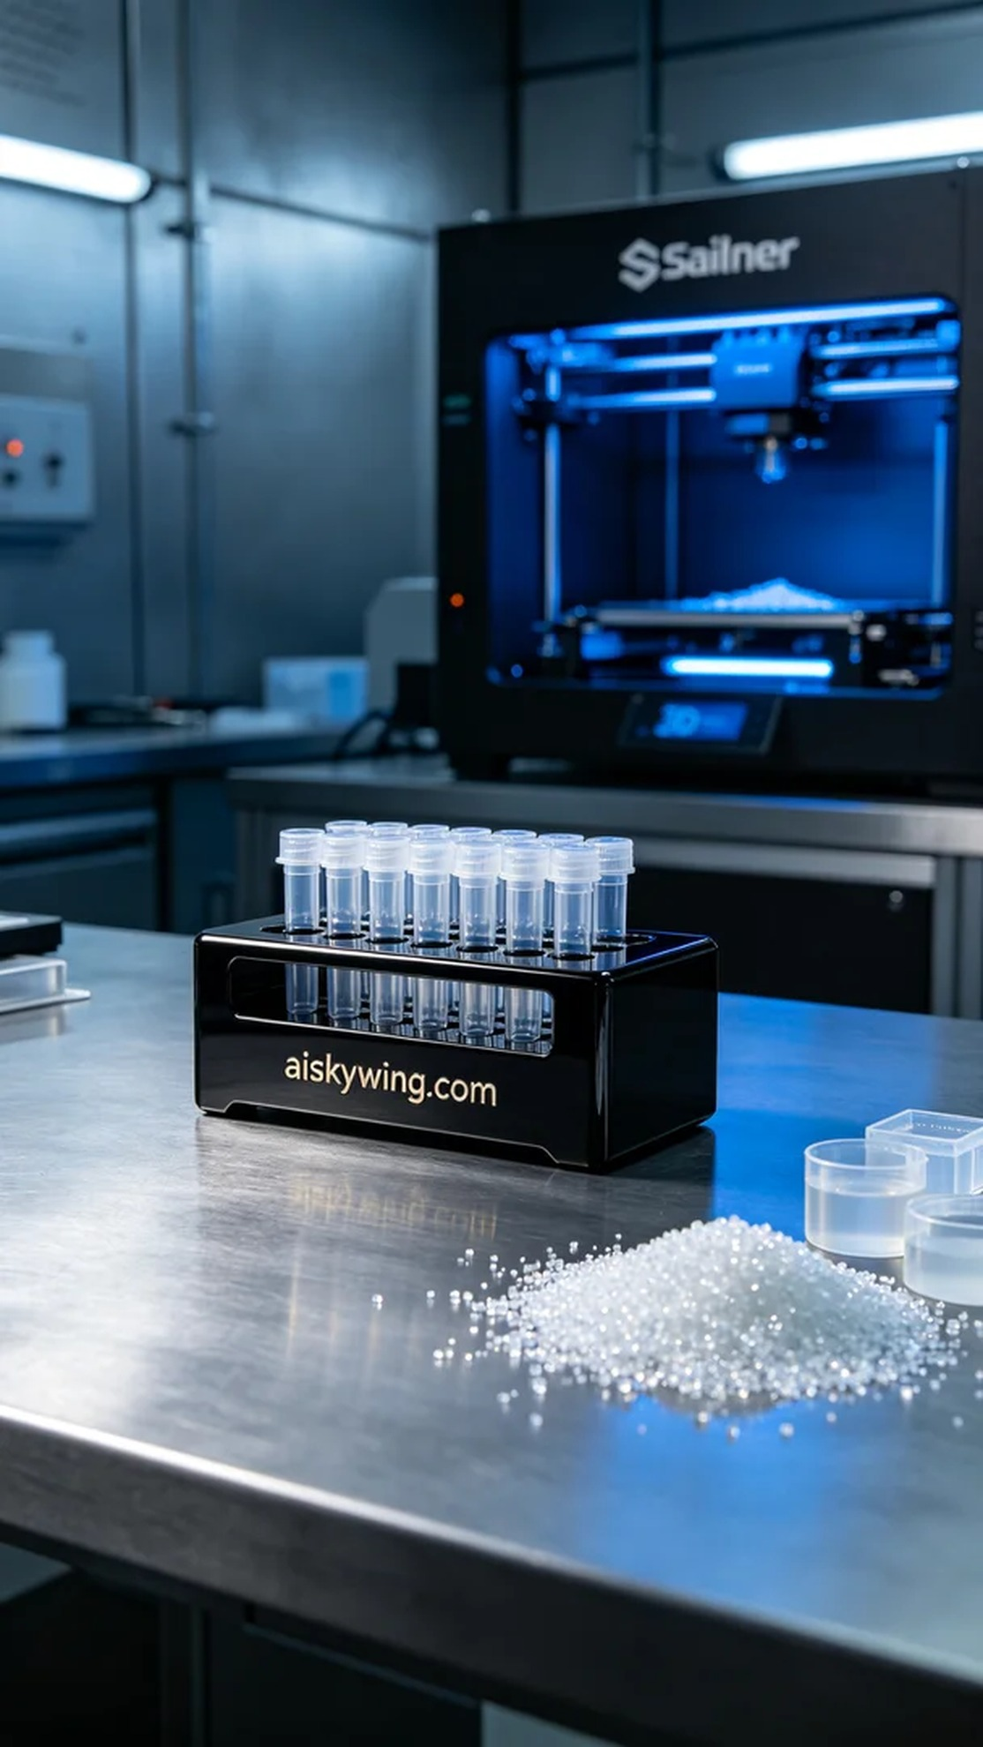
Recently, we received a request for the production of a medical PCR tube rack from someone looking for high-quality medical equipment on Instagram. They were in search of a product that was both aesthetically pleasing and practical. After some discussion, we decided to use SLA photopolymer resin for printing to ensure the quality and fine details of the product.
The raw material we used is SLA photopolymer resin, which is widely utilized in the manufacturing of medical devices due to its excellent fluidity and high precision. To ensure stable quality during the printing process, we set the parameters on the Stratasys printer: a layer thickness of 0.05 mm, a printing temperature of 25 degrees Celsius, a laser power of 50 milliwatts, a printing speed of 30 mm per second, and an estimated printing time of about two hours.
During the printing process, the Stratasys printer operated smoothly. We continuously monitored the print quality from start to finish. The print head followed the design file closely, ensuring that every layer was as perfect as possible. There were no blockages or drops throughout the print, and the resulting structure was clear, with a smooth surface.
After printing, we moved on to the post-processing phase. First, we cleaned the printed rack with isopropyl alcohol to remove any excess resin. Next, we sanded it down to achieve an even smoother surface. Then, we placed it in the UV curing machine for solidification, ensuring the material's hardness and strength were optimal. Finally, we conducted a thorough inspection of the product to ensure that every detail met the standards.
In the end, after a series of meticulous processes, we successfully produced a satisfying medical PCR tube rack. This not only makes me proud but also serves as the best proof of our team's spirit of cooperation and technical strength.
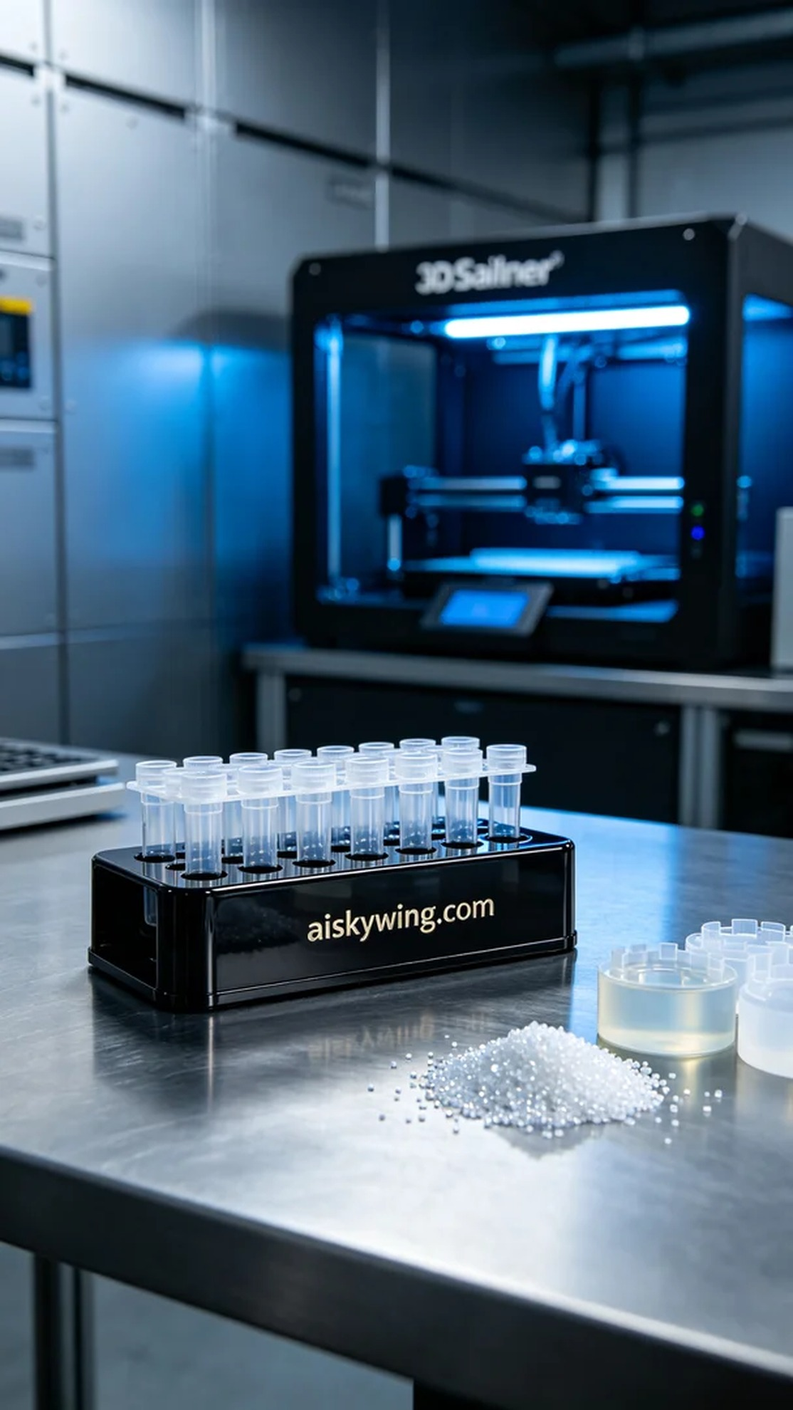
这次制作医用PCR管架的需求源于一位关注高精度医疗器械的朋友。他们希望能得到一款既美观又实用的产品。经过沟通，我们决定采用SLA光固化树脂来打印这个管架，以确保产品的质量和细致度。
我们使用的原材料是SLA光固化树脂，这种材料因其良好的流动性和高精度而被广泛应用于医疗器械的制造。为了确保打印过程中质量的稳定，我们设置了Stratasys打印机的参数：层厚0.05毫米，打印温度保持在25摄氏度，激光功率设置为50毫瓦，打印速度为30毫米每秒，预计打印时间约为两小时。
打印过程中，Stratasys打印机运行非常顺畅。我们从开始到结束都对打印质量进行了监控。打印头紧密跟随设计文件，确保每一层的细节都尽可能完美。整个打印过程中没有出现任何堵塞或脱落的现象，所生成的结构清晰可见，表面光滑。
完成打印后，我们进入了后处理阶段。首先，将打印好的管架用异丙醇进行清洗，去除多余的树脂。接着进行打磨，以确保表面更加光滑。然后，我们将其放置在UV固化机中进行固化处理，确保材料的硬度和强度达到最佳状态。最后，我们对产品进行了全面的检验，确保每一个细节都符合标准。
最终，经过一系列严谨的工序，我们成功制作出令人满意的医用PCR管架。这不仅让我感到自豪，更是对我们团队合作精神与技术实力的最好证明。
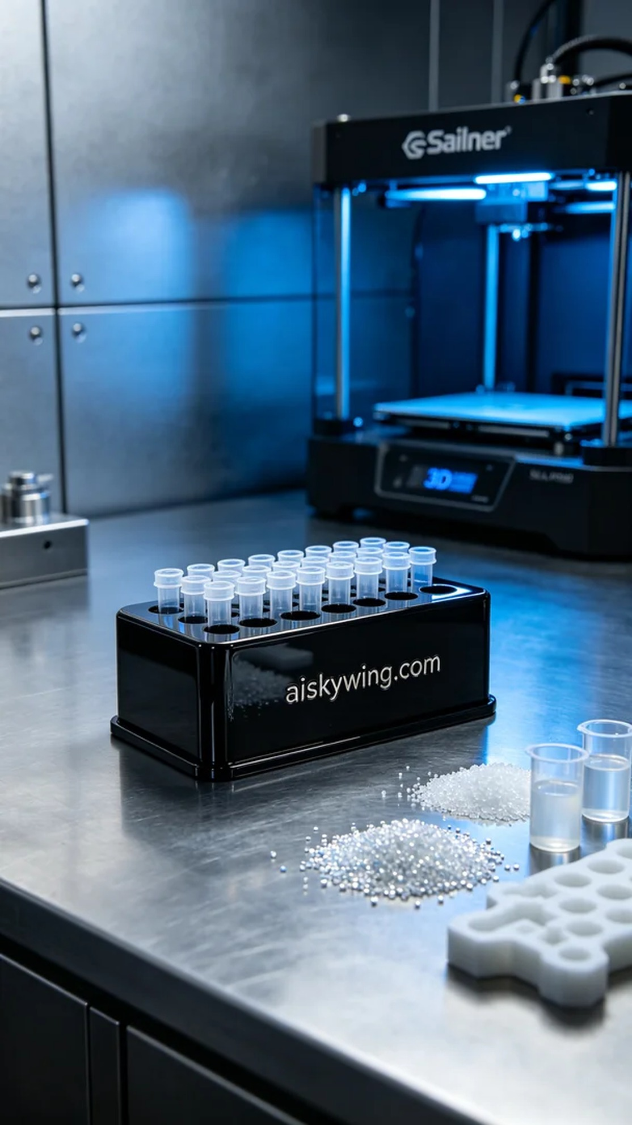
Aiskywing Industrial 3D Printing
Medical PCR tube rack


