0640-医用保护罩的3D打印生产日志
Medical protective cover
🖨️ SLA光固化
🖥️ 打印机: Voxeljet
📦 材料: SLA光固化树脂
生活就像3D打印，不断积累细节，最终成就完美。就在LinkedIn上，有人找到我们，希望能够制作出高质量的医用保护罩。
Life is like 3D printing, constantly accumulating details to ultimately achieve perfection. Recently on LinkedIn, someone reached out to us hoping to produce high-quality medical protective shields.
________________________________________________________________________________
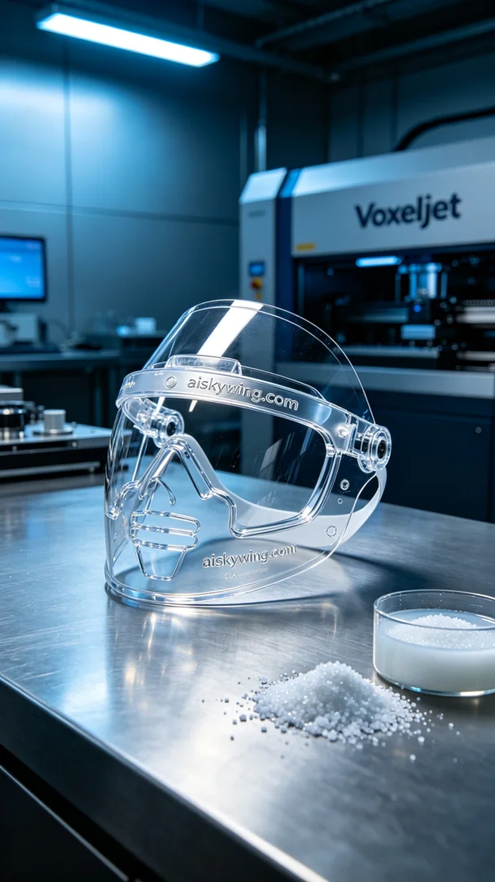
Life is like 3D printing, accumulating details to achieve perfection in the end. On LinkedIn, someone reached out to us, hoping to create a high-quality medical face shield in response to the growing demand.
To meet these requirements, we opted for SLA photopolymer resin as the printing material. This material has excellent gloss and transparency, enabling us to effectively showcase the product's details. Before printing, we adjusted the Voxeljet printer and set the layer thickness to 0.05mm, maintained the printing temperature at 25°C, set the power to 50mW, and established a printing speed of 30mm/s. The entire printing process was expected to take about 4 hours.
As the printing began, the equipment operated smoothly, and we closely monitored the model's formation. The photopolymer resin rapidly cured after exposure to light, ensuring the structural stability of the face shield. By continuously monitoring print quality, we timely adjusted the printing parameters to ensure the final product achieved the best results.
Once the printing was completed, we proceeded with the post-processing steps. First, we placed the printed face shield in a cleaning tank and thoroughly cleaned it with isopropanol to remove any excess resin. Next, we sanded the surface with fine sandpaper to ensure it was smooth and flawless. Finally, we conducted a curing process to enhance the material's strength, strictly inspecting its transparency and gloss during quality checks.
After all these processes, our medical face shield was finally completed, showcasing a transparent and glossy finish that perfectly met our expectations. This production experience not only deepened my understanding of SLA technology but also highlighted how every detail can impact the final product quality.
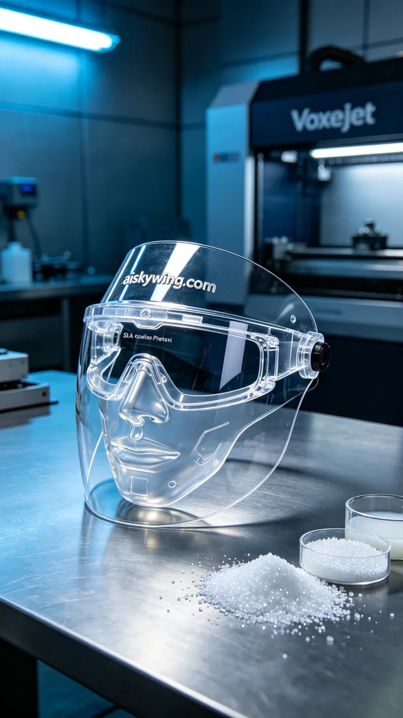
我们接到一个来自LinkedIn的请求，有人因疫情防控需要定制一款医用保护罩，以应对日益增长的需求。这位朋友对产品的透明度和耐用性有很高的要求，希望能够通过3D打印技术实现他的想法。
为了满足这些要求，我们选用了SLA光固化树脂作为打印材料。这种材料具有良好的光泽和透明度，能够有效实现产品的细节呈现。在打印前，我们使用Voxeljet打印机进行设备的调试，设置了层厚为0.05mm，打印温度保持在25°C，功率设定为50mW，打印速度为30mm/s，预计整个打印过程将耗时约4小时。
打印开始后，设备运转平稳，我们密切关注着模型的形成。光固化树脂在每一层的曝光后迅速固化，确保了保护罩的结构稳定。通过实时监测打印质量，我们及时调整打印参数，以确保成品达到最佳效果。
打印完成后，我们进行了后处理工序。首先将打印出的保护罩放入清洗槽中，使用异丙醇对其进行彻底清洗，去除多余的光敏树脂。接着，我们用细砂纸对表面进行打磨，确保光滑无瑕。最后，进行了固化处理，以增强材料的强度，检验时对其透明度和光泽度进行了严格把关。
经过这一系列的加工，我们的医用保护罩终于完成，外观透明且高光泽，完美达到预期效果。这次的生产经验不仅让我更加熟悉SLA工艺，也让我认识到每一个细节都能影响最终的成品质量。
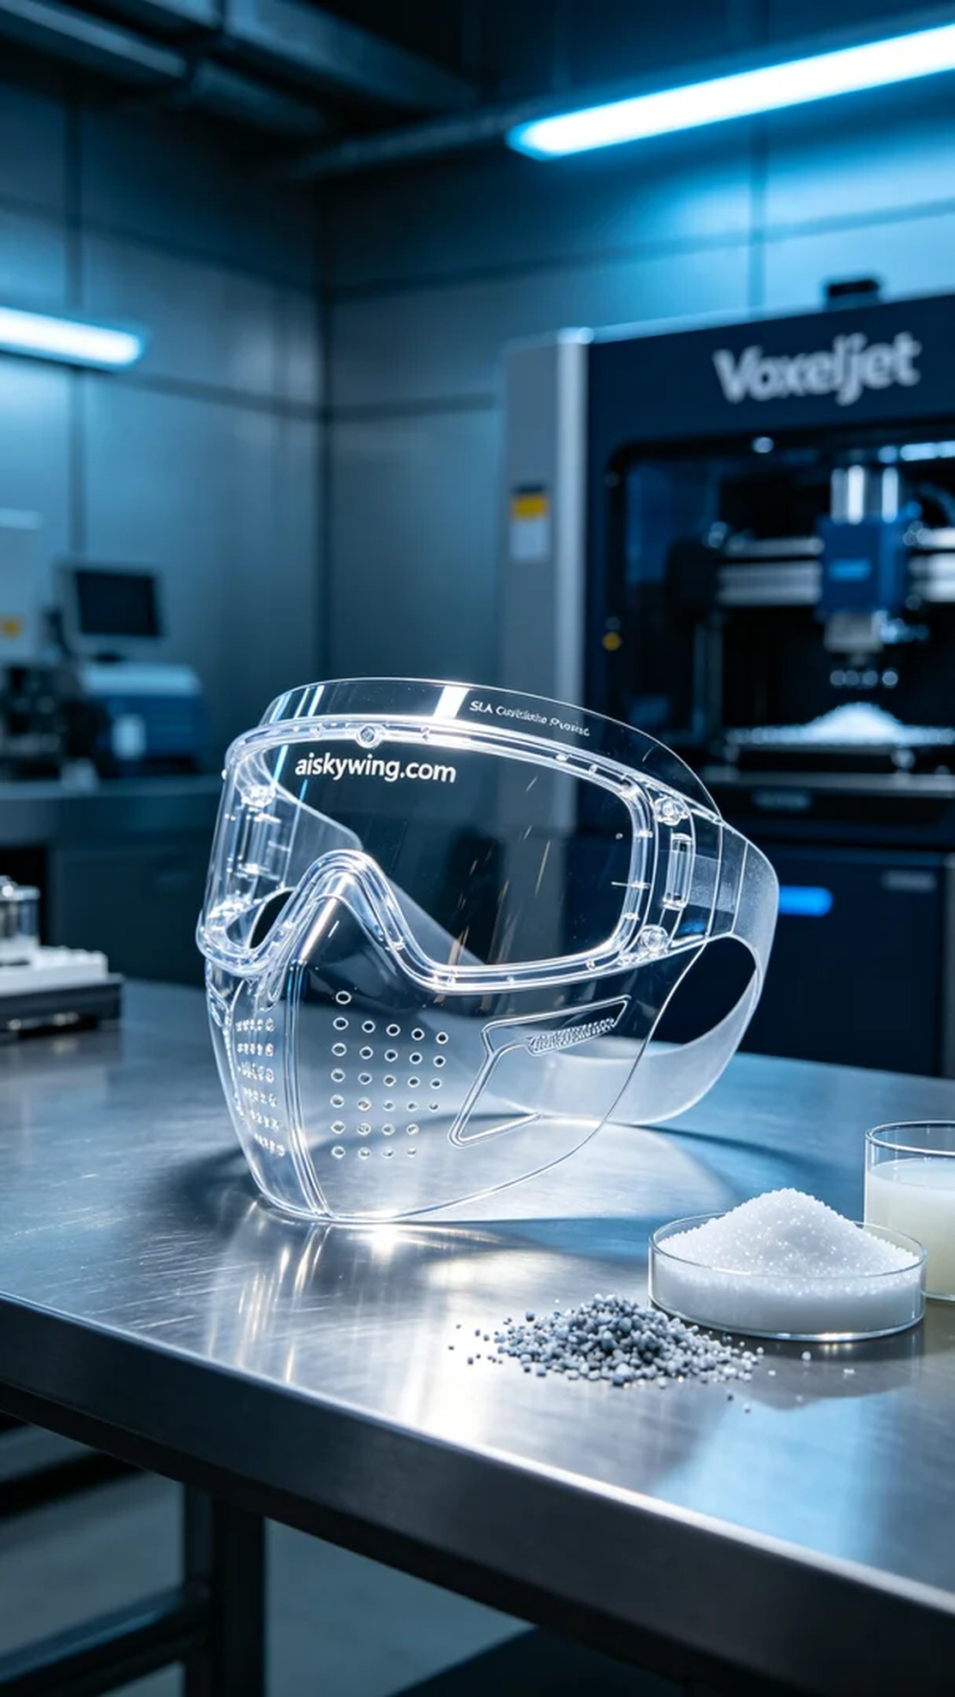
Aiskywing Industrial 3D Printing
Medical protective cover


