0641-医用冻存管架3D打印生产记录
Medical Cryopreservation Tube Rack
🖨️ SLA光固化
🖥️ 打印机: Voxeljet
📦 材料: SLA光固化树脂
在Facebook上，有人因为医用冻存管架的需求找到了我们。这让我想到，生活总会让我们面对挑战，而我们总能通过努力创造出更好的东西。
On Facebook, someone reached out to us due to the need for medical cryopreservation tube racks. This made me think that life always presents us with challenges, and we can always create better things through our efforts.
________________________________________________________________________________
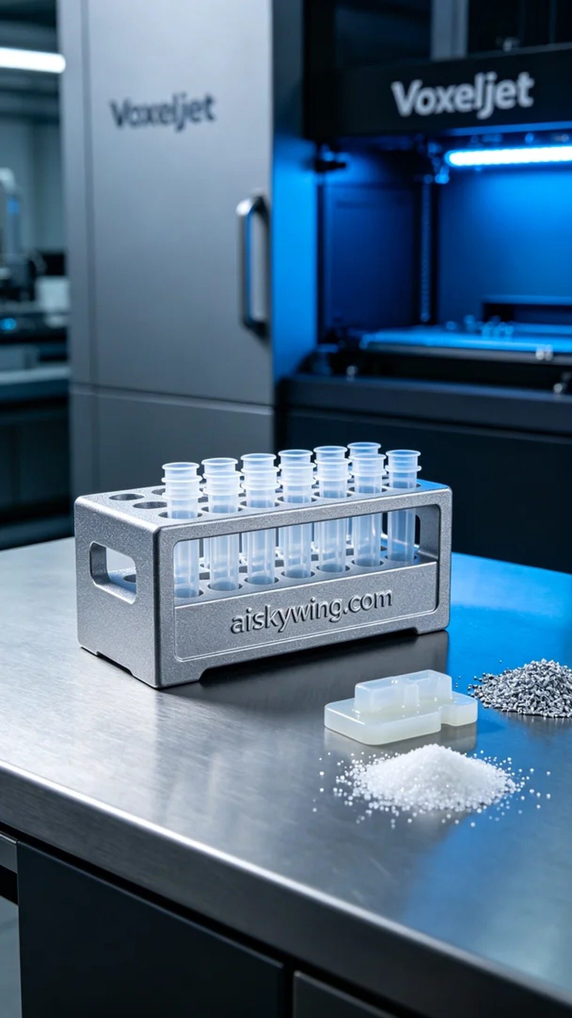
On Facebook, someone reached out to us with a request for a medical cryopreservation tube rack. They were looking for a 3D printing solution that could deliver both precise functionality and the capability for mass production.
Today's printing project will utilize SLA photopolymer resin, which holds high value in the medical field for its excellent chemical resistance and mechanical properties. During the equipment preparation phase, we equipped the Voxeljet 3D printer and set the layer thickness to 50 microns, maintained the printing temperature at 25°C, with a laser power of 200 milliwatts and a printing speed of about 40 millimeters per second. The entire printing process is expected to take approximately 5 hours.
During the printing process, the Voxeljet printer operated smoothly, with the quality monitoring system continuously checking the print quality of each layer. Thanks to the properties of the SLA photopolymer resin, we observed excellent adhesion between the cured layers, ensuring a tight bond. As the printing progressed, the outlines of the final product became increasingly clear, generating a sense of anticipation.
After completing the print, we conducted thorough post-processing steps. First, the finished product was placed in a cleaning solution to remove uncured resin. Next, fine sandpaper was used to smooth the surface, ensuring a refined touch. Finally, we cured it under UV light to ensure the material's strength met the standards and performed a final inspection to confirm that the engraving of "aiskywing.com" was clearly visible.
Through this 3D printing project, we successfully produced the medical cryopreservation tube rack. Looking at the final product, I felt a sense of accomplishment that truly fuels our dedication to our work.
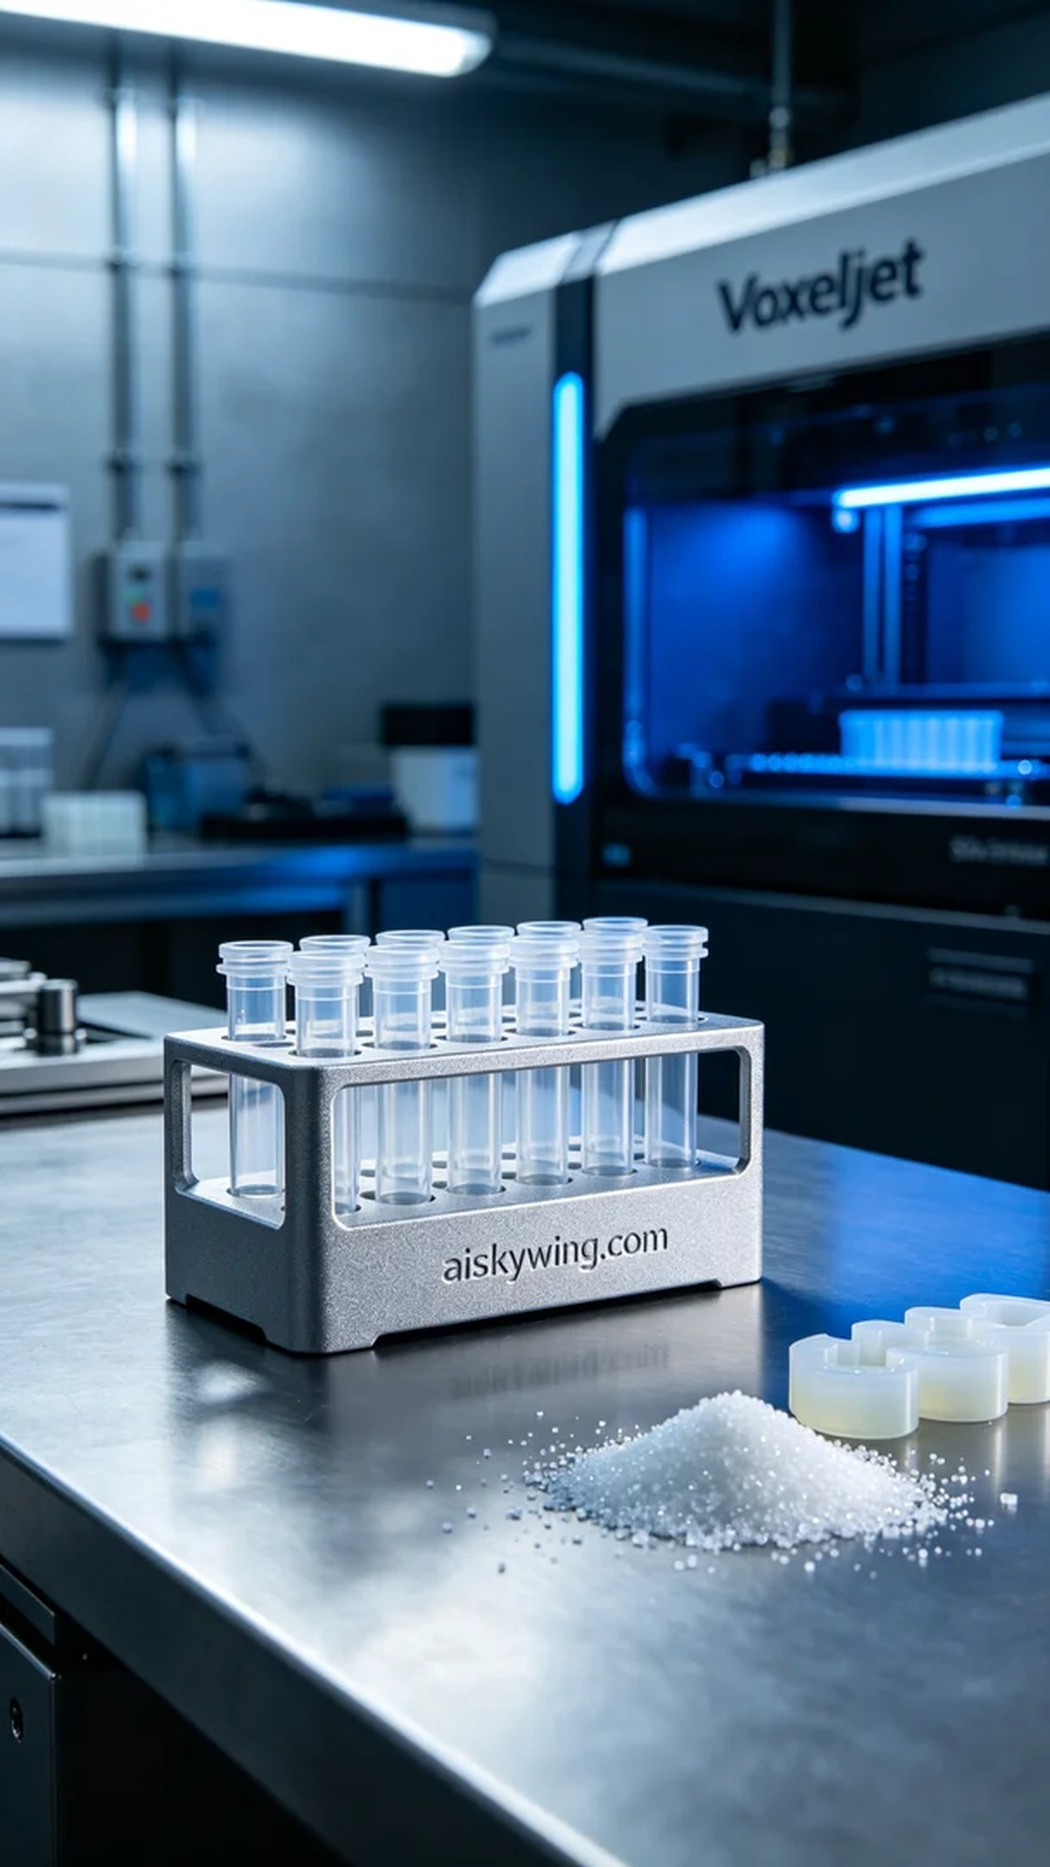
在Facebook上，有人因为医用冻存管架的需求找到了我们，询问能否用3D打印的方式生产出这种产品。他们希望能得到既具备精确功能又能满足批量生产的解决方案。
今天的打印项目将使用SLA光固化树脂材料，这种材料在医疗领域中有着非常高的应用价值，具备优良的耐化学性和机械性能。在设备准备阶段，我们使用了Voxeljet品牌的3D打印机，设定了层厚为50微米，打印温度保持在25℃，激光功率为200毫瓦，打印速度约为40毫米每秒。经过计算，整个打印过程预计耗时约5小时。
打印过程中，Voxeljet打印机的运行状态非常稳定，设备的质量监控系统实时监测着每一层的打印效果。由于SLA光固化树脂的特性，我们观察到固化后的层间附着力良好，确保了每一层之间的紧密连接。随着打印的进行，成品的轮廓逐渐清晰，令人期待。
完成打印后，我们进行了细致的后处理工序。首先，将成品放入清洗液中进行清洗，去除未固化的树脂。接着，使用细砂纸对表面进行打磨，以确保光滑度和细腻的触感。最后，我们在UV灯下进行固化，确保材料的强度达到标准，并进行最终的外观检验，确保“aiskywing.com”字样雕刻清晰可见。
通过这次的3D打印制作，我们成功地完成了医用冻存管架的生产。看着成品，我感到一种成就感，这正是我们努力工作的动力所在。
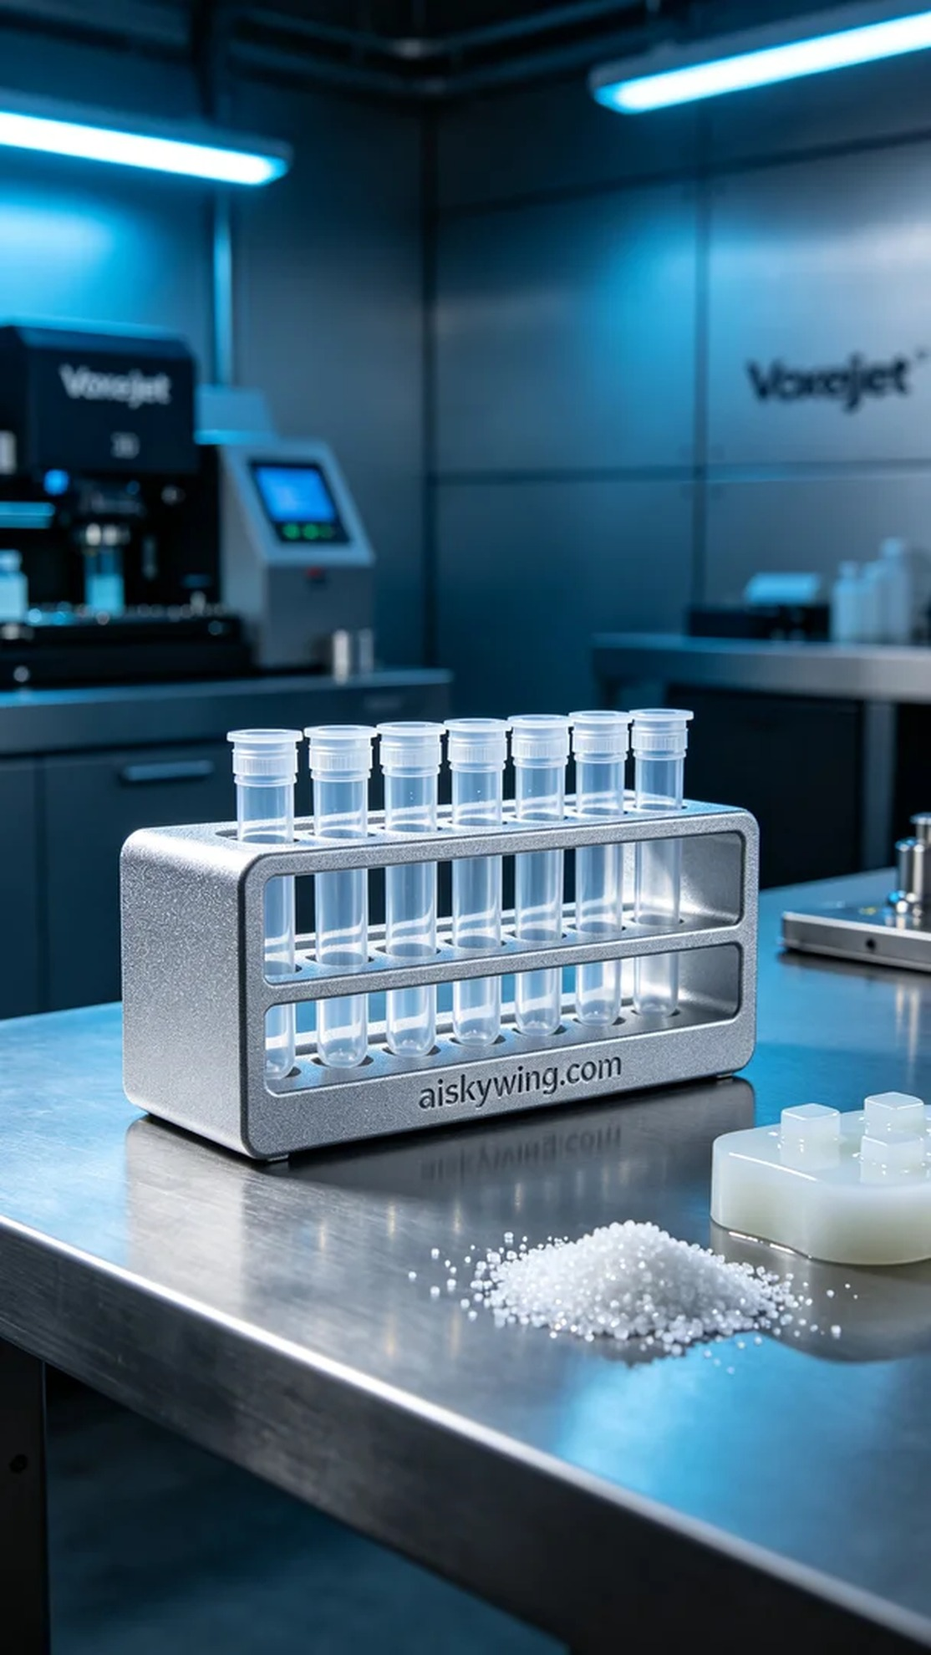
Aiskywing Industrial 3D Printing
Medical Cryopreservation Tube Rack


