0642-医用加样槽3D打印生产记录
Medical sample loading slot
🖨️ SLA光固化
🖥️ 打印机: Stratasys
📦 材料: SLA光固化树脂
在Twitter上看到有人在寻找一款医用加样槽，面对诸多挑战时，我想起了这件事情的分量，正如我们每一天都在为更好的产品努力。
I saw someone on Twitter looking for a medical sample tray. Faced with numerous challenges, I was reminded of the importance of this matter, just as we strive every day for better products.
________________________________________________________________________________
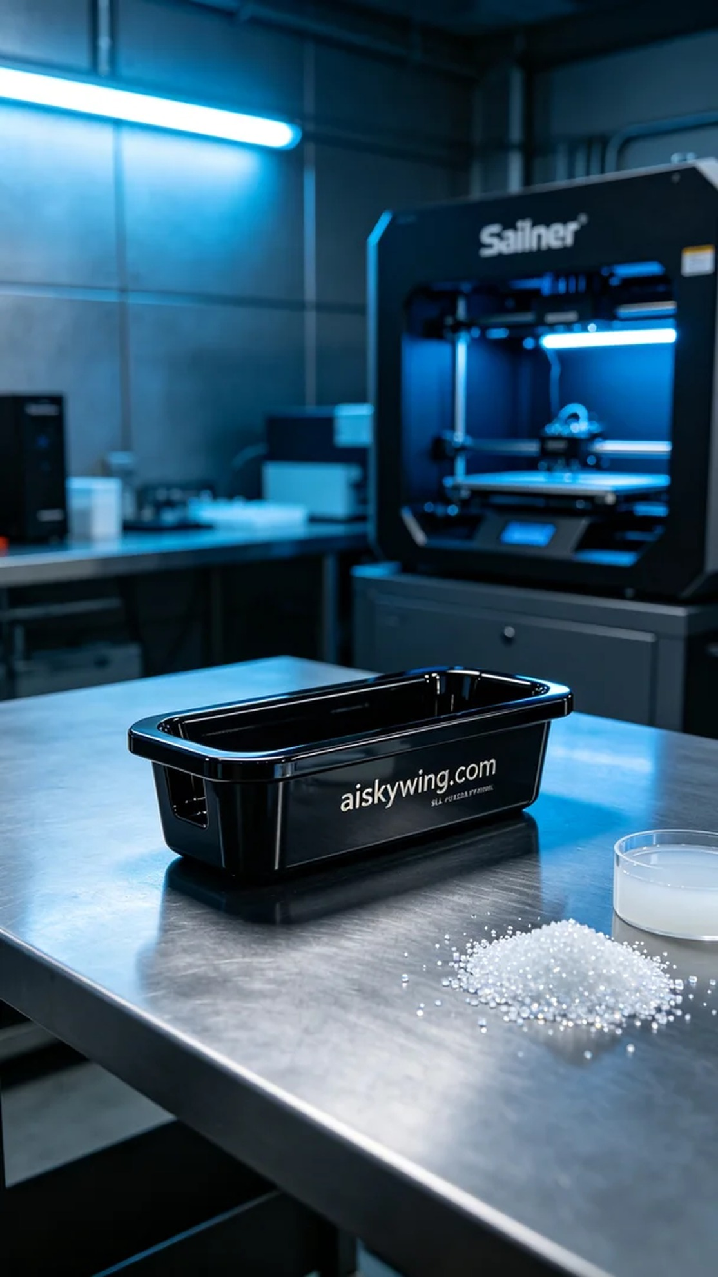
Recently, someone reached out to us looking to customize a medical sample reservoir. They were facing challenges in their laboratory, especially with sample handling and testing. This made me realize the importance of our work.
We selected SLA photosensitive resin as the raw material due to its excellent surface finish and precision. Before printing, we meticulously set the parameters on the Stratasys printer, with a layer thickness of 0.05 mm, a printing temperature of 25 degrees Celsius, power at 75%, and a speed of 40 mm per second, estimating a print time of about 4 hours.
During the printing process, the Stratasys printer operated steadily, evenly dispensing the photosensitive resin on the print platform. We closely monitored the printing status to ensure no bubbles or defects appeared. After some time, the reservoir gradually came into shape, and the quality was very satisfying.
Once printing was completed, we proceeded with post-processing. First, the finished product was placed in a cleaning tank with a specialized cleaning solution to remove any uncured resin from the surface. Next, we performed careful polishing to ensure every edge was smooth. Finally, the reservoir was placed in a UV curing machine for solidification to ensure that its strength met medical standards, followed by rigorous inspection to ensure complete compliance.
Ultimately, this medical sample reservoir was delivered on time, and everyone highly praised its quality and appearance. This production process not only brought us valuable experience but also reinforced our commitment to moving forward.
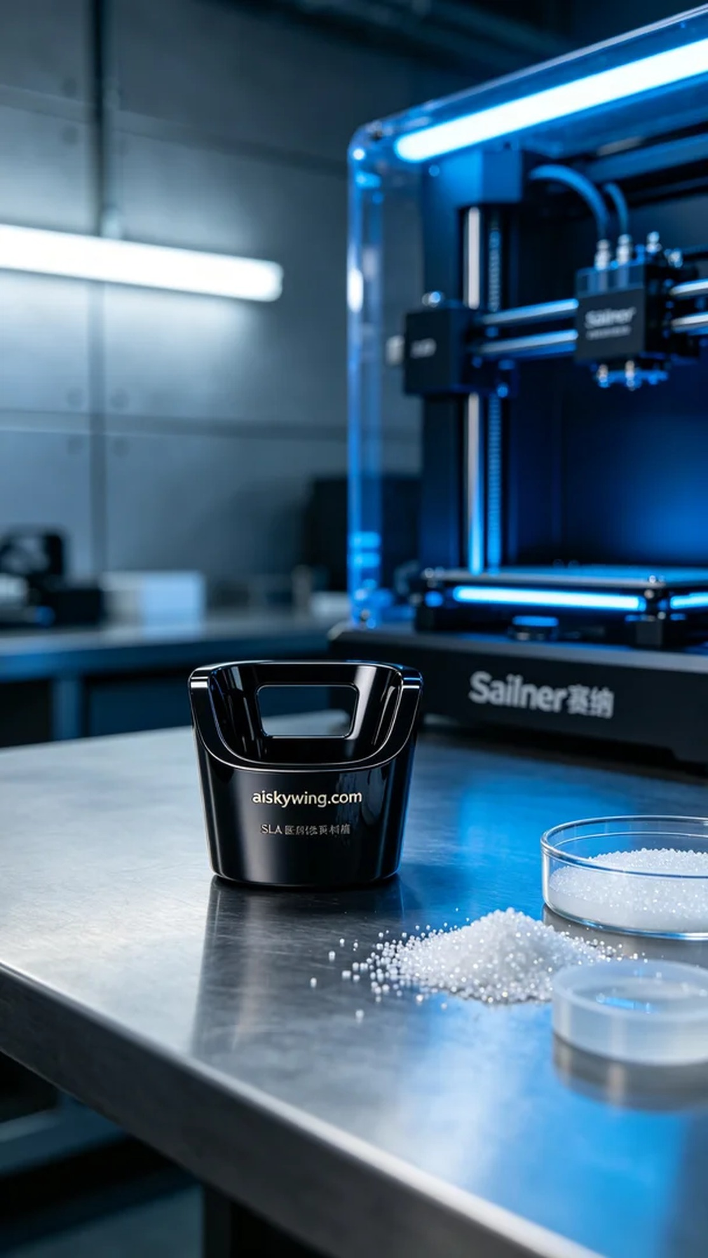
前几天，有人向我们求助，希望能够定制一款医用加样槽。他们在实验室里遇到了一些困难，特别是在样品处理和检测方面，希望通过我们的技术提高工作效率，这让我意识到这项工作的意义。
我们选择了SLA光固化树脂作为原材料，因为它具有优异的表面光洁度和精密度。准备打印之前，我们使用Stratasys打印机进行了详细的参数设置，层厚设定为0.05毫米，打印温度控制在25摄氏度，功率设定为75%，打印速度保持在40毫米每秒，预计打印时间为4小时。
在打印过程中，Stratasys打印机稳定运转，光固化树脂均匀地喷洒在打印平台上。我们时刻关注打印状态，确保没有出现气泡或其他缺陷。在一段时间后，层层叠加的加样槽逐渐成型，质量非常让人满意。
打印完成后，我们进行了后处理。首先将成品放入清洗槽中，使用专用清洗液清洗去除表面未固化的树脂。之后，我们进行了细致的打磨处理，以确保每一个边缘都光滑。最后，将加样槽放置在紫外线固化机中进行固化，确保其强度符合医用标准，之后经过严格的检验，确保产品完全合格。
最终，这款医用加样槽如期交付，大家对它的质量和外观都给予了高度评价。这次的生产过程不仅让我们收获了经验，更让我们坚定了继续前行的信念。
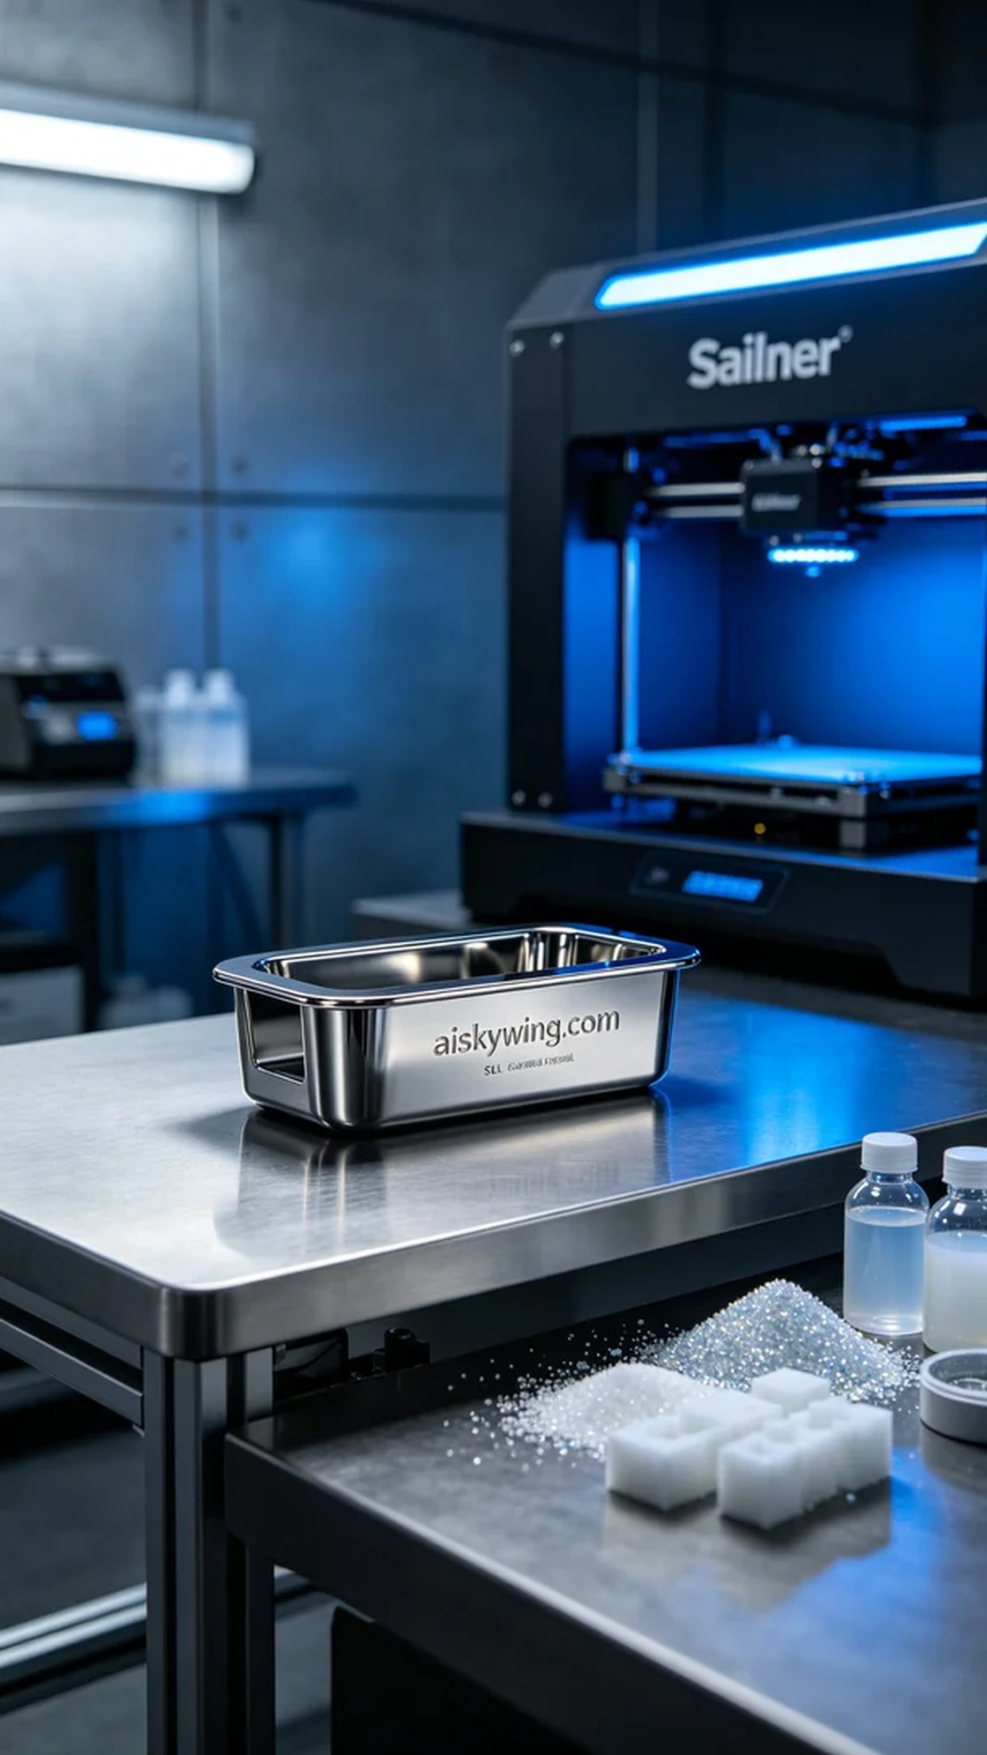
Aiskywing Industrial 3D Printing
Medical sample loading slot


