0643-医用口罩挂耳调节扣生产记录
Medical mask ear strap adjustment buckle
🖨️ SLA光固化
🖥️ 打印机: Systems
📦 材料: SLA光固化树脂
生活再难，也别停下脚步。就像接下这个医用口罩挂耳调节扣的单子，有人通过WhatsApp跟我说，他们需要一种既实用又美观的解决方案。
No matter how difficult life gets, don't stop moving forward. Just like when I took on the order for these medical mask ear strap adjusters, someone reached out to me via WhatsApp saying they needed a solution that is both practical and aesthetically pleasing.
________________________________________________________________________________
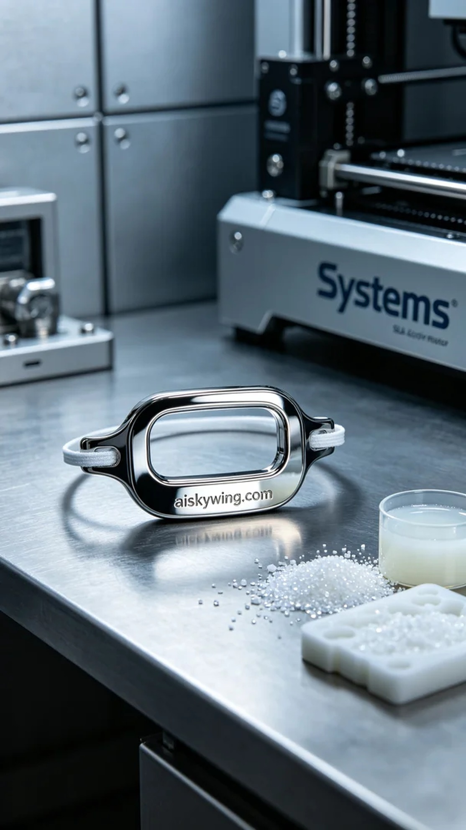
Sometimes life can be tough, but we must keep pushing forward. Recently, someone reached out to me through WhatsApp, asking for a comfortable ear adjustment clip for medical masks that is both functional and aesthetically pleasing.
For this project, we selected SLA photopolymer resin as the primary material. This resin offers excellent detail and strength, making it ideal for medical accessory production. We utilized a Systems 3D printer, setting the parameters to a layer thickness of 0.05 mm, maintaining a temperature of 20°C, a power setting of 150 mW, a printing speed of 30 mm/s, and an estimated print time of 2 hours.
During the printing process, the Systems printer operated smoothly, with the resin curing layer by layer, preserving the intricate design. I closely monitored the print quality throughout to ensure no bubbles or distortions occurred. After completion, the adjustment clips exhibited clean edges and surfaces, with no visible defects.
For post-processing, I first placed the printed clips into a cleaning solution to remove excess resin from the surface. After cleaning, I carefully sanded each piece to ensure a smooth surface for enhanced comfort when wearing. Next, we placed them in a curing machine for final solidification and, upon inspection, confirmed that all products met the required standards, successfully completing this production run.
Through a series of professional procedures, we successfully produced a batch of ear adjustment clips for medical masks that are not only functional but also elegant in appearance. Looking at the final outcome, I felt a sense of accomplishment.
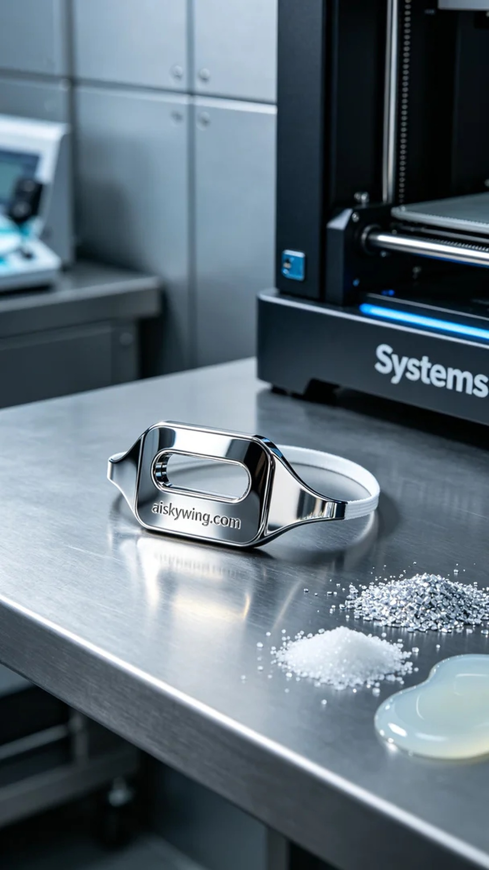
这次的任务是为医用口罩设计一个挂耳调节扣。我接到一个朋友的请求，想要改善现有的产品，避免耳朵的压迫感。他们希望这种调节扣能够在佩戴时更加舒适，且具备一定的美观性。
我们选择了SLA光固化树脂作为原材料，这种树脂具有优良的细节表现和强度，更适合精细化的医疗配件制作。设备方面，使用的是Systems品牌的3D打印机，打印参数设定为：层厚0.05 mm，温度保持在20℃，功率设定为150 mW，打印速度为30 mm/s，预计打印时间为2小时。
打印过程中，Systems打印机运行稳定，树脂逐层固化，保持着图案的细致和尖锐。在整个过程中，我时刻关注着打印质量，确保没有出现气泡或变形现象。打印完成后，调节扣的边缘和表面都显得干净利落，没有明显的瑕疵。
后处理方面，我们首先将打印好的调节扣放入清洗液中，去除表面多余的树脂。清洗结束后，我仔细地对每个部件进行打磨，确保其表面光滑，提升佩戴时的舒适度。接着，我们将其放入固化机中进行固化，最终经过检验，确认所有产品都达到标准后，顺利完成了这一批的生产。
经过一系列的专业操作，我们成功制作出了一批医用口罩挂耳调节扣，既符合实用功能，又具备了优雅的外观。看着最终的成果，心里满是成就感。
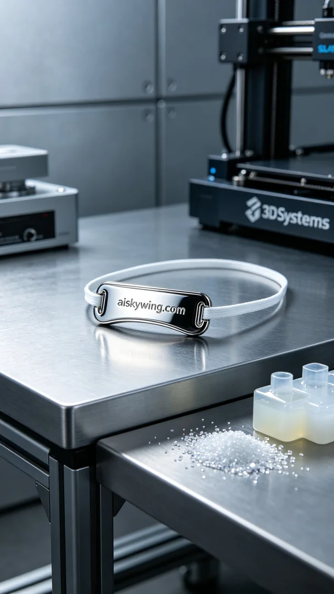
Aiskywing Industrial 3D Printing
Medical mask ear strap adjustment buckle


