0644-医用口罩支架3D打印生产记录
Medical mask bracket
🖨️ SLA光固化
🖥️ 打印机: EOS
📦 材料: SLA光固化树脂
生活就像3D打印，总是在不断调整和优化中前行。有人通过WhatsApp找上我们，希望制作一个医用口罩支架，以应对疫情带来的需求。
Life is like 3D printing, always moving forward through constant adjustments and optimizations. Someone reached out to us via WhatsApp, hoping to create a medical mask support to address the demand brought about by the pandemic.
________________________________________________________________________________
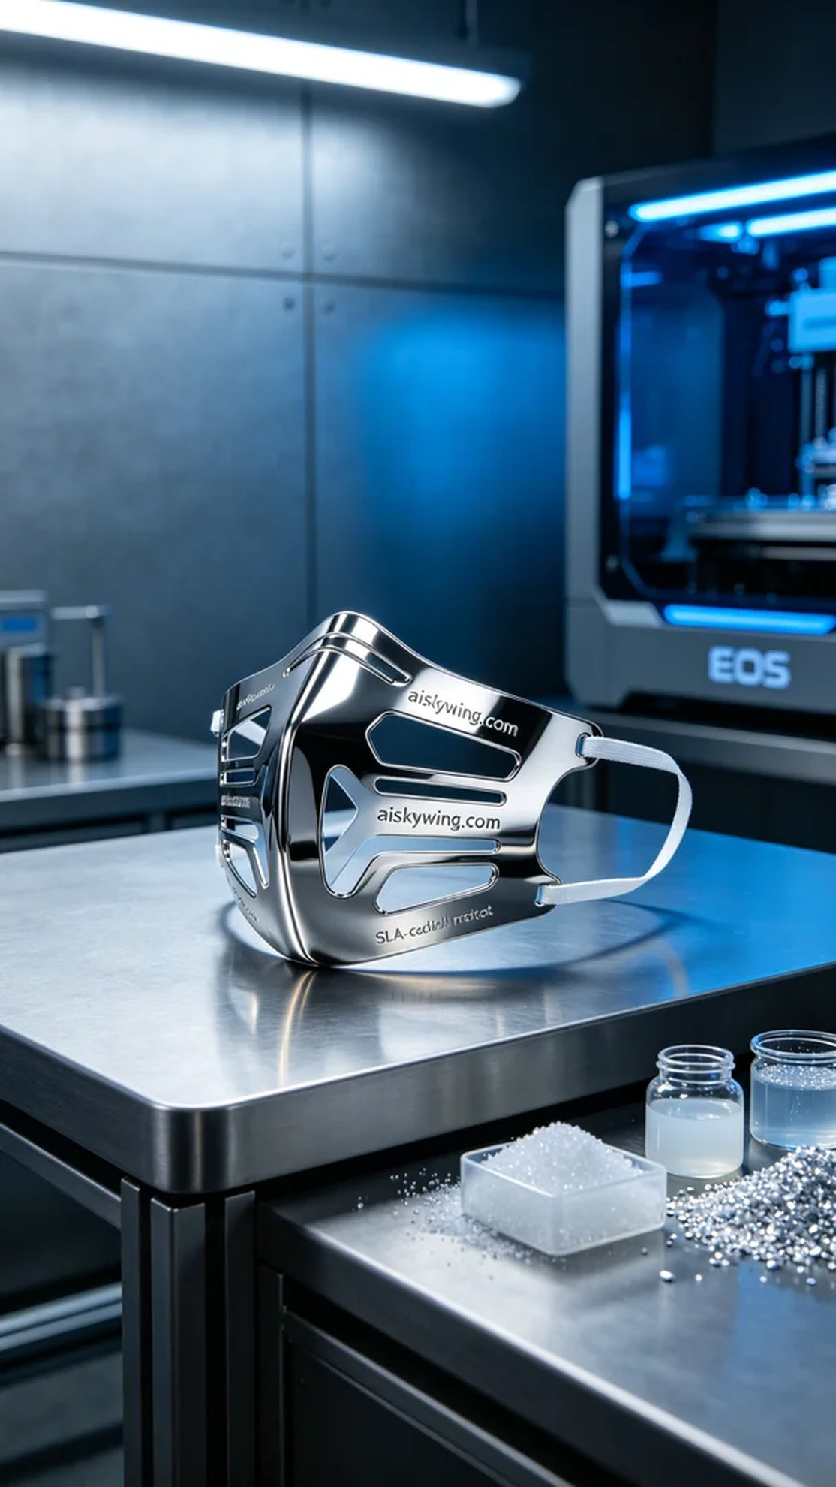
Life is like 3D printing, always adjusting and optimizing as we go. A friend reached out to us via WhatsApp, hoping we could create a medical mask support to enhance comfort for healthcare workers during the pandemic.
For this print, we used SLA photopolymer resin, known for its transparency, high strength, and chemical resistance, making it ideal for medical devices. We chose the EOS brand 3D printer, setting the layer thickness to 50 microns, maintaining a printing temperature of 25°C, adjusting the power to 50% to ensure stability during printing, and setting the printing speed to 30mm/s with an estimated total print time of 4 hours.
During the printing process, the EOS printer operated smoothly, with the resin curing layer by layer. We continuously monitored the print quality, using the printer's monitoring system to provide real-time feedback, ensuring perfect alignment for each layer, resulting in a flawless mask support with a smooth surface and clear detail.
After printing, we proceeded with post-processing. First, we immersed the printed part in a cleaning solution to remove excess resin, then sanded the surface with fine sandpaper to achieve the desired smoothness. Finally, we placed the support in a UV curing device to ensure material strength and stability, followed by a strict quality inspection to ensure every detail met the standards.
In conclusion, through this production, we not only manufactured a medical mask support but also showcased the potential and application of 3D printing technology in the medical field. Each effort is a hope for the future.
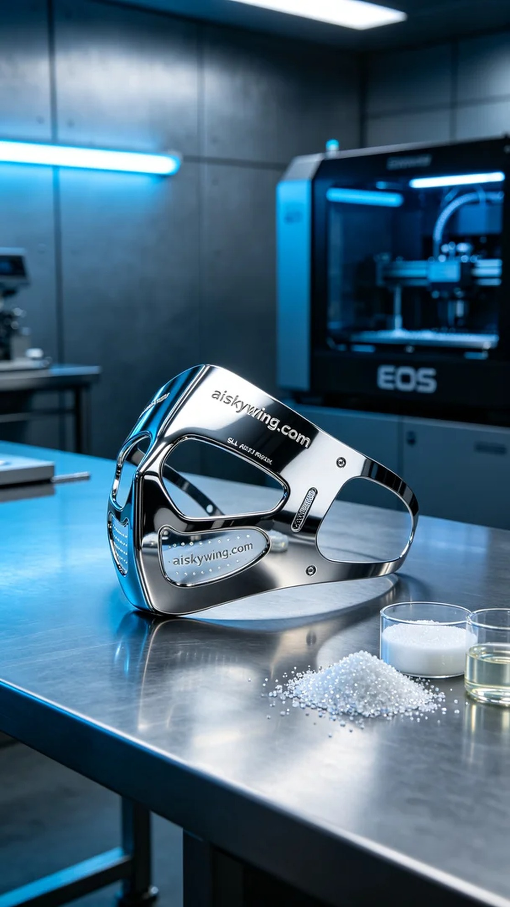
我们接到了一位朋友的请求，希望我们能帮忙制作一个医用口罩支架。他担心在疫情期间，医护人员的口罩佩戴舒适度不足，因此想要一个支架来提高使用体验。了解情况后，我们立刻开始准备。
此次打印使用的是SLA光固化树脂，这种材料具有透明度高、强度好和耐化学性强的特点，特别适合医疗器械的应用。我们选择了EOS品牌的3D打印机，设置了层厚为50微米，打印温度保持在25℃，功率调节在50%以确保打印过程中的稳定性，打印速度设置为30mm/s，预计总打印时间为4小时。
在打印过程中，EOS打印机稳定运转，树脂逐层固化，我们时刻关注打印质量。设备的监控系统在打印时提供了实时数据反馈，确保每一层的完美对位，最终得到了一个毫无瑕疵的口罩支架，表面光滑，细节清晰可见。
打印完成后，我们对支架进行了后处理。首先将打印件浸入清洗液中，清洗去除多余树脂，然后使用细砂纸对表面进行打磨，以达到理想的光滑度。最后，我们将支架放入固化设备中进行紫外线固化，确保材料的强度和稳定性，然后进行了严格的质量检验，确保每一个细节都符合标准。
最后，通过这次生产，我们不仅完成了一个医用口罩支架的制造，更是展示了3D打印技术在医疗领域的潜力和应用。每一次的努力，都是对未来的希冀。
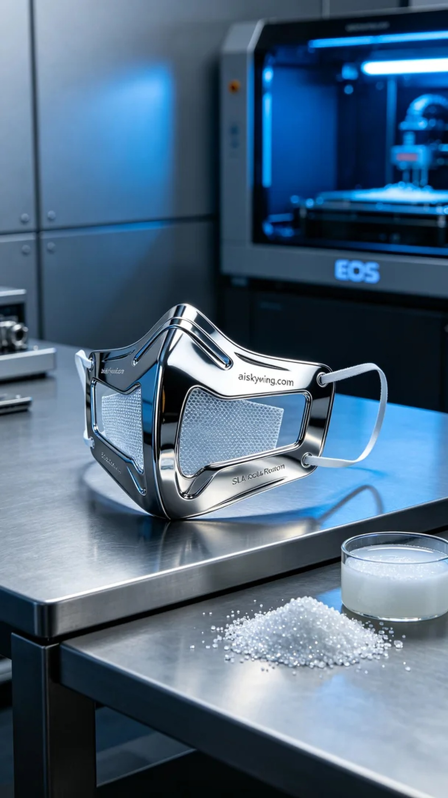
Aiskywing Industrial 3D Printing
Medical mask bracket


