0645-医用口罩鼻夹3D打印全记录
Medical mask nose clip
🖨️ SLA光固化
🖥️ 打印机: Voxeljet
📦 材料: SLA光固化树脂
在TikTok上看到大家对医用口罩鼻夹的需求，我决定接下这个活儿。这不仅是一份工作，更是在为健康出一份力。
Seeing the demand for medical mask nose clips on TikTok, I decided to take on this task. It's not just a job; it's also a contribution to health.
________________________________________________________________________________
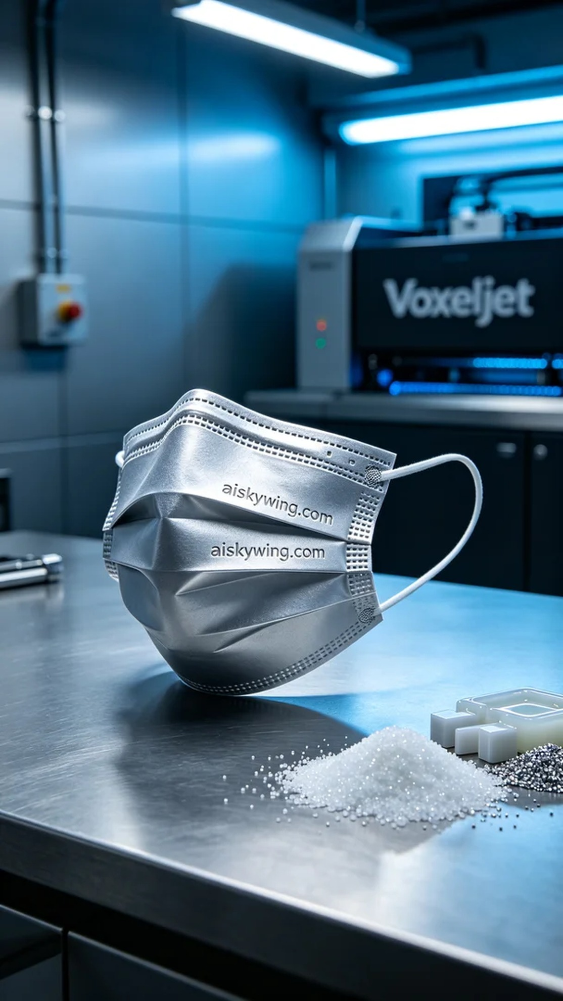
Today, we initiated the 3D printing of a medical mask nose clip, as someone reached out due to dissatisfaction with traditional clips, seeking a higher-quality product. This item not only requires precise craftsmanship but also safety assurance for use.
We chose SLA photopolymer resin as the raw material, known for its excellent fluidity and curing speed, which provides extreme clarity in details. The printer used is Voxeljet, set with a layer thickness of 0.05mm, operating temperature at 25 degrees Celsius, power set at 50mW, and a printing speed of 20mm/s, with an expected total printing time of 4 hours.
The printing process went smoothly, and the Voxeljet printer operated steadily. We regularly monitored the machine's status to ensure there were no failures or material shortages. Throughout this process, the machine's noise and vibrations remained within a controllable range, and each layer printed exhibited refined textures.
Post-processing is crucial. After printing, we first placed the product in a cleaning tank, using isopropyl alcohol for thorough cleaning to remove uncured resin. Next, we meticulously polished the surface to ensure smoothness, before placing the product under UV light for curing. Finally, a detailed inspection was conducted to ensure every detail met the standards before shipping.
After a series of rigorous procedures, the medical mask nose clip was finally completed. Seeing it on the silver-gray industrial table, emanating a matte luster, brings great satisfaction; this is not just the birth of a product, but a testament to our commitment to quality.
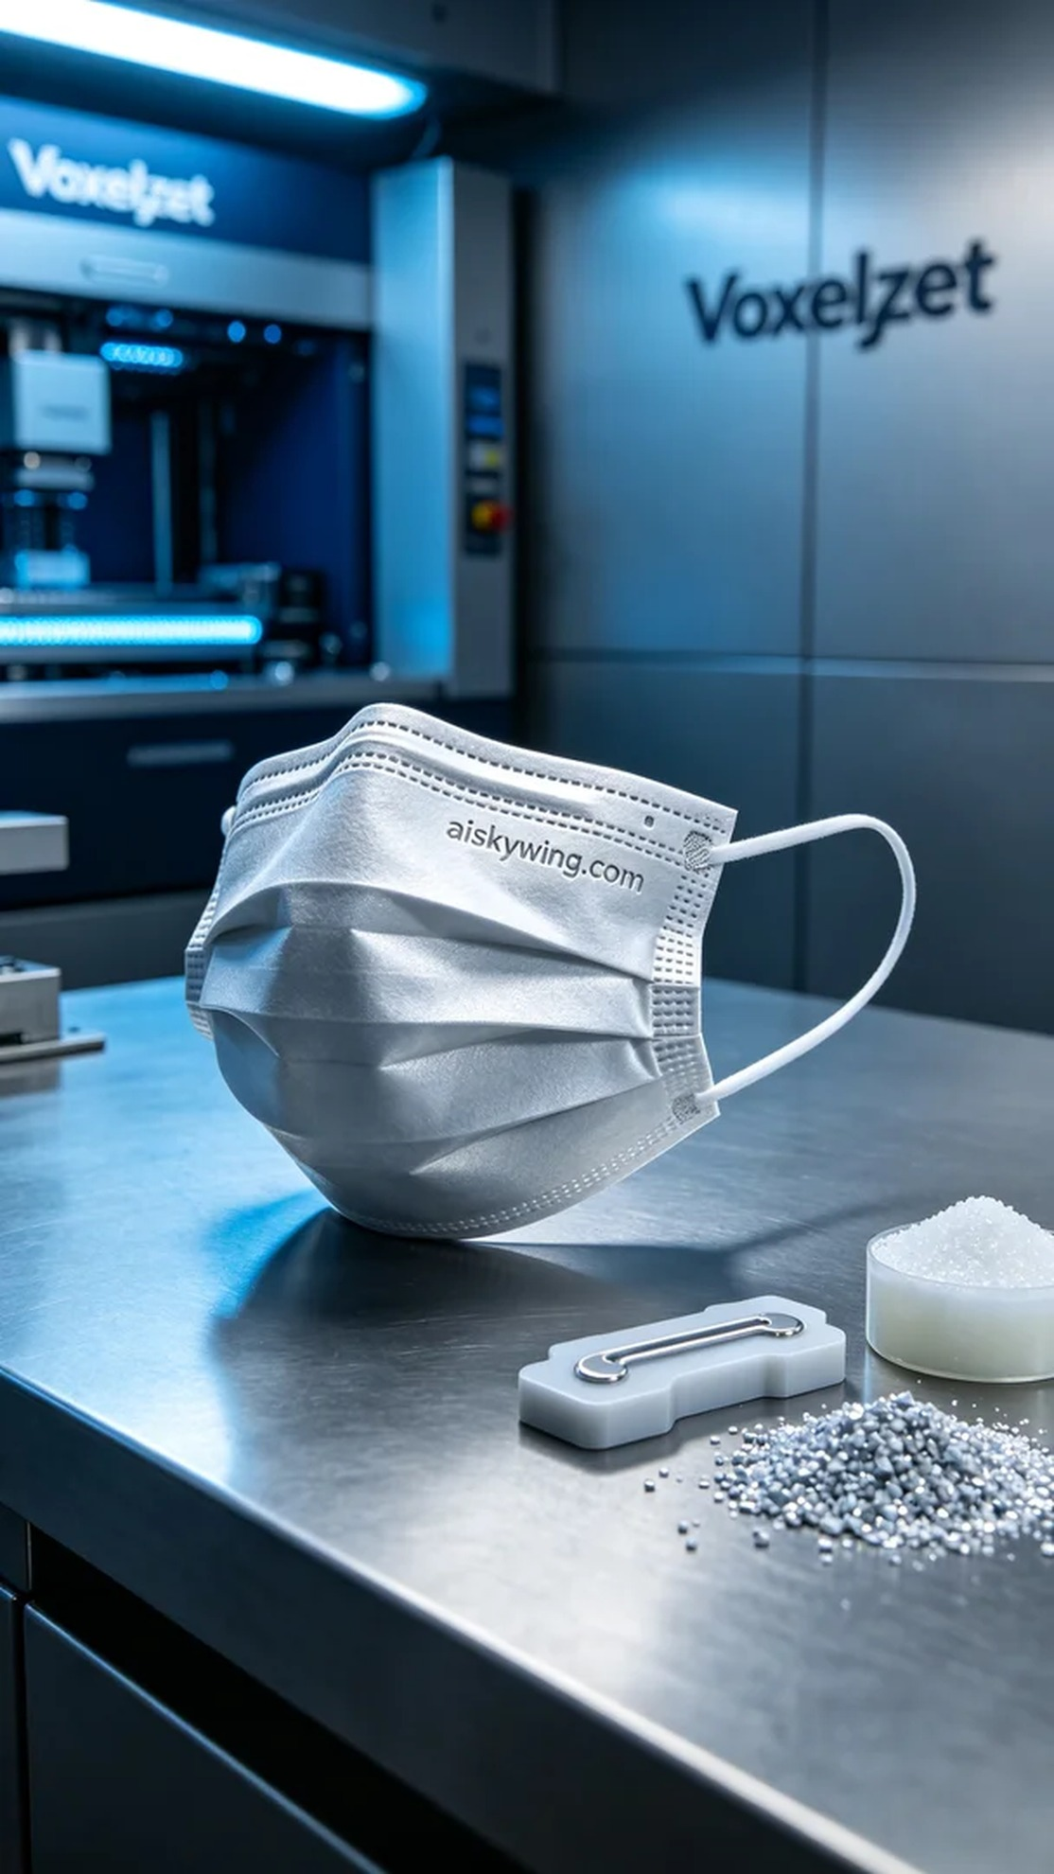
今天，我们开始了医用口罩鼻夹的3D打印工作，用户因对传统鼻夹的不满意而找上我们，希望能获得更高质量的产品。这个产品不仅需要精准工艺，还要保证使用的安全性。
我们选择了SLA光固化树脂作为原材料，这种树脂具有出色的流动性和固化速度，能够在细节上提供极致的清晰度。使用的打印机是Voxeljet，设置了层厚为0.05mm，打印温度保持在25摄氏度，功率设定为50mW，打印速度则为20mm/s，总体打印时间预计为4小时。
打印过程相当顺利，Voxeljet打印机稳定运行，我们定期监控设备的状态，以确保没有出现任何故障或材料短缺的情况。在这个过程中，机器的噪音和振动都在可控范围之内，打印出来的每一层都展现了细腻的质感。
后处理工序是至关重要的。打印完成后，我们首先将成品放入清洗槽，使用异丙醇进行充分清洗，以去除未固化的树脂。接着进行细致的打磨，确保表面光滑，然后将产品放入UV灯下固化，最后再进行细致检验，确保每个细节都符合标准，才能发货。
经过一系列严谨的工序，医用口罩鼻夹终于完成。看到它在银灰色的工业桌面上散发着哑光的光泽，令人心满意足，这不仅是产品的诞生，更是我们对品质的坚持与追求。
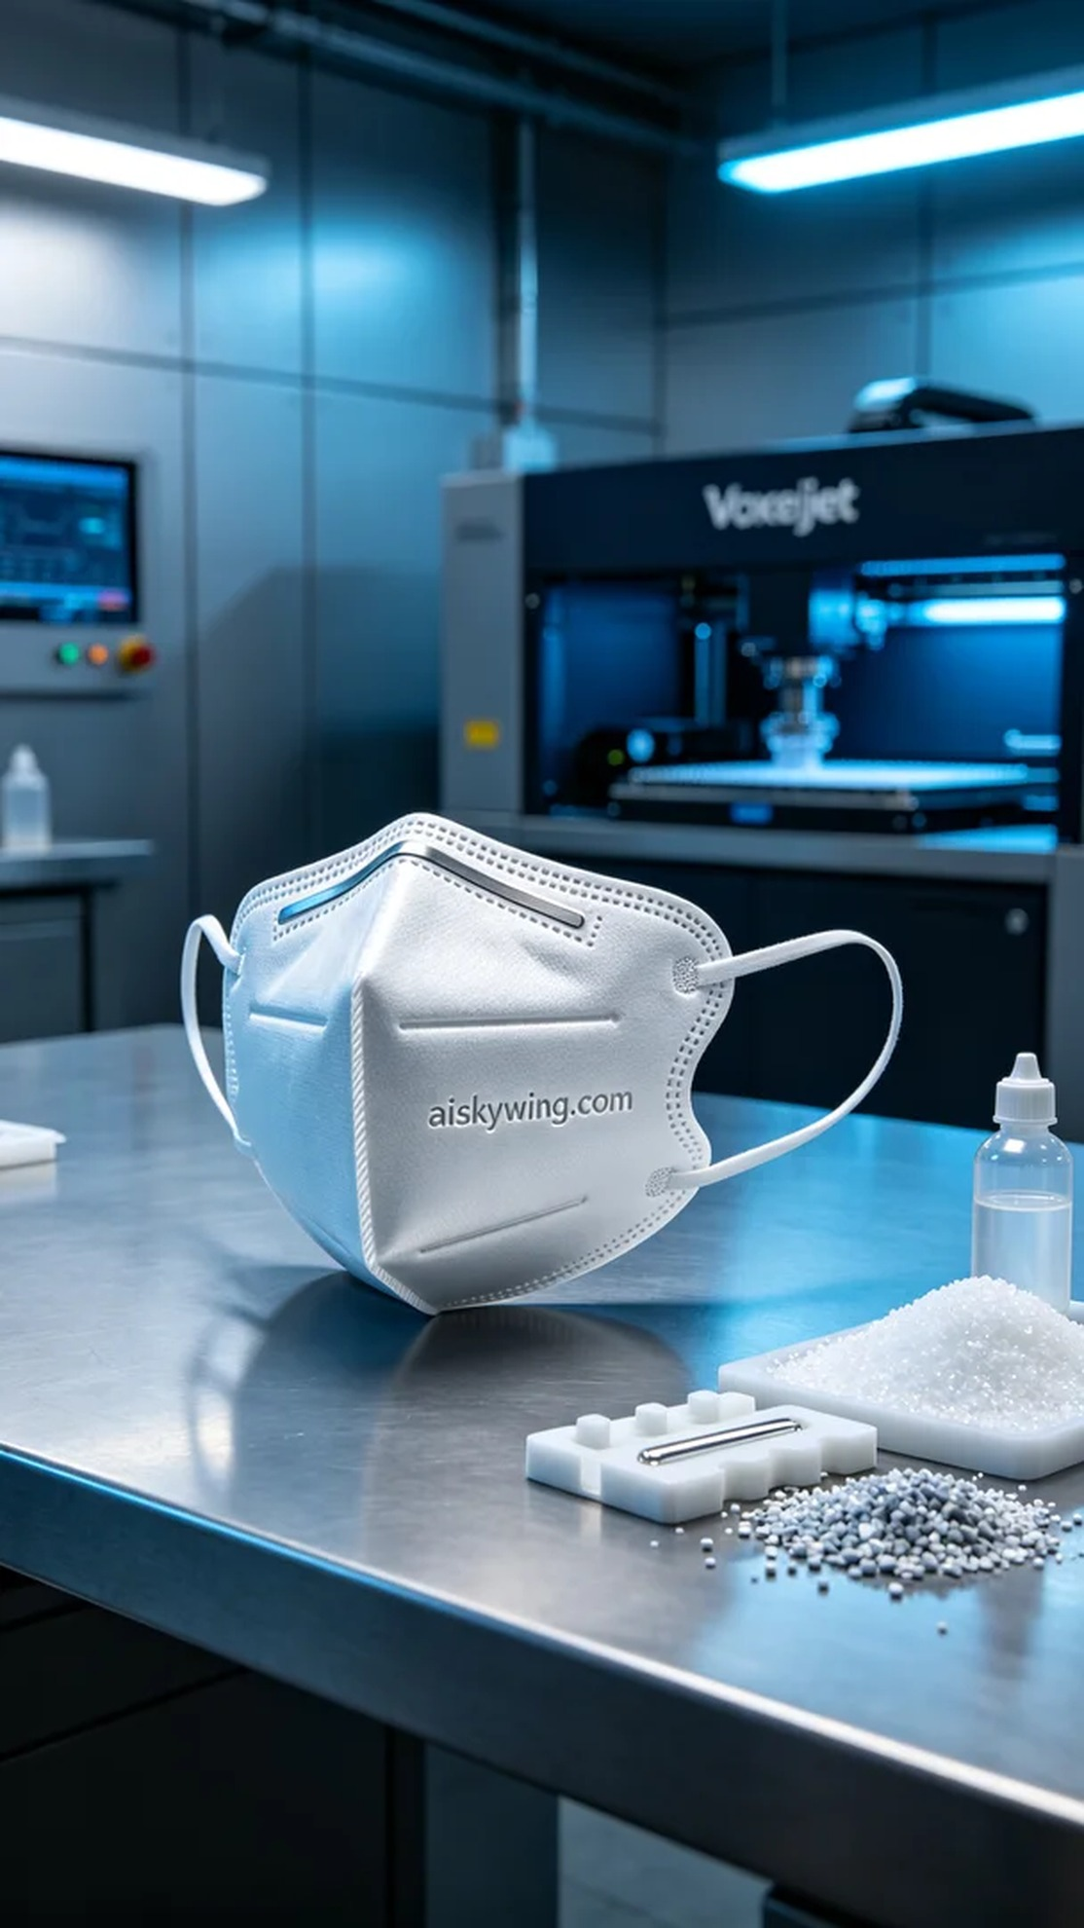
Aiskywing Industrial 3D Printing
Medical mask nose clip


