0646-医用吸引器外壳3D打印生产记录
Medical suction device shell
🖨️ SLA光固化
🖥️ 打印机: Stratasys
📦 材料: SLA光固化树脂
生活再难，也别停下脚步。就像接下这个医用吸引器外壳的单子，有人就是因为技术需求而来找我们。
No matter how difficult life gets, don't stop moving forward. Just like taking on this order for a medical suction device casing, some people come to us because of technical requirements.
________________________________________________________________________________
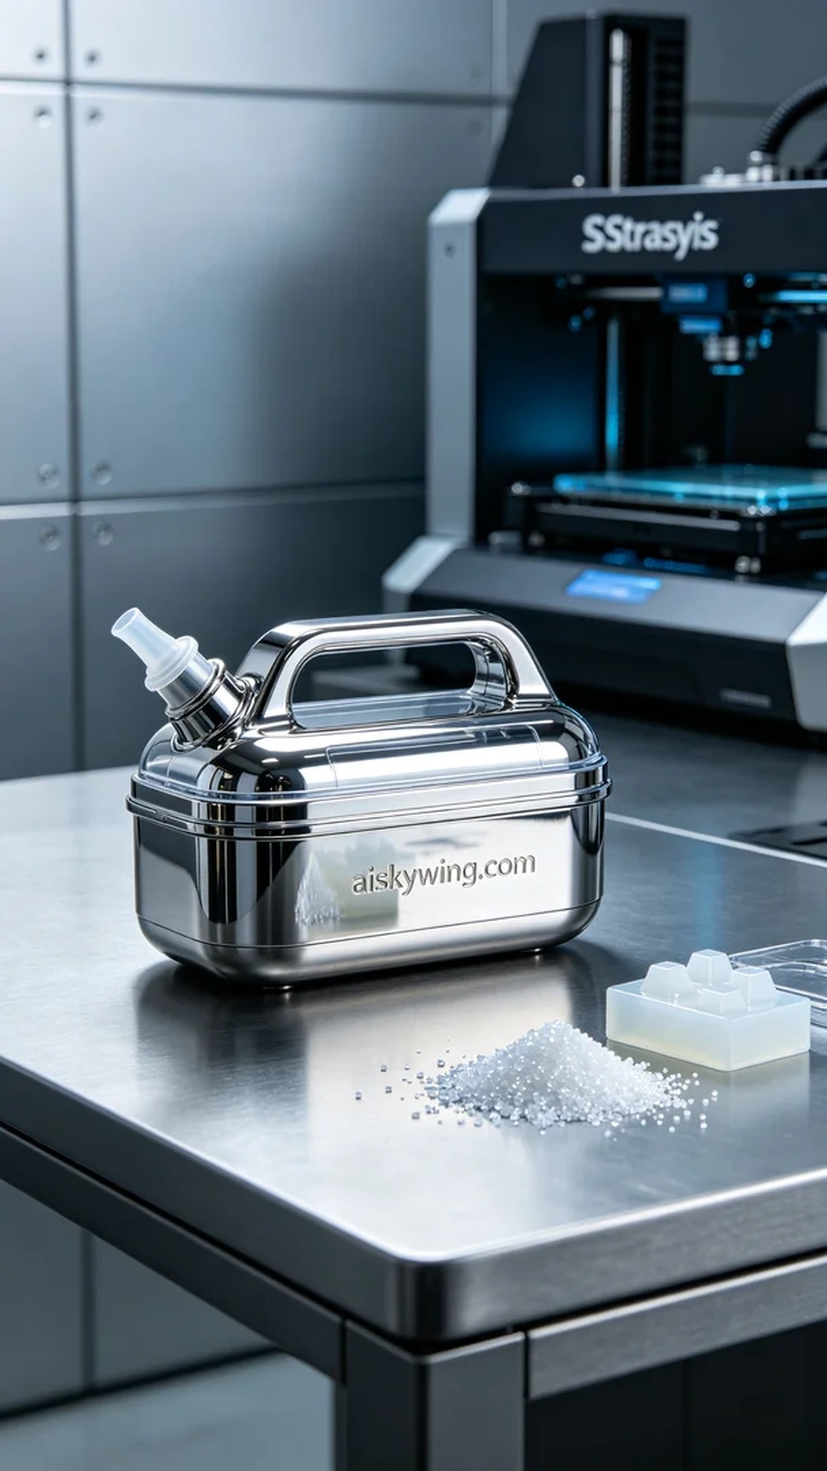
This project originated from a post on Twitter where someone needed to produce a medical aspirator shell with high expectations for both aesthetics and quality. They reached out to us to leverage our 3D printing technology to create a product that is both beautiful and practical.
We chose SLA photopolymer resin as our material due to its excellent forming properties and high detail rendering capabilities, making it ideal for medical device production. To ensure the printing quality, we utilized a Stratasys brand 3D printer, setting the layer thickness to 0.05mm, maintaining a printing temperature of 25℃, with a power setting of 50W and a print speed of 30mm/s. The entire printing process was expected to take around 8 hours to complete.
During the printing process, we performed real-time monitoring of the equipment to ensure the quality of each layer. We paid particular attention to the stability of the light source in the early stages of printing to avoid the formation of light spots. After approximately 6 hours of operation, the printer successfully completed the entire forming process of the aspirator shell, resulting in a smooth surface with clear details that met our expectations.
Next came the post-processing steps. We first placed the formed shell into a cleaning tank, using a dedicated cleaning solution to remove any residual resin from the surface. After cleaning, we meticulously polished the shell to enhance its smoothness and glossiness. Finally, we placed the shell in a UV curing machine to ensure its strength and durability. Upon inspection, the quality of the shell fully met the standards.
This project was completed successfully, with the medical aspirator shell not only looking stunning but also possessing great functionality, fulfilling the requirements perfectly. Each production is a new learning opportunity and breakthrough, and we look forward to the next challenge.
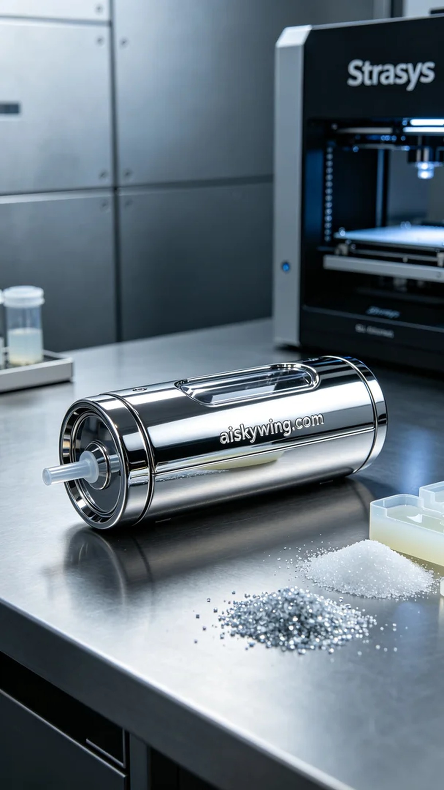
这次的项目源于Twitter上的一则信息，有人需要生产一款医用吸引器外壳，并且对外观和质量有着比较高的要求。他们希望我们能够利用3D打印技术，制作出一款既美观又实用的产品。
我们选择了SLA光固化树脂作为材料，这种材料具有优良的成型性能和较高的细节呈现能力，非常适合医疗器械的生产。为了确保打印效果，我们使用了Stratasys品牌的3D打印机，设定了层厚为0.05mm，打印温度保持在25℃，功率为50W，打印速度设定为30mm/s，预计整个打印过程需要8小时完成。
打印过程中，我们对设备进行实时监控，确保每一层的成型质量。在打印的前期，我们特别注意光源的稳定性，避免产生光斑。经过约6小时的运行，打印机顺利完成了整个吸引器外壳的成型，表面光滑，细节清晰，达到了预期的效果。
接下来是后处理工序。我们首先将成型的外壳放入清洗槽中，使用专用清洗液清除表面残留的树脂。清洗完成后，我们对外壳进行细致的打磨，提升表面的光滑度和光泽感。最后，将外壳放在UV固化设备中进行固化，确保其强度和耐用性。经过检验，外壳的质量完全符合标准。
这个项目顺利完成，医用吸引器外壳不仅外观精美，还具备了良好的功能性，成功满足了需求。每一次的制作都是一次新的学习和突破，期待下一个挑战。
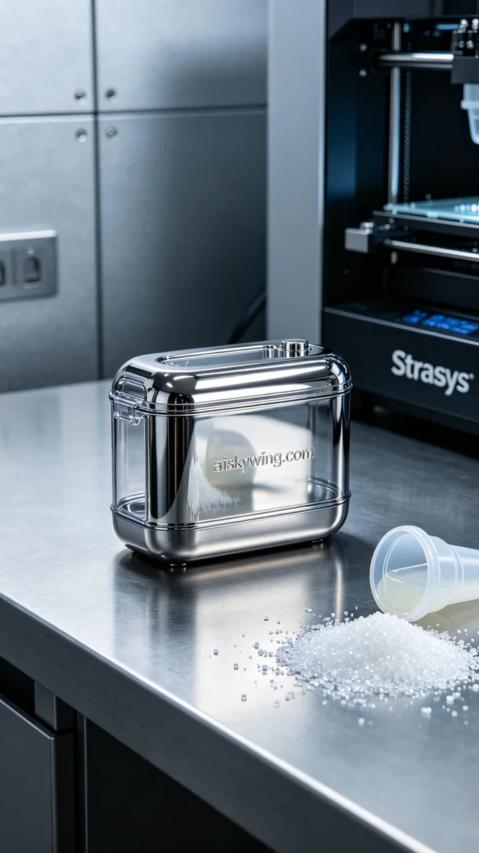
Aiskywing Industrial 3D Printing
Medical suction device shell


