0647-医用器械盒的3D打印日志
Medical instrument box
🖨️ SLA光固化
🖥️ 打印机: Voxeljet
📦 材料: SLA光固化树脂
生活再难，也别停下脚步。就像接这个医用器械盒的单子，很多人都在寻找更精确的医疗解决方案。
No matter how difficult life gets, don't stop moving forward. Just like taking this order for medical equipment boxes, many people are seeking more precise medical solutions.
________________________________________________________________________________
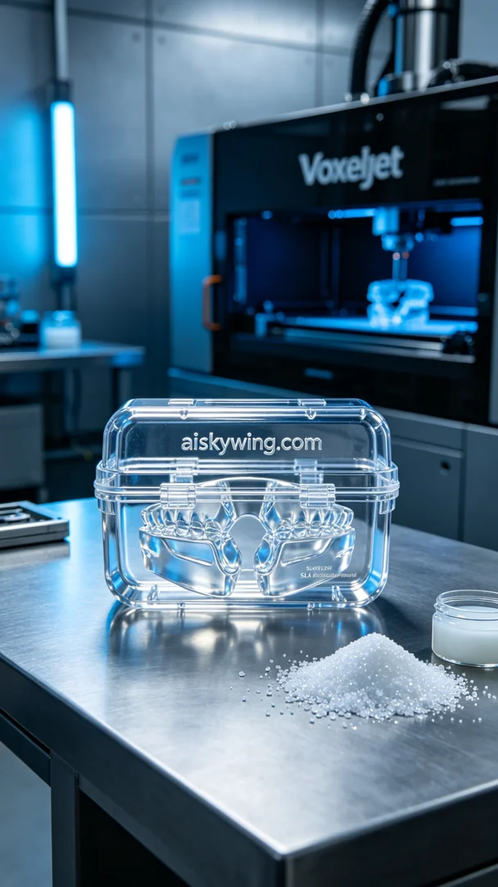
Recently, we received a request on Instagram from someone looking to customize a medical instrument box to solve their problems with product display and transport. This box needed to have not only an attractive appearance but also high strength and durability. Therefore, we decided to use SLA photopolymer resin for this product.
In the preparation phase, we chose high-quality SLA photopolymer resin, which has excellent transparency and gloss to effectively showcase product details. We used a Voxeljet printer with printing parameters set at a layer thickness of 0.1 mm, a printing temperature of 25 degrees Celsius, a light source power of 50 mW, and a printing speed of 60 mm per hour, with an overall expected printing time of about 8 hours.
During the printing process, the equipment was monitored throughout to ensure the curing quality of each layer. We carefully observed the printing progress to ensure there were no bubbles or other defects. After printing was completed, we performed a preliminary inspection of the appearance, confirming that the surface was smooth and the inscription “aiskywing.com” was clearly visible, with excellent transparency that reflected the cold industrial light.
After printing, we conducted the necessary post-processing steps. First, we placed the printed box into a cleaning tank, using isopropanol to remove any residual resin. Next, we used sanding tools to carefully smooth the edges, ensuring every corner was flawless. Finally, the box was cured under UV light to enhance strength, followed by a comprehensive inspection to ensure it met the required standards.
Through this series of processes, we successfully completed the production of this medical instrument box, meeting the requirements while showcasing the exquisite craftsmanship of 3D printing.
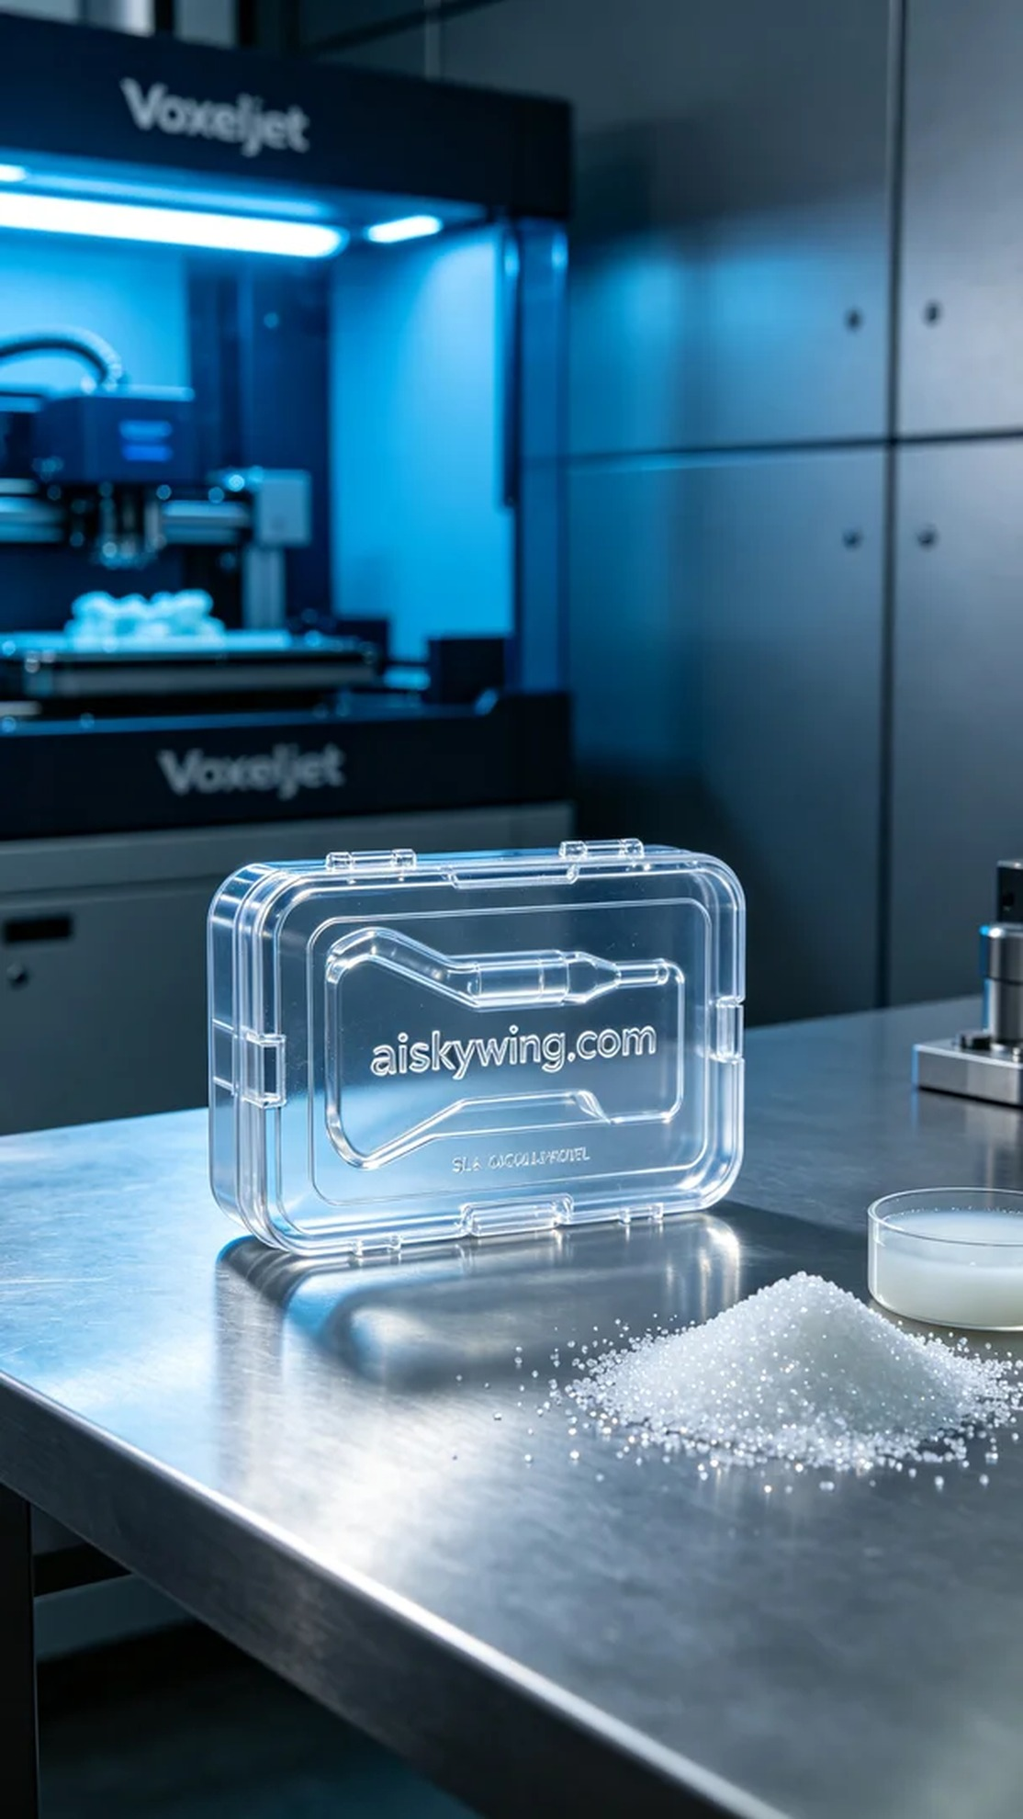
最近，我们在Instagram上接到有人求助，想定制一个医用器械盒，以解决其产品展示与运输的问题。这个器械盒不仅要有良好的外观，还要具备高强度和耐用性。于是，我们决定用SLA光固化树脂来制作这个产品。
在准备过程中，我们选择了高品质的SLA光固化树脂，其具有出色的透明度和光泽，能够有效显示产品细节。使用的打印机是Voxeljet，设置的打印参数为层厚0.1毫米，打印温度设定在25摄氏度，光源功率为50毫瓦，打印速度为每小时60毫米，整体预计打印时间在8小时左右。
打印过程中，设备全程监控，确保每一层的固化质量。我们仔细观察打印进度，确保没有气泡或其他缺陷。在打印完毕后，初步检查外观，表面细致光滑，字样“aiskywing.com”刻印清晰可见，透明度极佳，反射出工业光线的冷峻。
完成打印后，我们进行了必要的后处理。首先将打印好的器械盒投入清洗槽，用异丙醇进行清洗，以去除残留的树脂。接着，使用打磨工具对边缘进行细致打磨，确保每个角落都光滑无瑕。最后，器械盒在紫外线固化灯下固化，增强强度，之后进行了全面的检验，以确保达到使用标准。
通过这一系列工序，我们圆满完成了这个医用器械盒的制作，既满足了需求，又展现了3D打印的精湛工艺。
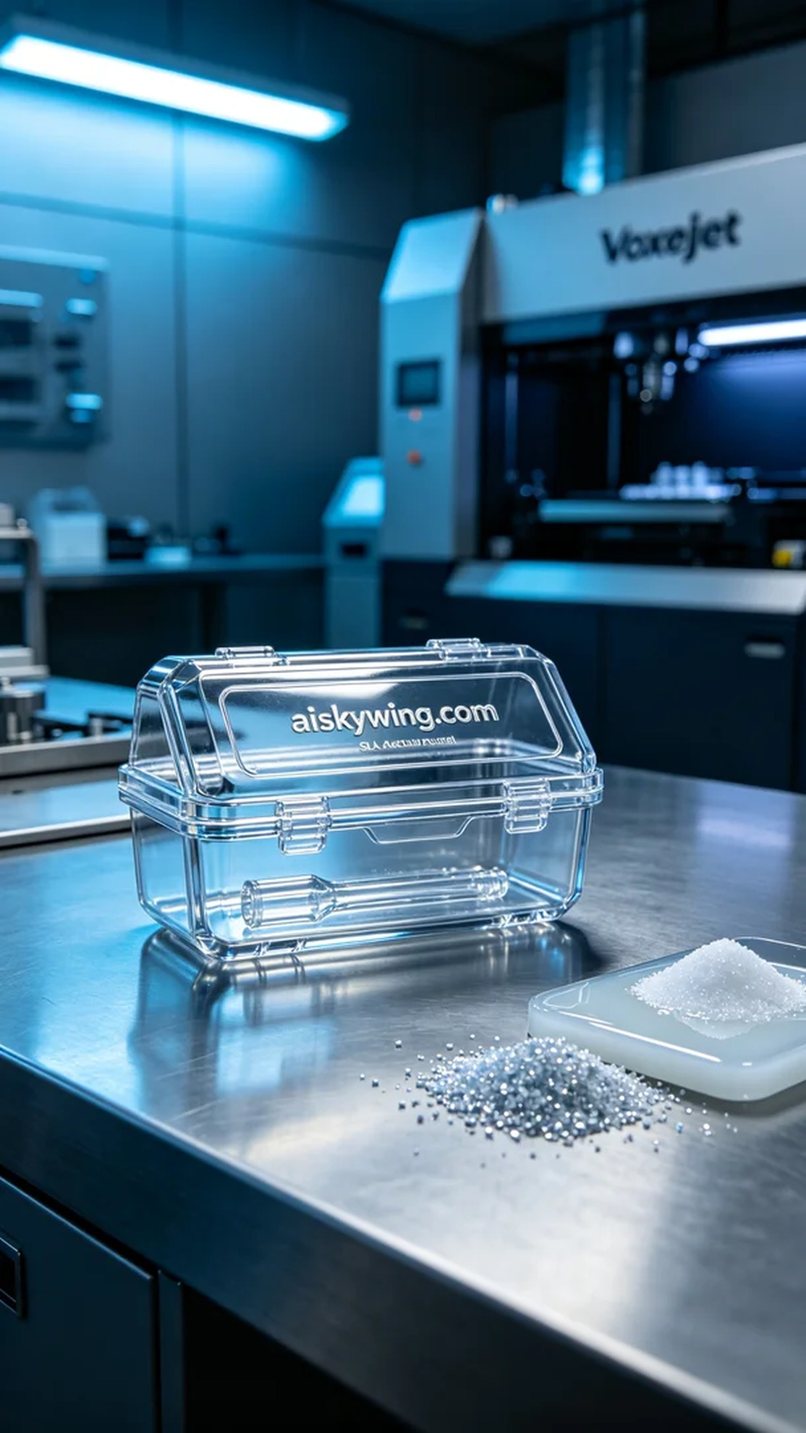
Aiskywing Industrial 3D Printing
Medical instrument box


