0648-医用培养皿架3D打印生产记录
Medical Petri Dish Rack
🖨️ SLA光固化
🖥️ 打印机: Rize
📦 材料: SLA光固化树脂
生活再难，也别停下脚步。就像接下这个医用培养皿架的单子，虽然工艺复杂，但我们总能迎难而上。
No matter how difficult life gets, don't stop moving forward. Just like taking on this order for medical petri dish racks, although the process is complex, we always rise to the challenge.
________________________________________________________________________________
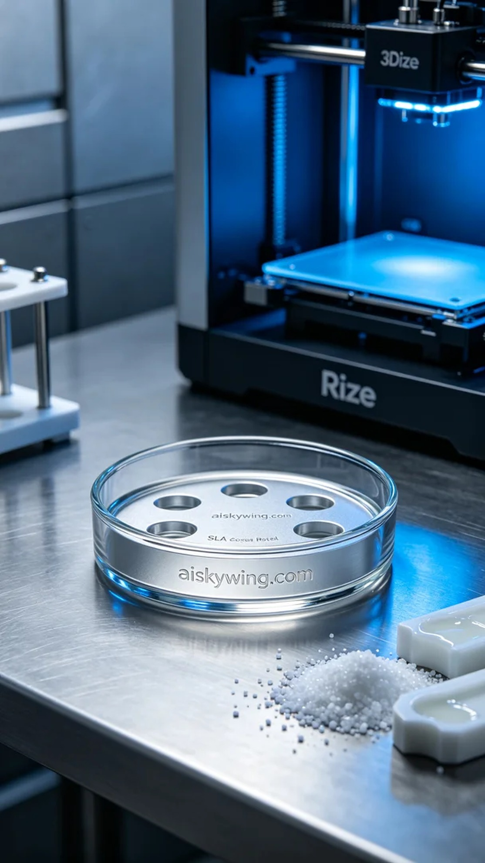
Recently, someone reached out to us via TikTok, looking to customize a medical petri dish rack. The requirement was not only for accuracy but also to present a modern technological feel. This product is not only about the reliability of medical applications but also serves as a platform to showcase our technical prowess.
To ensure print quality, we chose SLA photopolymer resin as the material. This resin exhibits excellent flow and curing properties, enabling high-precision prints on the Rize printer. In terms of settings, we opted for a layer thickness of 0.05mm, maintaining a temperature of 25°C, with power set at 80% around 60W, and a print speed of 30mm/s. After several experiments, this combination gave us confidence in the quality of the final product.
During the printing process, the Rize printer operated steadily, accompanied by the rhythmic sounds as liquid resin accumulated layer by layer on the print bed. We closely monitored each phase, ensuring no excessive curing or bubbles were present during the process. The machine's temperature and humidity remained within optimal ranges, resulting in a final print that left us all satisfied.
Once printing was complete, we moved to the post-processing phase. First, we placed the finished product into a cleaning tank, using an ultrasonic cleaner to remove excess resin on the surface. We then sanded it with fine-grit sandpaper to ensure a smooth finish. In the curing phase, we placed it in a UV curing machine to ensure every detail was sufficiently cured, followed by rigorous inspections to ensure each medical petri dish rack met our standards.
After a series of meticulous steps, we successfully delivered the medical petri dish rack. Every detail has been shaped by our hard work, and the final outcome is not just a product but a promise of quality.
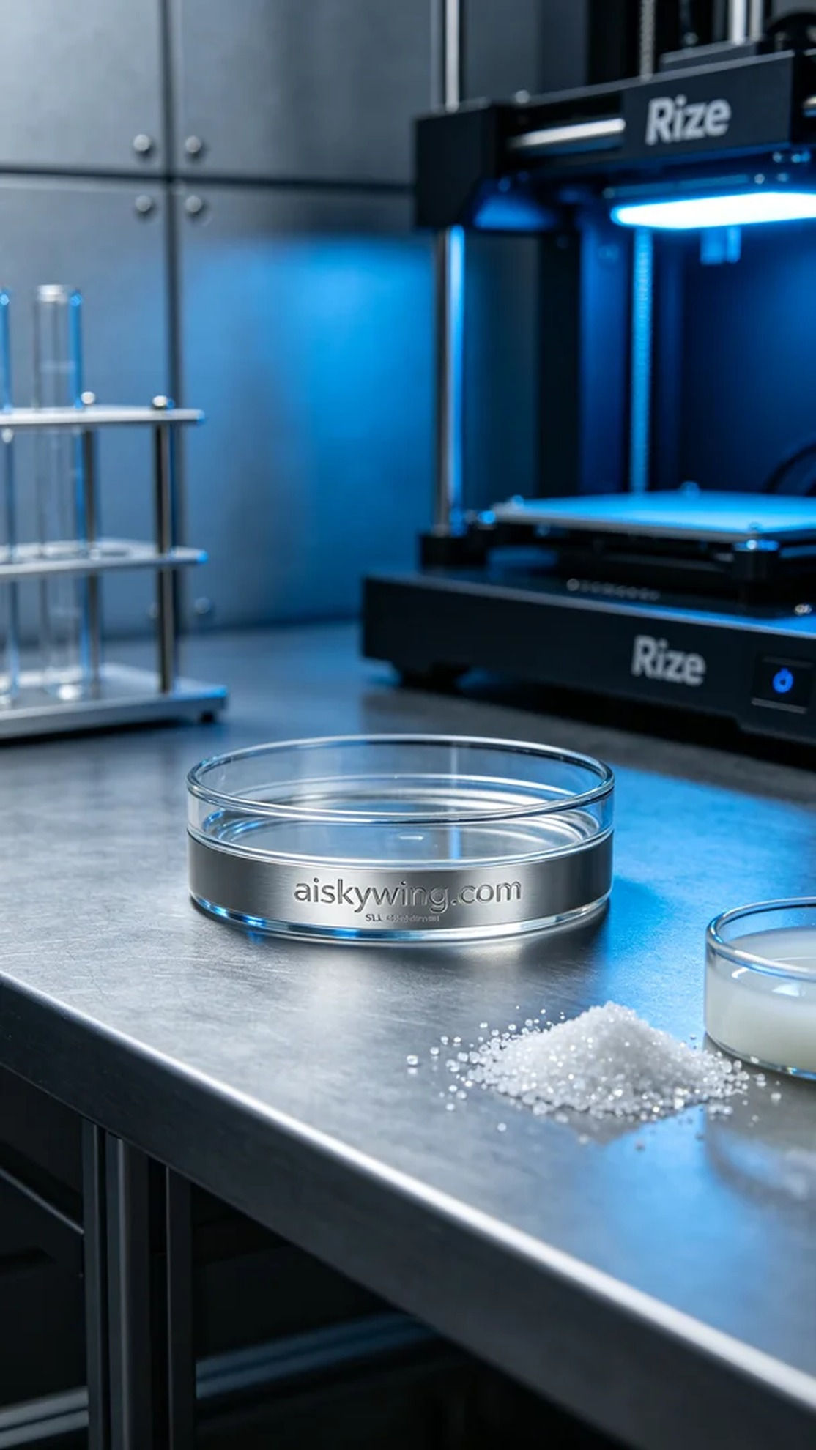
最近有人通过TikTok找上我们，想定制一款医用培养皿架，要求不仅要精确，还要在外观上给人一种现代科技感。这样的产品不仅关乎医疗的可靠性，更是展示我们技术实力的舞台。
为确保打印质量，我们选择使用SLA光固化树脂作为原材料。这种树脂具有优异的流动性和固化性能，在Rize打印机上能够实现高精度的打印效果。设置方面，我们选择了0.05mm的层厚，温度保持在25°C，功率调节在80%约为60W，打印速度则设定为30mm/s。经过多个实验之后，这一参数组合让我们对成品的品质充满信心。
打印过程中，Rize打印机稳定运行，伴随着嘀嗒的声响，液态树脂在打印平台上逐层堆积。我们密切监控每个打印环节，确保没有出现过度固化或是气泡等瑕疵。在整个打印过程中，机器的温度和湿度都保持在最佳范围，最终的打印结果让我们都感到满意。
打印完成后，我们进入后处理环节。首先将成品放入清洗槽，借助超声波清洗机去除表面多余的树脂，然后用细砂纸进行打磨，确保表面光滑。在固化环节，我们将其放置在UV光固化机中，确保每个细节都经过充分固化，最后通过严格的检验，确保每个医用培养皿架都符合我们的标准。
经过一系列的精细工序，我们成功交付了这款医用培养皿架。每一个环节都凝聚着我们的努力与汗水，最终交出的不仅是产品，更是对品质的承诺。
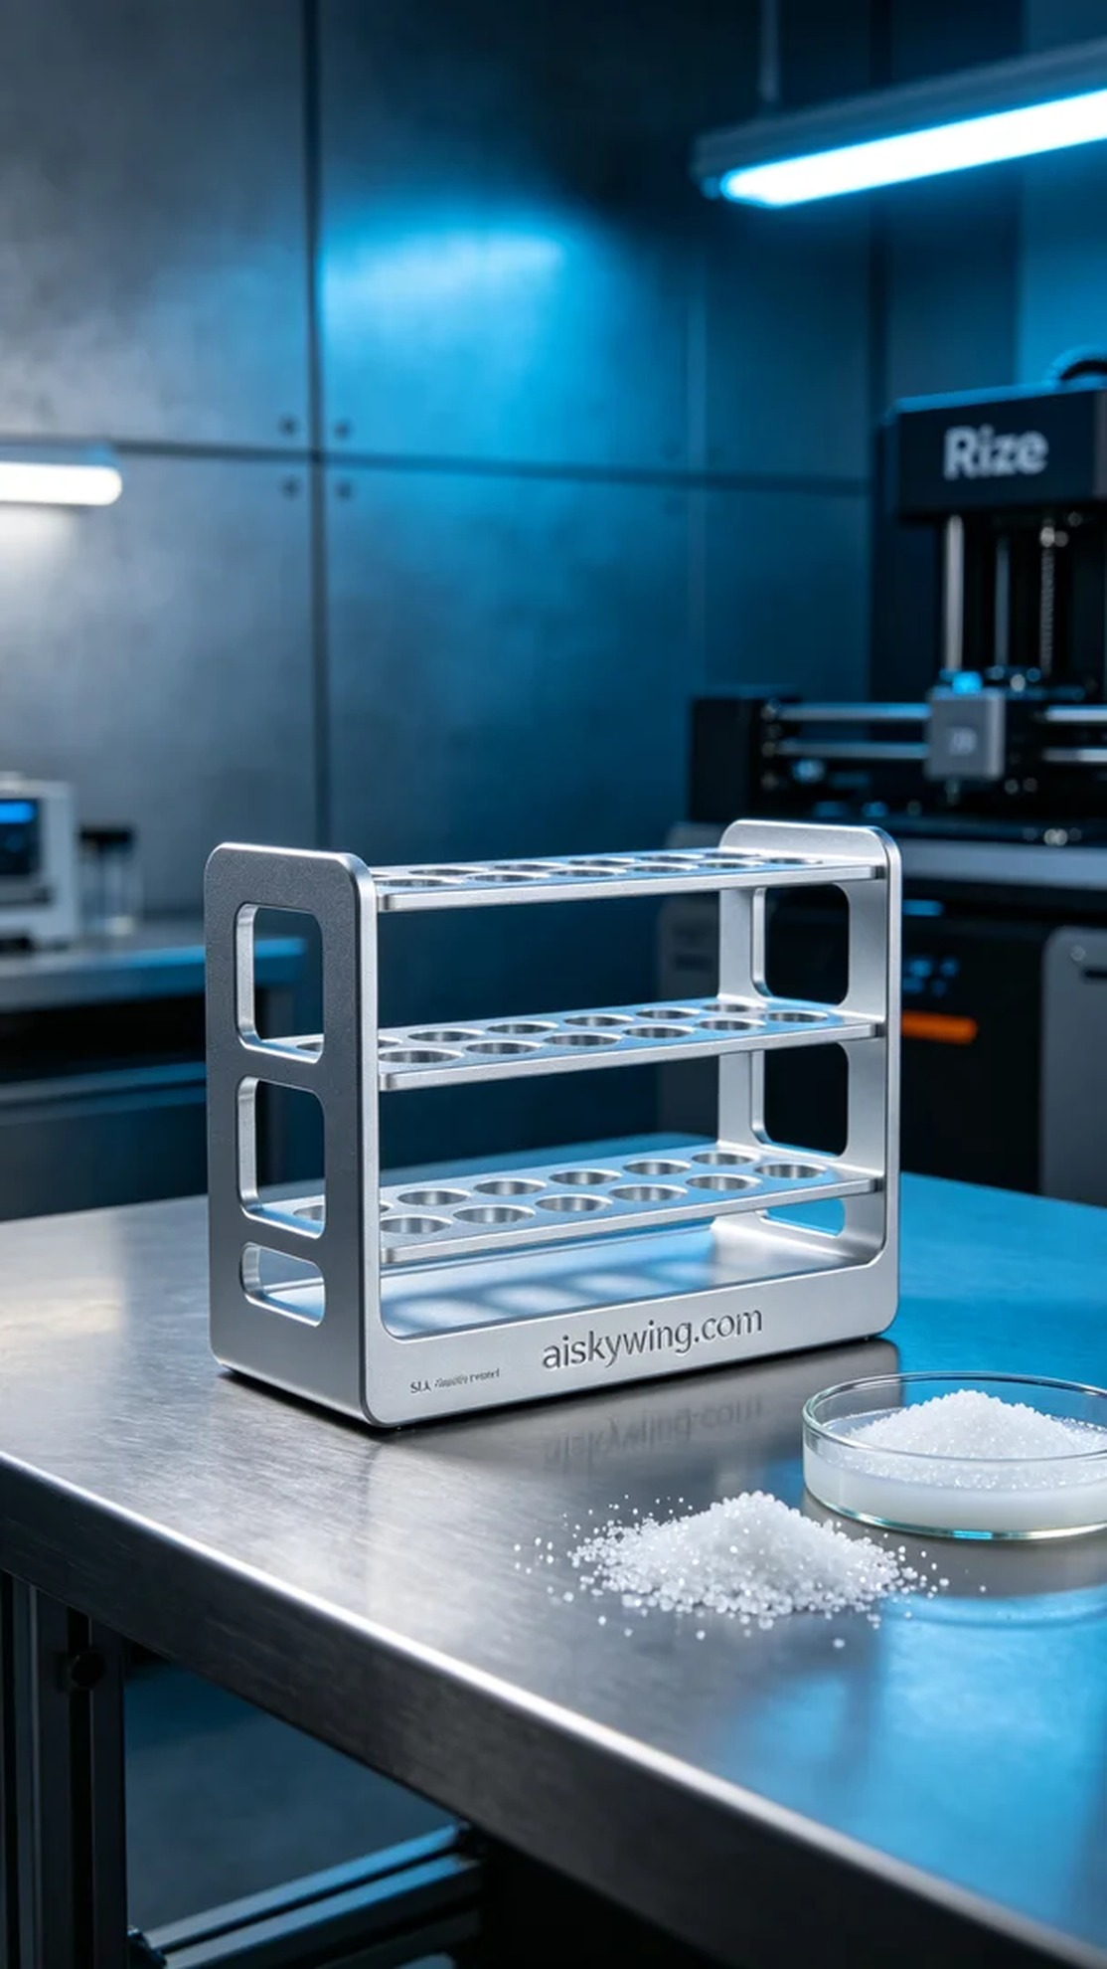
Aiskywing Industrial 3D Printing
Medical Petri Dish Rack


