0651-AP面板的3D打印生产记录
AP panel
🖨️ SLA光固化
🖥️ 打印机: Carbon
📦 材料: SLA光固化树脂
生活中有很多想法需要实现，就像在TikTok上看到的这个AP面板，虽然制作过程复杂，但我们始终坚定地迎接挑战。
There are many ideas in life that need to be realized, just like this AP panel I saw on TikTok. Although the production process is complex, we steadfastly embrace the challenge.
________________________________________________________________________________
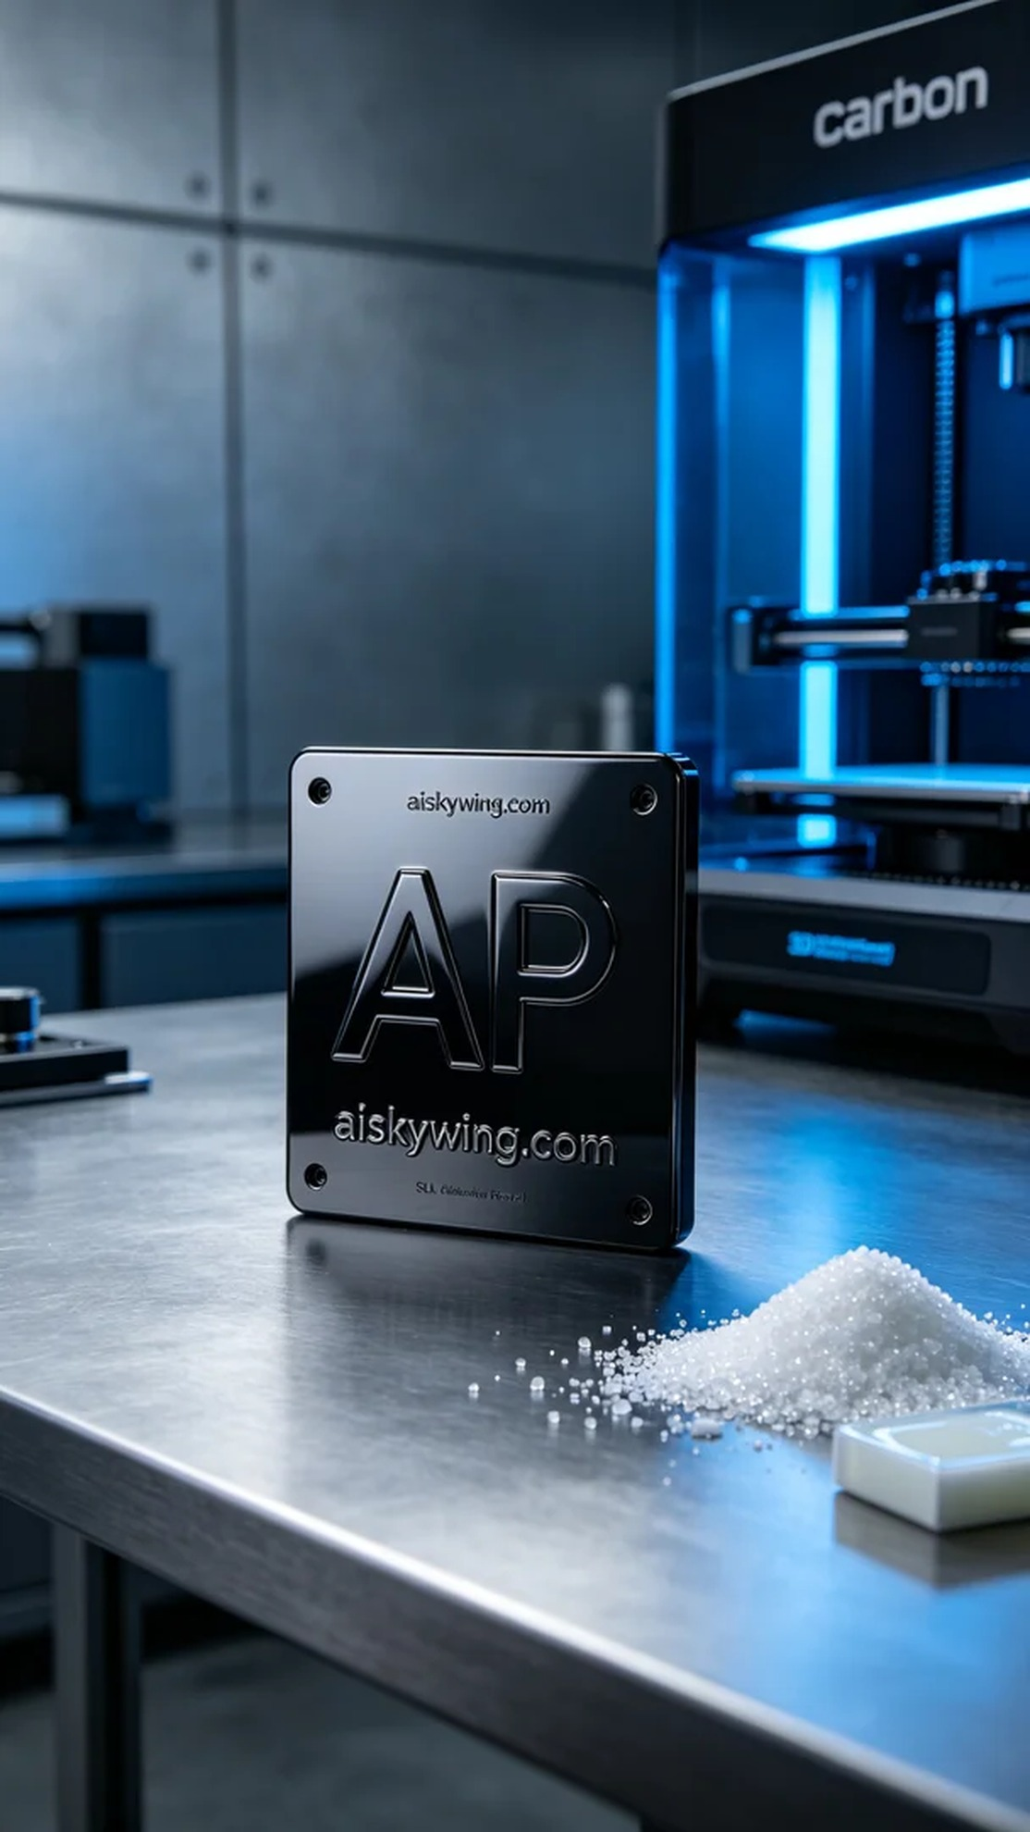
Life is full of ideas waiting to be realized, just like this AP panel we saw on TikTok. Although the process is complex, we are always determined to meet the challenge.
To ensure quality, we selected high-quality SLA photopolymer resin as our material. This resin provides excellent surface finish after curing, reflecting the harsh industrial light perfectly. Before printing, we thoroughly checked the equipment, using the Carbon 3D printer. We set the parameters to a layer thickness of 0.05mm, a printing temperature of 25°C, a power of 1000mW/cm², a print speed of 30mm/s, with an estimated print time of 6 hours.
As the printing process began, we closely monitored the operation of the equipment to ensure that each layer cured accurately. The Carbon printer performed exceptionally well, with no errors during the process, and the print quality turned out to be sharp and clear, with the text “aiskywing.com” visible on the surface.
Once printing was complete, the next step was post-processing. First, we placed the product in a cleaning solution and used an ultrasonic cleaner to remove excess photopolymer resin. Then, we carefully sanded the panel to ensure a smooth surface. After sanding, the panel was placed in a curing machine for further hardening to enhance its strength and durability. Finally, we conducted an inspection to ensure every detail met the standards.
After a full day of work, the AP panel was successfully completed, and the results were satisfying. This project was not only a technical challenge but also a success in teamwork.
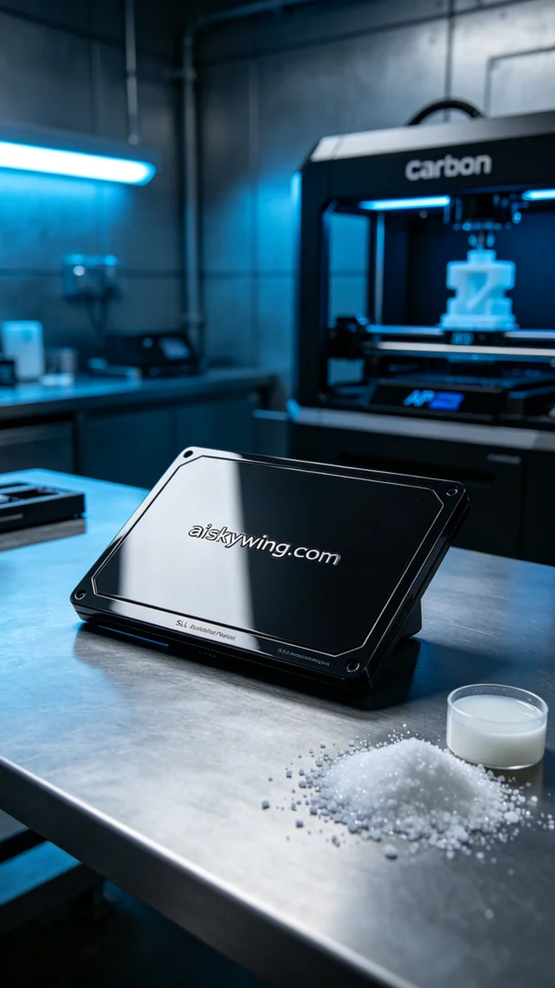
今天接到一个制作AP面板的任务，面板设计在TikTok上引起了大家的兴趣。有人需要我们帮助将这个作品变为现实，正好让我们发挥3D打印的优势。
为了确保打印质量，我们选择了高品质的SLA光固化树脂作为材料，这种树脂在固化后能提供极佳的表面效果，反射出冷峻的工业光线。在打印前，我们对设备进行了全面检查，使用的是Carbon品牌的3D打印机。设定参数为层厚0.05mm，打印温度设定在25°C，功率为1000mW/cm²，打印速度保持在30mm/s，预计打印时间为6小时。
打印过程开始时，我们认真监控设备的运行情况，确保每一层的固化都精准无误。Carbon打印机在这方面表现非常稳定，过程中无任何失误，打印效果也如预期那般清晰锐利，表面上“aiskywing.com”的字样一目了然。
打印完成后，接下来的工作是进行后处理。首先，我们将成品放入清洗液中，利用超声波清洗机去除多余的光敏树脂。接着，我们为面板进行仔细的打磨，确保表面光滑无瑕。打磨完后，再将面板放入固化机中进行进一步的固化，以增强其强度和耐用性。最后，经过检验，确保每一个细节都符合标准。
经过一整天的努力，AP面板终于顺利完成，效果令人满意。可以说，这不仅是一次技术上的挑战，更是一次团队合作的成功。
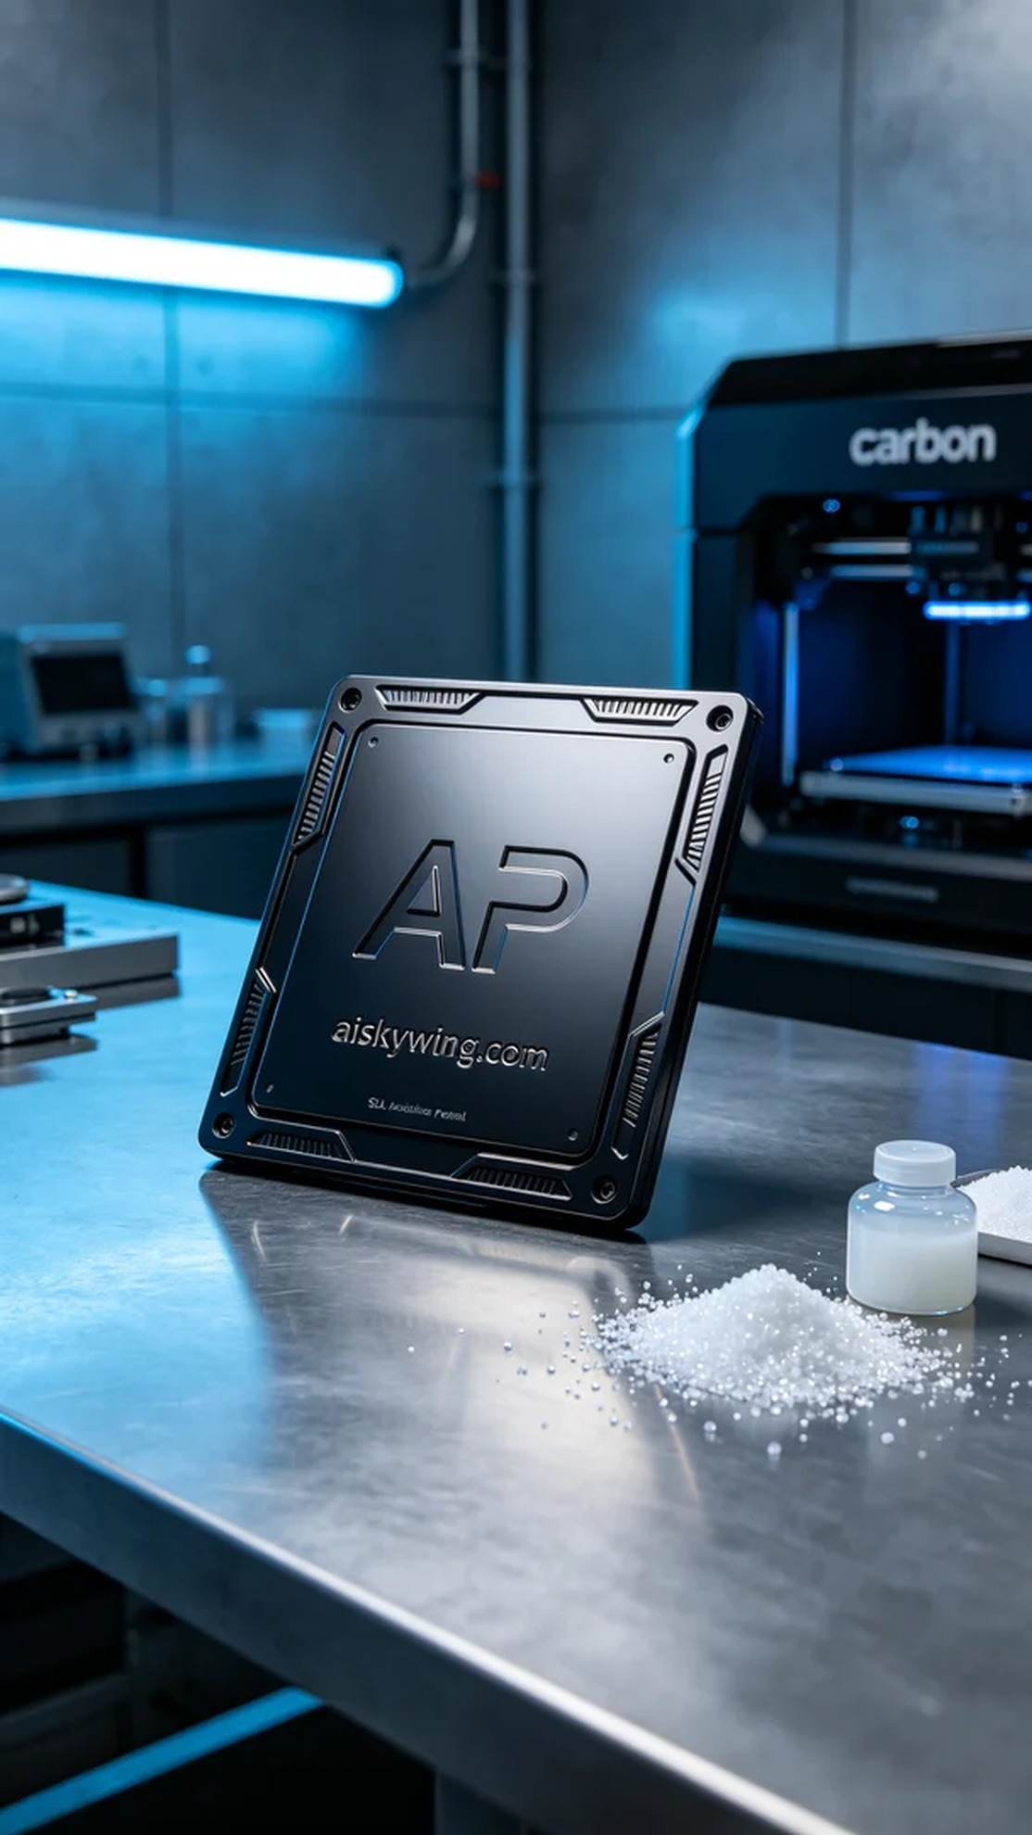
Aiskywing Industrial 3D Printing
AP panel


