0653-TWS蓝牙耳机充电仓的生产记录
TWS Bluetooth earphone charging case
🖨️ SLA光固化
🖥️ 打印机: Stratasys
📦 材料: SLA光固化树脂
生活就像3D打印，不断拼接出理想的样子。有人通过Twitter找到我们，请求生产TWS蓝牙耳机充电仓，我们欣然接受。
Life is like 3D printing, constantly piecing together an ideal form. Someone found us through Twitter and requested the production of TWS Bluetooth earphone charging cases, and we gladly accepted.
________________________________________________________________________________
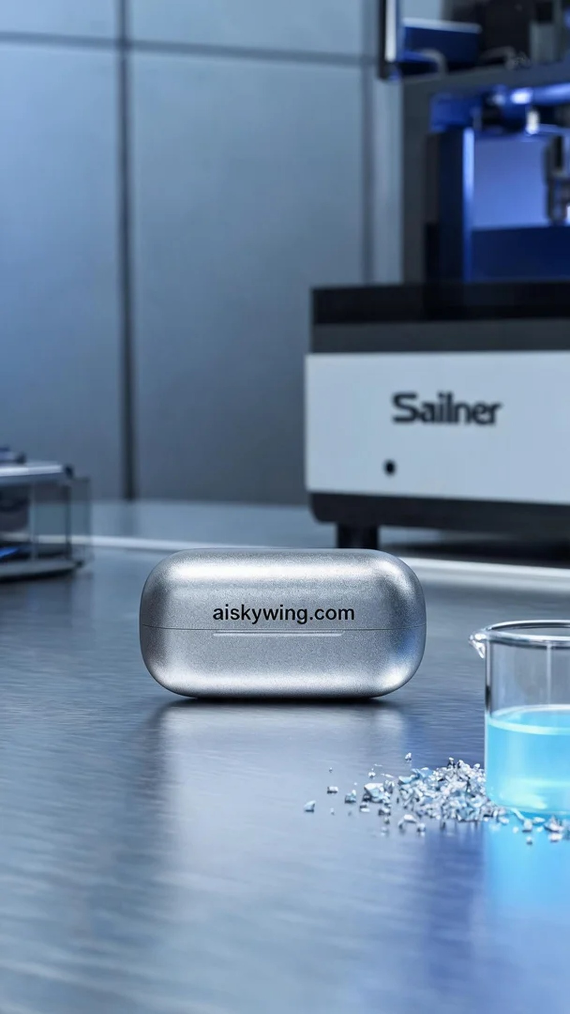
Life is like 3D printing, continuously piecing together the ideal form. Someone reached out to us on Twitter, requesting the production of a TWS Bluetooth earphone charging case, and we gladly accepted.
To ensure a smooth printing process, we chose high-quality SLA liquid resin as our material. This resin possesses excellent fluidity and high resolution, making it ideal for intricate product designs. We utilized a Stratasys printer, setting the parameters at a layer thickness of 0.05mm, with the nozzle temperature maintained at 25°C, a power output of 200mW, and a printing speed of 40mm/s. The entire printing process was estimated to take about 4 hours.
As we commenced the printing process, everything ran smoothly with the Stratasys equipment. Throughout the printing, we monitored the quality in real-time, ensuring that each layer adhered perfectly. After each print cycle, we conducted detailed checks, focusing on surface quality and detail representation to ensure the final product was flawless.
Once printing was complete, we proceeded with thorough post-processing steps. First, the formed charging case was cleaned in alcohol to remove any excess liquid resin. Next, we sanded the product to ensure a smooth and delicate tactile feel. Finally, we placed the product in a UV curing box to solidify its strength and durability, conducting strict inspections on each finished piece.
In the end, we successfully presented the TWS Bluetooth earphone charging case to the requester, perfectly meeting their expectations and showcasing the charm and value of 3D printing.
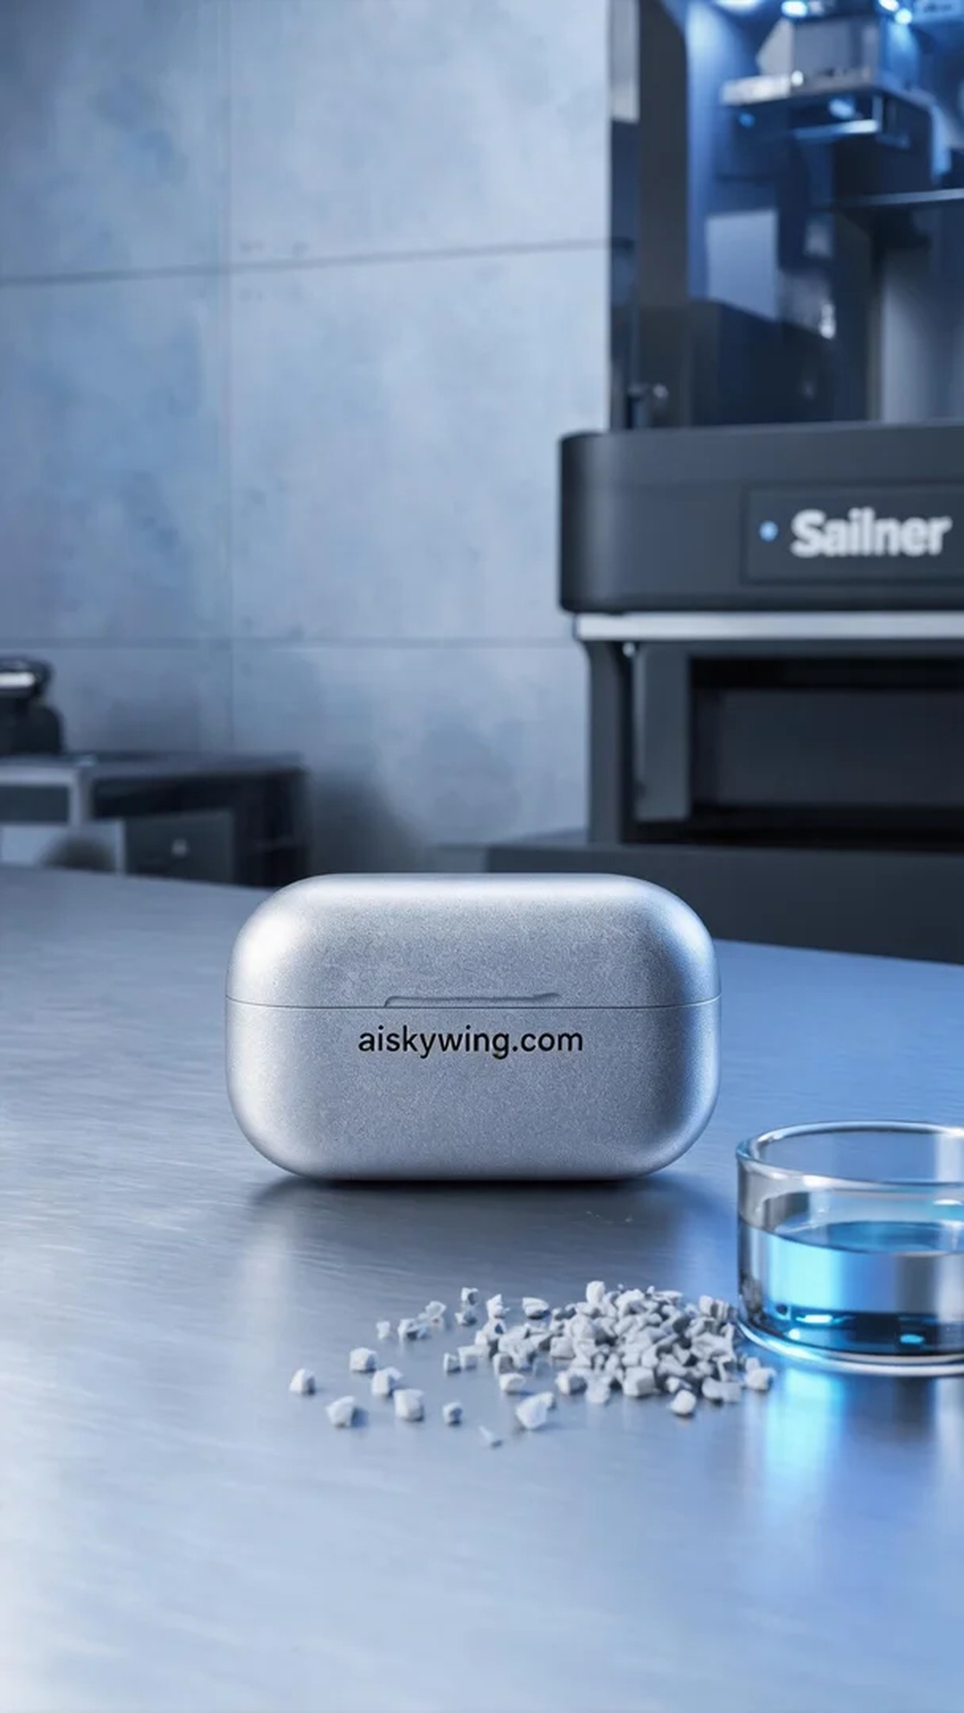
我们接到一个需求，想要生产一款TWS蓝牙耳机充电仓。在Twitter上，有人向我们咨询如何解决他们在材料选择和设计细节上的困惑。作为专业的3D打印团队，我们很高兴能为他们提供解决方案。
为确保打印的顺利进行，我们选择了高质量的SLA光固化树脂作为原材料。这种树脂具有优异的流动性和高分辨率，适合细节丰富的产品打印。我们使用Stratasys打印机，设置的打印参数为0.05mm的层厚，喷嘴温度控制在25℃，支持功率为200mW，打印速度为40mm/s，整个打印过程预计需要约4小时。
打印过程开始后，Stratasys设备的运行状态一切正常。在打印过程中，我们实时监控质量，确保每一层都完美附着。每次打印后我们都进行细致的检查，重点关注表面质量和细节表现，确保最终产品的完美。
完成打印后，我们进行了详细的后处理工序。首先将成型的充电仓放入酒精中清洗，去除多余的液态树脂。之后，我们对产品进行打磨，以确保表面光滑，手感细腻。最后，我们将产品放入UV固化箱中进行固化，确保其强度和耐用性，完成后对每个成品进行了严格的检验。
最终，我们成功地将TWS蓝牙耳机充电仓呈现给了需求方，完美地达到了他们的期望。真正体现了3D打印的魅力与价值。
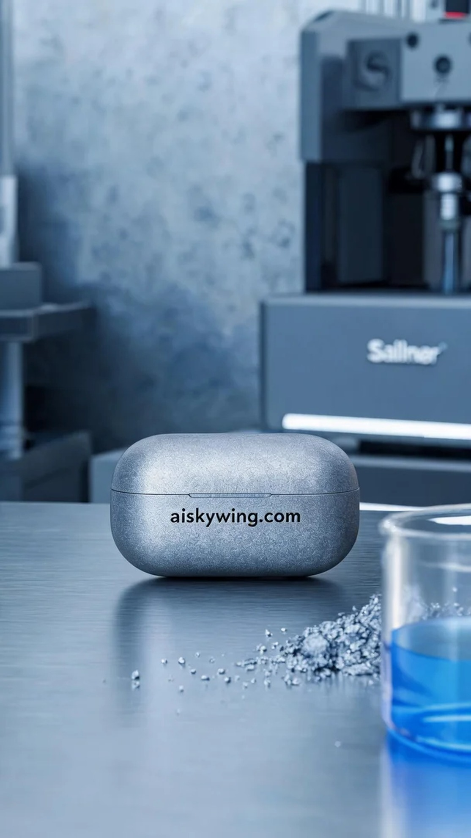
Aiskywing Industrial 3D Printing
TWS Bluetooth earphone charging case


