0654-U盘外壳3D打印生产记录
USB drive casing
🖨️ SLA光固化
🖥️ 打印机: Carbon
📦 材料: SLA光固化树脂
生活就像3D打印，都是一步一步建构的。有人通过Twitter找我们，想要制作一款U盘外壳，面临一些技术问题。
Life is like 3D printing; it's built step by step. Someone reached out to us through Twitter, wanting to create a USB drive casing, but they are facing some technical issues.
________________________________________________________________________________
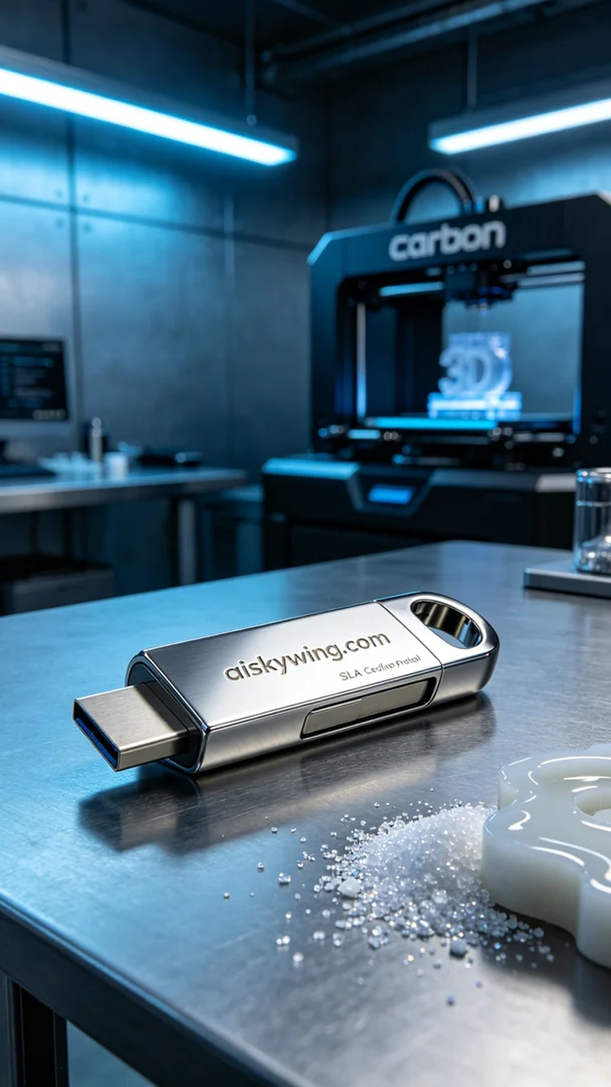
Life is like 3D printing; it's all about building step by step. Someone reached out to us via Twitter, looking to create a USB flash drive shell and faced some technical challenges.
To realize the design of this USB flash drive shell, we chose SLA photopolymer resin as our material. This resin is known for its excellent flow and curing properties, making it ideal for the fine engraving effect we needed. We prepared a Carbon brand 3D printer, setting the parameters to a layer thickness of 0.1 mm, maintaining a printing temperature of 25°C, setting the power at 30W, and the speed at 50 mm per second.
Once the printing process began, the machine operated smoothly. We closely monitored the curing status of each layer to ensure that there were no bubbles or defects. During this process, as the resin cured layer by layer, the outline of the USB flash drive shell gradually became clear, creating a sense of anticipation. The entire print took about four hours, during which we frequently checked the printing condition to ensure the quality met our standards.
After printing was complete, the first step was to clean the finished product thoroughly using isopropyl alcohol to remove any uncured resin from the surface. We then sanded down the edges with fine sandpaper to further enhance the smoothness and mirror finish. Finally, we placed it in the UV curing machine to ensure optimal strength and durability, followed by a final inspection to confirm that the engraving of “aiskywing.com” was clearly visible.
After a series of meticulous processes, this USB flash drive shell was perfectly presented. Through this creation, we not only accomplished our production task but also deepened our appreciation for the charm of 3D printing.
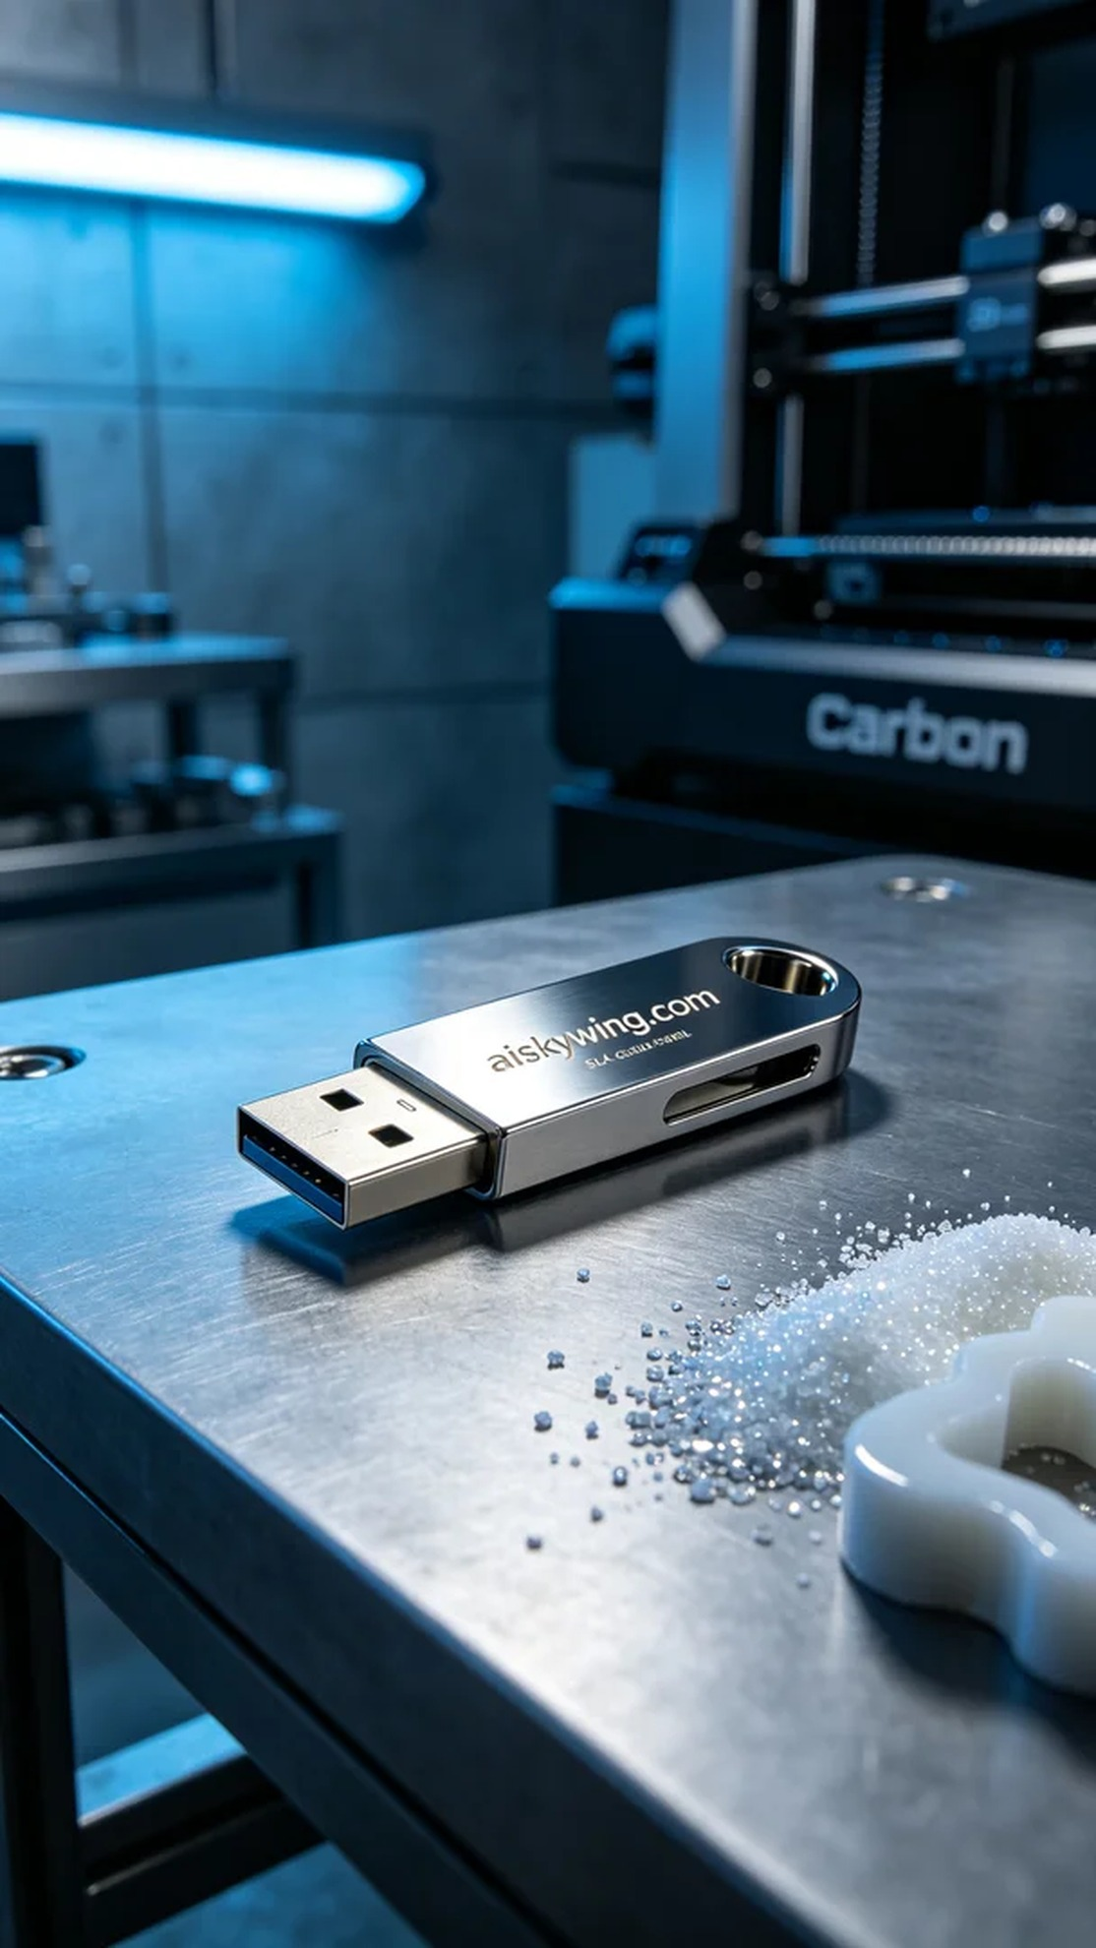
为了实现这个U盘外壳的设计，我们首先选择了SLA光固化树脂作为原材料。这种树脂具有优越的流动性和固化特性，非常适合我们需要的精细雕刻效果。同时，准备了一台Carbon品牌的3D打印机，设定参数为层厚0.1毫米，打印温度保持在25°C，功率设置为30W，速度为50毫米每秒。
打印过程开始后，设备运行得十分稳定。我们仔细监控每一层的固化情况，确保没有任何气泡或缺陷。在这个过程中，随着树脂逐层固化，U盘外壳的轮廓逐渐清晰，令人期待。打印整个过程大约耗时四个小时，期间我们不时检查打印状态，确保质量符合标准。
打印完成后，第一步是对成品进行清洗，使用异丙醇进行彻底清洁，去除表面未固化的树脂。之后，我们用细砂纸进行打磨，进一步提升表面光滑度和镜面效果。最后，将其放置在UV固化机中进行固化，确保其强度和耐用性达到最佳状态，并最终进行外观检验，确保“aiskywing.com”的雕刻字样清晰可见。
经过一系列精细的工序，这款U盘外壳终于完美呈现。通过这次制作，不仅完成了生产任务，也让我们更加深刻地体会到3D打印的魅力。
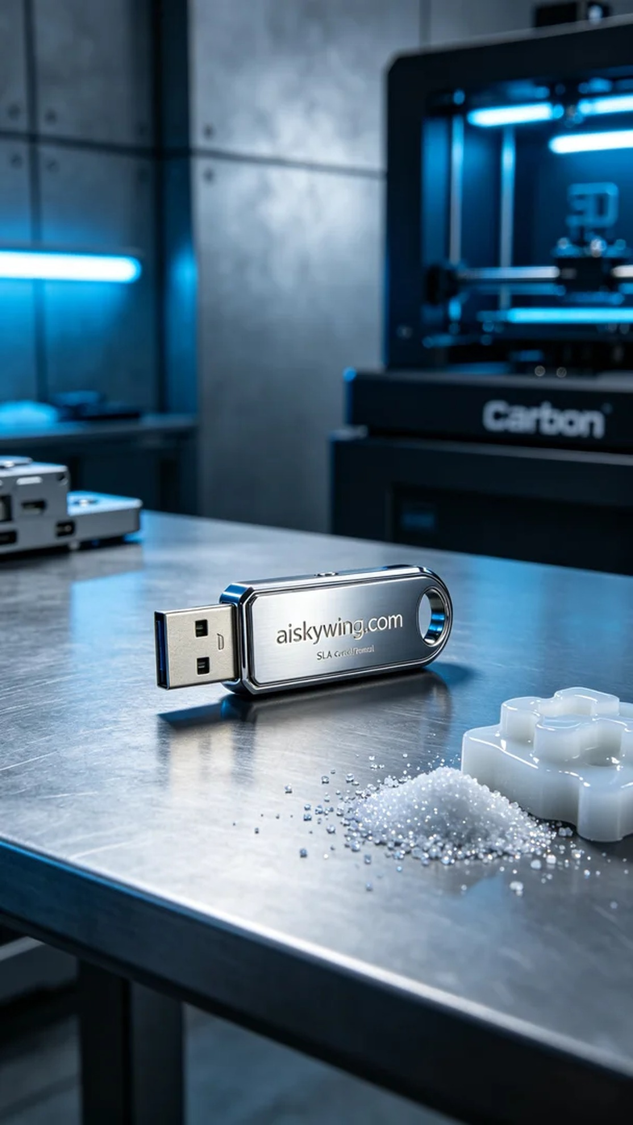
Aiskywing Industrial 3D Printing
USB drive casing


