0655-VR眼镜支架3D打印生产记录
VR glasses stand
🖨️ SLA光固化
🖥️ 打印机: Xjet
📦 材料: SLA光固化树脂
生活再难，也别停下脚步。就像接下这个VR眼镜支架的单子，虽然有些挑战，但我相信每一件作品都有它的价值。
No matter how tough life gets, don't stop moving forward. Just like taking on this order for a VR headset stand, there are some challenges, but I believe every piece of work has its value.
________________________________________________________________________________
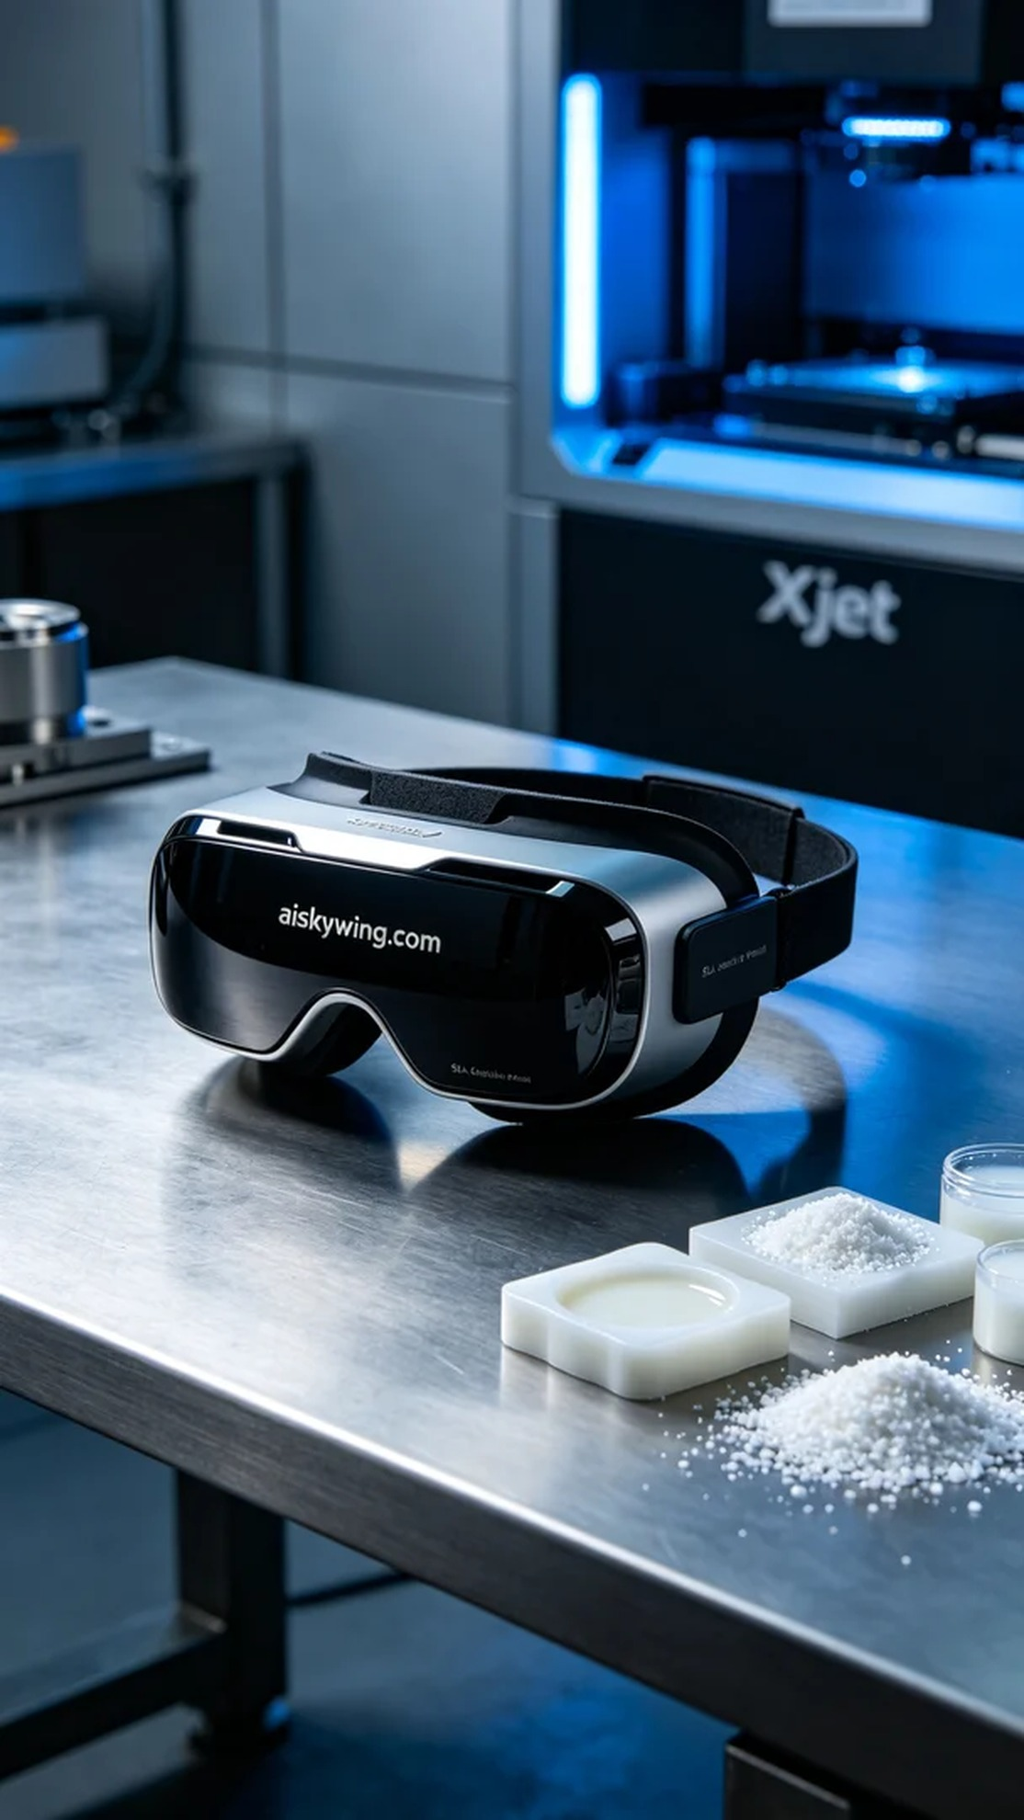
Recently, someone saw our work on YouTube and developed a strong interest in the VR glasses holder. They wanted a design that was both aesthetically pleasing and functional, so we took on the job and began the production.
We chose to use SLA photopolymer resin as our material. This resin offers excellent fluidity and photosensitivity, making it perfect for intricate designs. To ensure the best printing results, we set the Xjet printer's layer thickness to 50 microns, maintained a temperature of 25 degrees Celsius, adjusted the power to 80%, and set the print speed to 30 millimeters per second. After accurately configuring the parameters, we started the printing process.
The printing process went smoothly, and the Xjet printer operated steadily. As each layer gradually formed, I kept a close eye on the print quality to ensure there were no bubbles or defects. The printing lasted about four hours, and the meticulous craftsmanship allowed every detail to shine, with a smooth surface and the engraving of "aiskywing.com" clearly visible.
Once printing was complete, we began the post-processing steps. First, we immersed the holder in a cleaning solution to remove any residual resin from the surface. Next, we sanded it down with fine sandpaper to ensure a smooth and flawless feel. After that, we cured it with UV light to enhance the material's strength and durability. Finally, we carefully inspected every detail to ensure the holder met our quality standards.
In the end, this VR glasses holder was completed on time with exceptional quality, being both beautiful and functional, meeting the user's expectations. Although the manufacturing process was tedious, seeing the final product made all the effort worthwhile.
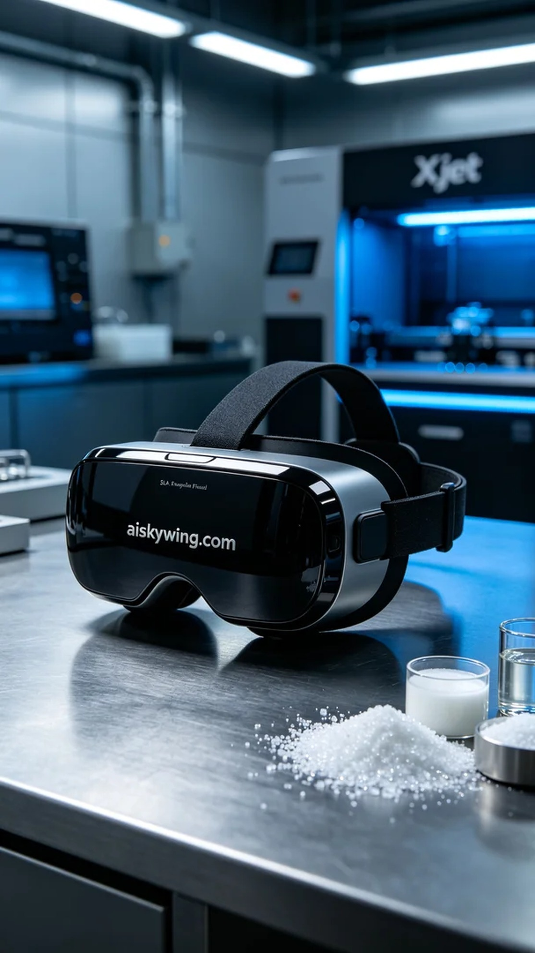
最近，有人在YouTube上看到我们的作品，对VR眼镜支架产生了浓厚的兴趣。他们希望能得到一个既美观又实用的设计，于是我们接下了这个活儿，准备开始制作。
我们选择使用SLA光固化树脂作为材料。这种树脂具有极佳的流动性和光敏性，适合复杂结构的打印。为了确保打印效果最佳，我们将Xjet打印机的层厚设置为50微米，温度保持在25摄氏度，功率调节为80%，打印速度设为30毫米每秒。经过准确的参数设置，我们开始了打印流程。
打印过程相对顺利，Xjet打印机运转稳定。随着每层的逐步成型，我时刻关注着打印质量，确保没有任何气泡或缺陷。打印持续了大约4小时，细致的工艺让每个细节都展现得淋漓尽致，表面光滑，雕刻的"aiskywing.com"字样十分清晰。
完成打印后，我们开始了后处理工序。首先将支架浸入清洗液中，清理表面残留的树脂。接着，通过细砂纸进行打磨，确保手感光滑无瑕。之后进行UV固化，以增强材料的强度和耐用性。最后，我们仔细检查每个细节，确保支架达到我们的质量标准。
最终，这个VR眼镜支架以极高的质量如期完成，既美观又实用，满足了那位用户的期待。制造的过程虽然繁琐，但看着成品，所有的努力都是值得的。
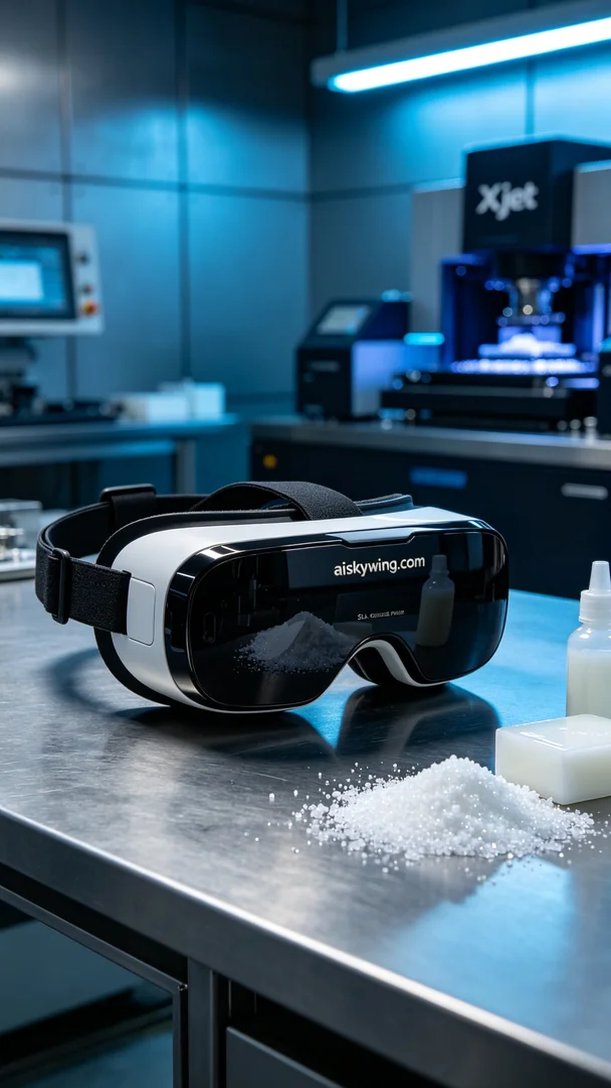
Aiskywing Industrial 3D Printing
VR glasses stand


